Home Link Workers – Scottish Attainment Challenge

Home Learning Activities

Activity Title | Grow a Rainbow
Age range: | All age ranges
Area of the Curriculum: | STEM / Science
Resources required: | Kitchen roll, Felt tip pens, paper clips or clothes pegs, piece of string, 2 containers to hold water eg cups
Time / length of the activity: | 30 mins to colour kitchen roll & assemble  Hours/days to see the rainbow grow
Number of people required: | As many as you like
Instructions: | - Cut the kitchen roll into the shape of a rainbow.  - Colour a rainbow with felt tips pens about 2cm up on both sides.  - Attach your paper clips or clothes pegs to the top of each side of the rainbow & tie a piece of string to it. This will give you something to hold the rainbow with.  - Fill each small containers/cups with water.  - Hold your rainbow with the ends slightly submerged in the water. Then watch your rainbow grow!  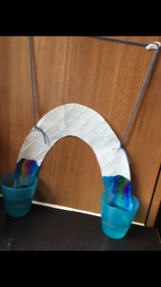
Further learning opportunities: | Learn the science behind it.  ‘Capillary action’ – water molecules like to stick to things including themselves. Sticking to things is called ‘adhesion’ & sticking to itself is called ‘cohesion’. The fibres in kitchen roll has lots of small holes. Water is ‘sucked’ through the holes because of adhesion (liking to sticking to other things) & cohesion (liking to sticking to itself) means the rest of the water follows.  The water pressure will eventually level out & the presence of gravity will mean it stops moving.

