[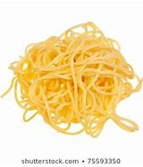](https://www.bing.com/images/search?view=detailV2&ccid=DGZuH25w&id=779BF8738346B2B74B26D16291426CE96118C74B&thid=OIP.DGZuH25wOyOHyFeuA9ij-gAAAA&mediaurl=https://image.shutterstock.com/image-photo/cooked-fresh-spaghetti-isolated-over-260nw-75593350.jpg&exph=280&expw=260&q=Cooked+Spaghetti+Background&simid=608023238666027649&ck=A51E6E94337D6EB4A4334D6966BD7B62&selectedIndex=92&FORM=IRPRST)[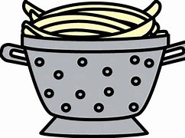](https://www.bing.com/images/search?view=detailV2&ccid=jx8RuZwJ&id=5B9D66015C8F3C3899A1619A69E97CEF63389E61&thid=OIP.jx8RuZwJG7wyafJkruWUTQHaFM&mediaurl=http://clipart-library.com/image_gallery/45394.png&exph=347&expw=494&q=playing+with+spaghetti+clipart&simid=608015159882943125&ck=17A9199C8E3517C008A5053B6F1B0C58&selectedIndex=48&FORM=IRPRST)

This is best:

Indoors

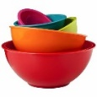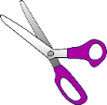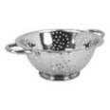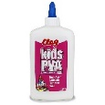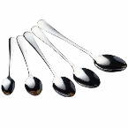[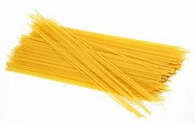](https://www.bing.com/images/search?view=detailV2&ccid=0t1Owayy&id=5CF2538507D293FE4F65807028C416A4A92F1D1D&thid=OIP.0t1OwayynTcyvnoEeKOO-wAAAA&mediaurl=https://sc01.alicdn.com/kf/UTB8BR59a._4iuJk43Fqq6z.FpXaY/Best-Quality-Spaghetti-Pasta-For-Sell.jpg_350x350.jpg&exph=222&expw=350&q=spaghetti+hard+&simid=607993474569734234&ck=8F6D10BA213666F7EB0499AF45688977&selectedIndex=8&FORM=IRPRST)

**Top Tip from our Speech and Language Therapy partners:**

**Being face to face with your child helps them develop their interaction and**

**communication skills.** Using action words for example: poke, squeeze or fun words like: yucky,

gooey, describing words like hot, brittle or bendy will help develop your child’s vocabulary.



**“The fun is in the journey, not the end result!”**

|  |  |
| --- | --- |
| **Make this simpler...**   * If your child is not able to poke the spaghetti through the colander you can play with him or her, exploring it, snapping it or perhaps playing with it with some pots or dishes. | **Make this more challenging...**   * If you have small scissors you can cut and snip the cooked spaghetti, this will help your child’s scissor control. |

**Tips to support your child:**

* Uncooked spaghetti: Show your child how to insert the spaghetti through the holes in the colander, encourage him or her to put a piece in lots of the holes. Your child can experiment with breaking the bits.
* Cooked spaghetti: Put some in a food bag with a very small amount of paint or food colour and use hands to work the colour in. The coloured pieces can be used to make a picture on paper and should stick on easily without glue. *Ensure your child does not eat cooked pasta coloured using paint
* Talk to your child throughout these activities being playful with the words that you use “yucky” “slimy” “gooey” when mixing the paint. Your actions throughout will encourage your child to communicate with you.

**The basic idea:** Play and explore with hard and soft spaghetti! Grab a colander, spoons, bowls, pots and pans and some spaghetti. Can your child carefully poke the spaghetti through the holes to reach the other side? Add (very small amount) of paint or a really tiny bit of food colouring to some cooked spaghetti and use it to make some fun pictures.

**Materials**

You may need:

* Cooked and/or uncooked spaghetti pasta
* Colander
* Different sized spoons
* Bowls
* Children’s paint and glue
* Food colouring
* Small food bags

**How this benefits your child:**

* Playing with the spaghetti whether dry or uncooked will support your child to build and strengthen the small muscles in their hands. The development of strength in these muscles is essential for being able to control a pencil when moving on to writing.
* Playing and talking to your child provides lots of opportunities for communication and language development. Your child will develop their ability to listen and respond during interactions as well as pick up new vocabulary.

Early Years Home Learning

Movement and Coordination

**Spaghetti**