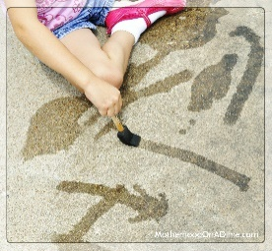

This is best:

Outdoors

[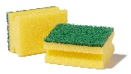](https://www.google.co.uk/url?sa=i&url=https://www.carlroth.com/com/en/brushes-cleaning-sponges/scrub-sponge/p/hca7.1&psig=AOvVaw0UfhmYM2AWlryEWVdhpePH&ust=1598093838137000&source=images&cd=vfe&ved=0CAIQjRxqFwoTCMiu0s6RrOsCFQAAAAAdAAAAABAd)[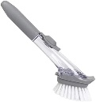](https://www.google.co.uk/url?sa=i&url=https://www.amazon.co.uk/VOANZO-Cleaning-Dispenser-Automatic-Dishwasher/dp/B0872WL494&psig=AOvVaw3ZJoGXtHSmsawhznYgfvW5&ust=1598093767273000&source=images&cd=vfe&ved=0CAIQjRxqFwoTCKDsjK2RrOsCFQAAAAAdAAAAABAH)[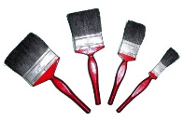](https://www.google.co.uk/url?sa=i&url=https://www.home-dzine.co.za/decorating/decorating-whichbrush.htm&psig=AOvVaw3uDRCMimUVSvlb6AUovHEJ&ust=1598093683838000&source=images&cd=vfe&ved=0CAIQjRxqFwoTCPj0wIWRrOsCFQAAAAAdAAAAABAL)[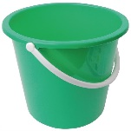](https://www.google.co.uk/url?sa=i&url=https://www.nisbets.co.uk/jantex-round-plastic-bucket-green-10ltr/cd806&psig=AOvVaw0rArgQUUhL07DVA5bfR0FG&ust=1598094006700000&source=images&cd=vfe&ved=0CAIQjRxqFwoTCPiP3p-SrOsCFQAAAAAdAAAAABAG)

**Top Tip from our Speech and Language Therapy partners:**

**Being face to face with your child helps them develop their interaction and**

**communication skills.** Make a comment and wait, for example you say” I’m going to

paint a big house” and then wait............ Hopefully your child will respond.



**“The fun is in the journey, not the end result!”**

**Tips to support your child:**

It’s a quick and easy set-up, mess-free and cost-free. Simply provide your child with a bucket or container, fill with water and give him or her different sized brushes or other things to use to experiment with such as sponges and sticks. You and your child may be able to think of other things to use. Show them areas they can ‘paint’ – the ground, walls, fences, steps…Paint with your child and support him or her to develop their own ideas and plans. Close supervision with water play is essential. Take a photo of their work when finished. You can refer back to this when your child wants to paint with water again. Have fun!

**The basic idea:** Painting with water is one of those activities that children usually really enjoy, become engrossed in and want to revisit. All you need is an outdoor space, brushes or other 'tools' and water! This works well in the sunshine but can be done whatever the weather with the right clothing. This is a simple activity but one that has varied benefits involves lots of movement and provides lots of creative, imaginative fun.

|  |  |
| --- | --- |
| **Make this simpler...**     * Use chunky brushes or sponges. These will be easier for your child to hold. * If painting with water is challenging for your child encourage them to wash objects with the water, sponges and brushes. | **Make this more challenging...**   * Encourage your child to use finer brushes to add detail to their work. * Encourage your child to mark make with purpose, for example write their name, a list, or story. (You can provide a name template to encourage independence and support your child’s confidence. Remember to let them follow their own ideas when mark making.) |

**Materials**

You may need:

* Different sized paintbrushes
* Old toothbrushes and cleaning brushes
* Sponges
* Sticks
* Bucket
* Water

Early Years Home Learning

Movement and Coordination  
Painting with Water

**How this benefits your child:**

Young children need to practise moving their bodies. Making big movements of the arms and legs are important 'gross' motor skills. Being physically active outside is also good for their health and yours if you join in! Holding and using the brushes and other tools develops the muscles in the hands and fingers, this will help with other skills such as mark making, using scissors and drawing. It also helps children to acquire hand-eye coordination skills. Having the freedom to choose what and how to paint helps develop creativity and decision making, these skills are also transferable and your child can apply them in other contexts.