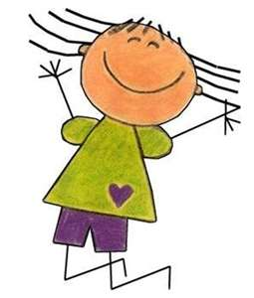

This is best:

Outdoors

Early Years Home Learning

Movement and Coordination

Colour Hop

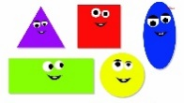

**Top Tip from our Speech and Language Therapy partners:**

**Give your child a reason to communicate**. Give your child a choice of different coloured

paper or chalk. They might point, make a sound or use words to choose.

Don’t worry if they don’t know the names of colours, just praise them for making a choice.



**“The fun is in the journey, not the end result!”**

|  |  |
| --- | --- |
| **Make this simpler...**   * If your child needs support with their movement move the colour spots closer together. This will make it easier for him or her to balance as they jump. When they are ready you can move the colours further apart. * You can also reduce the number of physical movements to just one movement that your child is confident in doing, such as jumping. | **Make this more challenging...**   * If your child is ready why not add a wider variety of colours for your child, or you could add coloured shapes. (‘Hop on the blue square’.) * Create a sequence for your child to follow, for example ‘hop on blue, then jump on red.’ * You could add more movements to the experience, for example, slithering, shuffling, rolling crawling, and sliding. You could even challenge your child to stand momentarily on one foot. * At the park you could incorporate play equipment and support your child to travel with confidence and skill around, under, over and through the play equipment. |

**Tips to support your child:** We want to get your child moving and being active. Give him or her plenty of space to run and jump. You can create this experience anywhere; inside, outside in your garden or even at the park. Outdoors offers a sensory experience and you could expand this experience by jumping in puddles or skipping through the leaves. Do not worry if your child can’t yet name different colours, you could hold up a colour to match the one that you would like them to find. Give your child plenty of time to understand what is being asked and allow time for them to process the information. Join in with your child, and encourage siblings to participate to turn it into a family experience. What active games did you used to play as a child? Talk about them and recreate them with your child.

**The basic idea:** The purpose of this experience is to develop your child’s large motor skills, such as hopping, jumping and skipping and enhance their colour recognition. Use some coloured chalks or coloured paper to mark out some different colours on the floor/ground. Ask your children to hop, skip or jump to a particular colour.

**Materials**

You may need:

* Coloured chalk
* Coloured paper
* Coloured objects from around the house
* Create shape cards with your child

**How this benefits your child:**

Your child will be learning to move their body well, exploring how to manage and control it and finding out how to use and negotiate space. They will develop their gross (large) movement skills and co-ordination through energetic play. They will also learn to match objects, and sort and share ideas with others. This will help the development of listening skills and the ability to follow instructions.