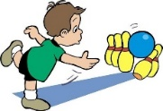[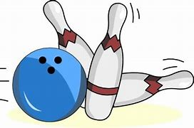](https://www.bing.com/images/search?view=detailV2&ccid=o9ZCE/UT&id=0C5F76B2A2BB49ACB06622E95032A9B2B25F7923&thid=OIP.o9ZCE_UTXOXr1-G-gMzjpgHaEn&mediaurl=http://wikiclipart.com/wp-content/uploads/2017/01/Bowling-clip-art-clipartfest-2.jpeg&exph=343&expw=550&q=bowling+game+cartoon+&simid=608040676260515818&ck=651CEF413016A9EF947336AB323BBCBC&selectedIndex=13&FORM=IRPRST)

This is best:

Indoors or Outdoors

[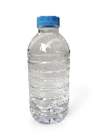](https://www.google.co.uk/url?sa=i&url=https://www.dreamstime.com/photos-images/empty-water-bottle.html&psig=AOvVaw2jjmyYMxY-xu0UEuuTRwJP&ust=1598091322394000&source=images&cd=vfe&ved=0CAIQjRxqFwoTCIjfkZ-IrOsCFQAAAAAdAAAAABAf)[Golf Ball Images, Stock Photos & Vectors | Shutterstock](https://www.google.co.uk/url?sa=i&url=https://www.shutterstock.com/search/golf%2Bball&psig=AOvVaw32cERvV5CvI0n9TUIMLGr2&ust=1598091561787000&source=images&cd=vfe&ved=0CAIQjRxqFwoTCIiSopGJrOsCFQAAAAAdAAAAABAE)[](https://www.google.co.uk/url?sa=i&url=https://www.gmcrafts.co.uk/product/football-iron-on-transfer/&psig=AOvVaw12J22Lwh2qFipbFcuaGOe_&ust=1598091475327000&source=images&cd=vfe&ved=0CAIQjRxqFwoTCPjK8-eIrOsCFQAAAAAdAAAAABAE)

**Materials**

You may need:

* Different sized bottles or containers
* Water, stones or other materials to weigh down bottles
* Different sizes and weight of balls
* Marker or number cards to number bottles
* Markers to decorate bottles
* Paper and markers to create a score list

**How this benefits your child:**

Your child will develop their ‘gross motor skills’ (large body movements) by working out how to roll the ball correctly to knock over the bottles. They will need to think about distance, direction and speed. You can talk to them about rolling the ball too hard, or too gently, and about the number of bottles knocked over. They can help to keep score and develop their understanding of number and addition.

**Tips to support your child:** To begin with, you will need some empty plastic bottles (you can use any number, usually up to ten). This is a good opportunity to talk to your child about the message of “reduce, reuse and recycle” single use plastic. You will need a ball and an area big enough to bowl. You can play this indoors (the hall or living room might work best) or outside. If playing outside, you might want to fill the bottles with some water or sand so that they don’t blow over.

Each person takes a turn of bowling the ball towards the bottles, and you can record how many bottles each person knocks over. After so many turns, you can add up the scores and find out who the winner is!

You could even decorate your bottles, add silly faces or whatever your child suggests. Have fun, be silly and laugh!

**The basic idea:** Line up some plastic bottles, and knock them over using a ball – all the fun of bowling, at home!

Early Years Home Learning

Movement and Coordination

Bowling

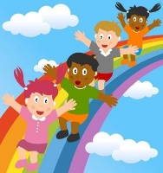[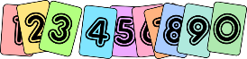](https://www.google.co.uk/url?sa=i&url=https://www.transum.org/Software/SW/Starter_of_the_day/Students/Hot/Challenges.asp&psig=AOvVaw330Kt--Zx2gtLjmwMFrjNC&ust=1598091631996000&source=images&cd=vfe&ved=0CAIQjRxqFwoTCPi857KJrOsCFQAAAAAdAAAAABAE)

**Top Tip from our Speech and Language Therapy partners:**

Children need to hear words several times before they start to use them.

Repetition of words allows your child to understand and even attempt to

imitate them… **“strike!”.**



**“The fun is in the journey, not the end result!”**

|  |  |
| --- | --- |
| **Make this simpler...**   * Start with five bottles, placed close together. As your child develops their bowling skills, you can work up to using more bottles and spacing them out slightly. * Use a large heavy ball, such as a football. This will be easier to roll. * Support your child to count how many bottles they knocked over. * Help your child record how many bottles were knocked over or alternatively ask your child to identify the corresponding number card to stick on the score board. | **Make this more challenging...**   * You could record the number of bottles knocked down each time in creative ways. Your child might put a dot next to their name for every bottle knocked down, then count all the dots at the end to find their score. You can also use tally marks or just record using numbers. * To challenge your child’s coordination and movement you can move the starting line further back and discuss distance, introduce different sizes and weight of balls, and introduce ramps for your child to roll the ball down. |