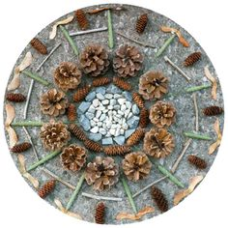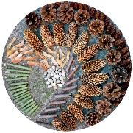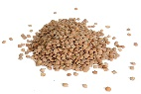

|  |  |
| --- | --- |
| **Make this simpler...**  Simply going on a walk and collecting items is a good starting point. What does your child notice? He or she may be interested in different sticks for example. Whatever your child is interested in is usually a good starting point. If they are reluctant, start small and praise their efforts. | **Make this more challenging...**  You could try looking up an artist with your child such Andy Goldsworthy who uses only natural materials to create art and use this to inspire your own artwork using gathered materials. |

**The basic idea:**

Use a variety of materials and objects to make a temporary, and changeable piece of artwork. Work with your child or let them try it on their own if they wish. You could take photos of it, however at the end it could be washed/blown or swept away.

**Tips to support your child:**

* First, decide if you are making your artwork inside or outdoors. If you are outside, leaves, shells, pebbles, sticks, sand, etc. can all be used. If indoors, you might wish to use a tray, and provide bowls of dry pasta, rice, lentils, oats, etc.
* Your child can decide what they want to make – something like a house, a smiley face, a tree and so on works well or sometimes something more abstract can be fun too. You can work together to lay out the resources and move them around, making the picture together.
* It can be as large or small as you like – outdoors is great for making huge works of art, which you can leave for others to notice and enjoy (remember to use only natural resources that you have found in the area). This activity is a good opportunity to use descriptive language – ask your child if they need something long/short, shiny, smooth, and so on.
* Make sure the materials are safe for your child to touch. It always advisable to wash hands after handling things you have found outside.

**How this benefits your child:**

* Working cooperatively helps your child develop team working skills.
* If you allow your child to control the project, they also learn leadership skills. Children who are less keen to sit and draw are often more likely to engage with this type of activity.
* Moving and placing the objects helps develop the muscles in the fingers -‘fine motor control’.

**Materials**

You may need:

* Materials to try this indoors could include - rice, pasta, lentils, flour.
* Materials to try this outdoors may include – pine cones, shells, leaves, rocks, acorns, conkers.

This is best:

Outdoors

Early Years Home Learning  
Confidence, Creativity & Curiosity

**‘Transient’ or movable Art**

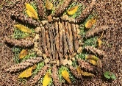[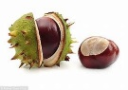](https://www.bing.com/images/search?view=detailV2&ccid=3mtOYQks&id=F2B82B80A37038690347245BFA08442ABA0591E3&thid=OIP.3mtOYQksIUQR2r5wiGQFnQEsDJ&mediaurl=http://i.dailymail.co.uk/i/pix/2016/10/14/14/2CC9B41A00000578-3838298-image-a-104_1476451807276.jpg&exph=425&expw=634&q=conker+&simid=608005032332167936&ck=BC15F13F8A4294A43C0C13AB565678D6&selectedIndex=13&FORM=IRPRST)[Image result for acron ](https://www.bing.com/images/search?view=detailV2&ccid=9G6zgeeG&id=B40B1A3FD578BEEBD62EFBCFC41D77B02A891F2C&thid=OIP.9G6zgeeGXyHbXdrmCGyClgHaE8&mediaurl=https://wonderopolis.org/wp-content/uploads/2016/12/dreamstime_xxl_4590644.jpg&exph=2828&expw=4242&q=acron+&simid=608009288735264614&ck=A553BD6B07A0AC84385262939C359386&selectedIndex=1&FORM=IRPRST)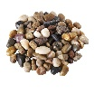[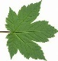](https://www.bing.com/images/search?view=detailV2&ccid=z3eJDRwS&id=F964E9F78B5404DB2A696771E3E1D16F551083B3&thid=OIP.z3eJDRwSB8Q4WuDp-WB2AQHaHK&mediaurl=http://4.bp.blogspot.com/-8qklL-HIBLI/UmpVo9iNSGI/AAAAAAAAFCk/Ulj8dGN3qjY/s1600/Leave%2b00%2bback%2bcolour.jpg&exph=1547&expw=1600&q=leaves&simid=608009181331066256&ck=1B522D7EFA5642A7191DA324914BEF2E&selectedIndex=16&FORM=IRPRST)[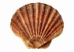](https://www.bing.com/images/search?view=detailV2&ccid=h5c5xiRX&id=F5D28F296CDC6DFCED7DD2F70D5B8A64A973FD1C&thid=OIP.h5c5xiRXyN00VdfA7O4wTwHaFO&mediaurl=https://cdn.pixabay.com/photo/2016/01/26/15/54/sea-1162744_960_720.png&exph=677&expw=960&q=shells&simid=608025480697678599&ck=4D3F4E46A28BD3C3BD37819CD7171770&selectedIndex=12&FORM=IRPRST)[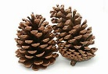](https://www.bing.com/images/search?view=detailV2&ccid=CMtSfRKy&id=A0D9D3CED6E07D6689E26C1DC4C398D1EBE0CE76&thid=OIP.CMtSfRKyi8M0bIMLRyJJ0QHaE7&mediaurl=http://4.bp.blogspot.com/_ZVmJAJtu81s/TPiy8jh7yPI/AAAAAAAAE_8/sJxcvsqkFSQ/s1600/pine-cones.jpg&exph=768&expw=1154&q=pinecones+&simid=607995978570794898&ck=F191A4A1CE90657416555DC2E41F17A9&selectedIndex=6&FORM=IRPRST)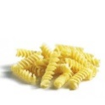

**Top Tip from our Speech and Language Therapy partners:**

**Being face to face with your child helps them develop their communication skills.**

Practising turn taking promotes listening and waiting skills which are important

when sharing a conversation.



**“The fun is in the journey, not the end result!”**