[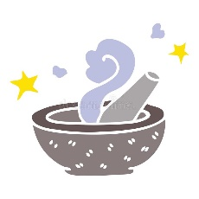](https://www.google.co.uk/url?sa=i&url=https://www.dreamstime.com/illustration/magic-mortar.html&psig=AOvVaw00BTnULxROU-myCxeUF0CZ&ust=1598966631580000&source=images&cd=vfe&ved=0CAIQjRxqFwoTCKif-ILFxesCFQAAAAAdAAAAABAE)[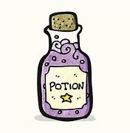](https://www.bing.com/images/search?view=detailV2&ccid=431yCj25&id=200BF2103513B9F6F011799012A5A63D8390ADD1&thid=OIP.431yCj25sifbCGIyotU6-QHaHa&mediaurl=https://media.istockphoto.com/vectors/cartoon-magic-potion-vector-id517401357?k%3d6%26m%3d517401357%26s%3d612x612%26w%3d0%26h%3dw1k1K-NFtJcyIEv4bclqEjA-KsUI21H1EpSIPqyjqMI%3d&exph=612&expw=612&q=potion+clip+art&simid=608010362470009931&ck=49636D2E4D85B7CDEB9A75A85E9CAE95&selectedIndex=6&qpvt=potion+clip+art&FORM=IRPRST)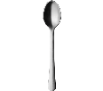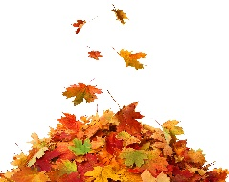[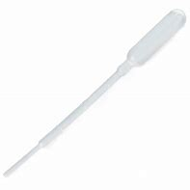](https://www.bing.com/images/search?view=detailV2&ccid=/XJOuY3r&id=05DFE91956A7A0AEEA9DD332239768DCB8DE2DC3&thid=OIP._XJOuY3roBxDY4lU5dIT1wHaHa&mediaurl=https://www.stevespanglerscience.com/wp-content/uploads/2017/07/G-WPHK-100_100-pack-of-pipettes_20170707_01.jpg&exph=1500&expw=1500&q=pippettes&simid=608027641043290021&ck=B05E76C1A96653B32D95194BA593EC55&selectedIndex=5&FORM=IRPRST)[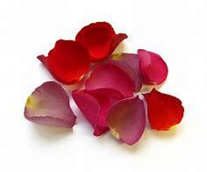](https://www.bing.com/images/search?view=detailV2&ccid=N0T3rOjU&id=B2D2727F739A32754671C0683FDD0DC195AED75E&thid=OIP.N0T3rOjU-VzkzG7rVZSc1QHaGH&mediaurl=http://www.fengshuidana.com/wp-content/uploads/2014/07/real-flower-petal-confetti-company-wedding-rose-petals-red-pink-mauve.jpg&exph=1323&expw=1600&q=flower+petals+&simid=608040006312199038&ck=AC123F48808165D5AB8C45CD182AB902&selectedIndex=4&FORM=IRPRST)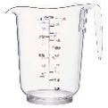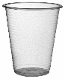

**Top Tip from our Speech and Language Therapy partners:**

**Being face to face with your child helps them develop their interaction**

**and communication skills.** Join in and play, Try to make comments for example instead

of saying “What are you going to mix together? You could say, “I’m going to mix……….

and see what it smells like.”



**“The fun is in the journey, not the end result!”**

**Tips to support your child:**

Begin by exploring the materials together taking turns to name different objects. Allow time for your child to find what interests them and follow their lead. Encourage your child to describe textures, smells, colours etc. While adding/mixing different things you could begin to introduce phrases and questions such as ***I wonder what would happen if… What do you notice? I noticed you….*** This experience can be revisited and take on new directions. Talk about your own childhood experiences. Did you make potions as a child?

**The basic idea:**

Explore and develop creativity through the senses and a variety of objects (see materials list on the left). You can do this outside (this is easiest for getting messy) or you could use the sink, a basin or old plastic storage boxes. If you’re someone who doesn’t like mess, try and remember - often the messier play gets, the more creative the learning!

This is best:

Outdoors

**How this benefits your child:**

There is opportunity to explore textures, smells, colour, nature, volume, solids, liquids, cause and effect and how things change when mixed together (maths and science!). Asking ‘open’ questions such as “why do you think..” prompts your child to use and develop their thinking skills to compare, predict, offer reasoning as they work out how to solve problems.

**Materials**

You may need:

Here are some suggestions – not all need to be used, all these could be adapted to suit your own ideas too.

* small containers,
* plastic cups,
* small plastic bottles, water,
* measuring jug,
* flower petals,
* leaves,
* food colouring,
* dropper pipettes,
* small spoons,
* tongs,
* funnels.

Early Years Home Learning

Confidence, Creativity and Curiosity  
**Potions**

|  |  |
| --- | --- |
| **Make this simpler...**  Filling the kitchen sink with a few objects and bubble bath can be a great way to introduce water play to children who might be hesitant with getting wet or messy. You could try adding a few different object each time. | **Make this more challenging...**  Magic potion games – encourage your child to talk about what is going into their potion, and how to make it. Model using language such as – ‘What goes into the potion *first…second…third?’*  You could try coming up with a silly rhyme to recite as they make their potions. |