|  |  |  |  |  |  |
| --- | --- | --- | --- | --- | --- |
| EAC Logo 2015 | **EAST AYRSHIRE COUNCIL**  **ECONOMY AND SKILLS**  **CHILD’S PLAN** | | | |  |
| Named Person | | Louise Crawford | | | |
| Establishment Name | | New School ECC | Date / Time of TAC | 09/10/19 @ 1.15pm | |
| Child / Young Person’s Name | | John Smith | D.O.B. : | 23.03.15 | |
| Parent / Carer’s Name | | Jane Smith | Stage : | 3-5 years | |
| Address:  Postcode: | | 123 Oak Avenue | Telephone No. | 0743123123 | |

|  |  |  |  |  |  |  |  |
| --- | --- | --- | --- | --- | --- | --- | --- |
| ASN Identified: | YES | ✓ | NO |  |  | Date: | At Birth |

|  |  |  |  |
| --- | --- | --- | --- |
| Child’s Plan | YES / NO | Individual Learning Plan  (ILP)  *[formerly known as IEP]* | YES / NO |

|  |  |  |  |  |  |  |
| --- | --- | --- | --- | --- | --- | --- |
| Co-ordinated Support Plan  (CSP) | YES |  | NO | ✓ | Further discussion |  |

|  |  |
| --- | --- |
| **Team Around the Child (TAC) Details** | |
| TAC arranged by: | Laura Murray |
| Reason for TAC: | Review |

|  |  |  |  |  |
| --- | --- | --- | --- | --- |
| **Team Around the Child** | | | | |
| Name / Designation | Agency /Service | Contact | Invited | Attended |
| Laura Murray | EAC/ Depute New School ECC | 01563 533678 | ✓ | ✓ |
| Louise Crawford | Health Visitor |  | ✓ |  |
| Tracy Cane | EAC/ELC Graduate  New School ECC | 01563 533678 | ✓ | ✓ |
| Jane Smith | Mum |  | ✓ | ✓ |
| Gillian Henderson | NHS/Occupational Therapist | 01294 323070 | ✓ | ✓ |
| Tracy Robertson | NHS/Speech and language therapist |  | ✓ | ✓ |
| Maureen Munro | EAC/Support Assistant  New School ECC | 01563 533678 | ✓ | ✓ |
| Mhairi Isles | Visual Impairment |  | ✓ | ✓ |

|  |  |  |  |  |
| --- | --- | --- | --- | --- |
| **Progress Since Last Review** | | | | |
| What did we want to achieve? | How? | Who? | Met/not met | If not met, why? |
| For John to interact more with others. | Stories and songs  Welcome time  Face to face games | Jane Smith (Mum)  Louise Lane(Keyworker)  Maureen Munro  (support assistant) |  | John is integrating with the children during story time. The children in the 3-5 room will socialise with John and John is becoming more aware of his peers around him |
| For John to have access to lots of sensory experiences to help stimulate his senses | Tac Pac  Baby beats  Musical instruments  Tactile objects | Jane Smith (Mum)  Louise Lane(Keyworker)  Maureen Munro (support assistant) | Met |  |
| To develop John’s fine and gross motor skills | Tummy time  Time in standing frame  Rolling over from back to tummy  Opportunities to grasp and reach out.  Small objects to play with | Jane Smith (Mum)  Louise Lane(Keyworker)  Maureen Munro  (support assistant) | Met |  |
| For John to understand what’s happening next | Use the bag with familiar objects such as spoon and book so John can use that as a visual association to know what is happening. | Jane Smith (Mum)  Louise Lane(Keyworker)  Maureen Munro  (support assistant) |  | John is building on familiar objects and knows when he sees a spoon its snack time. Maureen will continue to build on his objects. |

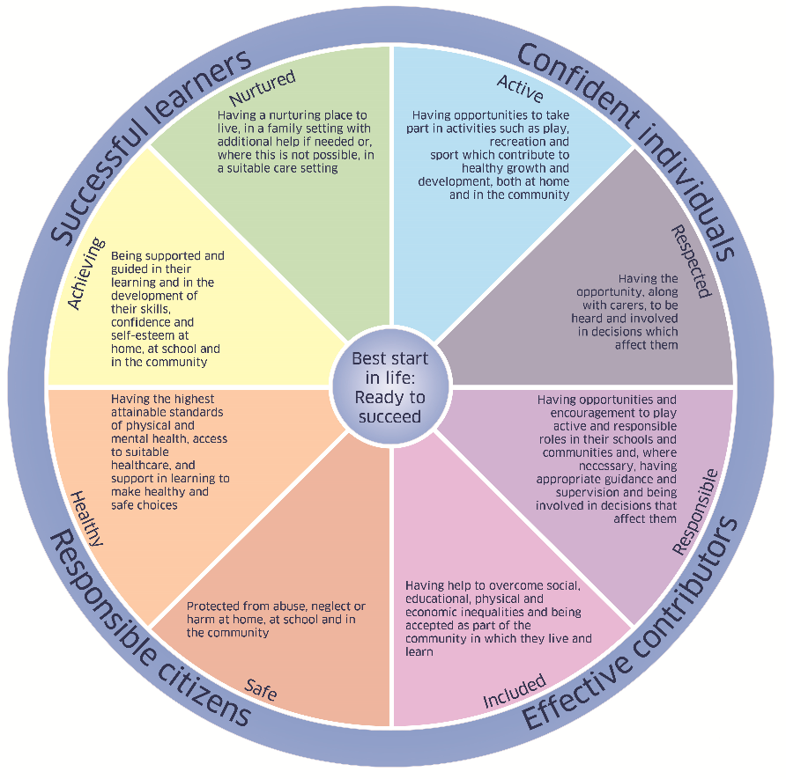

1. What is getting in the way of this child or young person’s wellbeing?
2. Do I have all the information I need to help this child or young person?
3. What can I do now to help this child or young person?
4. What can my agency do to help this child or young person?
5. What additional help, if any, may be needed from others?

|  |
| --- |
| **Assessment of Child – My World Triangle** |

This assessment report is based on the ‘My World Assessment Triangle’. The level of detail should be proportionate to concerns or needs identified.

|  |  |  |  |
| --- | --- | --- | --- |
| **Contributors to the Assessment - Named Person, Assessment Team** | | | |
| Role | Name & Designation | (Agency) Address | Tel No & E-Mail |
| Depute Manager | Laura Murray | New School ECC | 533678 |
| ELCP | Louise Lane | New School ECC | 533678 |
| Speech and language therapist | Katie Brown | NHS |  |
| Occupational Therapist | Gillian Henderson | NHS |  |
| Support Assistant | Maureen Munro | New School ECC | 533678 |

|  |
| --- |
| **How I grow and develop – Analysis of child developmental needs**  *(Comment on health, education, physical and emotional development and social skills including strengths, pressures and areas for development)* |
|  |
| **Evaluation of plan**   * John has lots of opportunities to socialise with his peers in the ECC. In his seat, standing frame or on the floor John is always at the same height of his peers. John’s peers socialise with him throughout the session and John is becoming more aware of his peers around him. John is included in small groups in a quieter environment to allow for interactions with his peers. * His support worker provides daily sensory experiences for John. He has Tac Pac sessions, baby beat sessions and his be active box. He also participates in sensory experiences in the playroom with adult support. * John is building his time in his standing frame and he is at 20 minutes. He has time on the floor where he is free to move around. John is attempting to roll over. John will grab out for object in his be active box. * His support worker has been introducing a spoon to John to let him know when it is snack time or lunch. She will give John his toothbrush and he knows it’s time to brush his teeth   **ECC**   * Transition Report completed by keyworker **(See attached report)** * John is developing on the Teacher Talking profile at 0-1 year **(See attached teacher talking profile)** * John is non mobile and requires the support of an adult at all times to engage in the life of the centre * He has settled well into the 1140 hours and is attending 5 x 1.15pm – 6pm * John has become more vocal with babbling in the ECC and lets his needs known with the tone of his voice * John is included in small groups where he can learn in a quiet environment * He is not napping as much now and is more alert in the ECC * Since wearing his glasses again John has become more animated * John is more aware of others around him and is more tolerant of his peers around him * John eats well at snack and lunch with a support worker feeding him * John particularly enjoys Tac Pac and will anticipate what’s coming next   **Health**   * John has a diagnosis of 1p36 chromosome Deletion, epilepsy, developmental, hearing impairment and visual impairment. * John’s seizures are controlled by medication Keppra 3ml twice daily which mum administers at home. There is a protocol in place for John at the ECC if he has a seizure * John had Auditory Brainstem Test and Myringotomy (incision in ear drum to drain fluid from middle ear) performed in July 2017 at the Royal Hospital for Children, Glasgow   **Hearing Impairment**   * Larissa McColgan is John’s Hearing Impairment teacher **(See attached report)**   **Gillian Henderson – OT**   * Helen Reid is John’s physio * OT is supporting to ensure that John is still fitted securely and appropriately in his bee chair and standing frame * Opportunity must be provided for John to move around the ECC on the floor in his chair or standing frame * OT sees progression in John and also finds him more vocal   **MhairiVisual Impairment**   * Mhairi Isle is John’s Visual Impairment Teacher **(See attached report)** * John is able to track objects with his eyes * John needs visual sensory and tactile experiences * Intensive interaction Mhairi feels she got more vocals and sounds from John * Important for John to be wearing his glass as his brain needs the visual picture. John’s vision may become lazy as time goes on if he is not wearing his glasses * Mhairi will come into the ECC for another block   **Tracy Robertson – SALT**   * Continue with intensive interaction * Allow John with choices when appropriate * Introduce more objects relating to activities so John knows what is happening next   **Education Psychologist**   * Lindsey Thomson is John’s Education Psychologist * Lindsey has visited the ECC to observe John * She has had in depth conversations with John’s keyworker and support worker * Lindsey has had a conversation with mum in regards to the recommendation of Willowtree School for John’s P1 provision |
| **What I need from people who look after me – Analysis of the impact on the child and the parents/carers ability to meet their needs**  *(Comment on level of care, safety, guidance and encouragement offered to the child or young person including strengths, pressures and areas for development)* |
| * John requires 1 to 1 support at home and in the ECC to keep him safe. * John has an evacuation plan in place * John has a protocol in place if he should take a seizure while in the ECC adults know how to respond * John is now using a hoist for when he is getting changed which require adults to operate the hoist * John needs 1-1 support for him to continue to grow and develop * John needs specialist and skilled professionals to ensure he continues to reach his full potential * John is well cared for at home by Mum, Jane. |
| **My Wider World – Analysis of the impact on the child - environmental**  *(Comment on the influences of relatives, friends, home and community including strengths, pressures and areas for development)* |
| Mum feels that John would be best placed at Willowtree School for P1. Mum hasn’t visited the school as of yet but has had a discussion with Lindsey Thomson Education Psychologist |

|  |  |
| --- | --- |
| **Identified Risks and Needs** | |
| Where risks have been identified, details should be given on what may trigger harmful behaviour or increase risks to the child/young person or to others by the child/young person and the circumstances in which risks are most likely to occur | |
| Safe | John needs 1 to 1 support to keep him safe within the centre, he has a support assistant. |
| Healthy | John requires medication to keep him healthy and reduce the likelihood of seizures.  Emergency protocol is in place |
| Active | John has a standing frame and time on the floor where he can be a little more active. |
| Nurtured | John is nurtured at home by his mum. John particularly enjoys Tac Pac sessions in a calm and nurturing environment in the ECC. |
| Achieving |  |
| Respected |  |
| Responsible |  |
| Included | John requires the support and encouragement of staff to be included in all activities within the centre. |
| Note any assessment tools which have been used, by whom and when | |
| * Transition Report – Louise Lane(ECC Keyworker) * Teacher Talking – Tracy Cane (ECC Equity and Excellence Lead) * My World Triangle – Mhairi Isle (Visual Impairment) * Annual Monitor Report 2018-19 – Larissa McColgan (Hearing Impairment) | |

|  |
| --- |
| **Informed Views of Child/Young Person** |
| N/A |
| **Informed views of Parent/Carer** |
| Mum is happy with the progress John is making. She feels he is becoming more vocal at home. John has recently got a new baby sister and he is adapting well. John has an audiology appointment coming up. Mum feels that Willowtree school is where John will be best placed. |

|  |  |  |  |  |  |
| --- | --- | --- | --- | --- | --- |
| What do we want to achieve? | What are we going to do? | How will we do it? | Who will do it? | By when | How will we know we have done it? |
| For John to interact more with others. | Provide opportunities for John’s interactions | Stories and songs  Welcome time  Face to face games  Small groups | Jane Smith (Mum)  Louise Lane(Keyworker)  Maureen Munro  (support assistant) | June 2020 | When John is having more eye contact and interactions with others. |
| For John to have access to lots of sensory experiences to help stimulate his senses | Provide various sensory experiences | Tac Pac  Baby beats  Musical instruments  Tactile objects  Be active Box | Jane Smith (Mum)  Louise Lane(Keyworker)  Maureen Munro  (support assistant) | June 2020 |  |
| To develop John’s fine and gross motor skills. | Provide experiences and activities to encourage this development | Build on time in standing frame  Rolling over from back to tummy  Opportunities to grasp and reach out. | Jane Smith (Mum)  Louise Lane(Keyworker)  Maureen Munro  (support assistant) | June 2020 | When John’s motor skills have improved |
| For John to understand what’s happening next. | Provide John with a bag of objects. | Use the bag with familiar objects such as spoon and book so John can use that as a visual association to know what is happening. | Jane Smith (Mum)  Louise Lane(Keyworker)  Maureen Munro  (support assistant) | June 2020 | When John is able to understand what is happening next |
| Develop John’s communication skills | Staff to get training on Intensive Interaction from SALT | Staff to engage in Intensive Interaction with John | All staff | June 2020 | John will respond to Intensive Interaction |
| What might happen if the plan does not work?  John may not progress to his full potential. | | | | | |

|  |  |  |  |  |  |  |  |
| --- | --- | --- | --- | --- | --- | --- | --- |
| **I Agree with this Child’s Plan** | | | | | | | |
| This Child’s Plan has been discussed with the Child | | | Yes |  | | No | ✓ |
| This Child’s Plan has been discussed with the Parent/Carer | | | Yes | ✓ | | No |  |
|  |  |  | | |  | | |
|  | Name | Signature | | | Date | | |
| Child/Young Person |  |  | | |  | | |
| Parent/Carer |  |  | | |  | | |
| Parent/Carer |  |  | | |  | | |
| Named Person |  |  | | |  | | |
| Relevant Team Around the Child Member |  |  | | |  | | |
| Relevant Team Around the Child Member |  |  | | |  | | |

|  |
| --- |
| When will my wellbeing assessment and Child’s Plan be reviewed? |
|  |