HT Newsletter March 2023

As always, this has been a very quick term and the team and I cannot believe we are heading into our Spring Break. The pupils and children of Dunlop Primary and ECC have had a very busy term with lots of exciting learning and activities. I have enclosed a summary of these activities for you to see.
I would like to wish you all a lovely break and we are all looking forward to welcoming you back on Monday 17th April, at the usual time for the beginning of our summer term.
Kind regards,
Laura Kelly
Head Teacher

British Science Week
All classes participated in British Science week and the ECC participated in their STEAM month. We were delighted to welcome a number of guest speakers for our classes to listen to and for our P6 & P7 pupils to learn more about during our World of Work Fayre. Thank you to everyone who took time to volunteer for this fabulous week. I would also like to thank Mr Anderson & Miss White for organising the activities.

Outdoor Learning
Our classes have all been in engaging with outdoor learning from Mini-Forest in the ECC, RSPB Award with P1-3, LOST sessions across the school, John Muir Award with P5-7 and Geo-Caching with Olivia. It has been great to see the school and ECC exploring our local community and we are so lucky to have so many outdoor experiences on our doorstep.

P7 Residential – Lockerbie Manor
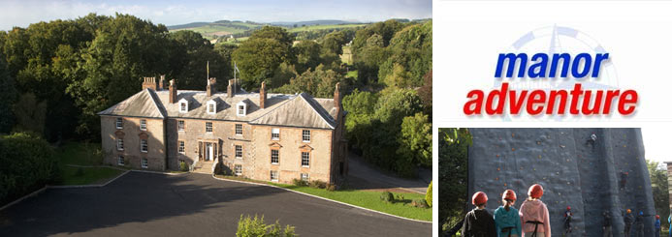
Our P7 pupils all experienced a wonderful week of team building, adventure activities and water sports at Lockerbie Manor at the end of February. There certainly was a lot of tired but happy faces returning on the Friday and I am sure A LOT of washing to be done too!

School Playground
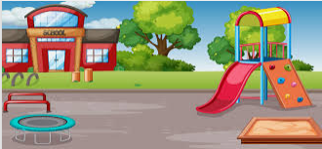
Our Pupil Council have been working hard on looking into ways for us to improve our school playground. A lot of thought has gone in from the pupils to research and decide upon resources to purchase. From the return from Spring Break, there will be additional resources in the playground including: loose parts play, basketball hoop, table tennis table, stage, Bug Hotel, Wormery, gardening tools and reading cushions. We are looking forward to seeing everyone benefit from the new playground equipment.

Scots Poetry
We had a very busy month in January with our Scottish focus month with all pupils and children learning something about Scotland including: Nessie, Scottish Inventors, Landscapes, Islands, Burns Breakfast and of course Scots Poetry, rounded up with a wonderful showcase of learning for our parents & carers.

Representing Our School
We were delighted that some of our finalists were able to represent Dunlop Primary School at the Ayrshire Association of Burns Club Schools Competition.

Our P6 pupils represented our school at the recent Kilmarnock Rotary Schools Quiz. Our team came a very respectable 5th place which we were delighted about! Thank you to our parents/carers who came and supported the team on the night!

Transitions
We are soon to be at the time where our ECC and P7 pupils transitions to P1 and S1 are coming closer. Our current P6 pupils have met with their new to P1 buddies and Stewarton Academy pupils and staff have been visiting our P7 pupils. Please look out for more information on the app regarding ECC-P1 transition activities and ‘Get Set For Stewarton’ P7-S1 transition activities.

ECC Updates
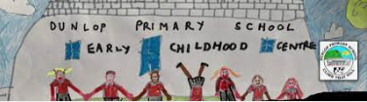
Our ECC children have been very busy this term with lots of exciting learning activities. Mini-Forest has been restarted with Mrs Taylor and Mrs Mallon. Our staff have delivered Stay and Play sessions for our parents & carers to join with. Our pupils participated in STEAM month and the focus topic in the ECC was Japan rounding up the learning with a Japanese Tea for children and their parents/carers. Our staff team have been engaging in professional learning with Kat and Louise for British Sign Language and we are excited to present our Daffodil Tea Fundraiser for all to enjoy. A huge thanks to Mrs Nouillan, Mrs Marshall and the ECC Team for providing such wonderful learning opportunities for our ECC children.

Parent Council
Our Parent Council are a small but active group of parents/carers who work towards the mutual benefit of all pupils and children in our school. I would like to take this opportunity to thank them for their support and also to let you know that the Parent Council are funding our end of year school trip (which will be to Dumfries House) which we are very thankful for.
Our Parent Council also have a sub group for fundraising and RespectMe and we would like to ask for more volunteers to support the work both groups do.

Our fundraising group focuses on raising essential funds for the children of Dunlop Primary School and ECC.
Our RespectMe group will be looking at our work on Equality, Diversity and Inclusion and how our parent body can support improvements in this area.

