Dunlop Primary School and ECC
Pupil Council Minutes
18/11/22
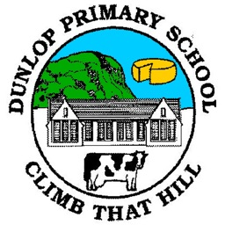

Attendees: Ruaridh (P4), Isla (P4), Kara (P5), Elif (P6), Olivia (P6), Manus (P60, Gracie (P6), Jamie Y (P7), Jamie M (P7), Isla (P7)
Agenda Item | Discussion | Action
Previous Minutes | - Previous minutes discussed and agreed. | - Mrs Trousdale will continue to look for Pupil Council badge and order School Council if unsuccessful.  - Mrs Kelly to speak to Miss White re: iPad for each class.
Pupil Council Boxes | - P4 suggestions:  If your birthday – celebrated at assembly/lunchtime.  Class Pet  Monkey bars in the playground  Lunchtime napkins  Books in the quiet area or a reading club at lunchtime.  - P5 suggestions:  Donut station at lunchtime  Calm down/quiet area at lunchtime  Mr Cowie to make a board for reminder of garden as quiet space.  Playground toys – soft balls and returning to class boxes  - P6 & P7 did not have any suggestions. | - Mrs Kelly will share the birthday idea with Mrs Nouillan for lunchtimes and assembly.  Class pet will be looked into.  No monkey bars due to H&S  Mrs Kelly will ask staff for volunteers for quiet club.  - Donut station not health promoting but Mrs Kelly will ask if occasionally that can be the lunchtime treat instead of cake.  - Mrs Kelly will ask Mr Cowie to make a board.  - Playground toys will only be purchased if responsibly used due to several injuries lately caused by misuse of toys.  - All Pupil Council members to remind their class about the suggestion box.
School Values | - Pupils agree their top 12 values from the previous session’s activity. Jamie M and Manus created a Parent Questionnaire and Pupil Questionnaire to be issued to gather feedback. | - Questionnaires to be completed on 21/11/22 at lunchtime and issued to parents and pupils for feedback.
AOCB – no additional business.

