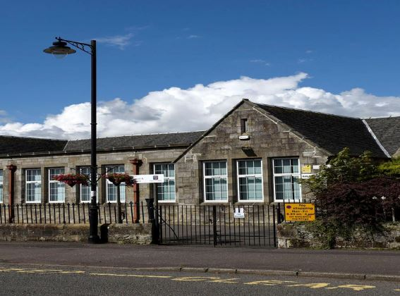

Dunlop Primary School and Early Childhood Centre
Main Street
Dunlop
KA3 4AN
Telephone No: | 01560 484098
Email: | eaDunlpop.PS@eastayrshire.org.uk  laura.kelly@eastayrshire.org.uk
School Blog: | https://blogs.glowscotland.org.uk/ea/dunlopprimaryschool/
Twitter: | @DunloppsEAC
School App: | Available on appropriate mobile devices
Denominational Status (if any): | Non-Denominational
School Roll: | 179 primary pupils and 32 ECC at 1140hrs
Further information: | www.east-ayrshire.gov.uk/schoolhandbooks

Dear Parent/Carer,

I am delighted to have this opportunity to welcome you to Dunlop Primary School and Early Childhood Centre (ECC).

The school handbook is compiled to give you, as the parent/carer of a new pupil to the school, basic information regarding the school and what we can offer your child. As a staff team we are delighted that you have chosen our establishment for your child to attend.

Our aim is to provide, in partnership with parents/carers, a well-balanced curriculum that will enable each child to reach their full potential, not only in the more formal aspects of education, but also in the many other activities which the school aims to provide. We hope to create in all children a positive attitude to learning, the ability to co-operate with others, to make reasonable moral judgements and to have a caring attitude to the community as well as fostering an appreciation of the world in which he/she lives. In addition, children have to be equipped with the skills required for a technological age and be prepared to take part in leisure activities.

A handbook however does not give you the whole story! If you would like more information on any aspect of our work, then please feel free to contact me at school or have a look on the school website. If you wish to look around our establishment and meet those who work to make our school a happy, productive place of learning please call in or telephone to arrange a suitable time to visit.

The staff and I look forward to working with you in a genuine partnership to ensure that your child achieves his/her full potential in all areas of the curriculum and enjoys life at Dunlop Primary School and ECC.

Yours sincerely,
Mrs Laura Kelly
Head Teacher
SECTION 1
Dunlop has boasted a school since the time of James 1 when Hans Hamilton provided the two storey building which still stands next to the church and is known as Clandeboyes Hall. In 1876 when compulsory education became law the present school was opened with part of the building being rebuilt in 1931. The Early Childhood Centre opened in September 1999. At present the working capacity of the school is 212 primary pupils and 30 in our ECC at 1140hrs. The school is a non-denominational, co-educational establishment, catering for pupils from Early Years to Primary 7. The present roll of 179 consists of:-
P1 P2 P3 P4 P5 P6 P7
19 22 19 32 27 27 33
Parents/Carers should note that the working capacity of the school may vary dependent upon the number of pupils at each stage and the way in which the classes are organised.

Our Vision:
The school’s motto is: ‘Climb That Hill’

In September 2019 the Pupil Council consulted with pupils, parents, staff and stakeholders and agreed that the 4 most important values for the children and pupils of Dunlop Primary School & ECC are for us to be:
Happy Respectful Kind Honest

Climb that Hill
We aim to do this by:
- Encouraging everyone to reach high standards of achievement.
- Promoting self-respect and respect for others regardless of race, gender, religion, family circumstances, ability or disability.
- Ensuring everyone has the right to be treated with dignity and privacy.
- Developing an enterprising attitude.
- Caring for the environment.
- Pursuing a healthy & active lifestyle.
Code of Conduct
This Code of Conduct applies to every person in the school and ECC.
- I treat everyone and everything with respect
- I always do my best
- I work and play safely
- I am honest
- I always behave in a responsible way

This session, our Code of Conduct will be reviewed in line with the United Convention of the Rights of the Child where we will be introducing a school charter through our Rights Respecting Pupil Group.
By following the Code of Conduct I will become:
- A Responsible Citizen
- A Successful Learner
- A Confident Individual
- An Effective Contributor

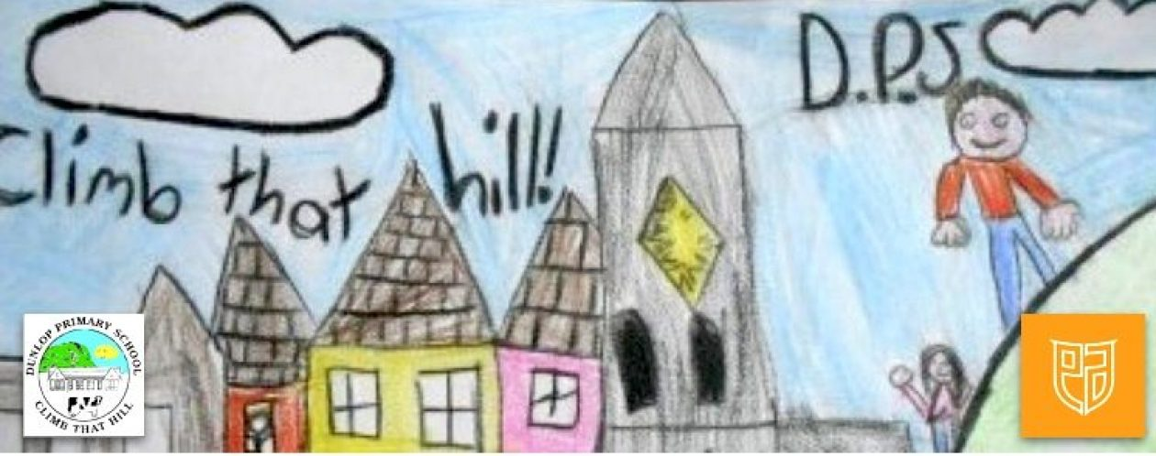

Parental Involvement
We encourage strong partnerships between home and school and work hard to develop strong home/school links. We receive amazing support from our parent/carer volunteers who kindly give up their time to support class-based learning, excursions, fundraising events, attend workshops, lead activities after school etc. We always like to utilise the many skills and talents of our parents/carers to enhance the curriculum.
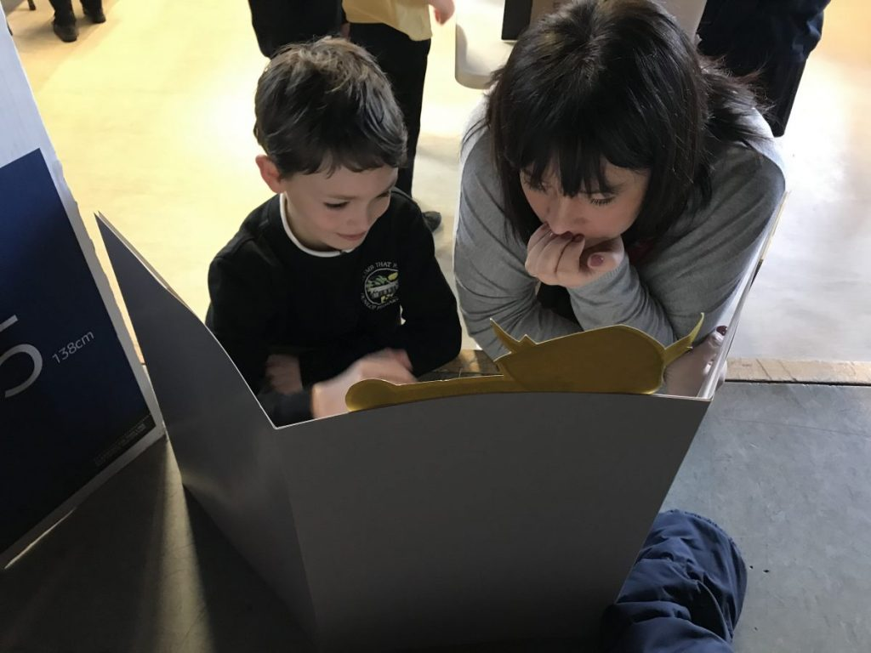

Wider Community Links
We aim to be a centre of excellence of education for the community we serve and are very proud of the reputation we have within Dunlop and the surrounding area. We make good use of the local community in visits, making learning experiential for the children. Members of the community are invited into our establishment to talk with the children and to support ongoing themes e.g. the fire-fighter, the school crossing patrol, the community police officer, the local farmer, the school nurse etc. We regularly participate in local competitions and local events. The support of the local community is highly valued.
SECTION 2
Enrolment
Registration for children due to start school in August takes place in January. Adverts are placed in the school, Early Childhood Centre, local shops and in the local press giving exact dates for enrolling beginners. Children due to be registered will normally be those whose 5th birthday falls on or before the last day of February following the beginning of a session.
When a child reaches his/her 2nd birthday, his/her name can be placed on the register of applicants for our ECC. Parents should contact the school, bringing the child’s birth certificate to fill in the application form.
Parents/carers seeking an Early Childhood Centre place for a child and wishing to pay a visit to the School and Early Childhood Centre Class should contact the Head Teacher who will be delighted to make suitable arrangements.
Induction visits for children who have been allocated a place at the Early Childhood Centre will be arranged for June. This will allow parents and children (mainly) to become aware of what takes place in the Early Childhood Centre environment and facilitate the transition from Playgroup or home.
Children who live in the catchment area of a particular school are required to enrol at that school. They will then be informed of their right to make a placing request to another school of their choice and the conditions pertaining to this.

Information and forms regarding placing requests can be obtained from the school and/or (click here: East Ayrshire Council Placing requests)

Induction of new entrants

It is the policy of Dunlop that the staff in the school involved with primary 1 will liaise closely with the various pre-5 establishments linked to the school, including visiting such establishments to meet the children.

Throughout their pre-school year children about to enter Primary 1 in August will be invited to the school for parts of a day. This provides the opportunity to meet peers and staff, to become familiar with the new surroundings and to experience some school activities. Staff will also have the opportunity to observe the children and to make informed allocations of children to particular classes.

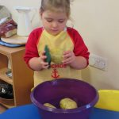

A special meeting for parents will be arranged in June to provide detailed information about school procedures and to answer queries. Parents will be invited to further meetings to discuss work programmes being used in the school and to discuss how they can help their children with these at home. We want to ensure we are getting it right for your child right from the start so we engage in meetings for children with any additional support need or medical condition that requires support. We ensure that all information is gathered to support an excellent start to the child’s journey through school.

It is vitally important that parents inform the school when updates to their child’s records are required. This is particularly important for telephone numbers, addresses and other emergency contact details.

When children are transferring from P7 to our associated secondary establishment, Stewarton Academy, a well-planned transition programme has been devised. Parents/carers receive details of all the planned transition events at the beginning of P7. For children with additional support needs, a meeting is arranged in January of P6 with relevant personnel from the appropriate secondary establishment and then again in P7 to discuss and plan the necessary support. Parents/carers, staff from both establishments and partners e.g., the Education Psychologist, are invited to these meetings, again to plan a smooth transfer which meets the individual needs of the child.

Stewarton Education Group Establishments
Kilmaurs Primary School, 15 Sunnyside, Kilmaurs. 01563 538388
Nether Robertland Primary School, Pokelly Place, Stewarton. 01560 482035
Lainshaw Primary School, Kilwinning Road, Stewarton. 01560 483653
Stewarton Academy, Cairnduff Place, Stewarton 01560 482342

Support for children & young people and parents/carers
We track each child’s progress very carefully in order that we can intervene early if
any difficulties are identified. Many children experience difficulty at some point in their
schooling. It is important that the difficulty is overcome as speedily as possible and
that parents are kept fully informed of the strategies being used and the progress being
made.

We offer personal support to all our children. Each child has the opportunity to regularly review their learning and plan their next steps. This includes planning opportunities for personal achievement. As part of our early intervention approach we try to identify, through our screening programmes and tracking, children who are experiencing difficulties with their learning. We use a staged model of intervention to provide the most appropriate support.

This support will usually be given in the classroom situation. Appropriate support can be provided in through classroom differentiation, in tutorials by our East Ayrshire Support Team Teacher and by our classrooms assistants. We have a range of ICT software which is used to support pupils with specific areas of difficulty. Where appropriate Individual Childs Plans or an Individual Learning Plan will be devised.

Every effort is made to meet the individual needs of all children including those within our Early Childhood and Supported Learning Centres.
When it’s difficult to meet any child’s needs within the classroom setting we seek support from a number of outside agences eg. Psychological Service, Speech and Language Service, Hearing Impairment Service. Regular meetings of our Extended Support Team help coordinate support for children throughout the school who are experiencing difficulty or would benefit from further challenge in their learning.

The Educational (Additional Support for Learning) (Scotland) Act 2004 has replaced the law relating to special educational needs. This has now been updated by the 2009 Act which came into force on 17 November 2010.
The 2004 Act has been updated by the Educational (Additional Support for Learning) (Scotland) Act 2009. This Act places additional responsibilities on local authorities for children who are looked after by the local authority. It will also give more rights to parents in respect of requesting assessments in relation to their child/young person.

Further information can be obtained from various leaflets that can be accessed through the council’s website, or individual copies are available in school. Mediation and advocacy services are also available.
Mrs Kelly (HT) is the Additional Support Needs co-ordinator for Dunlop Primary & ECC and any worries/concerns should be discussed with her in the first instance.

SECTION 3
Hours of Opening
The school and ECC are open from Monday to Friday during the school term and there is no provision of service during the school holidays.
OPEN 8.55 am
INTERVAL 10.45 am - 11.00 am
LUNCH 12.25 pm - 1.15 pm
CLOSE 3.00 pm

ECC hours of opening
OPEN 9am and 9.10am
LUNCH 11.40am
CLOSE 3.00pm and 3.10pm
Primary School Staff

Mrs L Kelly Head Teacher
Mrs N Nouillan Depute Head Teacher
Miss E White Principal Teacher

Class Teachers

Mrs K Sullivan P1
Miss C Rodgers P2
Mrs G Cochrane P3
Miss JA Ainsworth P4
Miss J McCrae P5
Mr C Anderson P6
Miss E White P7
Miss J Barrett NCCT

ECC Staff

Mrs P Marshall Senior Early Learning and Childcare Practitioner
Mrs S Thomson Early Learning and Childcare Practitioner
Mrs I Mack Early Learning and Childcare Practitioner
Mrs M Gray Early Learning and Childcare Practitioner
Mrs A Orr Early Learning and Childcare Practitioner

Visiting Specialists

Mrs G Cunningham East Ayrshire Support Team (0.6)
Miss V Laing Covid Recovery Teacher
Mr Keachie Brass Instructor

Support Staff

Mrs J Trousdale Senior Clerical Assistant
Mr M Cowie Janitor

Mrs H Stirling Classroom Assistant
Mrs M Keen Classroom Assistant
Mrs C Brown Classroom Assistant
Ms D McCrone School Meals Assistants
Mrs M Thomson School Meals Assistants
Mrs S Daily School Meals Assistants
Miss D Steele School Meals Assistants (ECC)
Mrs E Hyslop School Cleaner
Mr A Hyslop School Cleaner / Crossing Patrol Warden

Holiday Dates
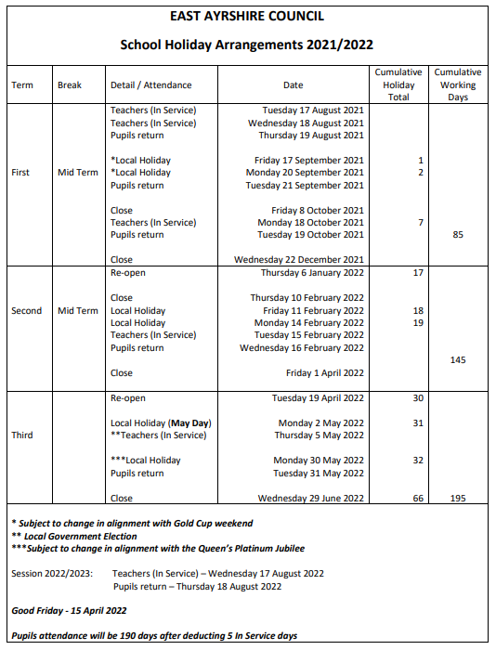
Attendance & Timekeeping
Registration is taken each morning and afternoon and any unexplained absence is followed up by a text message to any of the emergency numbers provided to ensure children are safe and reason for absence noted. Occasionally children give us a cause for concern due to an increased number of absences. In this case a meeting will be set up with school in order for us to work with you to maximise attendance.
It is important that children arrive at school on time for the start of the school day where activities for the day are shared through our visual timetables. Late comings are monitored and again we will work with parents to support them in getting children to school on time.

Reporting an absence
We request that you let the school know before 9am if your child will not be attending that day.

Behaviour & Anti-Bullying
We adhere to East Ayrshire Services’ Relationships Framework and recognise that positive relationships, in all settings is fundamentally important. This has been informed by ‘A National Approach to Anti-bullying for Scotland’s Children and Young People’ and operates within the context of the United Nations Convention on the Rights of the Child.
We address all allegations of bullying including prejudice and investigate thoroughly. All confirmed incidents of bullying are logged and an action plan put in place to protect all and restore relationships.
This session we will be working in partnership with all the whole school community to pilot the ‘Respect Me’ anti-bullying programme and training.

Dress Code

Within the school we have a uniform which comprises of:
- Grey/black school trousers/skirt or pinafore
- White polo shirt or shirt/blouse
- School tie
- Black sweater/cardigan
- Black school shoes
- House colour polo shirt for sporting events
- Gym kit: black shorts, plain white or house colour t-shirt/polo shirt, trainers for outdoor PE

Security & Visitors

For safety and security reasons it is essential that we know who is in the building at any point of the day. To this end all visitors, including parents, are asked to use only the main entrance to the school to enter the building. We ask parents not to enter with the children through the school playground doors as this makes it difficult to keep track of who is in the building. If parents wish to speak with the teacher please enter through the main entrance and speak to the Senior Clerical Assistant or a member of the Senior Leadership Team who will make an appointment for you to meet with the teacher at a suitable time.

All visitors and trades-people are asked to sign the register at the front of the school and sign out as they leave.

In the interests of your child’s safety, if a different adult is collecting him/her from school that the identity of this person is made known to the school. We will not allow your child to leave the school with an unknown adult, please do not be offended if you are asked to verify who the adult is!

We ask that after the 17th August 2021 only P1 parents/carers access the playground in the morning. At 3pm we encourage only P1 & P2 parents/carers into the playground to collect their child. Our playgrounds are manned from 8:40 until 8.55am

Should you wish to talk to a member of staff you should do so by entering the school by the Main Door and making contact with the clerical staff in the first instance.

The entrance to the Early Childhood Centre is located at the side of the extension and this door can only be opened from the outside with a security fob. This entrance should be used when bringing children to and collecting them from Early Childhood Centre. It is expected that a responsible adult will bring your child to and from the establishment.
In the interests of your child’s safety, it is essential that you make a point of telling the Head of establishment if the child is to be collected by someone not known to the Head of Establishment or staff members.

Reporting to Parents/Carers
When reporting to Parents/carers about their child’s progress we follow guidelines set out in the following documents:
Curriculum for Excellence: Building the Curriculum 5
Scottish Government: Statement for Practitioners 2016
Education Scotland: Reporting to Parents and Carers
East Ayrshire Council: Planning Assessment Moderation and Reporting Framework 2019
Approaches to reporting take many different forms and we always ensure that it is regular, meaningful, purposeful and on-going throughout the academic year. At Dunlop we have the following activities:
Reporting activities for individual learners | Reporting activities for group/class/school
- Learning conversations-pupil & teacher, pupil & pupil  - Learners’ reflections on their learning  - Learning Journals (ECC)  - E-portfolios(P5-7)  - Team Around the Child meetings with pupils involved  - Shared Learning homework tasks  - Ongoing feedback in class-oral & written  - Use of ‘Brilliant Blue’ and ‘Green for Growth’ in jotters  - Formal written report | - Assembly presentations  - Open Hour twice a year  - School Show  - Wall displays  - Glow blogs  - Class showcase events  - Social media/Twitter  - Parent Council Meetings  - Pupil Council Meetings  - Termly learning targets on Blog  - Teams (P4-7)

Lunches
The Schools (Health Promotion and Nutrition) Act 2007 sets out in detail the National Nutritional Food Standards. School Meals in East Ayrshire offer nutritionally balanced well-presented food in an environment that is sensitive to the needs of children. It offers a good lunchtime experience with an important break away from the classroom, while still being in the safety of the establishment.
We believe that school meals should be an interesting and enjoyable time. Our philosophy is to help children toward a good diet by providing an attractive and interesting range of wholesome cooked food made from excellent fresh quality ingredients, and there is virtually no processed food offered or used at any stage in the process. Many of the foods used are sourced from local food providers in East Ayrshire.
Currently there is a 3 week rota for School Lunch and this rota is available here https://www.east-ayrshire.gov.uk/EducationAndLearning/Schools-Catering/SchoolLunchMenus.aspx . Further to this there is a rota which ensures that each class has an equitable opportunity of being served 1st, 2nd, 3rd and so on. All P1 to P3 pupils are offered free lunches and are served first on a daily basis. Children who require a specific diet based on sound medical reasons will be catered for but parents/carers should contact the school and notify the Head teacher of the specific requirement.

The management of the Catering Service in Dunlop is provided by the Council through Onsite Services in conjunction with the Head Teacher.

All school lunches are booked at home via ParentPay, including P1-4 who are entitled to free school meals. You can now order, amend or cancel school lunches until 8am on the day the meal is required. If your child is absent from school you can login before 8am and cancel the lunch booking to avoid being charged for the meal. Please do not use the packed lunch option, this should only be used when directed to do so. The school will inform you when to do this i.e. school trips which require a packed lunch. Further details of ParentPay can be obtained from the school office.

Complaints Handling
Any complaint should in the first instance be directed to the school and the Principal Teacher or Depute Head Teacher for the infant or upper department. Should any investigation be required, the Head Teacher will be involved in the final decisions and therefore needs to instruct the PT/DHT to carry out an investigation. No matter how big or small your complaint is please allow us the opportunity to fully investigate and get back to you. This may involve a telephone call, email or team meeting as a follow up.

Administration of Medicine

The administration of prescribed medicines in an educational establishment is a matter for the discretion of the head teacher. If the head teacher agrees to administer medicine at the establishment, the member of staff administering the medication is legally required to exercise reasonable care to avoid injury. The Head Teacher is entitled to the full co-operation of the parents in helping to observe safe practices.

The only medicines allowed to be prescribed are those issued by a doctor or pharmacist – a prescribing label must be present and full administration details provided. Parents will be required to complete a form before medicines can be administered. You can obtain a copy of this from the school office or download from the Blog site. In the instance of ongoing medication a Health Care Plan will be formulated by the HT, school nurse and parent to ensure consistency of administration.

Data Protection

The school will handle all data in relation to children as per Data Protection Act 2018.

The establishment has a range of policies and procedures which are available for parents to read. There are a number of ways we like to communicate with you about your child’s learning and social media has become more popular over the past few years. In the first instance you will be provided with a form that gives us the information about what your child can and can’t access or be photographed for. This form must be completed and returned to school or your child will not have access to the internet for school studies. If at any time you would like to change the access your child can have please update the school teacher/office by letter or email.

Promoting Positive Relationships
At Dunlop we aim to create an atmosphere in which all pupils and staff can work, learn and play in safety. A variety of resources and strategies are in place to promote positive behaviour. The school aims to work in partnership with parents and will always consult parents when concerns and difficulties arise.
The school is a community in which children and staff spend considerable time together. If children are to learn and teachers are to teach, there must be agreed rules for everyone’s benefit, health and safety.

Parent Council & Parental Involvement

The school/ECC maintain a working partnership with parents. We try to keep parents informed of all events and achievements in the school through regular newsletters. Parents continue to actively support fund raising events, and are always willing to assist in extra-curricular activities. We welcome this support and enthusiasm and will continue to do all that is necessary to encourage and further develop this existing goodwill.

To help make use of the many skills parents have, we have extended this partnership to include parental help within the classroom/ECC on a voluntary basis.

Throughout the session, parents are encouraged to visit the school/ECC at any time to discuss the progress of their children. It is however, helpful, if parents initially contact the school, to arrange an appointment to discuss any matters relating to their children’s progress. Parents are welcome to speak to the Early Years Workers at the beginning or end of the session. However if you wish to discuss something in detail or in confidence, an appointment can easily be arranged. Parents are respectfully asked not to go directly to their child’s teacher as he/she will be busy with a class of children.

We are extremely fortunate that many parents give their support to the school whenever it is required.

As a parent/carer of a child in attendance at the school, you are automatically part of the Parent Forum of the school. The membership of the Parent Forum is made up of all parents who have a child at the school. The Parent Forum can decide to form a smaller body called the Parent Council. The Parent Council is a group of parents selected by members of the Parent Forum to represent them. There is a lively and enthusiastic Parents’ Association which organises social and fundraising events throughout the session. The school has benefited from many of its fundraising activities. The PA is pleased to welcome new members at any time.

Chair Person: Claire Tooze

SECTION 4
Curriculum for Excellence is the education system in Scotland. It includes nurseries, schools, colleges and community learning from 3 to 18 and beyond.
From autumn 2010, learners from pre-school to S1 have been working to Curriculum for Excellence guidance and standards. Pupils who were in S1 in 2010-11 will be the first to take the new Curriculum for Excellence qualifications from 2013-14. Young people in S2 and above will work primarily within the existing curriculum and qualifications system, whilst benefiting from improvements in learning and teaching through Curriculum for Excellence.
The table below matches the five curriculum levels to stages of learning generally applicable, with flexibility (for example, for young people who are particularly able and/or have additional support needs).
Level | Stage
Early | The pre-school years and P1, or later for some.
First | To the end of P4, but earlier or later for some.
Second | To the end of P7, but earlier or later for some.
Third and Fourth | S1 to S3, but earlier for some. The fourth level broadly equates to Scottish Credit and Qualifications Framework level 4.  The fourth level experiences and outcomes are intended to provide possibilities for choice and young people's programmes will not include all of the fourth level outcomes.
Senior phase | S4 to S6, and college or other means of study.

From pre-school to the end of S3 (3-15) young people will experience a broad general education which is designed to enable each child or young person to be a successful learner, a confident individual, a responsible citizen and an effective contributor. The broad general education will include all of the Experiences and Outcomes across all curriculum areas up to and including the third level. Throughout all learning, prime importance is given to literacy, numeracy and thinking skills; skills for learning, life and work; an understanding of society, the world and Scotland's place in it, and an active and healthy lifestyle. A range of teaching methods and contexts for learning is used, including active and enterprising learning, which encourage young people to become enquiring; learning across the curriculum which helps young people make links between subjects, and learning outside classrooms in the outdoors and in the community, which gives opportunities for learners to deepen their learning in real-life contexts. Most learners will progress into the fourth level in many aspects of their learning before the end of S3, laying strong foundations for more specialised learning.

Information about how the curriculum is structured and curriculum planning is available at http://www.educationscotland.gov.uk/thecurriculum/

Curriculum for Excellence emphasises that assessment is an integral part of day-to-day teaching and learning. Learners’ progress will be closely monitored by staff, who reflect with them on their strengths, learning needs and next steps, and take action based on this. Learners themselves will be increasingly involved in this process, as they develop the skills needed to be able to make effective judgments on their own learning; skills that will be important to them throughout life. Testing will continue to be part of the framework of assessment, providing additional evidence of what learners know, understand and are able to do, and helping teachers plan learning experiences which are motivating and challenging.
www.youngscot.org (learners)
www.parentzonescotland.gov.uk (parents and carers)
www.sqa.org.uk (information on qualifications)
www.hmie.gov.uk (standards, inspections)
www.ltscotland.org.uk (teaching practice and support)
www.engageforeducation.org (share ideas and questions about education)
www.scotland.gov.uk/cfeinaction (real-life examples)

All children and young people will have regular opportunity to learn outdoors both in the grounds and the establishment and in the local community.
The Primary School and the Early Childhood Centre have access to the larger playground, the Eco garden, the outdoor classroom and the park next to the school. These areas provide great scope for a variety of outdoor learning experiences. The children are supervised at all times by a member of staff who carries a mobile phone. The children will be actively involved in learning using the fantastic outdoor resources available.
Please ensure that your child has suitable outdoor clothing as outdoor learning takes place on a regular basis.
When the weather is cold a warm jacket, hat, gloves and appropriate footwear are recommended. The children will also be out sometimes in light rain so a waterproof jacket and boots or Wellingtons are advised. When the weather is warm and sunny it is essential that the children wear hats, t-shirts that cover the shoulders and sunscreen which should be applied before coming to school or nursery.

English Language

Talking and listening are developed systematically throughout school through Structured Activities; Show and Tell; personal Talks and Debates. Commercially produced materials such as “Stories for Thinking”, “Oral Language” and “Look, Listen and Think” are also used.
Reading is taught using “Look and Say” and phonic methods. The main reading programme in P1 - P3 is Oxford Reading Tree and comprehension is taught using the ‘Find it, Prove it, Talk it’ approach. In P3-7 we use Active Literacy Novels to promote excellent comprehension skills using a variety of strategies such as metalinguistics, visualisation, main idea, inference, prediction and summarisation.
We also teach and encourage children to make use of the school library and in doing so, children learn to use a variety of skills by reading different types of text and learn to derive enjoyment from books. We value the help of parents in encouraging children to read regularly. A wide variety of non-fiction materials are also available to extend the reading experiences of the children.
Children require to express themselves in different written formats and for different reasons. They are given the opportunity to give account, and express their own feelings, ideas and feelings through Creative, Personal and Functional Writing, within a programme of study based on the Active Literacy Writing resource. Various resources are used to improve punctuation and sentence structure and knowledge of language, such as, Active Spelling, Nelson Skills, Dictionaries and Thesaurus. These resources are however not used in isolation, but are part of an integrated approach to ensure accuracy and fluent expression.
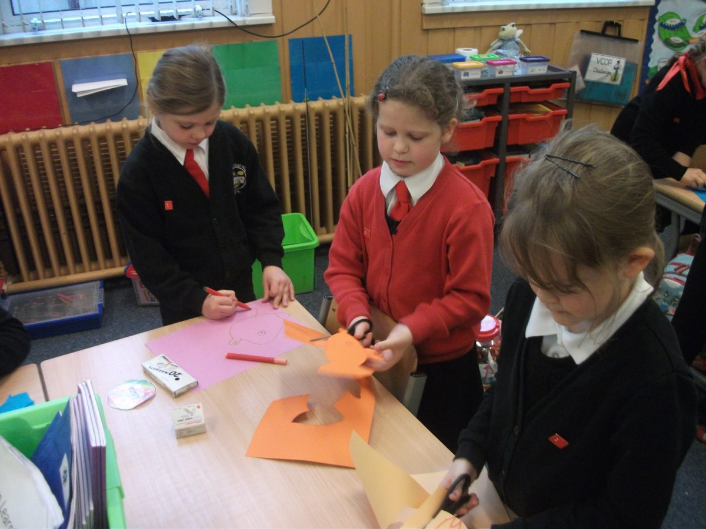

Numeracy & Mathematics
For young children maths is embedded in their play and everyday situations. Here in Dunlop Primary we build on and extend these experiences in a structured way. Opportunities are available to all children to develop their skills within their own abilities, as they progress through the levels.
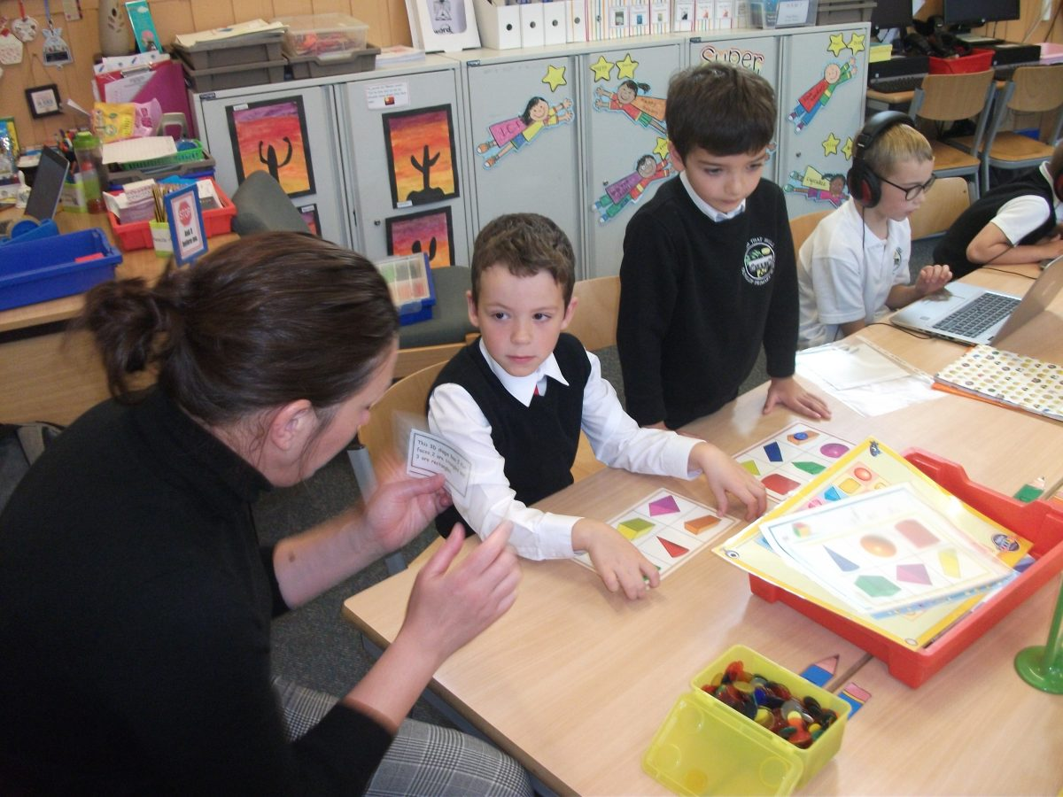
The computer is a valuable resource and learning tool in Mathematics. Learning programmes have been devised using PCs, consolidating the processes of learning. ‘Education City’, ‘Sumdog’ and problem solving software are also used to enhance the work.
Mental calculation is an extremely important skill and regular practice forms part of the daily maths programme. This approach ensures that the children are actively involved in their learning and a deeper sense of understanding is achieved. It encourages discussion, problem solving, collaboration and choice. Challenge and support can be delivered easily and the children have an opportunity to use their skills in real life experiences. We have introduced Number Talks to increase our learner’s confidence and mental agility.

Science and Social Subjects
In Dunlop PS and ECC we use a variety of approaches and topics to deliver Science and Social Subjects in a structured and progressive way
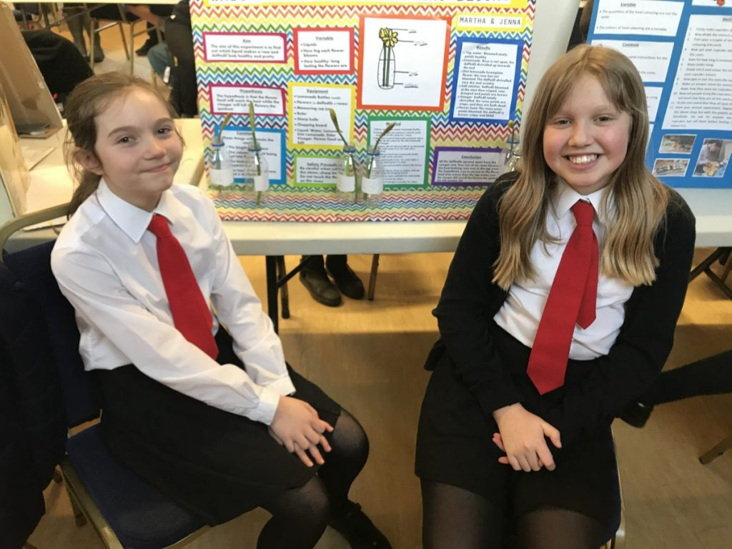
Teachers have the opportunity to plan the breadth and balance of the curriculum over each year stage by using a combination of Topics and Mini Topics. The topics will be linked to other curricular areas to give a meaningful and motivating context to the other curricular experience.
Children are encouraged to learn by being involved and the key words are activity and enquiry.
These aspects of learning progress from the known to the wider world; back into the past; living things; energy; design; knowing about ourselves; collecting and using information, so that the children are more able to cope with, and understand life in our modern world and introduces them to the idea that social, physical and cultural conditions affect and influence the lives of individuals and communities.

Expressive Arts

This includes Art, Drama, Music and Dance where a common curriculum is offered to both boys and girls.
Music
‘Sounds of Music” and musical performances provide tremendous resources for both children and class teacher to explore. The main priority of music making in the classroom is to lead children to listen to music, feel music, understand music, play music, invent music and, most of all enjoy music.
Brass and woodwind tuition, available to a number of children from P6 - P7, is given by visiting specialists
Art
The main skills covered are drawing, painting collage printing, 3D work, fabric work and appreciation of the work of famous artists. Art work is linked to topic work or specific occasions during the year to give meaning and purpose to the application of skills.
Drama
The aims of drama are to develop imagination, expression, understanding and cooperation. This is carried out in full class and group activities, role playing, mime and improvisation. A variety of resources are used and these are linked to topics wherever possible.
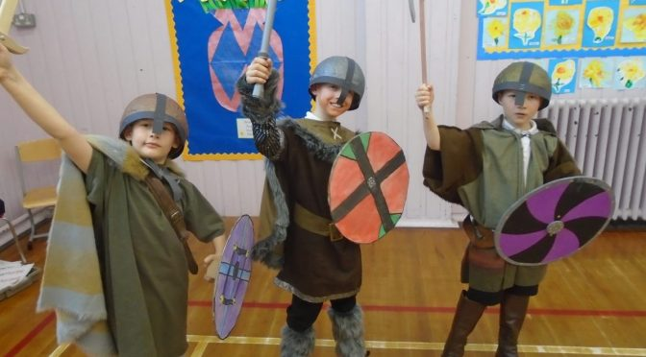

Modern Languages

As part of the Modern Languages in the Primary School 1 + 2 initiative, P5, P6 and P7 pupils are taught a foreign language on a formal weekly basis but it permeates the curriculum from the ECC to P4. French has been chosen by Stewarton Academy and its associated Primary Schools. Pupils receive regular lessons with emphasis on the spoken language. Topics covered in this course are homes, the family, colours, the weather, numbers, days of the week and months of the year. Pupils in P5-7 are also taught a block of Spanish each session.

Spiritual, social, moral and cultural values

Religion as a significant area of human experience requires its place in the curriculum.
Policies on religious education and religious observance take regard of the national advice set out in SOED Circular 6/91 and the Education (Scotland) Act 1980.
Here in Dunlop PS and ECC we aim to encourage pupils to:-
- develop a knowledge and understanding of Christianity and other world religions
- appreciate moral values such as honesty, liberty, justice, fairness and concern for others
- investigate and help children understand what religion has to offer
- formulate their own beliefs, attitudes, moral values and practices through personal search

Our RE programme meets the requirements of the Curriculum for Excellence, giving a prominent place to Christianity, while exploring Islam and Judaism. Pupils have a need to understand how important religious faith is to the believer and to develop sensitivity and tolerance to the belief of others especially where they differ from one’s own.
Parents have the right to withdraw their child from religious education and/or religious observance. Any parent who does not wish his or her child to take part should contact the Head Teacher so that alternative arrangements may be made for the child.

Parents from ethnic minority religious communities may request that their children be permitted to be absent from school in order to celebrate recognised religious events. Only written requests detailing the proposed arrangements will be considered. Appropriate requests will be granted on not more than three occasions in any one school session and the pupil noted as an authorised absentee in the register.

Health and Wellbeing
Physical Education
The class teachers provide differentiated weekly lessons using the Borders Regional Council PE Guidelines, and a variety of other resources. We aim to provide up to two hours PE each week. All Primary 5 pupils receive swimming lessons at the Galleon Sports Centre, Kilmarnock. The school & ECC take part in the Daily Mile regardless of the weather. Please make sure your child has weather appropriate clothes and shoes.
Earrings and body piercing jewellery must not be worn for any PE-related activity.
Health
Children cover a variety of health and safety-related topics as they progress through the school. Dunlop Primary is a “Health Promoting School” and an “Eco School”. Events are organized each year to focus on different aspects of health and wellbeing e.g. Health Awareness Day, Kerbcraft for P1, Golf Day and a Dance Week.
The children are also encouraged to value themselves, to be aware of others and their needs, to take care of the environment and how to keep themselves safe.
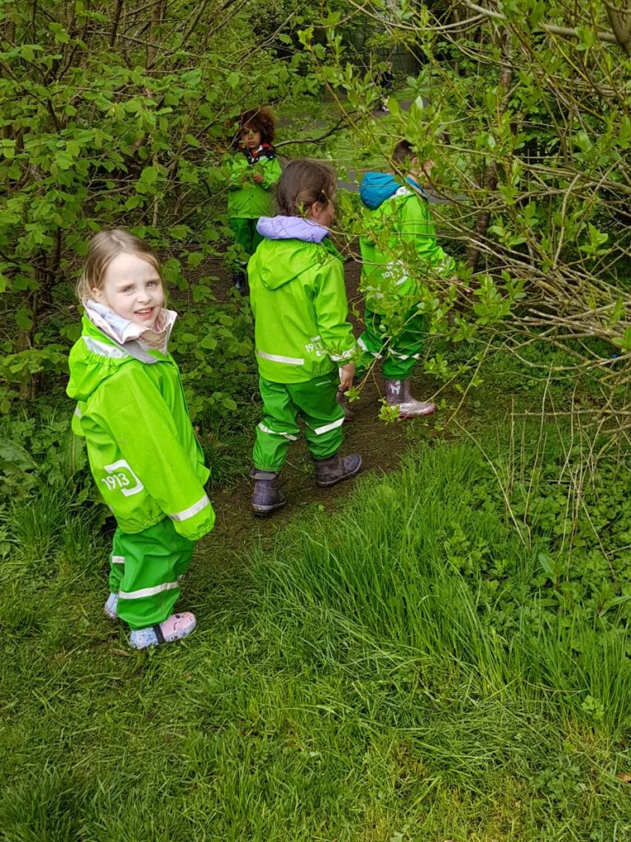
We endeavour to create a community which provides a warm, caring and supportive atmosphere by treating pupils as individuals, listening to their needs, offering equal opportunities to all, highlighting positive achievements and encouraging strong links between parents/carers, children and the school.
The school delivers a programme of Relationships, Parenthood and Sexual Health to the children in the school and ECC. Parents are notified of when this takes place.
Parent leaflets are available on the Blog.

SECTION 5
In November 2019 we had a very positive HMIe Inspection which identified the following strengths:

- The positive and caring ethos in both the school and early childhood centre. This is supporting children to be highly motivated and actively engaged in their learning. Children are proud of their school.
- Led by the Head Teacher, the strong sense of teamwork and drive of all staff in continuing to improve the quality of learning and teaching. Effective approaches to planning learning and assessment and monitoring children’s progress in supporting this well.
- The high levels of attainment in literacy and English.

- We continue to be extremely proud of our inter-generational work in the community, hosting a Harvest Tea for our Senior Citizens, providing Baking and entertainment from the pupils. We also entertain the Senior Citizens at their Christmas Lunch with singing from our choir. On request, our choir was also invited to perform at a Family Service at Dunlop Parish Church and at the Stewarton Wind Ensemble Concert in the Village Hall.

- Building on the success of last session’s Leadership Groups we have continued to provide opportunities to develop our young people’s skills for learning, life and work in motivating contexts for learning and work alongside partners to provide well-planned opportunities for learners to develop an awareness of the world of work. This session’s Leadership Groups in P4-7 were: Eco, Rights Respecting Schools, Digital Leaders, Citizenship, Health & Yearbook, promoting decision-making relating to the life and work of the school (such as school policies, school improvement activity); encouraging pupil voice; determination; respect for other’s points of view; collaboration and dialogue; inclusion and participation in the wider community.

- We were delighted to achieve our Bronze Rights Respecting Schools Award and we will be continuing to work towards our Silver Award next session.

- This year the school was represented at various competitions and community events and were delighted to win the first ever Kilmaurs Photographic Competition and have won it again this year for the second year in a row. We have participated in the East Ayrshire Cross Country events, Sports Hall Athletics & Netball Competition.

- During Lockdown our children were successfully engaging with digital learning through Teams and SeeSaw with daily literacy, numeracy and health & wellbeing tasks and several Family Learning Weeks. We celebrated our childrens’ achievements through the creation of video clips.

Dunlop Primary School & ECC
School Improvement Plan Priorities 2021 - 2022

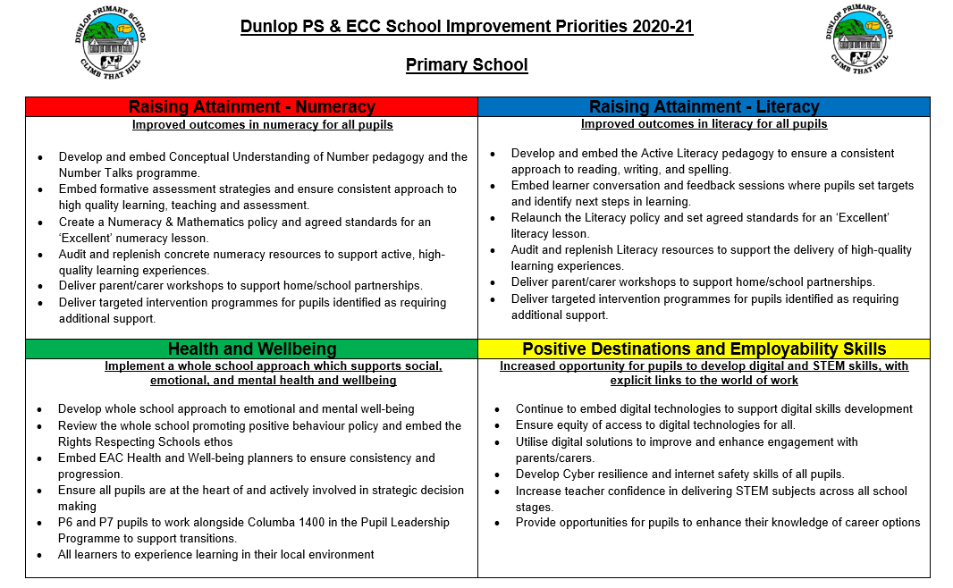

SECTION 6

Assessment

Curriculum for Excellence emphasises that assessment is an integral part of the day-to-day teaching and learning. Learners’ progress will be closely monitored by staff, who reflect with them on their strengths, learning needs and next steps, and take action based on this. Learners themselves will be increasingly involved in this process, as they develop the skills needed to be able to make effective judgments on their own learning; skills that will be important to them throughout life. Testing will continue to be part of the framework of assessment, providing additional evidence of what learners know, understand and are able to do, and helping teachers plan learning experiences which are motivating and challenging.

Teachers regularly use formative and summative assessment to inform the next steps in learning and teaching. Assessment becomes “Formative” when teachers modify their teaching as a direct result of the assessment in order to improve subsequent learning. Research has found that learners learn best when they:

- understand clearly what they are trying to learn and what is expected of them
- are given feedback about the quality of their work and what they can do to make it better
- are fully involved in deciding what needs to be done next and who can give them help if they need it

The children are actively involved in self and peer assessment after identifying the success criteria for a piece of work.

In summative assessment teachers are constantly monitoring children’s progress in all areas of the curriculum, using written assessments periodically to measure progress. Such assessments include maths assessment, activity assessments in all curricular areas and class teacher assessment sheets. These assessments and the evidence gathered of progress made help teachers decide whether children are developing skills, consolidating skills or if they are secure in the skills of each level in Curriculum for Excellence. Continuous assessment, plus close co-operation among teaching staff helps to ensure that children cover all areas of the curriculum no matter what stage or class they may be in.

Reporting to parents

Parents will be given a short format written report annually, usually June, to inform them of their child's progress. We will host three Parents Evenings per session to give parents the opportunity to discuss their child's progress with the appropriate member of staff. Parents need not wait for these meetings to discuss their child’s progress or any matters causing concern, but are welcome to call at the school at any time. It is advisable however, to arrange this by telephone first to ensure that the teacher is available. Children who may have additional support needs, or who require a Co-coordinated Support Plan will be assessed in a way suited to their individual requirements. The Head Teacher and Class Teacher will discuss this with parents. We also report to parents via – the blog, Twitter, newsletters, open afternoons and e-portfolios.
Reporting To Parents/Carers (ECC)
It is important that parents and staff develop a positive relationship to ensure a full supporting role in the child’s development. Any worries or concerns should be notified immediately so that they may be resolved before becoming major problems. This should be relatively easy as parents are normally in daily contact with early childhood centre staff. The Head Teacher and Principal Teacher are always available should there be any personal or confidential matters you might wish to discuss. During the session there will be various notes, newsletters etc. sent out to keep you informed as to what is happening in the school as well as in the early childhood centre and you will be invited to a review meeting every 6 months to discuss your child’s progress with their key worker.

