Week 3 - Friday Family Learning Challenges
Friday Family Learning tasks will be set each week – you will generally have a choice of an Outdoor Learning Task, a creative task or a STEM task.
Choose one family challenge activities to complete with your family.
Please send me a photo, tell you what you did or take a video to show what you have done for your chosen task.
The idea is that these activities you can complete as a family with all those participating contributing at their level.
If you have more than one child in the school, feel free to add it to just one TEAMs assignment (and let me know if there are any other siblings.)
If you are P1 -3 please e-mail anything to Rachel.fullard@eastayrshire.org.uk.

Challenge 1 – Mental Heath and Wellbeing– We are all stars!
This week is nationally dedicated to mental health and wellbeing. Have a think why it is good to be you and what makes you special. It is good to be different and to celebrate what makes us special. Have a go at decorating the star below with a picture of you and what makes you so special! Cut out and display!
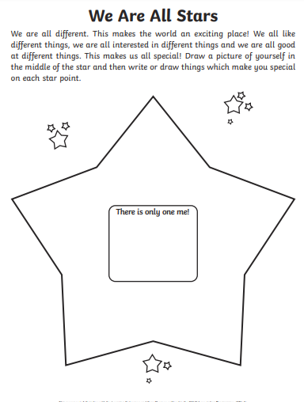
Challenge 2 – Winter Fun Outside.
It is supposed to be cold (and maybe snowy) this weekend so get outside and enjoy some very cold fresh air!
Spending time outdoors is important for our mental and physical health at the best of times and is becoming an even more important part of many people’s days right now. Below is a list of ideas to try out on winter walks, in local greenspace or even in gardens. The aim of these activities is to have fun, slow down and take notice of the world around you. Learners and their families can choose which activities to do, how many times they do them and which order they do them in. How many boxes can you tick off?
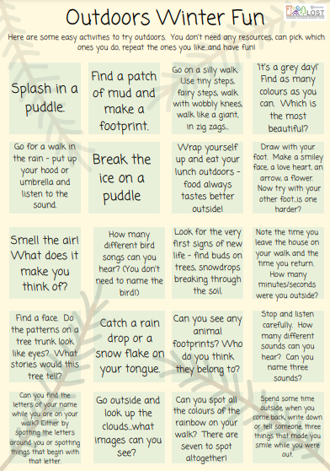
Challenge 3 – STEM Task – Make slime (Adult supervision needed)
Make your own slime following the link from BBC below:
Ingredients needed:
- 100ml PVA white glue (children’s craft glue or CE marked glue)
- ½ tsp bicarbonate of soda
- gel food colouring
- 1 tsp contact lens cleaning solution
Follow the instructions below to make slime:
https://www.bbcgoodfood.com/howto/guide/how-make-slime
Other slime recipes are available on this site below.
https://littlebinsforlittlehands.com/homemade-slime-recipe/
Learn about the science behind slime by watching the YouTube links in the form below. There are two clips explaining how slime works and whether it is a solid or a liquid.
https://forms.office.com/Pages/ResponsePage.aspx?id=oyzTzM4Wj0KVQTctawUZKeLDFAd6n9RHrMV39SrcoepUN1RBVFRQVEJZWlBTTzE5RFdORVlPWjA0Ny4u

REMEMBER TO ONLY DO THIS ACTIVITY WITH ADULT SUPERVISION.
If you don’t have the ingredients to make slime at home at the moment, you could save this activity for another time when you can.

Challenge 4 – Drawing with Rob Biddulph and reading his book ‘Odd Dog Out’.
Gather up your painting aprons, paints, pens and pencils.
Follow award winning author and illustrator Rob Biddulph videos on how to draw one of his creatures.
Try drawing Odd Dog Out with a reading of his story at the end of the clip.
Another option is to draw a robot picture following his instructions.
Colour, paint or decorate your drawing however you want.
Share you efforts on Teams or on SeeSaw!
Click on the links below to see the YouTube videos.
https://forms.office.com/Pages/ResponsePage.aspx?id=oyzTzM4Wj0KVQTctawUZKeLDFAd6n9RHrMV39SrcoepUODVZTllUNk5SSkEyVUw5R1FBRjFKME9UMy4u

