Week 3 - Friday Family Learning Challenges
Friday Family Learning tasks will be set each week – you will generally have a choice of an Outdoor Learning Task, a creative task or a STEM task.
Choose one family challenge activities to complete with your family.
Please send me a photo, tell you what you did or take a video to show what you have done for your chosen task.
The idea is that these activities you can complete as a family with all those participating contributing at their level.
If you have more than one child in the school, feel free to add it to just one TEAMs assignment (and let me know if there are any other siblings.)
If you are P1 -3 please e-mail anything to Rachel.fullard@eastayrshire.org.uk.

Task 1 – Family History Scavenger Hunt

Family History Is Everywhere!
Have a scavenger hunt in your house to see how many things you can find that are about your family history. You can look for birth certificates, a family bible, old pictures and scrapbooks, or anything that reminds you of the past. Remember to check with a parent/carer before getting out any documents or old things that you could damage.
If the items are moveable you can make a display, and if not, you can take and print pictures. Make an inventory (list of what you have found). You could make a family history museum – collection.
Have a chat with adults in your family. Have they got any family stories? You could talk to grandparents, your parents, or any other relatives on the phone. Remember to check with your parent or carer that it is ok before you talk to another relative.
Write done any stories you have found out about your family to keep for the future.

Task 2 – Outdoor Learning – Tiny Treasure Hunt
For this week's Outdoor Learning I would like you to get a small box (e.g a empty match box, a sandwich box, a butter tub, a empty small toy box). It is preferable with a lid so you can close it.

I would then like you to go on a walk around your local area and collect as many things as you can to go into your box. They must fit inside it! It might be a leaves, pine cones, seeds, a bit of a twig or anything that you find. It can be natural or man made.

Once your box is full, have a look at what you've managed to collect. Can you sort it into groups? Can you put it in order from smallest to largest? Can you decide which item in there is the most important? Why? Which item is the least important? Why?

Don't forget at the end to return all your items back to their natural environment.

You can send me a photo of what you have found or tell me in a message. Feel free to share your findings on Teams or SeeSaw. Most importantly, have fun doing this task!

Follow the link below for the LOST team explaining this task.
https://forms.office.com/Pages/ResponsePage.aspx?id=oyzTzM4Wj0KVQTctawUZKeLDFAd6n9RHrMV39SrcoepUQU9KNUdQVVEzRks3OTNXSkZJMzc4TUtCRi4u

Task 3 – STEM Task – Make a basket out of a paper plate

Paper Plate STEM Basket Challenge
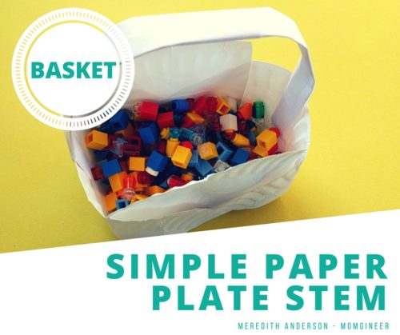
Can you use just ONE paper plate and a piece of paper and create a basket? This one requires a lot of planning and careful cutting. Try minimising seams so there aren’t places for your items to “leak” out. Test with marbles, toys, or if you are feeling brave, rice. Does it break or can it hold the items?

Task 4 – Scottish Art
Gather up your painting aprons, paints, pens and pencils.
Using Little Art School’s daily draw videos on YouTube draw a picture of a Scottish thistle. You can all draw one as a family and then paint, colour or decorate as you wish to.
There is a link for a junior thistle drawing and a link for a senior thistle drawing. Choose which one suits your family.
Share your thistles on Teams or Seesaw.
Follow the link below for the videos.
https://forms.office.com/Pages/ResponsePage.aspx?id=oyzTzM4Wj0KVQTctawUZKeLDFAd6n9RHrMV39SrcoepUMDc3QUQ3VjIyTlpHU1hWOTQyRlRWMlYwSC4u

