Week 1 - Friday Family Learning Challenges
Friday Family Learning tasks will be set each week – you will generally have a choice of an Outdoor Learning Task, a creative task or a STEM task.
Choose one (or two if you are feeling brave) family challenge activities to complete with your family.
Please send me a photo, tell you what you did or take a video to show what you have done for your chosen task.
The idea is that these activities you can complete as a family with all those participating contributing at their level.
If you have more than one child in the school, feel free to add it to just one TEAMs assignment (and let me know if there are any other siblings.)
If you are P1 -3 please e-mail anything to Rachel.fullard@eastayrshire.org.uk.

Task 1 – Family History
Who is in your family? Create a family tree for your family. How far can you go back? Feel free to use photos/drawings or any way you would like to create a family tree.
P1 -3 Challenge – Include as many people from your family as you can
P4-7 Challenge – Can you include birth (and death if applicable) dates for each person?
Please feel free to be creative with how to show your family tree – here are some suggestions.
- Use a computer programme to show it.
- Create it on the floor using pictures and paper.
- Use chalk and create outside.
- Use picture/drawings/paint
- Draw it on paper

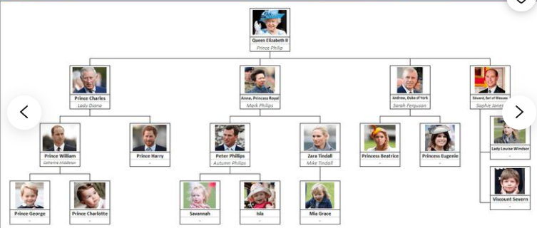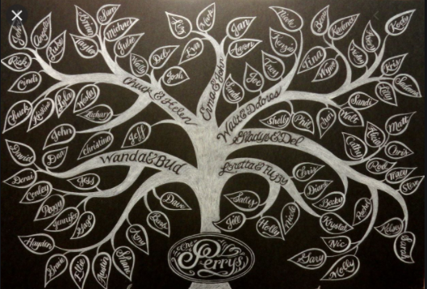
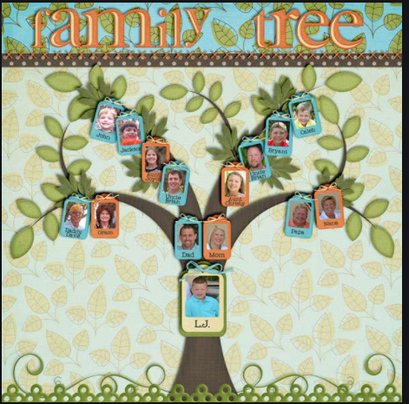
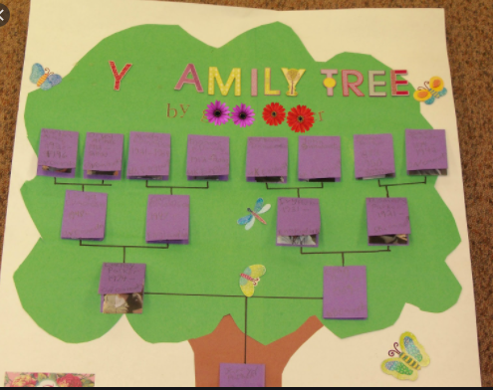
Extension
Have a discussion with your family who is in your family tree. How many cousins do you have? How many grandparents? Do you have any great-grandparents? Who is the oldest in your family? Who is the youngest?
Task 2 – Outdoor Learning – RSBP Wild Challenge
Have a go a wild challenge designed to complete outdoors. There are lots of Wild Challenges available on the RSBP website. If you complete 6 you can be awarded a bronze award.
Challenge option 1 – Feed the Birds
Create birdseed feeder for the birds in these cold months. If you don’t have all the ingredients use what you might have that is suitable – e.g. porridge oats, cereal like Cherrios, raisins. You can use butter instead of lard.
https://www.rspb.org.uk/fun-and-learning/for-families/family-wild-challenge/activities/feed-the-birds/
Challenge option 2 – Trees, Leaves and Seeds
Have a go and see if you can find any winter seeds outside. There is a RSBP sheet to help you see what you can find.
https://www.rspb.org.uk/globalassets/downloads/wildchallenge/activity-sheets/english/770-0214-18-19-wild-challenge_trees_aw.pdf

Task 3 – STEM activity
Create a water- power system
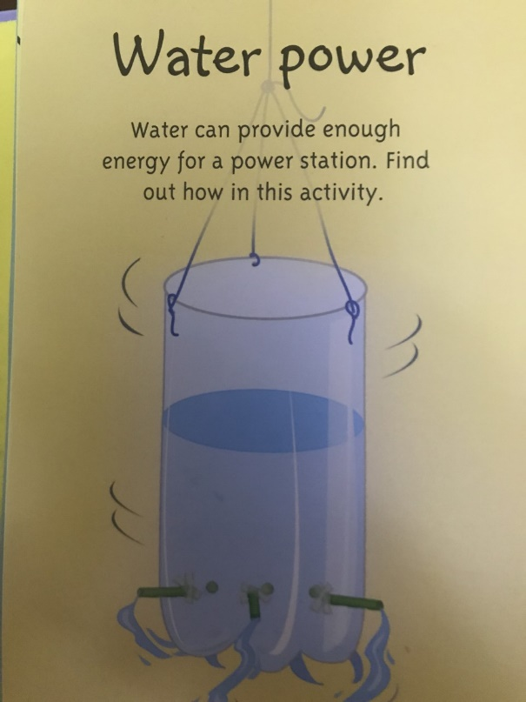
Water is great for creating energy. Build your own water power to show energy.

