Numeracy
Numeracy begins with an activity in our messy maths jotter. You can choose between ‘Green for go’ or ‘Pink for think’. Use the numbers below, add two and 5 to each number. Remember to use things like a whiteboard, number line, cubes and so on to help you work out which is which.
Green for go
1 | 4 | 15
0 | 7 | 6
19 | 23 | 18

Pink for think
18 | 98 | 37
25 | 13 | 68
54 | 89 | 12

Today I have attached a PowerPoint for you to look at all about Mrs Odd and Mr Even. When you have finished looking at it you could create a world for Mr Odd and one for Mrs Even.

Below I have attached some activities for you to try. You do not need to do them all. Remember no work is posted tomorrow so you might do some today and some tomorrow.
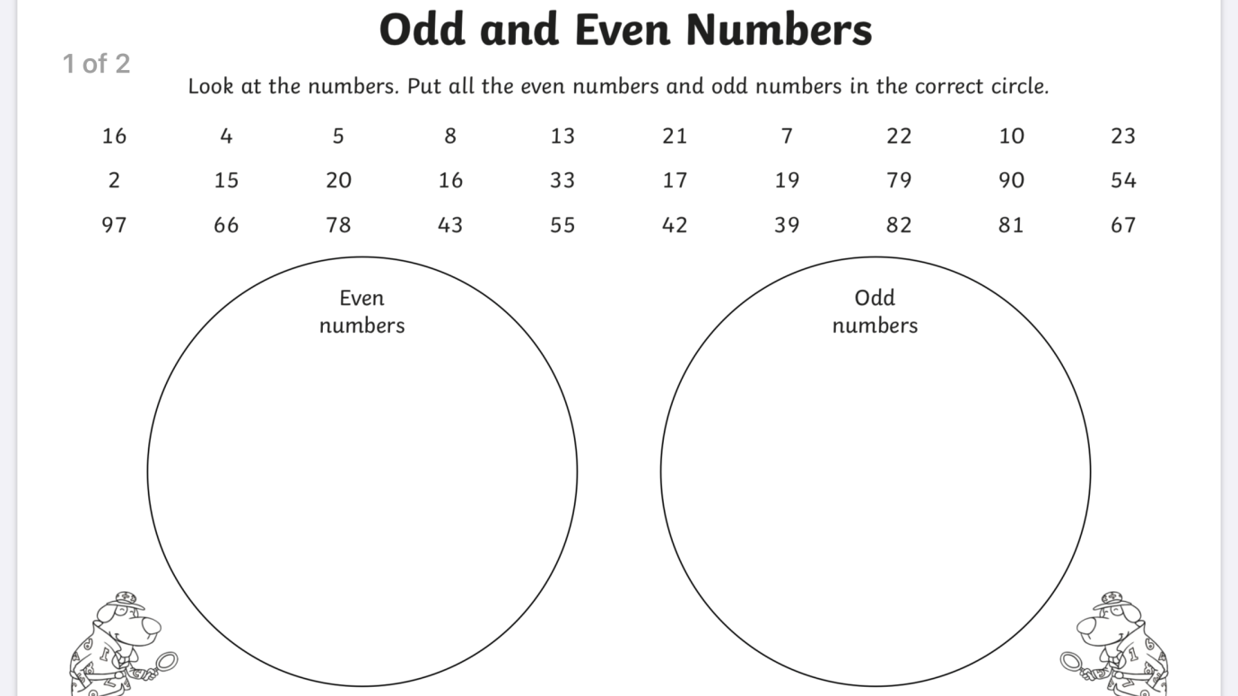

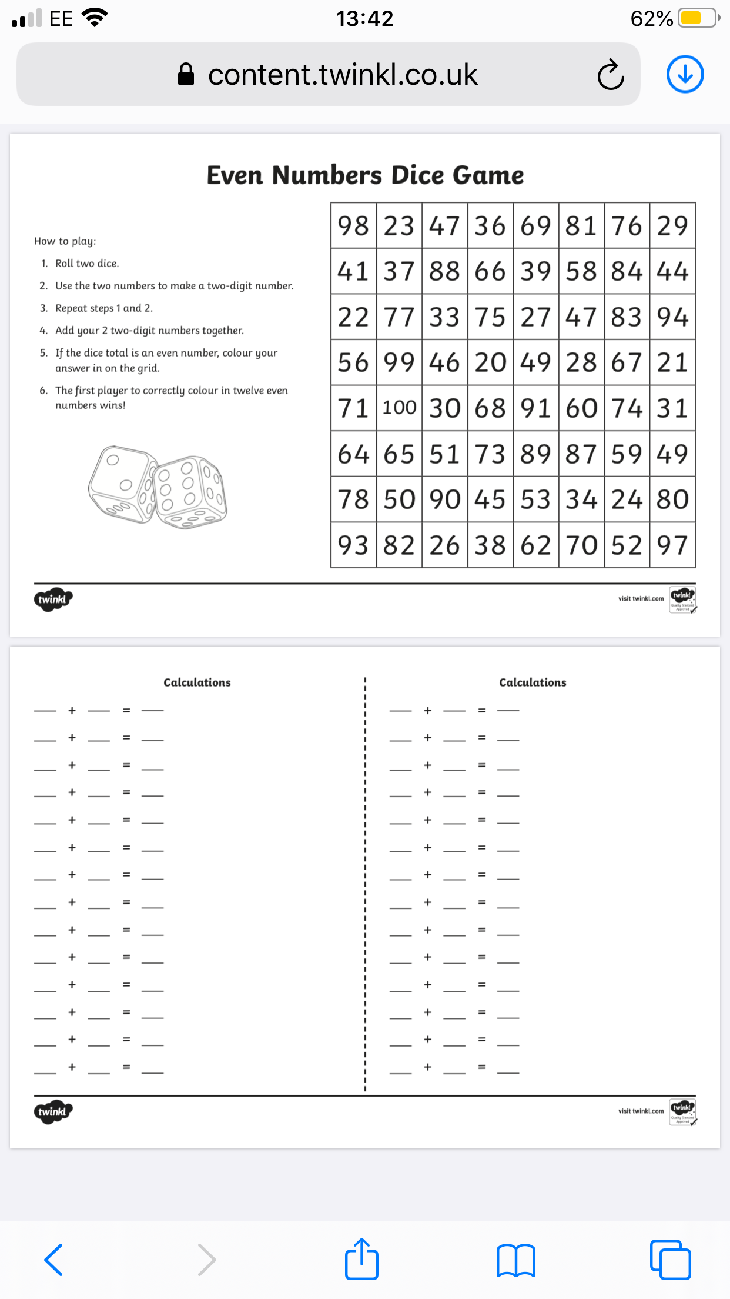
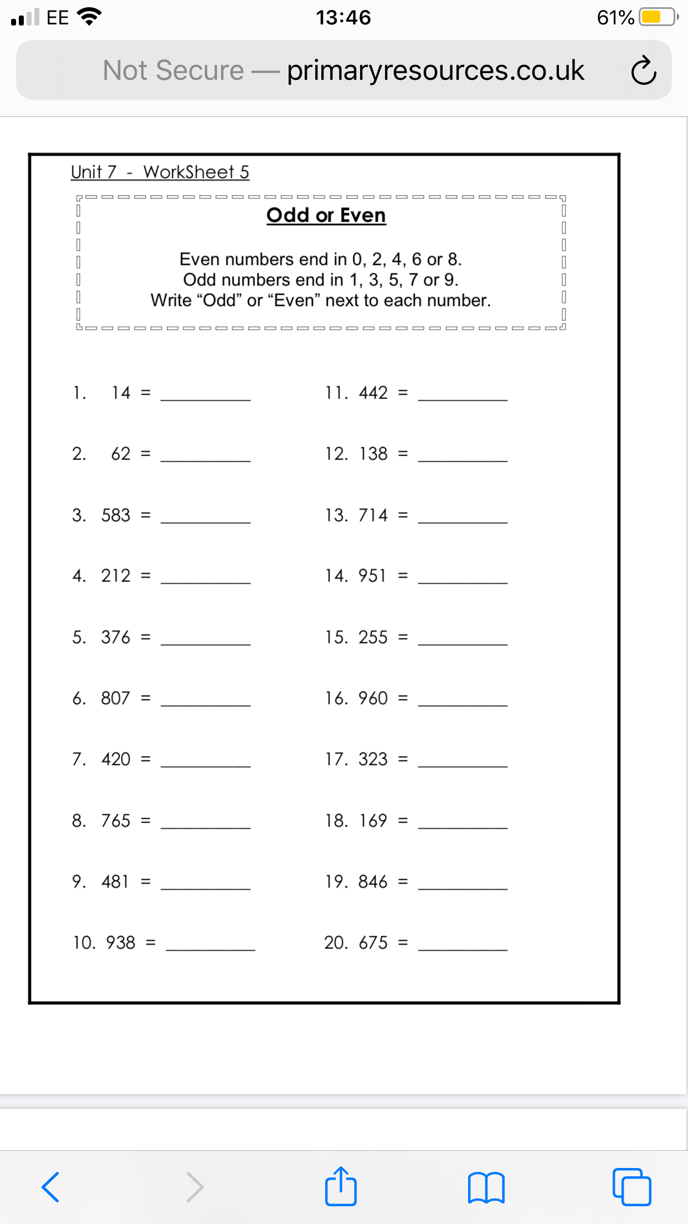
Literacy
Thursday is our story writing day. Today I would like you to write a story all about elephants. Perhaps you go on a trip and find some wild elephants, do they need your help? Perhaps you are there to make a documentary all about them now that you know some elephant facts. When your story is finished you could draw a picture to show what happened in your story.
When writing your story remember
- Capital letters and full stops
- Finger spaces
- Think about the size of the letters, are they tall, small or do they go under the line?
- Make sure your writing goes from the beginning of the line to the end.
- Check to see if your story has a beginning, middle and end.
- Read over your story to check that it makes sense.

Today you should also be revising your tricky words and phoneme. Normally we would have a spelling test on a Friday, perhaps this is something you would like to do tomorrow?

Expressive arts
Today I would like you to draw an elephant. To do this, go to YouTube and type in great artist mom – elephant. Remember to pause as you watch to give you time to draw each part. You could also include a background. You might like to add colour to your picture, you could do this with paint, pens, pencils or whatever you have at home. Remember that you are the artist and it is up to you to decide how you want your final picture to look.
