Numeracy
Numeracy begins with an activity in our messy maths jotter. You can choose between ‘Green for go’ or ‘Pink for think’. Using only the numbers below. Today you are only allowed to double the numbers. Remember to use things like a whiteboard, number line, cubes and so on to help you work out the answers.
Green for go
2 | 5 | 8
3 | 9 | 7
10 | 20 | 1

Pink for think
50 | 14 | 25
30 | 16 | 22
45 | 9 | 100

Odd and Even
Your challenge today is to find out if a number is odd or even. Remember if a number is even then everyone has a partner, if a number is odd then one is left out. At home gather together some objects and sort them to find out if they are odd or even.
For example
- Get some socks and put them in pairs. How many do you have? Do you have an odd or even number? (You could ask your grown up to take some away, what have you got now an odd number or even number?)
- Gather together some teddies/cars/figurines can you give each a partner? How many do you have?
- Go for a walk, what do you notice about the numbers on the houses in your street? Why do you think they are this way? Is your house number odd or even?
- Can you create your own street with odd numbers on one side and even numbers on the other? (You might choose to draw your street/build with lego/create on the computer). I can’t wait to see what you do.
Literacy
Begin by looking at your phoneme and tricky words. Choose a different way to create them today. Also remember to read your reading book as much as you can (and any other books/comics you enjoy reading).
Previously we were learning about prepositions. We explored where the teddy and elf were in the picture. Today I have attached a listening activity all about the position of items in a playground. If you’re not able to print then instead I would like you to draw a picture of a park with a slide, climbing frame and seesaw, and then ask your grown up to read the instructions below.
- Draw a boy sitting on the seesaw
- Draw a bike beside the slide
- Draw a balloon above the climbing frame.
- Draw a football between the slide and the climbing frame.

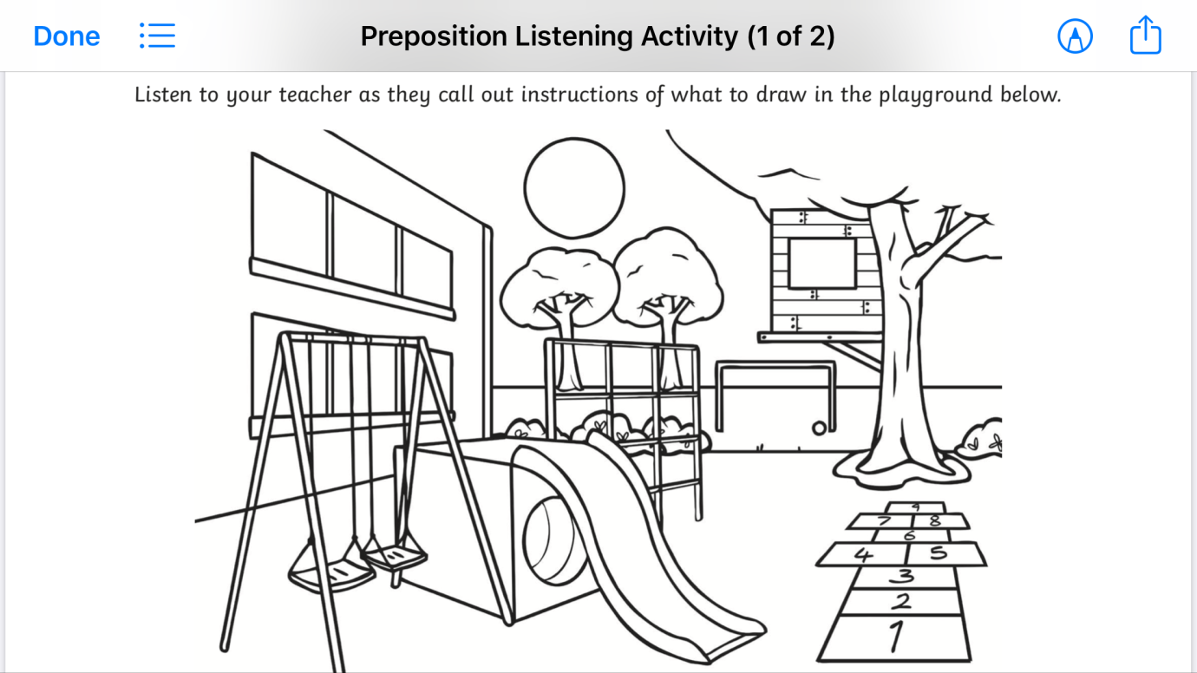

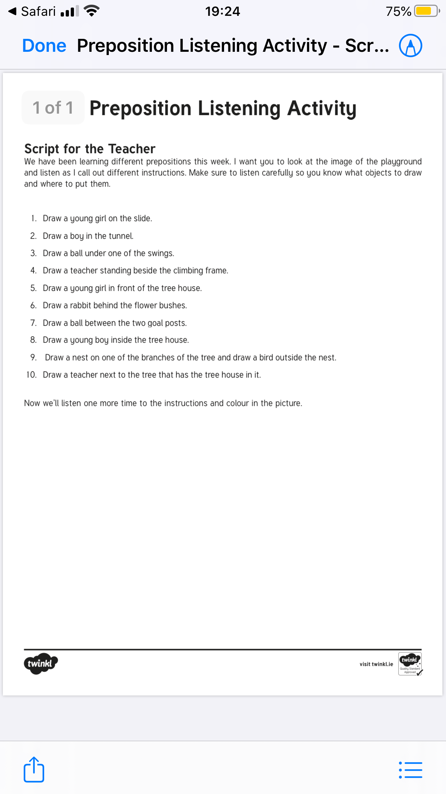
Health and wellbeing

Today I would like you to try mindfulness with your family. Even though we are at home we are all still very busy.
Mindfulness is a tricky concept to grasp. It could be looking out of the window in the morning to see what the weather’s doing, and to help you know what you need that day. If it’s raining outside, you know you need an umbrella. If you’re feeling stormy inside, you can ask yourself what you need – maybe that’s to be on your own for a bit or to ask for a hug or to do some exercise.

Take a few minutes to lie down in a quiet place and think about your senses. You might focus on just one today and focus on another one next time.

Notice six things that you can see. Cast your eyes around and bring your attention to six things you might not normally notice. Choose something you wouldn’t ordinarily pay attention to, like a shadow or a small gap in the blinds.
Notice three things that you can feel. Bring your awareness to these three things you are currently feeling, like the texture of your socks, the feeling of the breeze on your skin, or the surface of the floor you are resting your hands on.
Notice four things that you can hear. Try to listen carefully to the sounds around you. What can you hear in the background? This might be a bird singing, the low hum of the television or the sound of people outside.
Notice one/two things that you can smell. Tune your senses into smells you might not normally notice, even if they’re pleasant or unpleasant. If you’re outside the wind might be bringing some scents to you.
Notice one thing that you can taste. Concentrate on one thing you can taste right now. You might take a sip of water, enjoy some fruit, eat something, notice the current taste in your mouth.

