Dunlop Primary
P3a Home Learning
Monday 11th January

Today’s Learning
Literacy
Phonics This week’s phoneme is ‘C’. Your phoneme words are:
- recite
- city
- icy
- central
- December
- circle
- circus
- cinema
- celebrate
The ‘c’ in the words above is a soft ‘c’, because when the letter ‘c’ is followed by the letters i, e or y, the ‘c’ makes an ‘s’ sound.

Task 1
Watch Geraldine the Giraffe
Geraldine the Giraffe learns soft c - YouTube
Task 2
Read your phoneme words saying each word out loud and using your 5 finger strategies, can you say, make/break, blend, read and if you have some paper write each word 3 times remembering your heavenly handwriting.
Task 3
Can you find any items around your house that have a soft ‘c’ in their name. If you have paper, make a list of your findings.

Reading
On our return to school the Ready Readers and Brilliant Bookers were going to be given the same novel to engage with, therefore you will all have the same books allocated to you on Giglets to read.
Please log in to giglets https://giglets.com/ using your own personal log in details.
Could you please read Snow White and then complete the Higher Order Thinking Skills task. If you have paper, write down your answers to these higher order thinking skills questions or otherwise share your thoughts with your parents.

Lockdown Journal Entry
Please complete a Lockdown Journal Entry with details about what you have done over the previous week, something positive that happened and your favourite part of the week. You could also share some weekend news, as we would usually do this every Monday in class.
I have attached a template on the blog that you could print and complete if you have a printer. Don’t worry if you don’t, you can use paper to write your Journal.

Maths
In class we were going to focus on practicing our number work, starting with sequencing numbers forwards and backwards. I have found a YouTube video that gives an explanation and will help you to understand sequencing- Number Patterns - Identifying Missing Numbers - YouTube
Task1
Please log in to MyMaths using your personal log in details - MyMaths - Bringing maths alive
Once logged in, complete the Counting 1 task. Remember to complete the ‘lesson’ section before completing the task.
Task 2
Please complete the sequencing activity. You could print out this image or complete on paper.
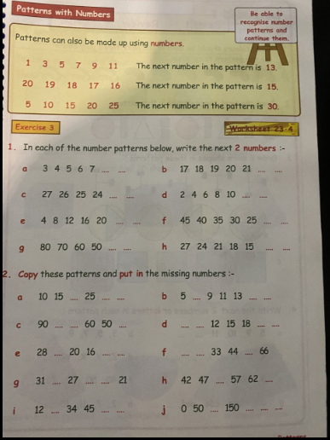

Topic

We are going to support the RSPB with their annual Big School Bird watch which is taking place from 29th – 31st January. I will attach a hyperlink to the RSPB website if you would like to research some information - Big Garden Birdwatch | Join the fun - The RSPB

Task 1
I have attached a PowerPoint to the blog, detailing the different birds you could see in your area. Please have a look at this.

Task 2
From a window in your house, in the back garden or on a walk take note of how many birds you see landing on the ground. Do not count those in the sky. I wonder who will see the most birds today. Did you recognise any birds from the PowerPoint in your local area?

Have a wonderful day P3 and I so look forward to seeing your fabulous work.

PE
On a Monday we would usually be taking part in PE to keep your body healthy and active. It is important you still do this, so I have the following activity for you:
Follow the hyperlink to take part in Joe Wicks’ PE lesson.
P.E with Joe | Tuesday 24th March 2020 - YouTube
To help you relax after such a hard day’s work, follow the hyperlink to GoNoodle and choose some of the activities you would like to complete.
GoNoodle
You could also practice ‘Freeze’ as I know you loved this so much in class!

