Dunlop Primary
P3b Home Learning
Monday 7th December

Today’s Learning
Literacy
Phonics This week’s phoneme is ‘U-E’. Your phoneme words are:
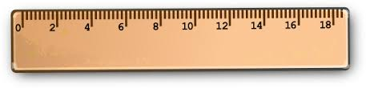

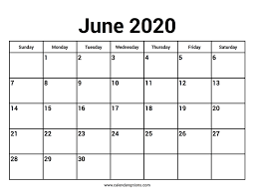

- June
- rule

- ruler
- rude
- flute
- tube
Task 1
Watch the Silent E Video
https://www.youtube.com/watch?v=1I4H2U2LH1Y

Task 2
Read your phoneme words saying each word out loud and using your 5 finger strategies, can you say, make/break, blend, read and if you have some paper write each word 3 times remembering your heavenly handwriting.
Task 3
Can you think of a way you could make your phoneme words using items you have in your house or bedroom? This might be lego, pasta, or maybe you have coloured pencils or pens and you could practice writing these in bubble writing.

Reading
Please log in to giglets https://giglets.com/ using your own personal log in details, this was sent home with your reading books a couple of weeks ago.
Once logged in you will see that you have been allocated 5 books. For today,

Incredible Illustrators and Wonderful Writers
Could you please read Don’t Make believe in Dragons and then complete the Higher Order Thinking Skills task. If you have paper, write down your answers to these higher order thinking skills questions or otherwise share your thoughts with your parents.

Amazing Authors
Could you please read Carmen the Farmer and then complete the Higher Order Thinking Skills task. If you have paper, write down your answers to these higher order thinking skills questions or otherwise share your thoughts with your parents.

News Writing
I always love a Monday when you share with me news from your weekend. If you have paper please write your weekend news using the classroom format. Begin your news ‘At the weekend…’ then tell me what you did, who you were with, where you went and don’t forget to add interesting details and wow words. Remember to draw a detailed picture too.

Maths
We have started working on the two times table, so let’s use this time to practice our counting in twos to help us.
Today watch these YouTube clips to help

https://www.youtube.com/watch?v=hae10bsW_CM

https://www.youtube.com/watch?v=GvTcpfSnOMQ

- write from 0 and go up in 2’s how far can you get, do you see the pattern
- count out loud to a parent or toy

Please log in to mymaths https://login.mymaths.co.uk/login using your own personal log in details, this was sent home with your reading books a couple of weeks ago.
Please complete the counting 2 activity.
To finish show your parents how you have been learning to add with carrying using vertical layout sums. Please complete the activity Adding in Columns.

Topic
This week we would have started learning about our 5th and final sense, taste. Follow the hyperlink to watch our favourite Dr Binocs explaining the different parts of the tongue and how it works https://www.youtube.com/watch?v=9uQSfOEFvgA
- Write a sentence telling me how our sense of taste works.
Cooking/Food Preparation
Following on the huge success of our tasty flapjacks and pitta pizza, we were today going to make Christmas empire biscuits. I will keep this for you for when you return to school and we will all enjoy together. Mrs Nouillan has also said she wants to come!
If you are allowed, why don’t you help your parents with some cooking or food preparation, it could be helping to make the lunch or dinner. Don’t forget to send me a photograph as I’d love to see what you make or do to help! Thinking about our topic what lovely tastes have you enjoyed today?

Finishing task
To help you relax after a hard day’s school work put your feet up and enjoy a good book. If you have paper you could draw me a picture of the character or the setting, or perhaps you could re-design the book cover.
Have a wonderful day P3 and I so look forward to seeing your fabulous work.

