
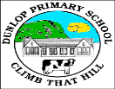
Dunlop Primary School
August- December 2020
Miss Barrett

P3b
Termly Targets
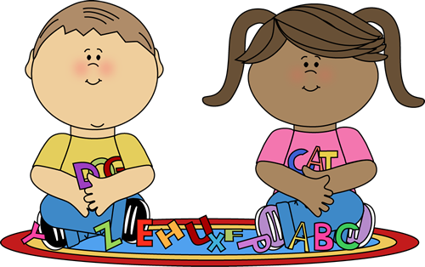  Literacy |  | 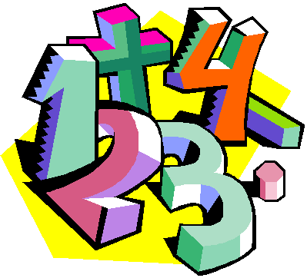  Numeracy |  |   Health & Wellbeing
Reading: The children will continue with weekly reading and they will engage in a range of find it, talk it, prove it activities which will show comprehension of text and reading skills.  Writing: To begin our functional writing block, the children will develop their personal writing skills. Writing will also be linked to our interdisciplinary learning themes of Africa with a focus on Kenya. The children will develop their functional writing skills with a focus on reports.  Grammar: In grammar, the children are learning about common and proper nouns, verbs, adjectives, question words/ question marks and pronouns.  Spelling: In spelling, we will work on weekly phonics and high frequency words and these are reinforced every day in class using a range of active resources. |  | To begin our numeracy lessons, the children will first engage with a Number Talk to explore number patterns and mental math strategies, to develop number sense and confidence.  The children will continue to practice number bonds to 20 with addition and subtraction. They are also adding and subtracting within 100 using vertical layout with carrying and exchanging.  They will also be counting in 2s, 5s & 10s as this is good preparation for moving on to the concept of multiplication.  For beyond number, the children work with Mrs Sullivan and they will work on Measure, including length and volume. They will also develop their skills in using money and telling the time using digital and analogue clocks. Mrs Sullivan will also develop the children’s skills in problem solving by completing problem solving tasks. |  | P.E: PE will continue to be twice a week. The focus will be on fitness including a range of circuit activities. The children will then progress to developing small and large ball skills.  Daily Mile: As part of our ongoing commitment to promote healthy lifestyles and keep the children active on an ongoing basis, the Daily Mile will continue. This is a great opportunity for us to use the wonderful park facility. This enables us to promote healthy activities in the local environment.  Health: Initially the health programme focuses on social and emotional wellbeing and Circle Time is used to promote the sharing of thoughts and feelings in a supportive way.  The children will then progress to learning about their senses and they will enjoy lots of fun experiments and activities to reinforce this learning.
Social Studies/Science |  |   Technologies |  | 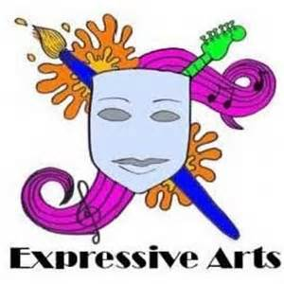  Expressive Arts
In Social Studies, the children’s learning focus came from the Julia Donaldson book The Ugly Five. The book was then used as a vehicle to explore Africa with a particular focus on Kenya.  The children have been learning about  - Geography  - Similarities and differences between Scotland and Kenya  - The Big Five and the Ugly Five  - The life of the Maasai people  We will then move on to exploring science and health and wellbeing focusing on the senses. |  | Every day I use technology as a vehicle to enliven my lessons and engage the children in the teaching and learning. This includes using the Promethean Board, Youtube clips, online games and digital literacy packages to support learning.  To support the sharing our fabulous class learning via the class blog, the children are learning to take photographs of their work. |  | Art and Design is linked to the class topic of Africa with a focus on Kenya as well as seasonal activities. The planned at activities focus on developing painting, line drawing and using media.  We are also using The Great Artist Mom, available on Youtube, to develop drawing skills through her online tutorials.  In music, as we are currently unable to sing, the children are developing their appreciation of music through listening to classical music, music for studying/ relaxation and the children are encouraged to share their thoughts on what they listen to.

