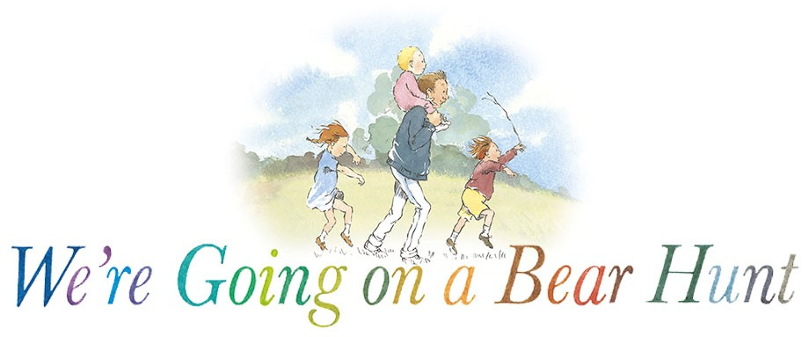

**Maths Through Stories**

* How many different characters are in the story? Who came 1st, 2nd, 3rd etc. in each part of the story?
* Can we find things that are longer, thicker, deeper and narrower?
* Let’s look at the weather in the pictures. Is it always the same?
* How many bears are in the story?
* Count your own bears and sort them into categories.

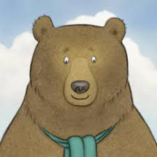

* Can we make an obstacle course to go under, over and through?
* Can you create your journey using a map or maze?
* What can we use to make patterns? Using objects, shapes and numbers to make patterns. Refer to story to see patterns in book.
* What would be the best clothes to wear in the snow storm?
* Are there any signs in the book? What would be a good sign to help the characters in the book? Left, right, to the cave etc. Why?

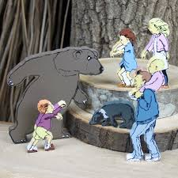

* Can you estimate and then measure objects using non-standard units and discuss/explain your choices?
* What was your favourite obstacle in the story? Why?
* Gather information to construct a pictogram then discuss information found out, e.g. most/least favourite ask your family what their favourite obstacle is too.