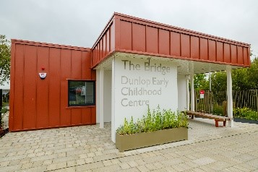


Establishment
Improvement
Plan
2026-27
Establishment:
Dunlop Early Childhood Centre

East Ayrshire Council
Education and Skills

School Improvement Plan | Dunlop Early Childhood Centre
Head Teacher/Head of Centre: | Laura Kelly
Date Submitted | Submitted to Chief Education Officer on: 25/06/26

School / Centre  Vision and Values | The centre’s motto is:  ‘Climb That Hill’  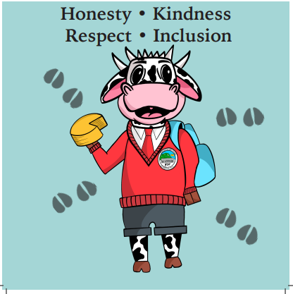  Following consultation, our Pupil Council engaged with pupils, parents, staff, and stakeholders to discuss our school values. It was agreed, the four most important values for the children and pupils of Dunlop Primary School & ECC are, for us to value:  Kindness Respect Honesty Inclusion  Dunlop ECC, which is known as “The Bridge” has been designed to ensure that children have full access to quality learning opportunities and experiences, both indoors and outdoors. The Bridge is also the Council’s first Passivhaus building, meaning the ECC has been built to a world-leading energy efficiency and thermal performance standard. The design will help the Council move towards achieving sustainability targets while providing a comfortable learning environment for our learners.  Within our centre, the whole staff team positively model our values to our children and parents/carers daily. This helps to ensure our new learning environment at “The Bridge”, is welcoming and nurturing for all.

Checklist

In line with the Standards in Scotland’s Schools etc. Act 2000 (amended 2016), the following checklist is designed to assist Heads of establishment with whole school/centre improvement planning that fulfils statutory duties in accordance with the Act. This must be completed prior to submission.

SIP Consultation included the following stakeholders: | Complete |  | Content of plan | Complete
Children and Young People |  |  | Takes account of strategic priorities outlined in the Education Service Improvement Plan. https://www.east-ayrshire.gov.uk/Resources/PDF/E/Education-Service-Improvement-Plan.pdf
Parent Council and Forum |  |  | HGIOS 4 and EYQF are used as the frameworks to inform the content of SIPs. Where appropriate.  https://education.gov.scot/media/v5sh3dqt/frwk2_hgios4.pdf  https://education.gov.scot/inspection-and-review/inspection-frameworks/quality-improvement-framework-for-the-early-learning-and-childcare-sectors/
Teachers, practitioners and ALL school/centre staff |  |  | There is clear focus throughout the plan on measures to reduce of inequalities of outcome as a result of socio-economic disadvantage.  PEF: https://www.gov.scot/publications/pupil-equity-funding-national-operational-guidance-2023/documents/  CEF: https://www.gov.scot/publications/care-experienced-children-young-people-fund-operational-guidance-2023-24/documents/  SEF: https://www.gov.scot/publications/strategic-equity-funding-national-operational-guidance-2023/documents/
Volunteers/ Community partners |  |  | Appropriate cognisance has been made of the links between the plan and the working time agreement for teaching staff.
Head Teacher Signature:   |  |  | An accessible summary of the SIP is available and contained in this document and will be provided to parents, children and young people.

Child and parental strategic involvement

For session 2026-27, please describe below how children and young people will be involved in decisions relating to the operation of the school/centre | For session 2026-27, please describe below how parents will be involved in decisions relating to the operation of the school/centre
- Consultation through mindmaps  - Voting systems  - Eco Committee  - Children’s Charter  - Online Learning Journals  - Responsive and spontaneous planning  - Daily helpers  - Daily communication  - Personalised Learning Targets | - Parent Council  - Stay and Play Sessions  - Parent/Carer Surveys  - Personal Plan Discussions  - Personalised Learning Targets  - Parent/carer workshops  - Transition profiles/meetings  - Daily communication  - Feedback on the ECC app

Community Plan East Ayrshire  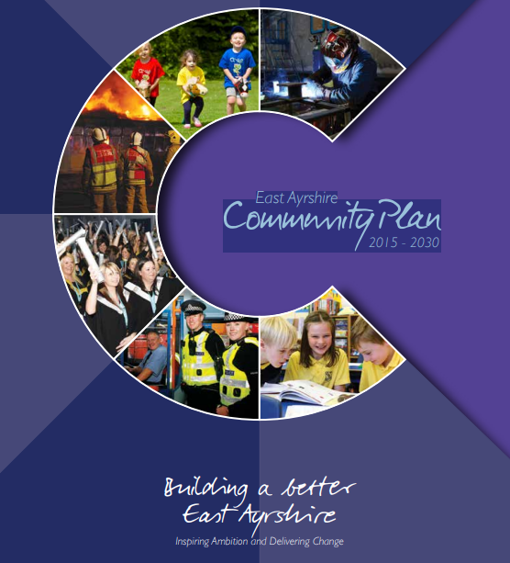  2015 - 2030 | Together, in achieving our Vision, Partners will demonstrate:  Effective leadership  We will provide clear leadership in Community Planning and engage effectively with our employees and communities  Collective ownership  We will take collective ownership for delivering on the Community Plan, the associated Single Outcome Agreement and the Community Plan Delivery Plans, and work hard to improve outcomes for local people and communities  Good governance  We will implement clear operating arrangements to support effective strategic direction, scrutiny and accountability  Democratic accountability  We will measure and report on the impact of our activities to demonstrate how effectively we are improving outcomes for local people and communities, and all partners will be held to account for their contribution.
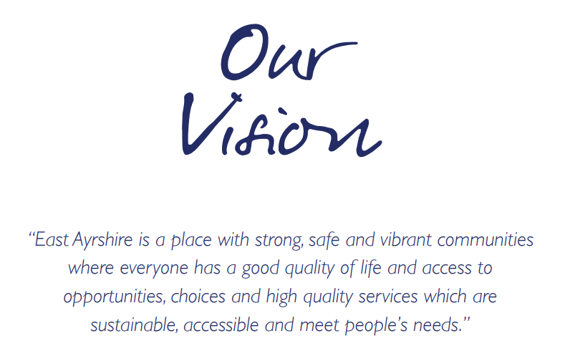  Our Partnership will continue to work to meet the needs of the people who live in our communities. Our guiding principles will be reflected in all that we do and should be evident for all to see. |  | We will:  - Promote lifelong learning.  - Promote equality and tackle inequality;  - Adopt a preventative approach;  - Ensure effective community engagement in the planning and delivery of local services;  - Utilise the strengths and resilience within communities;  - Drive efficiency and performance improvement;

National and Local Priorities
The Scottish Government’s vision for education in Scotland:  - Excellence through raising attainment and improving outcomes  - Achieving equity  Key priorities of the National Improvement Framework:  - Placing the human rights and needs of every child and young person at the centre of education  - Improvement in children and young people’s health and wellbeing  - Closing the attainment gap between the most and least disadvantaged children and young people  - Improvement in skills and sustained, positive  school-leaver destinations for all young people  - Improvement in attainment, particularly in literacy and numeracy | NIF drivers of improvement in the outcomes achieved by children and young people are:  - School and ELC leadership  - Teacher and practitioner professionalism  - Parent/carer involvement and engagement  - Curriculum and assessment  - School and ELC improvement  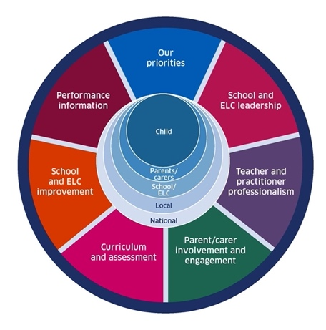  - Performance information | Scottish Attainment Challenge (SAC)  Scottish Attainment Challenge: framework for recovery and accelerating progress  Scottish Attainment Challenge Logic Model – Tackling the Poverty-Related Attainment Gap – Our Theory of Change  SAC organisers:  - Learning and teaching  - Leadership  - Families and communities

East Ayrshire Plans
Key Priorities | Education Service Improvement Plan: | Children’s Services Plan: | Community Learning and Development Plan:
1: Our Leadership | We actively support, promote and enact leadership at all levels. Our young people are supported to be leaders on their learning in our centres, schools and wider life experiences. All staff have ready access to appropriate CLPL and experiences to promote leadership in every classroom and centre. | Priorities for 2023-26:  - Our children and young people feel respected, listened to and influence change  - We are working collaboratively, reducing the impact of social and economic poverty on our children and young people  - Our children and young people feel safe  - Our children and young people have the best start in life  - Our children and young people’s mental health is improving | Outcomes:  - Growth  - Wellbeing  - Fairness  - Sustainability  Action areas  - Youth voice and participation  - Lifelong learning and skills development  - Empowering communities  - Wellbeing and inclusion
2: Teaching and Learning Together | Our young people should experience a teaching, learning and curriculum offer that meets their needs, and those of our local and national context. All staff should be supported to deliver in new and innovative ways by accessing CLPL relevant to their needs and those of our young people.
3: Our Wellbeing and Belonging | We want all of our young people to feel supported by people who know them well, and feel included in all of our schools and centres. Our staff need to be supported in their working with our young people, especially in times of adversity. As a key universal service, it is our vision that all young people attend our establishments on a full-time and regular basis to support them in their development at all stages.
4: Our Attainment, Destinations and Achievements | We want the very best for all of our young people in East Ayrshire. We aim to ensure all young people secure a positive destination through excellent achievement and attainment at all levels.

Our Leadership: Improvement priority: What is going to be the focus of this priority?
Rationale – Playroom monitoring processes highlighted inconsistencies in learning experiences across learning zones, a staff working party with a focus on “excellence” will be created to ensure we are providing a consistent high quality learning environment for our learners.
NIF key drivers: | Teacher & practitioner professionalism |  |  | School & ELC improvement |  |  |  | Select driver |  |  | Select driver
QIF ELC: | 1.1 Leadership and management of staff and resources |  | 1.3 Leadership of continous improvement |  | 2.1 Children experience high quality spaces |  |  | Select QI |  | Select QI |  |  | Select QI
ESIP key priorities: | Y Teaching & Learning |  |  |  |  |  |  | Y Our Wellbeing |  |  | Y Our attainment
Outcomes for our learners by June 2027 |  | Our actions/Approaches/Interventions |  |  |  | PEF | Who |  | Measures |  |  | Review/milestones
All staff will work together to continuously reflect on their practice to provide excellent learning opportunities for our learners. |  | Staff will meet monthly to review progress within each learning zone  The planning format will be altered to increase children’s voice  Peer and self-assessment will continue with a focus on resources used for high quality learning experiences |  |  |  |  | K Mitchell & P Marshall |  | Meeting minutes  Monitoring of the playroom and planning format  Increased level of engagement among learners  Decrease in areas of improvement within quality assurance |  |  | Monthly  August 2026  Termly
Learners will further develop their digital skills in a digitally rich environment while staff work towards achieving our digital schools award. |  | Staff will regularly complete the environment reference tool to identify areas for improvement  Staff will source CLPL to ensure they are able to provide current and relevant digital learning experiences |  |  |  |  | A McGowan |  | Digital self-evaluation  Increased level of understanding among learners  Being successful in achieving the digital schools award |  |  | Monthly  Throughout the year
Learners will continue our Eco journey by embedding a sustainable approach to their learning within the ECC. |  | Establish a new Eco Committee  Develop an Eco café  Refresh our Swap Shop items considering families views and interests |  |  |  |  | P Marshall & H Buchanan |  |  |  |  | September 2026  May 2027  October 2026
Teaching and Learning Together: Improvement priority: What is going to be the focus of this priority?
Rationale –The ECC tracking system has identified gaps in learning within social studies and has highlighted further support is required within numeracy and mathematics, the weekly planning check in with staff will ensure that these experiences are being covered within all learning zones.
NIF key drivers: | Curriculum & assessment |  |  | Performance information |  |  |  | Select driver |  |  | Select driver
QIF ELC: | 1.2 Staff skills, knowledge, values and deployment |  | 3.1 Playing, learning and developing |  | 3.2 Curriculum |  |  | Select QI |  | Select QI |  |  | Select QI
ESIP key priorities: | Y Our Leadership |  |  |  |  |  |  | Y Our Wellbeing |  |  | N Our attainment
Outcomes for our learners by June 2027 |  | Our actions/Approaches/Interventions |  |  |  | PEF | Who |  | Measures |  |  | Review/milestones
Staff will embed numeracy within all learning zones to increase the progress of pre-school learners by 10% |  | Apply to Maths Week Scotland for funding to purchase new resources  Create home learning bags  Numeracy focus within each learning zone |  |  |  |  | All staff |  | ECC tracking system  Professional judgement and daily observations  Strong progression across curricular areas |  |  | August 2026  Monthly  Daily
Learners will increase their knowledge and understanding of social studies through the introduction of intergenerational working within the local community |  | Begin to build partnerships with the elderly in the community  Social studies focus within each learning zone  Liaise with local community to participate in social events while learning from one another |  |  |  |  | A Wallace & P Marshall |  | Broader coverage of social studies within the curriculum  Increased sense of belonging |  |  | September 2026  Monthly  Termly
Learners will experience a sense of pride and achievement when showcasing parent contributions from home |  | Devise interactive parental workshops  Amend stay and play sessions to suit the needs and interests of new families  Collaborative working with other agencies such as Community Practitioner |  |  |  |  | K Mitchell & I Mack |  | Attendance and parental feedback  Increase in parental interactions and contributions on Learning Journals  Increase in parents sharing skills |  |  | Throughout the year  Monthly  Termly

Our Attainment, Destinations and Achievements: Improvement priority: What is going to be the focus of this priority?
Rationale – Recent staff feedback following CLPL sessions has identified a lack of awareness and understanding of the Curriculum Improvement Cycle, this will be a focus for the whole staff team for the year ahead.
NIF key drivers: | School & ELC leadership |  |  | School & ELC improvement |  |  |  | Select driver |  |  | Select driver
QIF ELC: | 4.3 Children's progress |  | 3.2 Curriculum |  | 3.3 Learning, teaching and assessment |  |  | Select QI |  | Select QI |  |  | Select QI
ESIP key priorities: | Y Our Leadership |  |  | Y Teaching & Learning |  |  |  | Y Our Wellbeing
Outcomes for our learners |  | Our actions/Approaches/Interventions |  |  |  | PEF | Who |  | Measures |  |  | Review/milestones
Learners will achieve improved outcomes while staff develop a better understanding of the Curriculum Improvement Cycle |  | Deliver relevant and high-quality learning experiences within all curricular areas  Collaborate with colleagues across East Ayrshire Council  Ongoing target groups for identified learners |  |  |  |  | K Mitchell |  | Staff CLPL  Working party  Quality assurance processes  Pace and challenge meetings |  |  | Ongoing throughout the year
All learners will participate in home learning through the introduction of family learning bags |  | Collated data will inform the focus of home learning  Learners will continue to choose a library book on a rota basis  Home learning will be showcased during digital group time |  |  |  |  | P Marshall & L Houston |  | Positive relationships  Sense of pride and achievement  Increased attention and listening skills  Family engagement |  |  | Monthly
Enterprise events will be organised in conjunction with pupils from Stewarton Academy to promote wider achievements |  | Learners will develop skills for life through woodwork, baking etc.  Learners will be meaningfully and actively involved in their learning  Increase collaborative working within Education group |  |  |  |  | H Buchanan & A McGowan |  | Broader coverage of the curriculum  Well attended events  Learners are well informed of possible future destinations  Coherent learning |  |  | Termly

Our Wellbeing and Belonging: Improvement priority: What is going to be the focus of this priority?
Rationale – Feedback from learners and parents/carers has identified an interest in developing links and building relationships with the wider community, therefore monthly visits will now be included in our yearly calendar of events.
NIF key drivers: | Parent/carer involvement & engagement |  |  | School & ELC leadership |  |  |  | Select driver |  |  | Select driver
QIF ELC: | 4.2 Wellbeing, inclusion and equality |  | 3.3 Learning, teaching and assessment |  | 4.1 Nurturing care and support |  |  | Select QI |  | Select QI |  |  | Select QI
ESIP key priorities: | Y Our Leadership |  |  | N Teaching & Learning |  |  |  | Y Our attainment
Outcomes for our learners by June 2027 |  | Our actions/Approaches/Interventions |  |  |  | PEF | Who |  | Measures |  |  | Review/milestones
Develop partnership working with Stewarton library to allow learners to learn about the wider community. |  | A small group of learners will attend Bookbug sessions at the library to develop confidence in literacy skills.  Learners will have the opportunity to experience train travel.  Learners will be able to play the role of “Safety Officer” |  |  |  |  | All staff |  | Increased progression within literacy skills.  Further understanding of the world of work.  Increased awareness of road safety |  |  | Monthly
Create connections with Kilmaurs ECC to share good practice and build wider relationships for our learners. |  | Reciprocal visits will be introduced with Kilmaurs as a follow up to our previous online Microsoft teams calls  Staff will have the opportunity to observe practices, share knowledge and improve collaboration |  |  |  |  | All staff |  | Observations  Learners will develop their confidence  Staff CLPL feedback forms |  |  | Monthly
Collaborate with Ayrshire360 to highlight the importance of wellbeing to our learners and families |  | Incorporate additional outdoor learning opportunities by promoting responsible use of our community areas  Enhance quality of life for learners and families through a holistic approach to wellbeing  Continue with daily emotional wellbeing check in  Continue to track the purposeful usage of the Calm Zone |  |  |  |  | N Taylor & I Mack |  | Self-evaluation using the Quality Improvement Framework  High level of engagement  Collated data will track individual learners |  |  | Termly  June 2027  Weekly  Weekly

Summary of Improvement Plan directly linking to Education Service Improvement Plan

Our Leadership | Teaching and Learning Together
- Learners will experience a high-quality learning environment where they are empowered to lead their own learning  - Digitally rich learning experiences will be available for learners to further develop their skills and knowledge  - The ECC will continue our Eco journey by embedding sustainability through the introduction of an Eco café and establishing a new Eco Committee. | - Home learning bags will be introduced to further develop numeracy skills while encouraging family engagement.  - The ECC will begin intergenerational working within the wider community to increase learners’ knowledge of social studies.  - Stay and Play sessions will be tailored to suit the needs and interests of new and returning families.
Our wellbeing and belonging | Our Attainment, Destinations and Achievements
- Partnership working with Stewarton library will begin where learners will participate in Bookbug sessions.  - Reciprocal visits with Kilmaurs ECC will be introduced to allow learners to build relationships with peers who they will attend school with at a later stage.  - Additional outdoor learning opportunities will be provided in conjunction with Ayrshire360. | - Learners will achieve improved outcomes while staff work towards the implementation of the Curriculum Improvement Cycle.  - Skills for life and work will be developed through a variety of enterprise events.  - Achievements will continue to be celebrated through online Learning Journals and achievement boars within the ECC.

