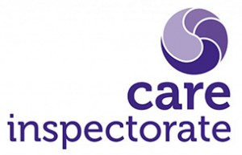

Dunlop ECC

Care Inspectorate

Duty of Candour Report

August 2022 – June 2023

Dear Parents/Carers,

The Care Inspectorate Duty of Candour came into effect on 1st April 2019 and it means that services must take specific steps to carry out their duty of candour when a serious adverse event happens.  Services will need to let the people affected know, offer to meet with them, and apologise.  This is an important part of being open with people who experience care, and also learning from things that go wrong.

As outlined by the Care Inspectorate, all health and social care services in Scotland have a duty of candour and an important part of this duty is that we provide an annual report about the duty of candour in our service.

This short report describes how Dunlop ECC has operated the duty of candour during the time August 2022 – June 2023.

**How many incidents happened to which the duty of candour applies?**

In the last year, there have been no incidents in Dunlop ECC to which the duty of candour has applied.

**Information about our policies and procedures**

Where something has happened that triggers the duty of candour, the ECC staff immediately report to myself, Depute Head Teacher in charge of the ECC, and I then report to the Head Teacher who has overall responsibility for ensuring that the duty of candour procedure is followed. The Head Teacher records the incident and reports as necessary to the Care Inspectorate. When an incident has happened, the Head Teacher and staff set up a learning review. This allows everyone involved to review what happened and identify changes for the future.

All new staff learn about the duty of candour at their induction.

We know that serious mistakes can be distressing for families who use our service as well as staff and we have arrangements in place to provide welfare support as necessary.

If you would like more information regarding this, please contact me via the school office

Kindest regards, Mrs Nouillan