CALENDAR ORDERS (can be ordered until Friday 27th November 2026)

I would like to order the following calendars:

Individual Calendar: .......... (amount) @ £2.50 per calendar Name: ..............................
Family Calendar: .......... (amount) @ £2.50 per calendar Family Name: ....................
Class Calendar: .......... (amount) @ £2.50 per calendar Class: ....................

Amount to be paid on Parent Pay: £…………………………. or
Amount to be paid in cash (included with order): £………………………….

Pupil’s name: ............................................................ Class: ....................

Parent’s/Carer’s signature …………………………………………………………………
----------------------------------------------------------------------------------------------------------------------------------------------
REINDEER FOOD ORDERS (can be ordered until Friday 27th November 2026)

I would like to order the following number of bags of reindeer food:
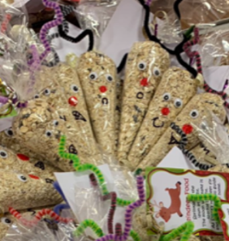
Number of bags of Reindeer Food @ £1:50 each: ………………

Amount to be paid on Parent Pay: £…………………………. or
Amount to be paid in cash (included with order): £………………………….

Pupil’s name: ............................................................ Class: ....................

Parent’s/Carer’s signature …………………………………………………………………
----------------------------------------------------------------------------------------------------------------------------------------------
SNOWMAN SOUP (Hot Chocolate Cones) (can be ordered until Friday 27th November 2026)

I would like to order the following number of Hot Chocolate Cones:

Number of Hot Chocolate Cones @ £1:50 each: ………………

Amount to be paid on Parent Pay: £…………………………. or
Amount to be paid in cash (included with order): £………………………….

Pupil’s name: ............................................................ Class: ....................

Parent’s/Carer’s signature …………………………………………………………………

