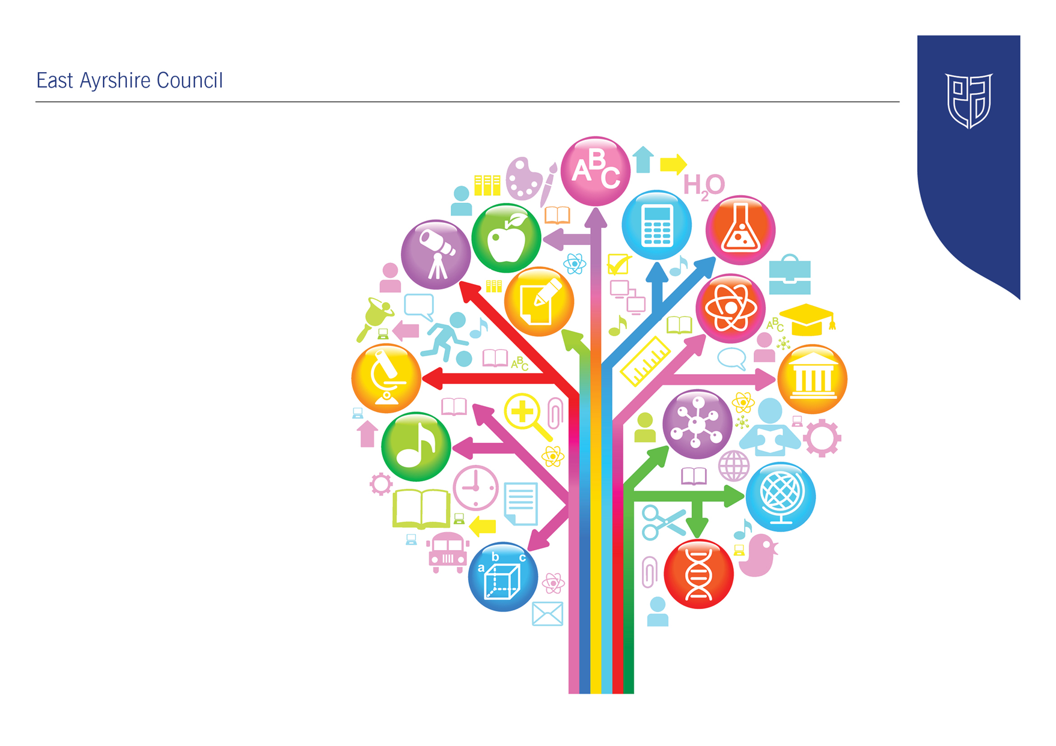
Standards and Quality Report
2025-26

Drongan ECC

Establishment Context
- Including the following:
- What makes the establishment unique; local context of the centre; progress in implementing priorities set out the centre improvement plan, taking into account national and local priorities; provide an evaluative summary of the quality of the work across a range of areas in the centre using quality indicators to support self-evaluation; highlight strengths and identify priorities for next year

Establishment Vision, Values and Aims


In Drongan Primary School and Early Childhood Centre our vision for all is:

To have a sense of belonging and pride in our local community where everyone is valued and we work together to be the best that we can be.

Within our school, ECC and local community, the shared values that we feel are important to instil in all are:

Teamwork, mutual respect, trust, inclusion, self-belief and resilience (ECC will focus on the values in bold)

Improvement Priority  (Expressed as outcomes for learners)  The new quality improvement framework will be officially launched in September 2025 and will be used as part of all scrutiny activity. | Improvement Priority (Expressed as outcomes for learners)  To improve monitoring and self-evaluation processes across the centre.  By June 2026, all children will experience high quality interactions, spaces and experiences almost all of the time.  By June 2026 all children will have made progress in their learning as a result of accessing a service, where quality assurance and improvement are led well. | Education Service Improvement Plan 1: Our Leadership  We actively support, promote and enact leadership at all levels. Our young people are supported to be leaders of their learning in our centres, schools and wider life experiences. All staff have ready access to appropriate CLPL and experiences to promote leadership in every classroom, playroom and centre.
Our Leadership
Progress and Impact | - A training session was planned in September 2025 by Depute Manager to introduce to all staff the quality improvement framework. This allowed staff to see and make it familiar to themselves about what inspections will now look like whether it is Care Inspectorate only inspection or a joint inspection with HMIe. Staff were guided through the document, and it was highlighted to them that the indicators have been removed but we matched them accordingly to an indicator. Staff were able to see what a very good illustration would look like but also a weak illustration.  - Self-evaluation using the QIF is very much part of our quality improvement calendar and evidence is documented on what indicators we have covered as an establishment. Currently we have been working on two indicators and really stripping back what is telling us and how we are tailoring our practice around the illustrations. Recent Care Inspection in February 2026 acknowledged we were using the document and had made a good start to evaluating the service using it. Almost all actions have been progressed, and we are making further actions if required.  - Our monitoring calendar was agreed by staff and is now fully implemented. We have looked at what areas of the service required to be monitored, and this is where our QIF journey started.  - Feedback from audits and monitoring was discussed with all staff and where gaps or improvements were required all staff took these on board to ensure we were learning and improving.  - Staff worked together in small groups to answer discussion questions and made a consecutive effort to fully evaluate and be honest when doing so. This was able to give us a true reflection on where we were in regard to develop the service.  - All children have achieved a minimum of 3 next steps in Term1 and Term 2. This is evident from learning journal data and celebration of children’s achievements  - 3 children have not met their agreed targets in Term 3 due to absence. However, all children form Term 1 and 2 continued to meet their 3 agreed learning targets.  - From self-evaluation of the QIF it is evident that children’s rights are dominant in the document. From familiarising the document with staff it is evident that the UNCRC is not at the forefront of our daily practice.
Next Steps | - We will now rate our illustrations (6,5,4,3)  - We will continue to work throughout the document and evaluate our practice and protocols in place.  - We will continue to track and monitor children achieving their learning targets.  - We will monitor children’s attendance and support parents/carers where possible. This will be in line with the Health Visitors.  - We will begin our journey in achieving our RRSA bronze award.

Improvement Priority  (Expressed as outcomes for learners) | Improvement Priority (Expressed as outcomes for learners)  To ensure that every child achieves the highest possible standards in literacy.  By June 2026 all children transitioning to school will secure very good progress across the identified milestones and almost all (40 of 51) children will make good progress in their literacy development.  This will be measured using the plus function on Learning Journals to track. | Education Service Improvement Plan Priority 2: Teaching and Learning Together  Our young people should experience a teaching, learning and curriculum offer that meets their needs, and those of our local and national context. All staff should be supported to deliver in new and innovative ways by accessing CLPL relevant to their needs and those of our young people.
Teaching and Learning Together
Progress and Impact | - As a staff team we discussed that through monitoring from planning that there were gaps in children meeting their literacy milestones.  - As a staff team we agreed on eight milestones from the EAC monitoring and tracking tool. This was done through a series of team meetings to ensure we were capturing the different levels of each child.  - We ensured that when doing planning we had a real focus on literacy and how we were incorporating the identified milestones into the daily planning. Staff were able to ensure their key children’s targets were age and stage appropriate.  - When completing observations on Learning Journals staff were able to link the observation to the necessary milestones which we then were able to see progression across literacy.  - Prior to this management scrutinised the pre-schoolers literacy data which was evident that there were gaps in literacy. This then drove us to improve the literacy focus across the planning and targeted intervention.  - Targeted support groups were created to support the children who were at risk of not attaining. This allowed a key member of staff to work closely with these children to focus solely on the identified milestones. This member of staff tracked their progress and documented observations to show progress.  - Term 1 we saw little impact as we were starting the work to progress in literacy.  - Term 2 we saw evident progress in children achieving their milestones. 55% of children were achieving the milestones  - Term 3 we had an 87% total of children who have achieved the identified milestones.  - We have not reached all children meeting the identified milestones, but this is due to inconsistent attendance.  - Through tracking all children were rated amber and or green to show progression and achievement. This allowed staff and management to see any further gaps in learning and how we can tailor our planning to have a focus on gaps.  - All learning and progress reports were shared with Primary 1 teachers and a transfer of their learning journal to show where each child is at in their learning journey. Discussions were made around if the child was on track and this supported the Primary 1 teacher in starting to plan their groups.  - Throughout the academic session staff planned 3 stay and play sessions with a focus on providing fun, stimulating literacy experiences for children and their parents/carers. Feedback from parents was positive and they reported that it’s good to see how we provide experiences for the children in a fun way to capture their interest.  - After Progress Reports were completed by key workers, audits concluded that all children achieved very good across their literacy.
Next Steps | - Since there was a real focus on literacy, we have not had a balance of numeracy to literacy. Throughout our literacy we supported children through speech, language and communication also which supported children in meeting their milestones.

Improvement Priority  (Expressed as outcomes for learners) | Improvement Priority  (Expressed as outcomes for learners)  To promote and embed the establishment values | Education Service Improvement Plan Priority 3: Our Wellbeing and Belonging  We want all of our young people to feel supported by people who know them well, and feel included in all of our schools and centres. Our staff need to be supported in their working with our young people, especially in times of adversity. As a key universal service, it is our vision that all young people attend our establishments on a full-time and regular basis to support them in their development at all stages.
Our Wellbeing and Belonging
Progress and Impact | - Through team meetings we looked at the values as a staff team. We discussed how it looked to us as a staff team, how we are going to promote and what does it look like for children.  - We focussed on the values of Teamwork, Inclusion and Resilience.  - Teamwork now demonstrates that all children know what staff members are in each zone. Children know when they are participating in play and learning experiences that staff members are there to facilitate and support the learning taking place. Staff now actively speak about teamwork. Evidence from playroom monitoring demonstrates that staff are making a clear effort to encourage children to work together and have demonstrated positive interactions with children. Children are now high fiving their peers to demonstrate they are working together and are showing a real pride in themselves and their peers.  - We have had a real focus on inclusion. Evidence from asn audits show that we have a high level of asn and playroom monitoring has showed that these children are not responding well to the environment. Work alongside outer agencies supported the drive to change the environment and create a safe place for them to have a soft start/finish and regulation throughout the session.  - A safe place was created for children who were identified with complex needs and now receive a place for a soft start/finish and for regulation throughout the session. From our recent care inspectorate inspection, they spoke highly of the inclusion and how we were best meeting the needs of the learners.  - Resilience – throughout literacy we have supported and challenged children throughout the terms. Evidence from learning journals detailed what milestones were being covered and the gaps and progression in learning. We set up targeted support groups which pinpointed children at risk of attaining or children who required challenged. Challenge groups were created in term 3 as this was where we saw an increase on children meeting their milestones.
Next Steps | - As an acting head teacher has been appointed, we will now look at the reinvigorating the whole centre vision, values and aims. This will be done as a full staff team through various team meetings throughout term 1.

Improvement Priority  (Expressed as outcomes for learners) | Improvement Priority  (Expressed as outcomes for learners)  To improve the quality of the learning environment for all children. | Education Service Improvement Plan Priority 4: Our Attainment, Destinations and Achievements  We want the very best for all of our young people in East Ayrshire. We aim to ensure that all young people secure a positive destination through excellent achievement and attainment at all levels.
Our Attainment, Destinations and Achievements
Progress and Impact | - It was evident from academic session 2024-25 that Drongan ECC have a high volume of neurodiverse children. From room monitoring it is evident that children were finding it difficult to reach their full potential within the playroom set up. Observations from Educational Psychologist and speech and language team have highlighted that some children would benefit from a different set up to ensure they were reaching their full potential.  - In term 1 we worked very closely with Educational Psychologist and SALT to create a smaller more inclusive environment to support the children’s needs. We identified a play and learning space within the playroom and set it up with age and stage appropriate resources. We created visuals to support transitions for children and now and next boards.  - All staff attended training from Educational Psychologist and SALT to further develop their knowledge of autism and SCERTS.  - A member of staff was identified to carry the inclusion group forward. A support assistant was designated to the area to support the key worker to meet the needs of the children.  - Team with the Family meetings were set up to speak about the inclusion group for identified children. Extremely positive feedback from parents welcomed the initiative. One parent ran an ultra-marathon in support to raise funds for the inclusion group. A total of £1000 was raised in support to furnish the area identified.  - A new planning system was created which supports milestones from the complex needs tracker and being me. Monthly planning was created where we discussed each child and planned based on their needs. This was then incorporated into the play and learning experiences. Monthly observations were written in detail highlighting the progression of each child. Evidence documented through milestones that children were achieving and playroom monitoring and planning monitoring backed this evidence.  - Termly TWF meetings took place to discuss children’s development.  - Parents were invited into the setting to see the provision set up and also for them to stay and play during their session. Feedback from this was positive. Parents were able to take away ideas and see what resources suited their child’s needs for their age and stage.
Next Steps | - This provision will continue.  - A new cohort of children will be identified  - A new staff member will be appointed to take on the leading role due to current staff member going off on maternity leave.  - Further input from Educational Psychologist to improve the set up.

Care Inspectorate Inspection (Reports aligning to QIF only)

Date:

QUALITY THEME | GRADE | KEY STRENGTHS | REQUIREMENTS or RECOMMENDATIONS | IMPROVEMENT ACTION
Leadership | 5 |  | N/A
Children Thrive and Develop in Quality Spaces | 5 |  | N/A
Children Play and Learn | 5 |  | N/A
Children are Supported to Achieve | 5 |  | N/A

Establishment Capacity for Improvement
We will continue to improve on the above priorities
Develop the ASN inclusion group.
Support children’s speech, language and communication through QI.
Work alongside the school to develop the Vision, Values and Aims.
Have a focus on raising attainment through numeracy.

