
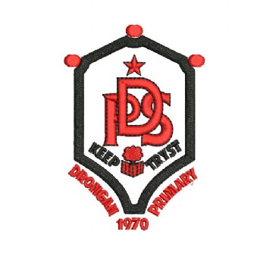
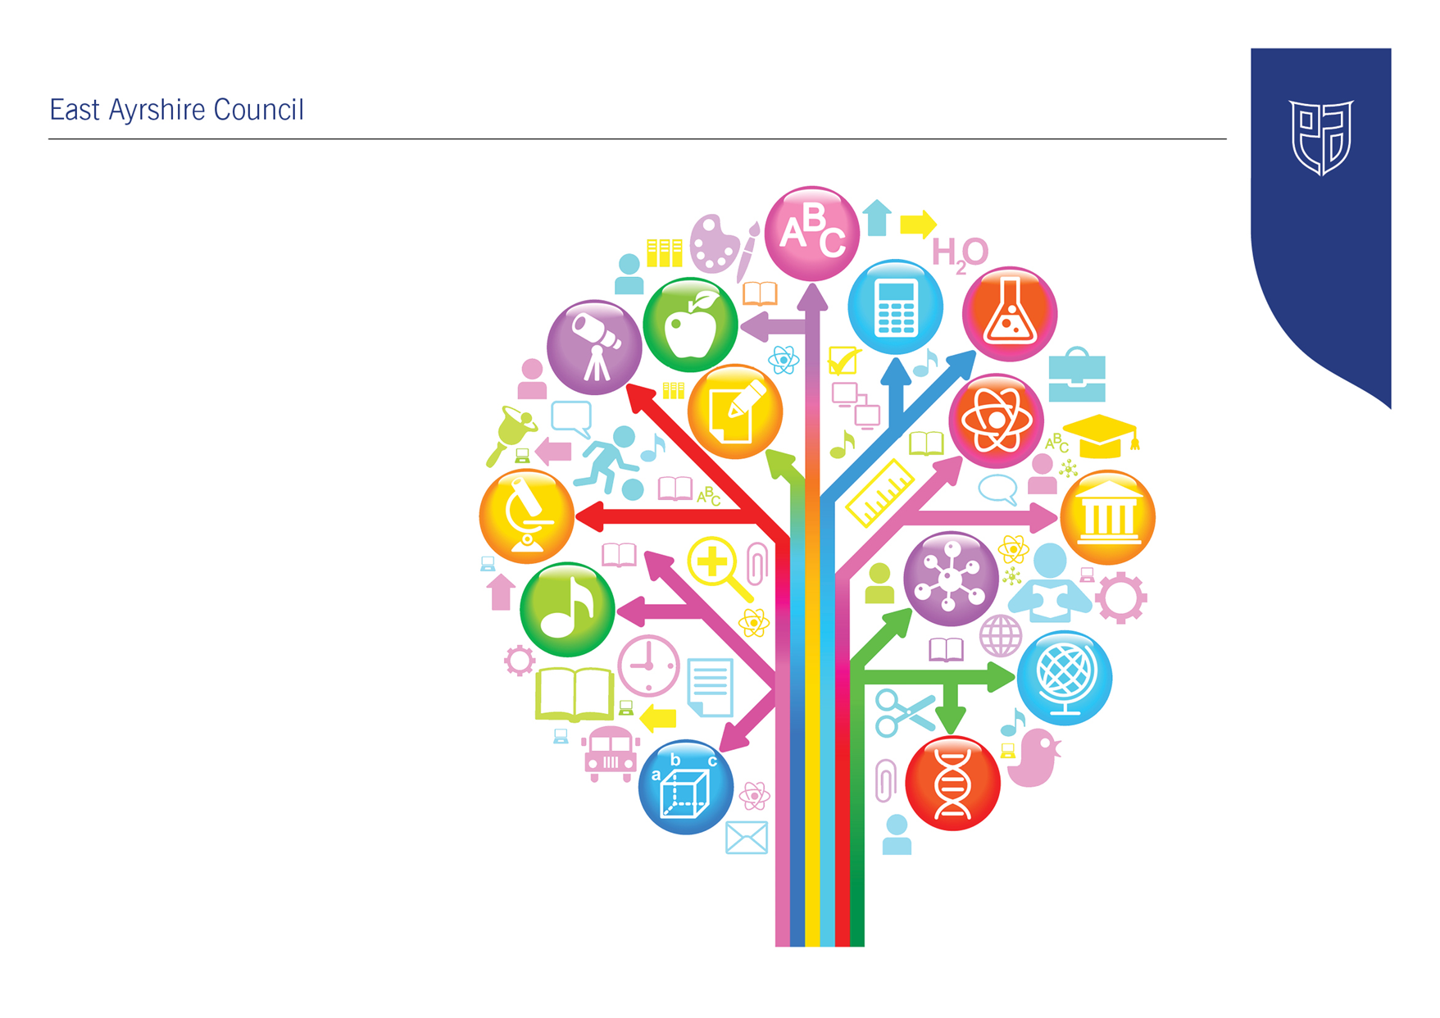
Standards and Quality Report
2025 - 2026

Drongan Primary School
Establishment Context
Drongan Primary School and Early Childhood Centre is a non-denominational school, currently in the Barony Education Group. The village of Drongan (originally known as Taiglum) is a former mining village on the western edge of Ayrshire and is situated between Cumnock and Ayr, roughly 8 miles from both towns. In 1946, it was proposed that Drongan should be developed as a ‘new town’ and families from various small mining communities were also re-housed in Drongan. Drongan was a thriving and prosperous place when the Killoch and Barony pit mines were operational; however, was hit hard during the demise of the mining industry. In the most recent census in 2022 Drongan had a population of 3020 people.

We have a current role of 247 and within the ECC the maximum capacity is 64. We also have a 2-year-old provision.
Based on our current school roll our SIMD data indicates that 40% of our pupils are within SIMD 1 and 2. 42% of our children are entitled to free school meals. We consistently recorded an attendance percentage ranging from 93 – 94%. Unfortunately, following the pandemic, this dropped to 92% in session 2021-22, 90% in session 2022-23, and then increased to 93% in session 2024-25. For session 2025-26, the current attendance to date is sitting at 92.4%
There has also been an improving trend with a significant reduction in exclusions. Since 2019 there has only been one exclusion. 21% of our children are currently on the Additional Support Needs log and supported by EAST and Classroom Assistant support staff.

Local Context
In East Ayrshire’s Southern Locality Profile, which Drongan is included, it discusses how East Ayrshire is considered an idyllic setting. However, the rural environment has led to challenges for some local populations in relation to access to services / amenities, transport links and employment opportunities. This has led to socio-economic and health deprivation for some residents and has influenced outward migration of working age individuals from the area. It is projected that there will be a significant rise in older people living in the southern locality of East Ayrshire. There are currently one in five (20%) people in this area who are aged over 65. Around 27% of people live in a deprived neighbourhood with 20% of children living in poverty. The level of both overall and youth unemployment is higher than the East Ayrshire average. Of those not in work, one in five is long-term sick or disabled. 85% of secondary school leavers in the Southern locality achieved SCQF Level 4 in Literacy and Numeracy, with 55% achieving SCQF Level 5 in Literacy and Numeracy. This has risen by roughly 7% over the last three years. 93% of school leavers are in positive destinations including college, university, training or work. Over half of the people in this area work in health and social work, retail, construction or manufacturing.
There are significant challenging trends relating to health and wellbeing in the Southern Locality. One in ten (9%) of Primary 1 children are overweight or obese and 37% of children in Primary 1 have tooth decay. There is a higher level of teenage pregnancies compared with the East Ayrshire average. One in three (35%) of Southern Locality residents have a long-term health condition and the rate of alcohol and drug related hospital stays is higher than the East Ayrshire average. 22% of residents are prescribed drugs for anxiety, depression or psychosis.
The Southern Locality Profile highlights that many people in this area do not live in a home that is warm, dry, secure and affordable. There is a high crime rate, which suggests an unsafe community, having a negative effect on the quality of life and personal safety. It also highlights that the health of young people could be improved by reducing smoking and alcohol use in pregnancy, promoting healthy diets and physical activity, and by offering more support to families in need with housing, finance, safety, parenting and social isolation. There is a higher percentage of people living in bad or very bad health compared with the East Ayrshire average.
Overall, The Southern Locality Profile shows that this area came out significantly worse than the East Ayrshire average in 8 out of 15 indicators, while East Ayrshire as an authority came out as worse in 10 areas compared with the Scottish average.

In Drongan Primary School and ECC we have worked hard to develop a positive and aspirational culture that challenges these assumptions as well as some of the protected values and beliefs that exist in the community. Through the promotion of our revised aspirational vision, all stakeholders are encouraged to be the best we can be and take a pride in our local community. We encourage children to lead a healthy lifestyle by promoting the wellbeing indicators and we have achieved gold accreditation as a Rights Respecting School. We include all children in learning and encourage all children to work hard to achieve their full potential. It is the responsibility of every adult who contributes to the lives of our young people here at Drongan, to reinforce the message that regardless of the challenges that they may face, all children can achieve their full potential and live a healthy, happy and successful life where they demonstrate the shared values that have been instilled in them. Drongan Primary has been accredited with gold standard for inclusive practice.

Drongan Primary School and Early Childhood Centre has been on a significant journey in recent years. In April 2018 the establishment was inspected by HMIE. Although some strengths were highlighted, there were significant improvement priorities identified.

In September 2019 HMIE carried out a follow-up visit and stated that the school is making good progress in taking forward the improvement priorities detailed above. A review and report on progress was scheduled to take place in May 2020 but unfortunately due to the school closure this did not take place. Instead, a further HMIE Inspection took place in November 2021. This was a very positive inspection leading to the establishment being officially signed off from Education Scotland Engagement. You can read the report issued by HMIE by clicking on link below:
https://education.gov.scot/education-scotland/inspection-reports/reports-page//?id=2380

In August 2021 the school and ECC moved away from the improvement priorities outlined by Education Scotland following the improvements that had taken place. You can see the improvement priorities for session 2025-26 in the School Improvement Plan for the current session.

The school had a local authority inspection / learning visit in March 2024. This was a very worthwhile visit and the feedback that was received was extremely positive, with many strengths being highlighted. Information regarding the feedback received was shared on the school app.

We look forward to continuing our journey to excellence by promoting a culture of improvement and change, underpinned by our shared vision, values and aims and our curriculum rationale.

Further information about the school can be found on our website:
https://blogs.glowscotland.org.uk/ea/dronganpsecc2016/

Establishment Vision, Values and Aims
In session 2018 -19 we undertook an initial consultation with all stakeholders when we reviewed and agreed our shared vision for our establishment. This vision is underpinned by agreed values and aims, which were created following a detailed consultation process.
This vision and values have been reviewed regularly since and agreed that they were still relevant. In session 2026-27, we will be undertaking a full consultation on the Vision, Values and Aims, ensuring they meet the needs, expectations and aspirations of our current cohort of pupils, staff and partners within the Drongan Community.

Vision

In Drongan Primary School and Early Childhood Centre our vision for all is:
To have a sense of belonging and pride in our local community where everyone is valued and we work together to be the best that we can be.

Values

Within our school, ECC and local community, the values that we feel are important to instil in all are:

Teamwork – by working together with those around us in a supportive culture

Mutual respect – where everyone feels valued, is treated fairly and is communicated with in an effective and appropriate way

Trust – through demonstrating honesty and integrity in all situations

Inclusion – where everyone feels included in their learning and in the life of the school and all staff works as part of a team

Self-belief – where children are provided with opportunities to develop confidence and are encouraged by all adults that they can achieve

Resilience – where children are encouraged to never give up and that they can do it

Aims

In Drongan Primary School and Early Childhood Centre our aim is to develop the four capacities outlined in Curriculum for Excellence in all of our pupils to prepare them for future life.
We will encourage our children to be:

Confident individuals by promoting self-worth, ambition and resilience

Responsible citizens by promoting diversity, communication skills and confidence

Effective contributors by promoting community spirit, enjoyment and participation

Successful learners by promoting skills development, challenge and engagement in learning

Improvement Priority  (Expressed as outcomes for learners) | Improvement Priority (Expressed as outcomes for learners)  Provide increased opportunities for pupils and staff members to have a meaningful voice and contribute to the change and improvement process. | Education Service Improvement Plan 1: Our Leadership  We actively support, promote and enact leadership at all levels. Our young people are supported to be leaders of their learning in our centres, schools and wider life experiences. All staff have ready access to appropriate CLPL and experiences to promote leadership in every classroom, playroom and centre.
Our Leadership
Progress and Impact | PRD Processes  As part of their PRD process, all teaching and promoted staff members engaged with relevant GTCS standards. This was a valuable self-evaluation activity where staff members were provided with the opportunity to reflect on the standards, highlighting strengths and identifying areas for development. This allowed for appropriate targets to be set in line with personal targets and school improvement priorities. As a result, it has seen staff at all levels playing an active role in leading and supporting change across the school.  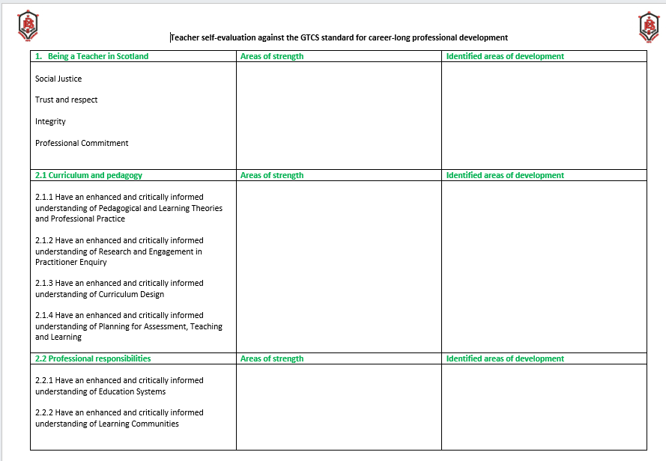  Leader of Learning Programme  In its third year, the Leaders of Learning programme continues to strengthen consistency and practice across the school. This session’s focus on learning intentions and success criteria has led to a shared understanding and consistent use of language in all classes, helping pupils to better understand what they are learning and what success looks like.  The module on meeting learners’ needs, alongside engaging and motivating learners, has supported staff in adapting their approaches to better support all pupils. There has been an increased use of digital tools to enhance learning, more flexible groupings to respond to pupils’ needs, and a stronger focus on creating inclusive, communication-friendly classrooms. This has helped ensure that learners feel supported, can access learning more easily, and are more confident in sharing their ideas.  Together, these developments are contributing to more confident teaching approaches, improved clarity for learners, and a more consistent approach across the school.  Committee Groups and Home-Circles  Over the course of this session, pupils and staff members have had increased opportunities to have a meaningful voice and contribute to the change and improvement process. All staff have been allocated to a committee and have collaborated with pupils to make progress towards school improvement priorities. The committees have made strong progress in supporting school improvement priorities. Meetings have taken place regularly, with opportunities for all members to contribute. Pupils have demonstrated increasing confidence in sharing their views, taking ownership of discussion points, and following through on agreed actions.  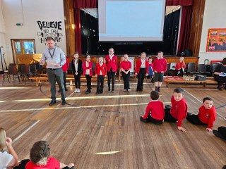  Key areas of progress include:  - Identifying priorities through pupil voice activities (e.g. surveys, class feedback)  - Working collaboratively with staff to develop and implement improvements  - Monitoring changes and gathering feedback to evaluate impact  Pupils have taken on a variety of meaningful roles, including:  - Representatives: Gathering views from their peers and accurately feeding these into meetings.  - School leads: Taking responsibility for specific initiatives (e.g. school garden, organising litter picks, raising awareness of school issues).  - Presenters: Children have shared initiatives with peers and the community through committee videos, blog updates and school assemblies.  Through these roles, pupils have:  - Developed leadership, communication, and teamwork skills.  - Demonstrated responsibility and commitment to improving their school environment.  - Actively contributed ideas that reflect the needs and interests of the whole school.  The work of the committees has had a positive and noticeable impact across the school. This includes:  1. Improved School Environment  Pupil suggestions have led to practical changes (no school bell, increased resources, a school garden), making the school a more inclusive and enjoyable place for all. At the end of the session, we issued a survey to all children contributing to a committee. Evaluating the Impact of Pupil Committees – Results  All pupils involved in committees (100%) agreed that their work has helped to improve the school. This exceeds our improvement plan target to increase by 5 percentage points the number of pupils who feel they play an important role in school life, from 86% to 91%.  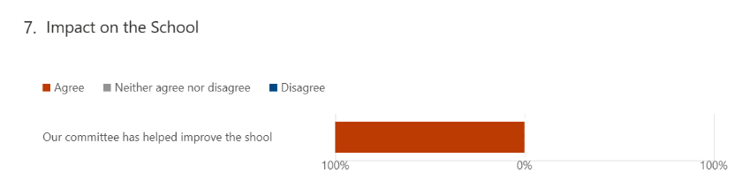  However, overall data shows that only 80% of pupils feel they play an important part in the life of the school, highlighting a gap between those who are involved in committees and those who are not. To address this, next session we will introduce Class Committees to ensure all pupils have regular opportunities to contribute. This will strengthen pupil voice, support greater inclusion, and increase engagement in school improvement across the whole school.  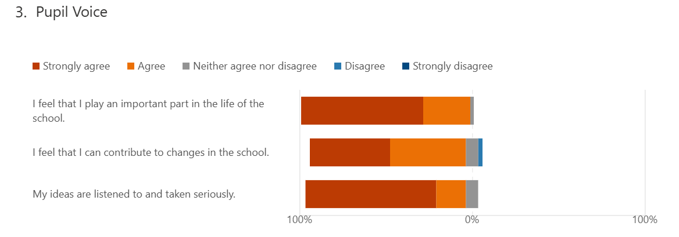  2. Enhanced Pupil Voice  There is a stronger culture of listening to pupils. Learners feel that their opinions are valued and can lead to real change, increasing engagement and confidence.  3. Greater Sense of Belonging  By being involved in decision-making, pupils feel more connected to the school community and take pride in their environment.  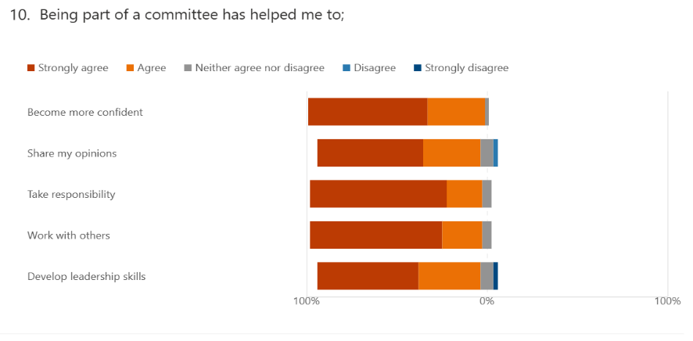  4. Wider Skill Development  Pupils participating in the committee have developed:  - Leadership skills  - Problem-solving abilities  - Communication and teamwork  These skills are transferable across their learning and wider life.  The committees are making a meaningful contribution to school improvement by ensuring that pupil voice is central to decision-making. As a result:  - Changes reflect the needs of pupils  - Pupils feel empowered, respected, and involved.  This has led to a more inclusive, responsive, and positive experience for all learners.  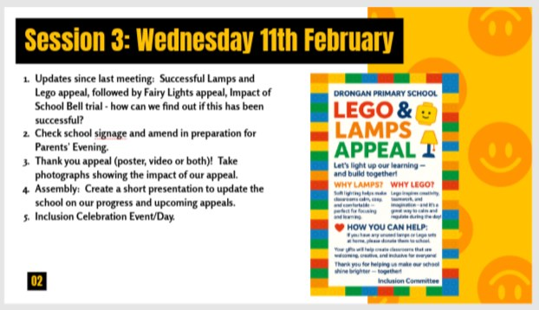  Committee Groups  Inclusion Committee  The Inclusion Committee have played a highly effective role in driving school improvement, with clear impact on both the wider school community and the children involved. The committee has successfully communicated their work through a range of methods, including app and blog updates, social media, assemblies, videos and posters, ensuring that pupils, staff, parents and the local community are well informed and engaged.  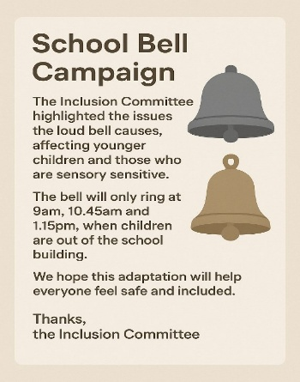  This has supported successful campaigns such as the donation of lamps, Lego and fairy lights, which have directly enhanced classroom environments for all learners. The Inclusion Committee has led meaningful change by evaluating previous improvements, creating action plans, and implementing initiatives such as improved school signage and an updated inclusion display, making the school more accessible and welcoming for all. Their school bell campaign, including surveys and direct communication with the Head Teacher, resulted in the removal of the bell, with evaluations showing a calmer, more inclusive environment across classes. In addition, Inclusion Week increased awareness and understanding of the needs of others across the school.  https://blogs.glowscotland.org.uk/ea/dronganpsecc2016/2026/05/12/inclusion-week/  The link below details the journey the Inclusion Committee has been on this session.  https://sway.cloud.microsoft/GUirUrQFg3sN4JyL?ref=Link&loc=play  Pupil Council  The Pupil Council has had a meaningful and positive impact on both the school community and the pupils involved, through a range of engaging and purposeful activities. Events such as World Book Day, including the Masked Reader, book swap, free book initiatives, competitions and in-class literacy activities, successfully increased learner engagement and enjoyment in reading. These activities raised the profile of literacy across the school, encouraged creativity, and fostered a genuine love of reading among pupils.  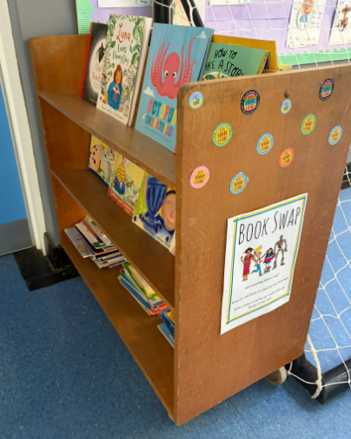  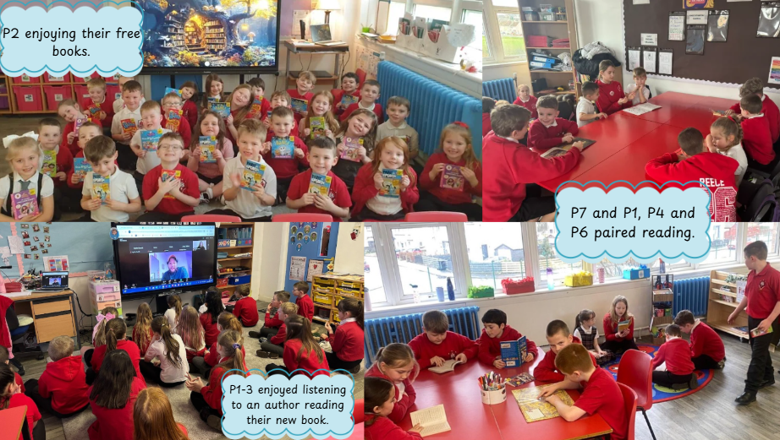  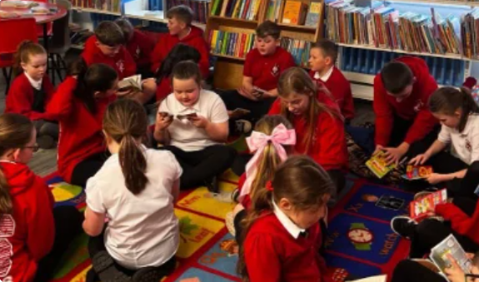  The ongoing book-swap has further supported this by promoting sustainability and encouraging children to explore new genres and authors, helping them develop their own reading interests while reducing waste.  The Pupil Council has also strengthened community links through initiatives such as their visit to Rowantree Court during Global Intergenerational Week, where pupils built positive relationships with residents through shared activities and conversation, highlighting the value of connection and collaboration across generations.  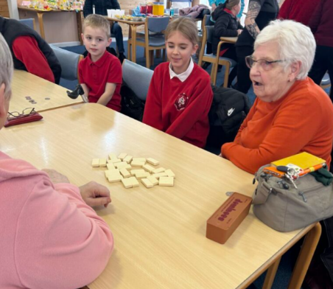  In addition, their work on the school time capsule has encouraged pupils to reflect on change over time, engage with staff and the wider community, and preserve meaningful aspects of school and local life.  For the pupils involved, these experiences have significantly enhanced their confidence, leadership, and sense of responsibility. They have taken ownership of initiatives, demonstrated strong teamwork, and developed skills in communication, organisation and decision-making. Members of the Pupil Council feel proud of their contributions and recognise the real impact they have had on the school and wider community. Overall, the Pupil Council has played a vital role in promoting pupil voice, enriching learning experiences, and supporting the development of confident, responsible and engaged learners.  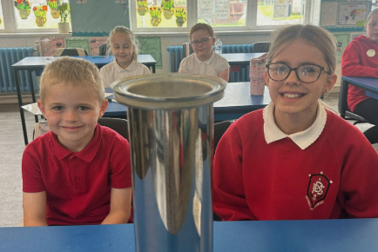  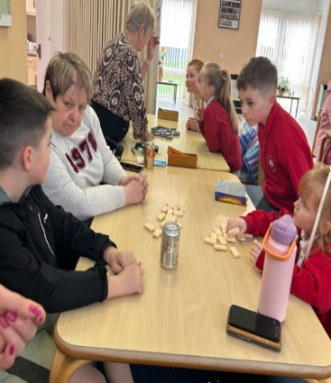  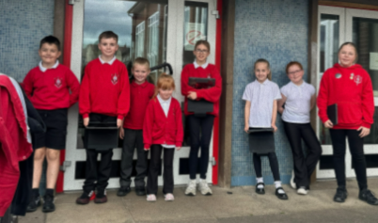  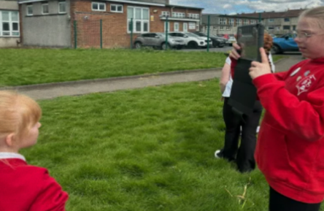  Digital Technologies  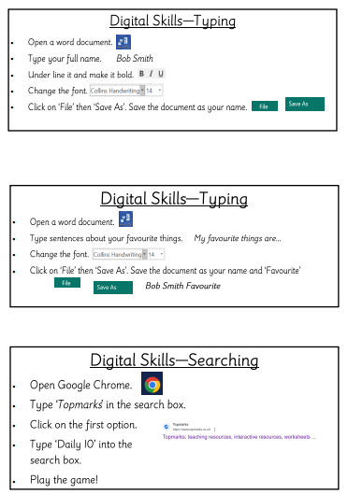  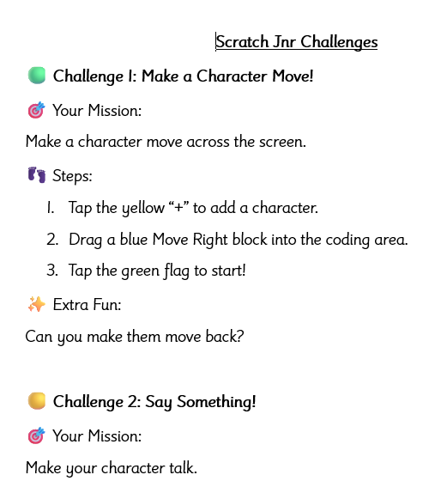  Pupil involvement and voice was central to the work of Digital Committee. Pupils played an active role in shaping school improvement by contributing ideas, sharing progress, and communicating updates with the wider school community through assemblies, displays, and digital platforms. Their input was instrumental in the creation of a Digital Skills Progression Planner, ensuring that learning reflected pupil needs and interests while supporting consistent, whole school development of key skills.  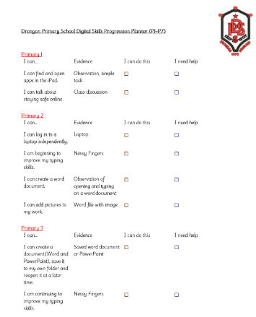  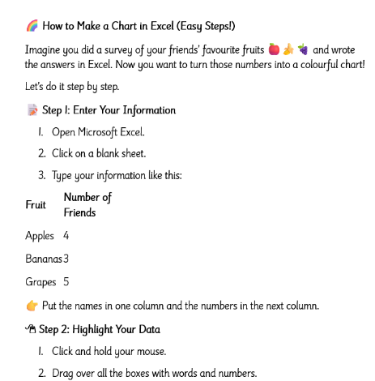  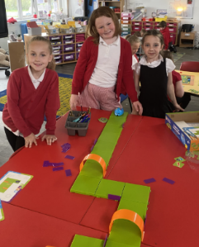  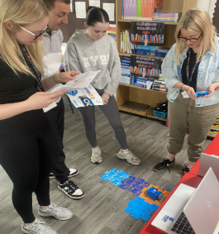  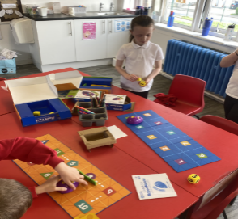  During initiatives such as STEM Week, pupils engaged with new technologies and provided feedback on their learning experiences, further influencing planning and resource use.  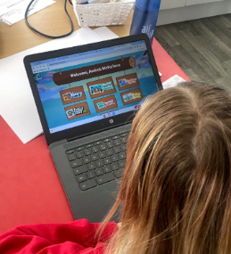  The introduction of new digital tools and software, including robotics resources and programmes such as Nessy, ClickView, and Minecraft Education, reflects both pupil voice and committee-led priorities.  As a result, pupils feel valued, heard, and proud of their contributions, demonstrating increased engagement, confidence, and ownership of their learning while developing important digital, communication, and teamwork skills.  Outdoor Committee  The Outdoor Committee has made a strong and positive contribution to school improvement during session 2025/26 through their ongoing work to develop and enhance the school garden and outdoor spaces. Building on progress from previous sessions, committee members actively engaged with local businesses and garden centres by writing letters to request support, resulting in generous donations of compost, seeds and gardening equipment from local supermarkets. The children have taken a hands-on approach to planning and developing the garden, carefully considering layout, growing conditions and suitability of plants. They worked collaboratively to weed, prepare beds in both the outdoor area and polytunnel, and plant a wide range of vegetables, fruit and herbs, many of which can be used in the school kitchen or taken home by staff and pupils.  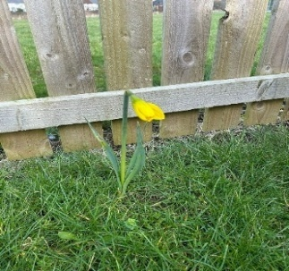  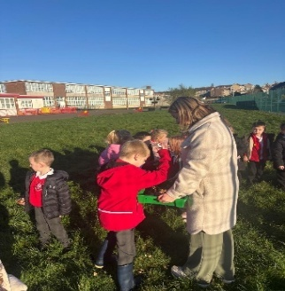  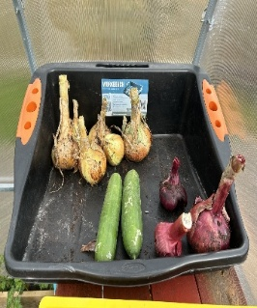  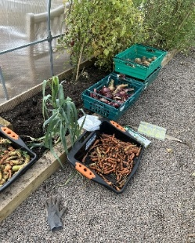  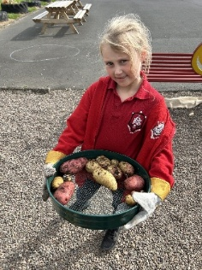  In addition, the planting of daffodils and other bulbs has enhanced the appearance of the grounds while supporting biodiversity and pollination.  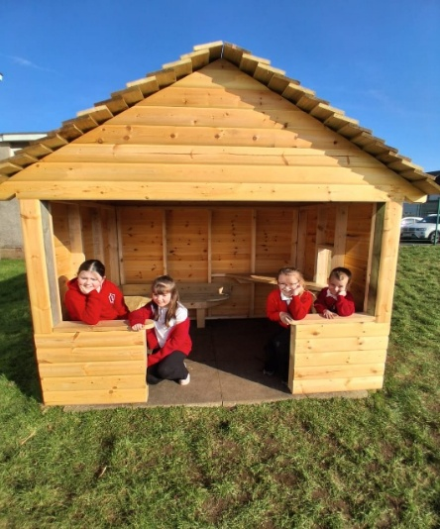  The committee has also supported pupil wellbeing through improvements to outdoor spaces, including the introduction of an inclusion hut in the infant playground, providing a safe and calming area for emotional regulation, and picnic benches in the upper playground to encourage positive social interaction.  These developments have increased pupils’ sense of responsibility and ownership of the school environment, with children expressing pride in the school grounds and sharing this positivity within the wider community. Committee members have developed valuable skills in teamwork, decision-making and leadership, and the impact of their work is clearly evidenced through displays and photographs shared on the committee’s display board. Overall, the Outdoor Committee has played a key role in promoting sustainability, wellbeing and community engagement while empowering pupils to make a meaningful and lasting difference to their school environment.  RRS Committee  This year we have been continuing to uphold the standards that we reached when we received our Gold Award. In doing so, we had a Halloween costume and Christmas jumper swap shop. The committee members created posters to advertise this in the school and in the community and presented to assembly. There were rails available at the front of the school for parents/children to add to and choose from. This reduced the cost and pressure within families and increased equity within our school. Our JRSO led a road safety campaign within the school. They spoke at assembly about the importance of road safety and provided activities and competition to complete.  Our committee presented at assembly about litter picking. The children helped make a PowerPoint, deliver a script and even performed a rap. A community litter pick was organised. Committee members helped create a rota for each class to take part. We had a good response from parents and carers who attended to help.  Walk to school week happens every year. The children took ownership of this and made a poster to be given to each class.  Ultimately, these activities are helping our pupils to continue to learn, understand and live their rights and maintain a high profile within our community.  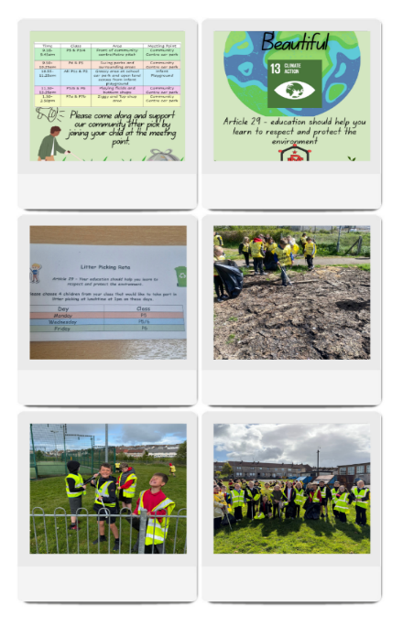  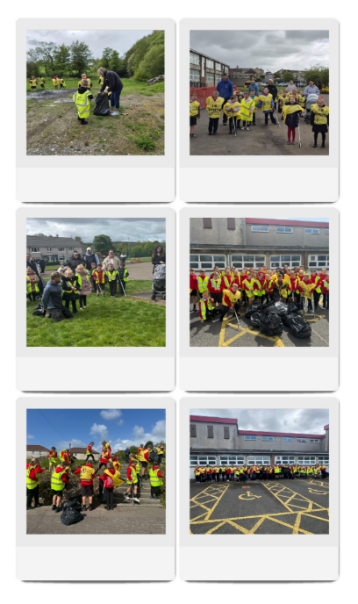  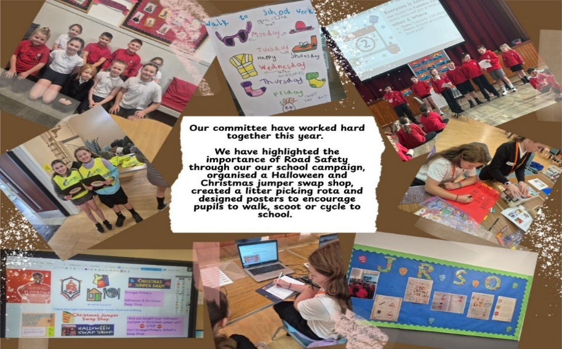  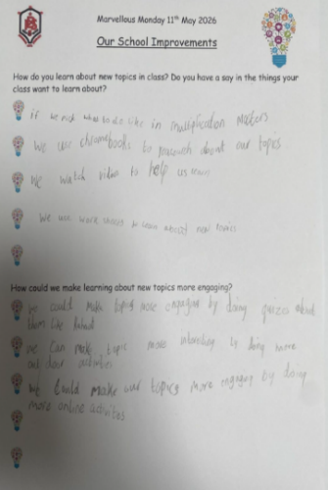  Home Circle assemblies  Home Circle assemblies have taken place regularly, providing pupils with opportunities to share their views on learning, engagement, and pupil voice. In a recent survey, 90% of pupils responded that they do, or sometimes feel like they help make changes in the school. Evidence from one mixed-stage Home Circle group shows that pupils feel their voice is heard by staff and that they are involved in aspects of their learning.  Evidence from one mixed-stage Home Circle group shows that pupils feel their voice is heard by staff and that they are involved in aspects of their learning.  When asked how they learn about new topics in class, most groups mentioned watching videos on ClickView, completing worksheets, being presented with PowerPoints and researching on a laptop or Chromebook. Most groups also said that they get to choose their tasks during certain lessons, such as Multiplication Masters, and they get to help plan their IDL topics.  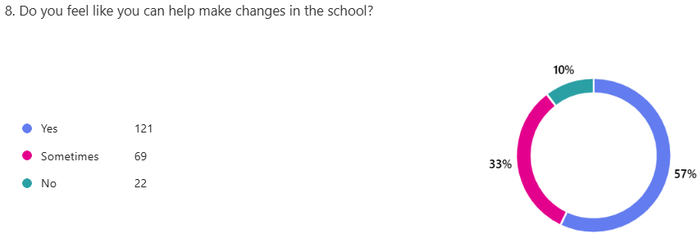  When asked about how topics could be made more engaging, most groups mentioned increased use of digital technologies. As a result of this feedback from learners, as well as staff self-evaluation, effective use of digital technologies, and consistent delivery of the technologies curriculum are going to feature as part of our School Improvement Plan for 2026/2027.  Almost all children have enjoyed collaborating with others through home circles and committee work. As a result, pupils feel increasingly confident in sharing their ideas, working with peers across stages, and contributing to decision-making within the school. Building on this positive feedback, we will continue to increase opportunities for mixed-stage collaboration and pupil leadership, through class committees. This will ensure that all learners have meaningful opportunities to contribute to the life of the school, with the clear aim of further increasing the percentage of pupils who feel that they play an important part in the life of Drongan Primary School.  We collected views from parents and asked the following:  “We have focused on developing pupil voice through home circle assemblies, pupil focus groups and pupil committees. Do you feel that your child's experiences at school help to improve their confidence?”  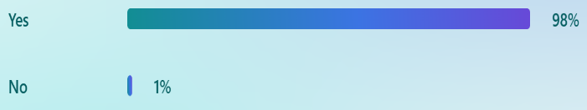  As shown in the pie chart, 98% of parents reported that their child’s experiences at school help to improve their confidence. This supports pupil feedback, indicating that developing pupil voice through initiatives such as home circle assemblies, pupil focus groups, and pupil committees has had a positive impact.
Next Steps | - Continue to provide all staff with opportunities to reflect on their own practice, relating this to the GTCS standards.  - Continue to engage with EAC Leaders of Learning programme.  - Provide opportunities for staff to share good practice during collegiate calendar.  - Build on the foundations of our Pupil Committee Afternoons by creating class committee groups.  - Provide opportunities for all pupils and staff to lead change in the school through Pupil Committees and CLPL.  - Evaluate and refresh the school’s Vision, Values and Aims so that they accurately reflect and respond to the aspirations and needs of the school community.

Improvement Priority  (Expressed as outcomes for learners) | Improvement Priority (Expressed as outcomes for learners)  Improve the quality of teaching and learning experiences in Literacy (Writing) to improve attainment in Writing. | Education Service Improvement Plan Priority 2: Teaching and Learning Together  Our young people should experience a teaching, learning and curriculum offer that meets their needs, and those of our local and national context. All staff should be supported to deliver in new and innovative ways by accessing CLPL relevant to their needs and those of our young people.
Teaching and Learning Together
Progress and Impact | Curriculum Rationale  At Drongan Primary and ECC we are proud of our inclusive, values-driven curriculum. We raise attainment, support wellbeing and inclusion, and celebrate success in many forms. Our values of Teamwork, Mutual Respect, Trust, Inclusion, Self-belief and Resilience are evident every day in our classrooms, playground and wider community.  Regardless of the challenges they may face, all children at Drongan can achieve their full potential and live a healthy, happy and successful life.  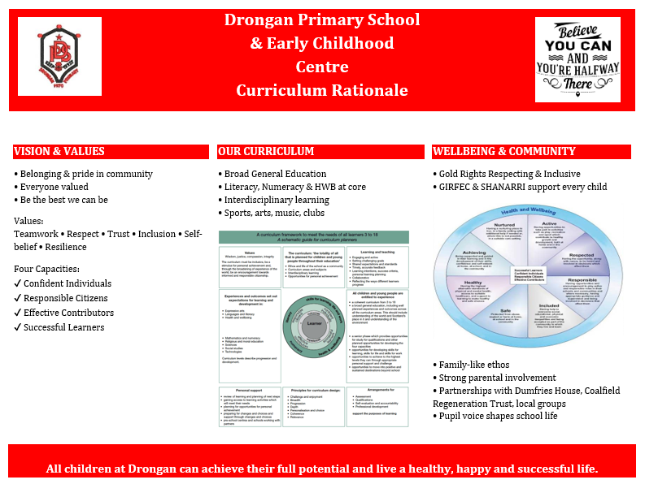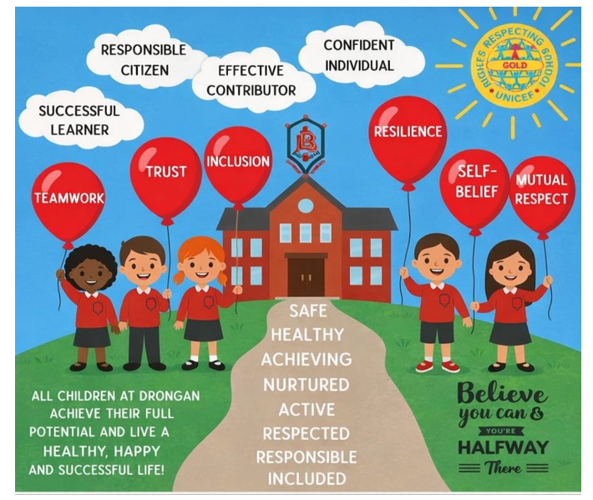  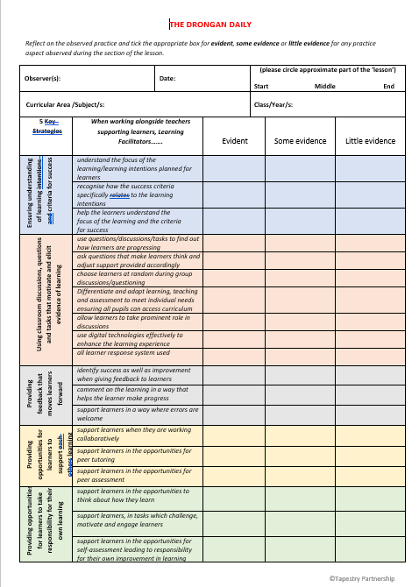  The Daily Drongan – Excellent Lesson  The development of The Drongan Daily has strengthened our approach to defining and sharing high-quality learning and teaching across Drongan Primary School. By refining the existing Excellent Lesson criteria, we have ensured that expectations are clearer, more relevant, and better aligned with our whole-school priorities. Rebranding this work as The Drongan Daily has helped to create a more engaging and accessible platform for communicating effective practice. It promotes a shared understanding among staff and pupils and celebrates the positive learning experiences taking place across the school. Further enhancements have been made to supporting materials. The updated comment sheet now includes a stronger focus on class ethos and environment, recognising the importance of relationships, culture, and inclusive practice in delivering excellent learning experiences. Additionally, pupil focus group questions have been revised to more closely reflect current whole-school priorities, ensuring that pupil voice is meaningful and directly informs improvement. A key strength of this development has been the collaborative approach. Staff and pupils worked together to co-create a child-friendly poster based on the Excellent Lesson criteria. This process not only supported pupil understanding of what high-quality learning looks like but also empowered them to contribute their ideas and perspectives. As a result, there is increased ownership and consistency across the school.  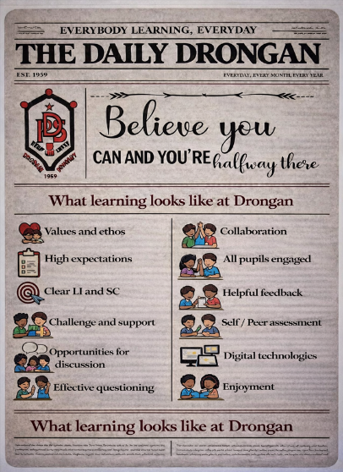  Overall, this work has had a positive impact on clarity, consistency, and engagement in learning and teaching. When consulting with parents, 98% responded that their child’s needs are being sufficiently supported/challenged at school. Moving forward, continued use of The Drongan Daily will support ongoing reflection, dialogue, and improvement across the school community.  CYPIC National Improving Writing Programme  Over the course of this session, P3/4, P4, P5 and P5/6 teachers took part in the CYPIC National Improving Writing Programme. Through this they developed and implemented a quality assured approach to daily writing with a key focus on Tools for Writing and vocabulary. Pupils in these classes have been writing 3-5 times per week for 15 minutes, followed by opportunities for self-and/or peer-assessment. Time has been given for self-editing, and instant feedback has been provided. This has allowed learners to reflect on areas of success and improvement.  Data has been collected daily on children’s progress with a clear focus on improving one aspect of writing at a time. Pupils have been involved in the process of collecting and analysing data on a run chart. Pupils have worked hard to meet their own individual targets and have all made progress.  Before the programme was implemented, pupils in P3/4 and P4 were asked for their views on writing lessons at Drongan Primary School. Some key results from this questionnaire are shown below:  P3/4 P4  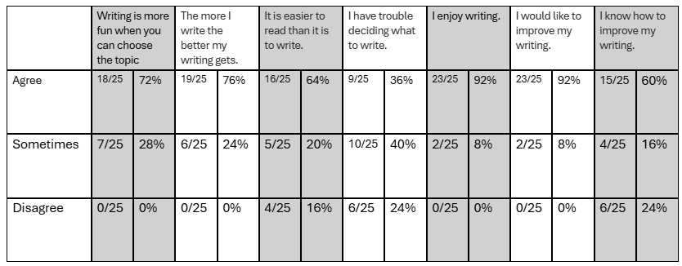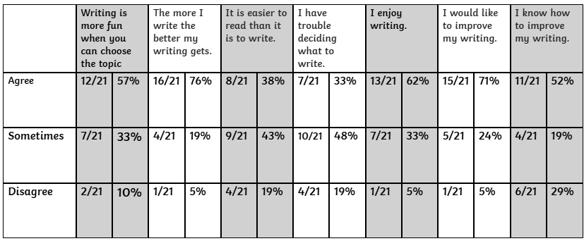  At parents’ night in October 2025, during the programme, parents were asked for their views on their children’s writing. Some key findings from this survey are shown below:  P3/4 P4  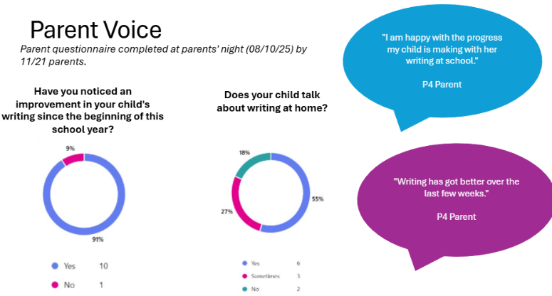  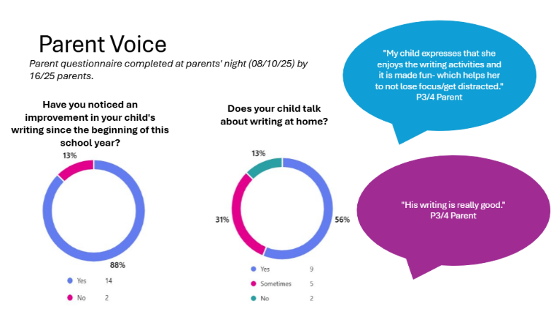  Pupils were also asked for their views on their writing during the programme:  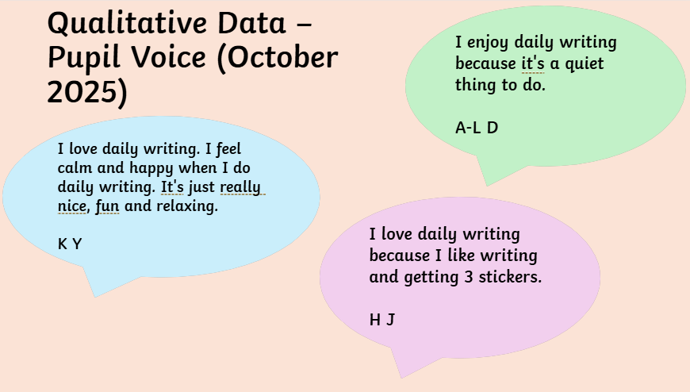  At the end of the programme, January 2026, pupils were asked for their views on writing lessons at Drongan Primary School. Some key results from this questionnaire are shown below:  P3/4 P4  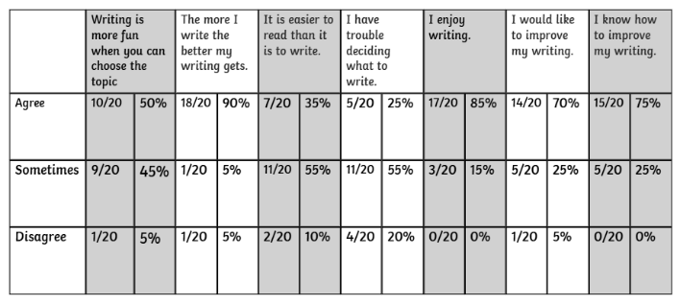  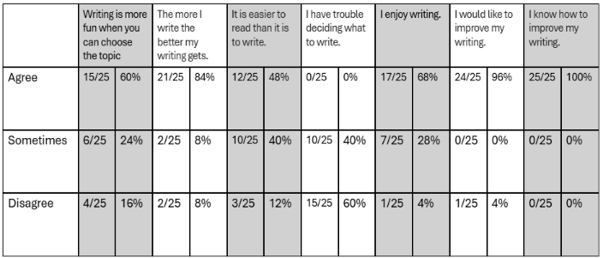  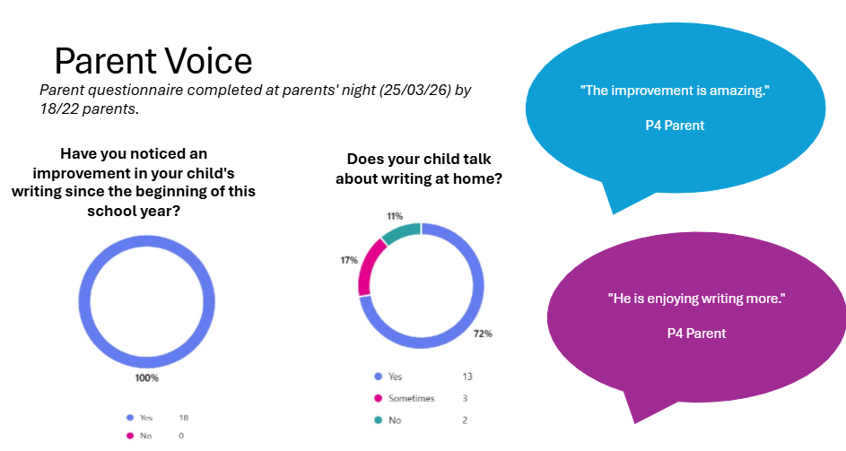  At parents’ night in March 2026, during the programme, parents were asked for their views on their children’s writing. Some key findings from this survey are shown below:  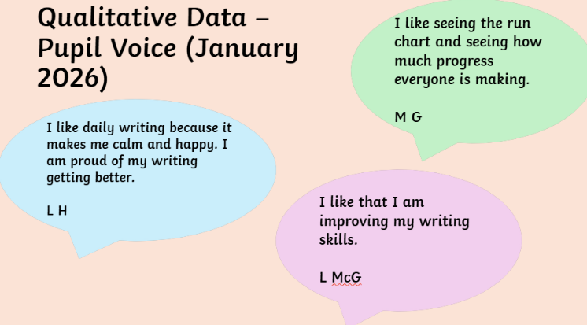  This programme led to more engagement in writing across P4, resilience and self-belief towards writing and reflective learners. It also led to an improvement in tracking data across all stages that took part.  Shown below is the P4 tracking data for periods 1, 2 and 3. The quality of learners’ writing has shown great improvements, as can be seen by the increase from 40% to 43% of children on track towards achieving the national expected level, and an increase from 29% to 34% of children exceeding the national expected level.  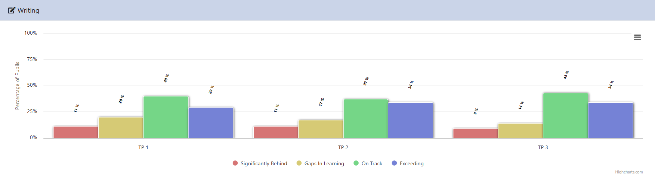  Nationally On Track Nationally Off Track  Tracking Period 1 69% 31%  Tracking Period 2 73% 28%  Tracking Period 3 77% 23%  Summary of the National Writing Programme in P3/4 and P4  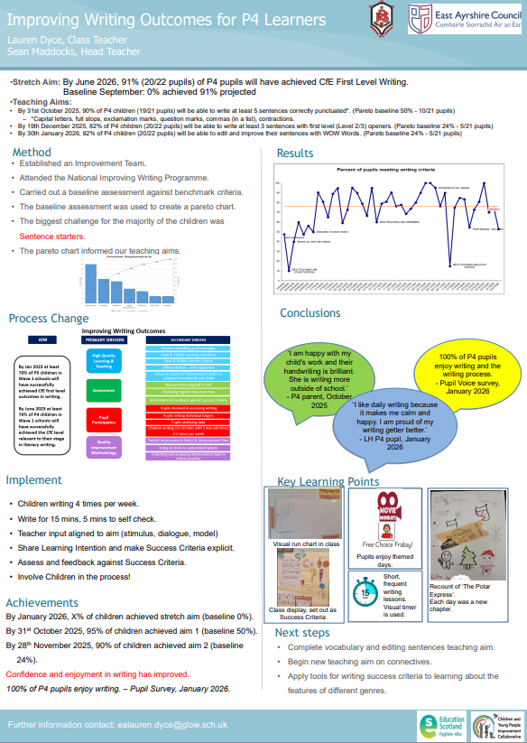  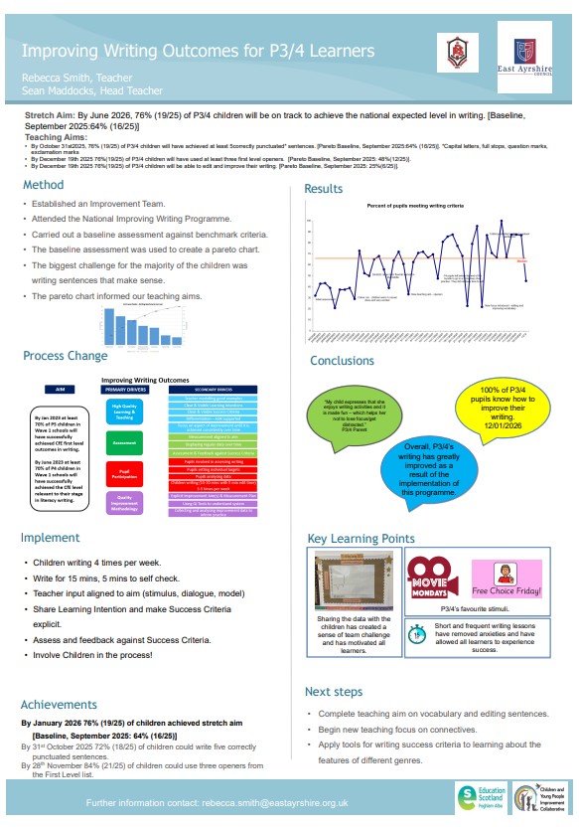  P5 and P5/6 started the National Improving Writing Programme in Term 3 as part of cohort 4. The pupils have engaged well with this, and it has had a positive impact on the percentage of pupils on track and exceeding towards national expected levels.  Below is the P5 attainment data for writing for TP1, TP2 and TP3. The graph shows that there has been an increase from 0% to 7% of pupils exceeding in writing from TP2 -TP3.  Nationally On Track Nationally Off Track  Tracking Period 1 81% 19%  Tracking Period 2 81% 19%  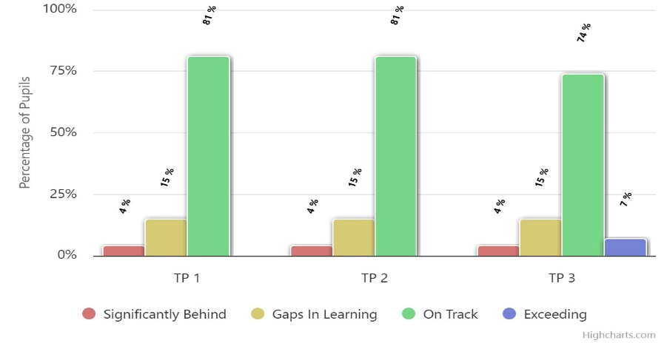  Tracking Period 3 81% 19%  Below is the P5/6 attainment data for writing for TP1, TP2 and TP3. The graph shows that there has been an increase from 71% to 88% of pupils on track in writing from TP1 -TP3.  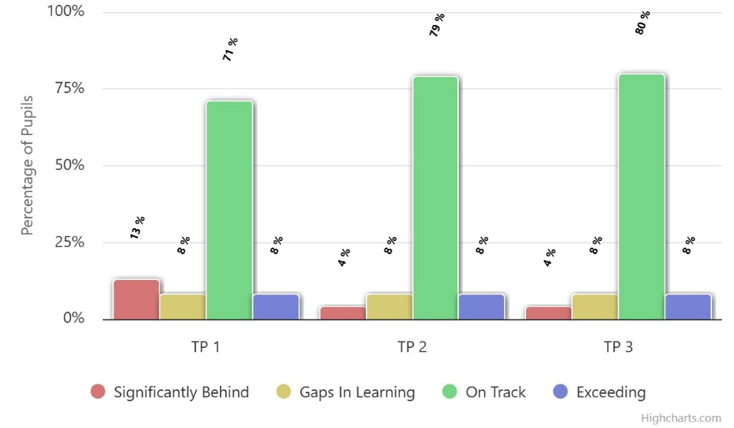  Pupils in P5 and P5/6 were asked to give feedback on the impact of the NIWP so far;  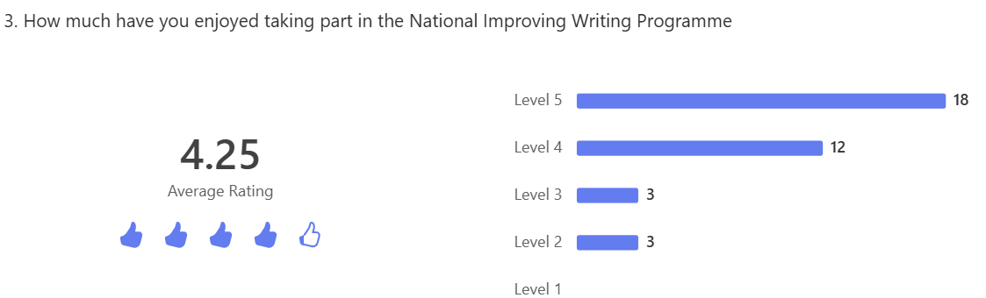  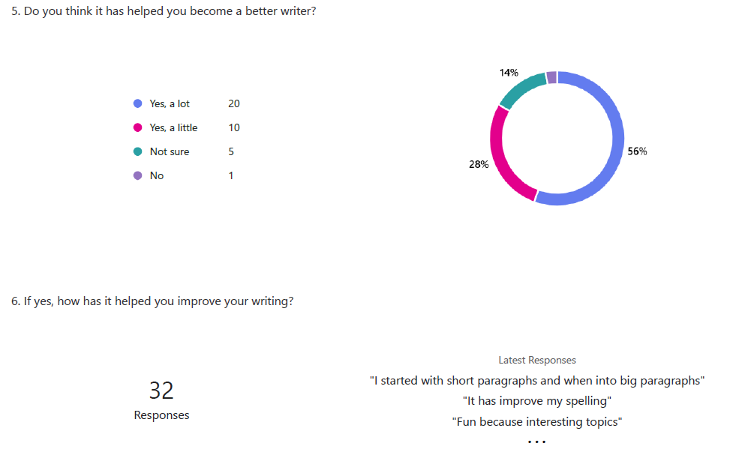  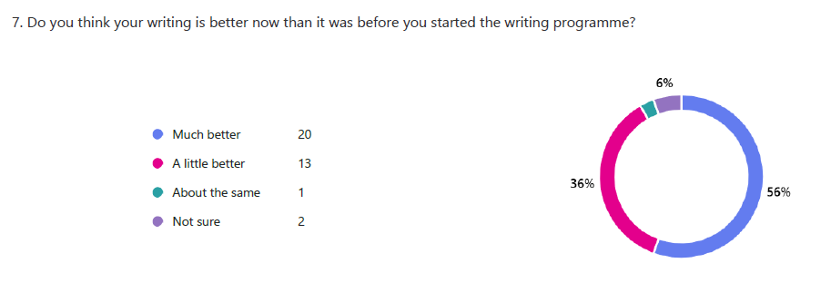  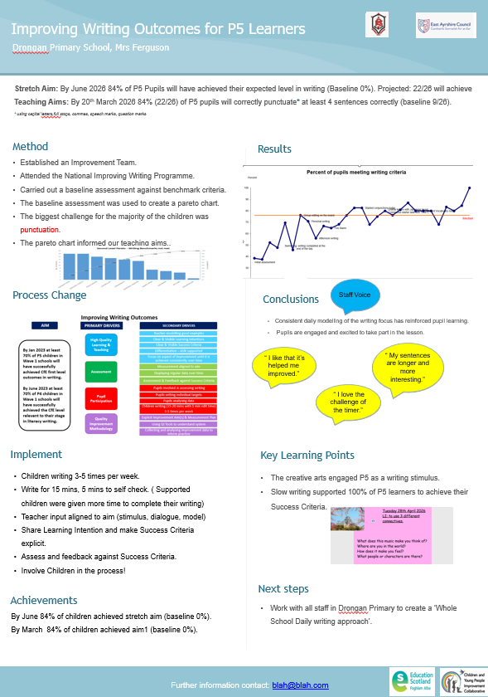  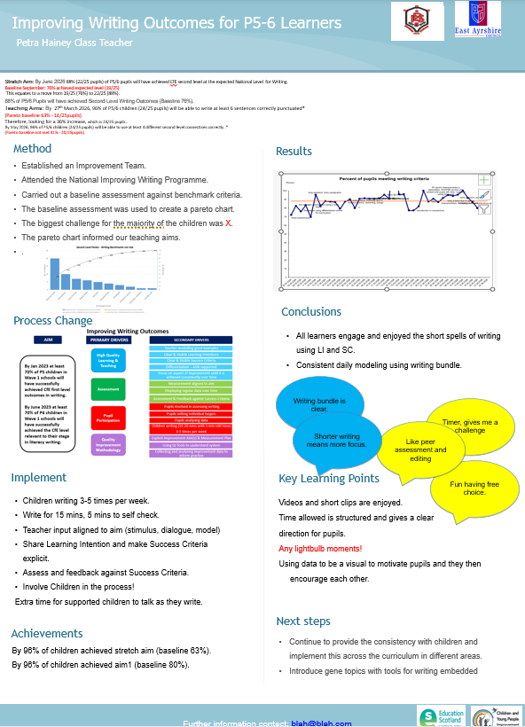  P5 and P5/6 summary posters of the National Improving Writing Programme.  Results from a recent parent/carer questionnaire asking, ‘Have you noticed an improvement in your child's writing this year?’  Next Steps:  To introduce the programme with new P4, P6 and P7 pupils starting in August 2026.  For P3 teacher to start to implement the programme with P3 pupils starting next session. For current P4, P5 and P5/6 pupils to continue to build on skills as they move into their next stage.  Moderation  As part of our commitment to raising attainment in writing, staff engaged in professional moderation activities with colleagues within the Barony Learning Community. This involved comparing pupil work and agreeing levels. This session strengthened confidence in professional judgement and supported a shared understanding of standards, providing valuable opportunities for professional dialogue. Staff worked collaboratively to analyse writing samples and discuss assessment approaches and explore progression. This process confirmed a high level of consistency across schools in both expectations and judgements. As a results. Practitioners reported increased confidence in their assessments and a clearer understanding of next steps for teaching writing. Feedback from staff evaluations highlights the positive impact of this professional learning opportunity. Across all responses, collaboration and professional dialogue were identified as the most beneficial aspects. Staff valued the opportunity to share practice, compare learners’ work, and validate their judgements against those of colleagues.  The moderation process has had a clear positive impact on practitioner confidence, consistency in assessment, and the quality of professional dialogue. Staff are beginning to apply new strategies in their classrooms, particularly in relation to writing tools, daily writing opportunities, and supporting reluctant writers.  Moving forward, staff have identified the importance of:  - Continuing moderation and professional dialogue opportunities  - Providing opportunities to observe practice across schools  - Embedding approaches from the National Writing Programme  - Maintaining a focus on writing tools and progression  Summary of Staff Feedback  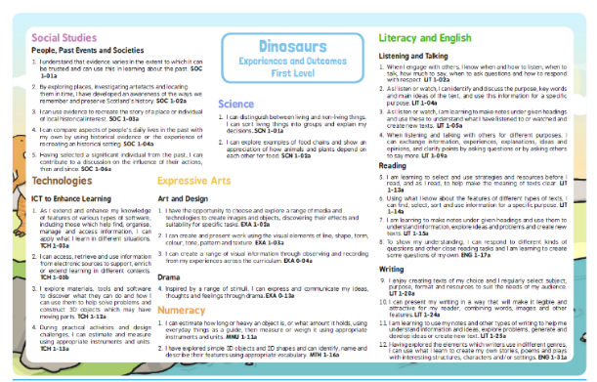  Interdisciplinary Learning and Social Studies  Progress has been made in developing the quality and consistency of Interdisciplinary Learning across the school this session. Building on last session’s priority to enhance Social Studies planning, staff have worked collaboratively to ensure that learning contexts are meaningful, relevant, and provide breadth and depth across the curriculum.  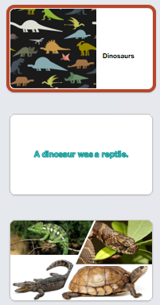  The development and collection of IDL grids for all class topics has been a key success. These now ensure clearer progression and improved coverage of the Broad General Education (BGE) across all stages. Teachers have a more consistent approach to planning, supporting progression in skills and knowledge.    The creation of Social Studies topic boxes, alongside an audit and organisation of existing resources, has significantly improved the quality of learning experiences. Most topics are now supported by well-resourced, accessible materials. These have been shared via the staff drive, allowing for effective collegiate working and consistency across stages. This has also supported staff transitioning into new year groups, ensuring continuity in planning and delivery.  Collegiate working has been a strong feature of this improvement work. Staff have shared practice, resources and approaches, contributing to increased confidence and a more cohesive curriculum.  In line with our focus on relevance, there has been continued consideration of interdisciplinary learning contexts, ensuring these reflect both local and wider community contexts. This has supported more engaging and purposeful learning experiences for pupils.  P2 Dinosaurs  K:\Curricular Areas Sharing Resources\Social Subjects\Primary 2\Dinosaurs\thedinosaurspack.pdf  K:\Curricular Areas Sharing Resources\Social Subjects\Primary 2\Dinosaurs\Dinosaurs\Dinosaurs ppt.pptx  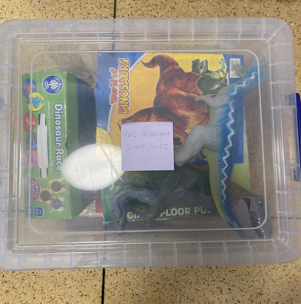  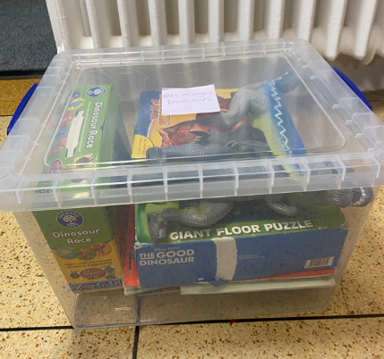
   | Nationally On Track | Nationally Off Track
  Tracking Period 1 | 79% | 21%
  Tracking Period 2 | 87% | 12%
  Tracking Period 3 | 88% | 12%
  Theme | Evidence from Responses | Frequency (n=9)
  Collaboration & professional dialogue | “Good discussion with colleagues”; “Prof dialogue with colleagues”; “Collaborating… sharing our learning” | 9
  Consistency of standards | “Reassured that there’s consistency across schools”; “Similarities among work”; “Professional judgements validated” | 6
  Sharing practice | “Chance to share practice”; “Finding out about what other schools do”; “Take tips from each other” | 7
  Increased confidence in assessment | “Reassured about standards”; “Backing up our judgements” | 4
  Focus on writing approaches/tools | “High focus on tools for writing”; “New strategy to support reluctant writers”; “Daily writing outwith genre” | 5
  Next steps – continued collaboration | “More opportunities to collaborate”; “Observe other schools”; “Meet up again to see progress” | 7
Next Steps | Next Steps  - Continued participation at the CYPIC National Improving Writing (NIW) sessions (Cohorts 5 & 6):  - Review Whole School Writing Overview and Tools for Writing Pathway at Drongan PS.  - Increase understanding of the root causes for writing difficulties / barriers (CLPL opportunities) – linked to Inclusion target  - Working memory training and CLPL for CAs and SLT  - Embed and consistently use IDL grids across all stages  - Extend opportunities for staff to observe and share effective IDL practice  - Further develop interdisciplinary planners with a clear focus on skills progression  - Gather and analyse pupil survey data to measure impact on learner engagement  - Continue to develop high-quality, relevant contexts that reflect local and global contexts

Improvement Priority  (Expressed as outcomes for learners) | Improvement Priority (Expressed as outcomes for learners)  Improve the wellbeing of all children with a specific focus on pupil achievement and how valued and respected they feel. | Education Service Improvement Plan Priority 3: Our Wellbeing and Belonging  We want all of our young people to feel supported by people who know them well, and feel included in all of our schools and centres. Our staff need to be supported in their working with our young people, especially in times of adversity. As a key universal service, it is our vision that all young people attend our establishments on a full-time and regular basis to support them in their development at all stages.
Our Wellbeing and Belonging
Progress and Impact | Nurture Provision  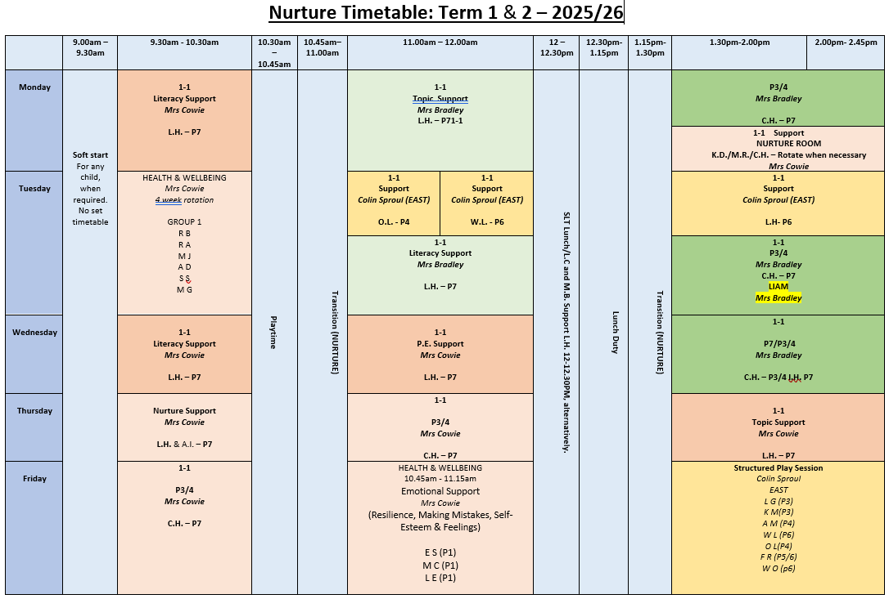  This session, our nurture provision at Drongan Primary School has continued to develop with a flexible, responsive approach, ensuring we meet the varying needs of our children.  Each morning, we provide a check-in opportunity for pupils who may find the start of the school day challenging. This allows them time and space to regulate before transitioning into class, supporting a calmer and more positive start to their learning.  We have also benefited from the support of an EAST teacher, who has been in school two days per week. During this time, he has led targeted play sessions for children experiencing difficulties with friendships, helping them to build positive social skills and relationships. In addition, he has delivered 1:1 nurture sessions for pupils who require time out of class to regulate, enabling them to return to learning more settled and focused.  Our nurture room remains a key support throughout the day. It is open during break and lunchtime for pupils who can find the playground environment overwhelming, providing a safe, calm space with a range of carefully selected activities. Timetabled sessions for brain breaks and regulation are also in place, and these are regularly reviewed and adapted to reflect the changing needs of our pupils. The room is further used as a supportive break-out space for children who may be struggling to concentrate in class at certain times of the day.  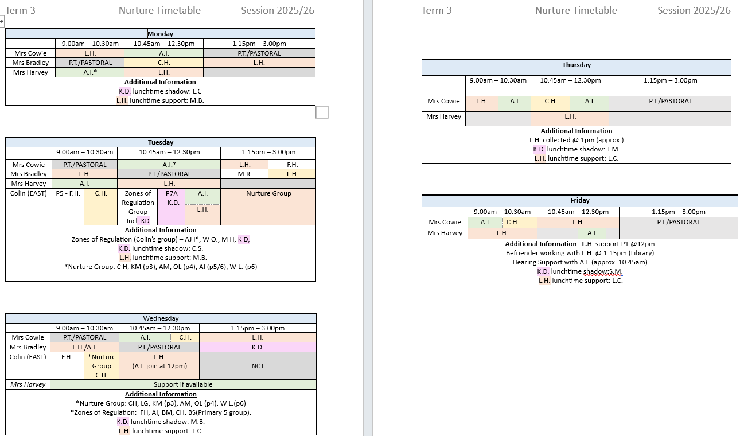  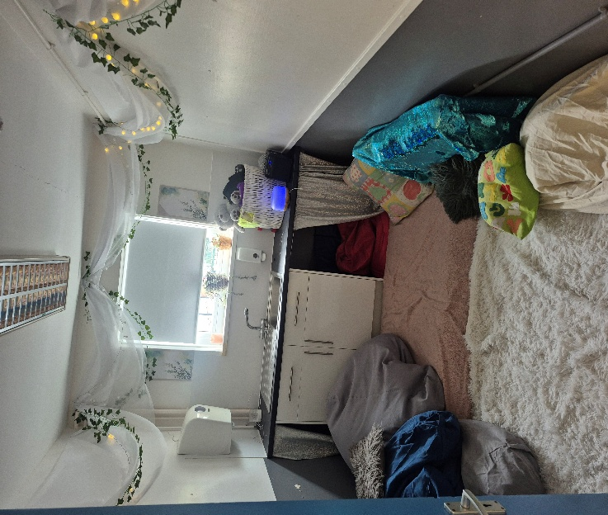  This session, we also introduced a sensory room, initially created to support one of our youngest pupils. This space has quickly proven to be invaluable, offering a quiet, highly supportive environment where children can regulate their emotions and sensory needs.  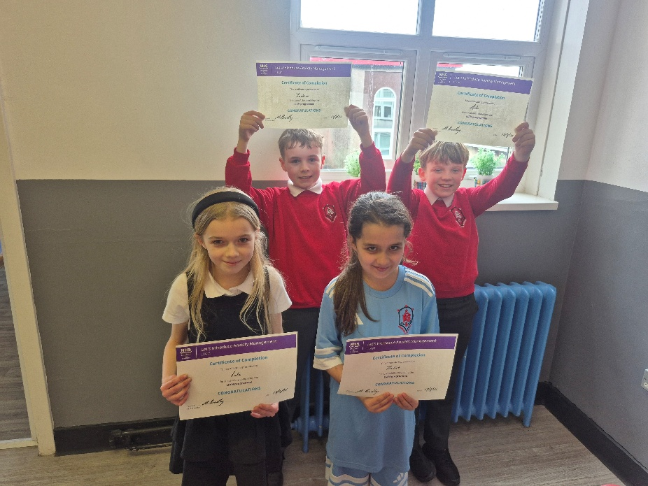  Targeted interventions have also been an important part of our nurture provision. We have delivered LIAM sessions to support older pupils experiencing mild to moderate anxiety, while younger pupils have participated in the Starving the Anxiety Gremlin programme. These sessions have helped children develop a greater understanding of anxiety, recognise how it presents for them, and learn practical strategies to manage their feelings effectively.  Overall, our nurture provision has been a vital component of our support for wellbeing this session, with its flexible and responsive nature allowing us to meet the individual needs of our pupils and promote positive engagement with learning.  Learner Profiles  This session, staff have been trained in using Learner Profiles. Across P5–P7, learner profiles are supporting children to talk more clearly about their learning and recognise their progress over time. Through regular opportunities to reflect and update their profiles, learners are becoming more confident in identifying what they are doing well and what they need to work on next.  An example of this is the P7 class making use of a slot in the week for children to update their own profile at their own pace and leisure.  Pupils are taking a more active role in their learning, with an increased awareness of their targets and next steps. They are beginning to make more meaningful links across different areas of the curriculum, and this is evident in discussions with staff and peers. Conversations between learners and staff are more focused and consistent, with a shared understanding of progress. There is now greater consistency across the upper stages in how achievements are recorded and discussed, which is supporting attainment and helping to strengthen transitions.  Overall, children are demonstrating a stronger sense of themselves as learners and are better able to articulate their skills, progress and achievements.  Pupil feedback indicates that learners:  - Understand the purpose of profiles as a tool for recording achievements and goals  - Can independently access and use the platform  - Value the ease of use and interactive features, which support engagement  - Show mixed understanding of relevance, particularly in relation to long-term career pathways  - Benefit from opportunities to reflect on achievements, with some pupils reporting increased sense of pride and accomplishment.  Overall, while learner profiles are successfully supporting achievement recognition and reflection, there is a need to strengthen learner understanding of purpose and relevance, ensuring children see the value in their learning journey at an earlier stage.  Wellbeing Data  Wellbeing Check-In Process  Each year, all pupils complete wellbeing check-ins during Term 1 and Term 3. The information gathered from these check-ins is carefully collated and reviewed to identify any pupils who may require additional support.  Pupils who score low (1 or 2) in any area of the wellbeing check-in are identified as needing further attention. For these pupils, a one-to-one conversation is conducted to better understand their individual needs and concerns.  Following this discussion, appropriate interventions are put in place to support the pupil’s wellbeing. These interventions are monitored and reviewed to ensure they are effective and responsive to the pupil’s needs.  Wellbeing Glow Form  Well-being Check in Term 3 2026 – Fill in form  Average results across all stages Average results P4-7  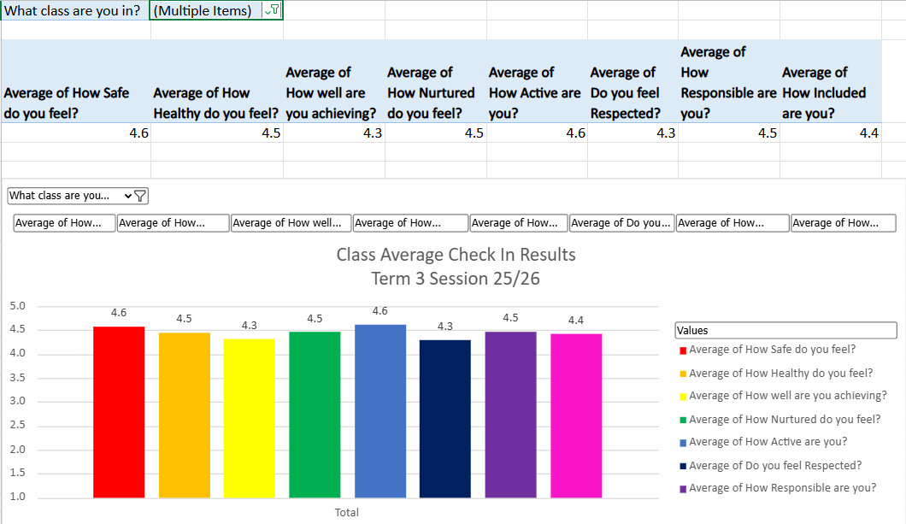  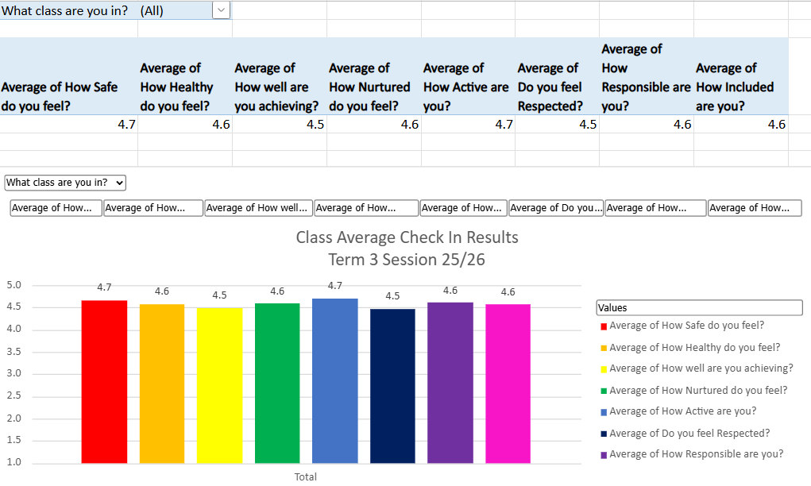  Intervention Grids  A one-to-one conversation takes place with each child and their teacher to discuss low ratings. An intervention is put in place and a review at the end of term 2 and 4 with SLT.  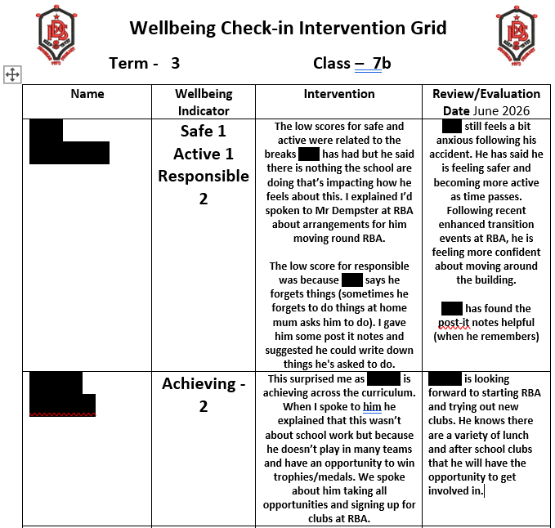  SIP Outcome for Learners - All children in P4-7 will record an improved score and there will be an improved collective score for achievement in their termly wellbeing webs by June 2026.  Focus on Achieving Indicator  Previous and predicted ratings:  This session we focussed on raising our achievement rating from 4.5 to 4.6. After completing term 1 wellbeing check-ins our average rating was 4.5. Pupils who recorded the lowest scores for achievement across the school were identified and invited to take part in a pupil focus group. This provided an opportunity to explore their perceptions of achievement in more depth.  During the sessions, staff worked with pupils to develop their understanding of what achievement looks like. Discussions focused on recognising that achievement can take many forms and may occur at different rates for different individuals.  Pupils were supported to reflect on their own progress, helping them to recognise that they are achieving, even if this looks different from their peers. The focus group aimed to build confidence, promote a positive mindset, and reinforce a broader, more inclusive understanding of success.  Each week at assembly there has been a focus on achievement with pupils across the school receiving recognition through Star of the Day, School values certificates, Handwriting Heroes, Multiplication Masters and Bronze, Silver and Gold awards. Wider achievements are also celebrated and displayed on our wider achievement wall.  Despite the considerable work and effort that has been undertaken, there has unfortunately still been a decline in the average rating for P4-7 pupils at the end of this session. However, we will continue to prioritise this area and maintain it as a key focus in the next session.  Current Achieving rating:  Parent/Carer Views  Results from a recent parent/carer questionnaire asking, ‘Do you feel that your child's wellbeing is well supported at school?’  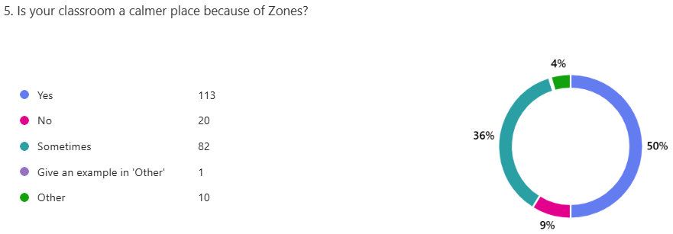  Zones of Regulation  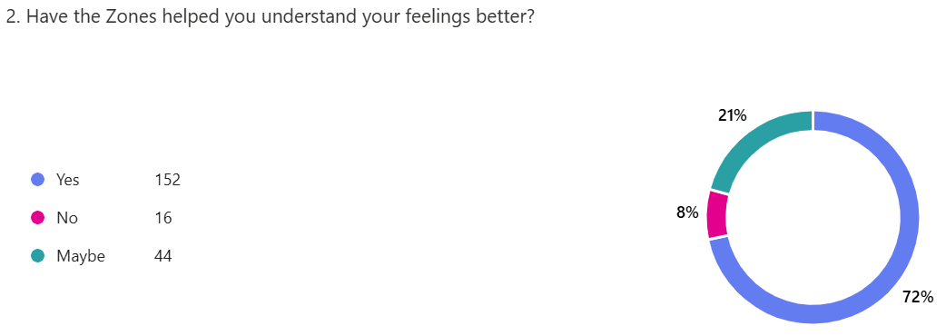  Following professional learning with the Senior Leadership Team and the Educational Psychologist, staff reviewed and re-implemented the Zones of Regulation programme with a clear focus on developing pupils’ emotional literacy, self-regulation and readiness to learn. The approach is now embedded across all classes, with consistent visual displays, whole-class and individual regulation toolkits, and the use of Zones of Regulation discs on staff lanyards to support immediate, non-verbal emotional check-ins and structured discussions. This consistent, inclusive approach validates pupils’ emotions and ensures they feel understood, valued and respected. Communication with families has further strengthened a shared emotional language beyond the classroom. As a result, learning environments are calmer, the frequency of dysregulated behaviour has reduced in almost all classes, and pupils demonstrate improved self-regulation and emotional awareness. These improvements have supported stronger relationships across the school and increased engagement in learning, contributing positively to pupils’ wellbeing and their capacity to achieve.  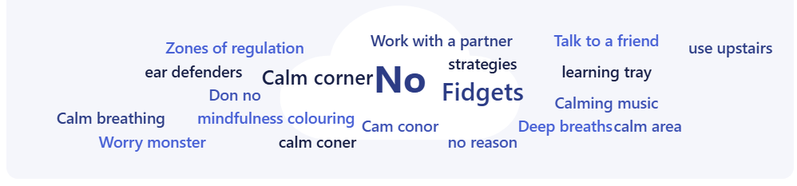  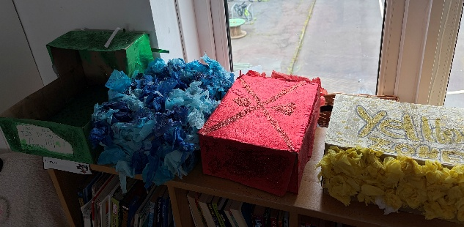  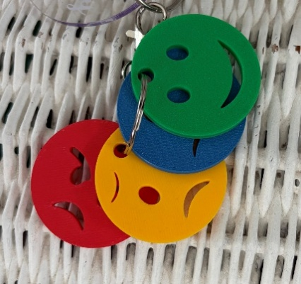  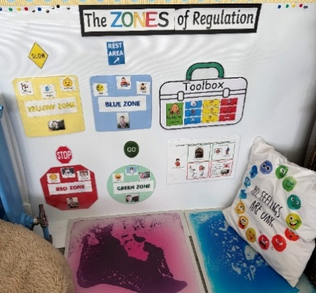  Rights Respecting Schools  As a Gold accredited Rights Respecting School, we continue to embed children’s rights at the heart of our ethos and practice. Our ongoing journey is supported through initiatives such as our “Right of the Month,” which promotes awareness, understanding and pupil voice across the school community.  We are committed to equity and inclusion, demonstrated through our successful “swap shop” campaigns for Christmas jumpers and Halloween costumes, helping to reduce financial pressure on families and support our poverty-proofing approach.  Our strong focus on global citizenship is evident through our litter picking initiatives, which link directly to the United Nations Sustainable Development Goals. Pupils participate in a weekly litter picking rota and have led a whole-school community litter pick, which was highly successful and fostered a shared sense of responsibility and pride within the community.  Through these meaningful actions, our learners continue to develop as responsible, informed and active members of their community, fully embracing the values of a Rights Respecting School.  The Promise  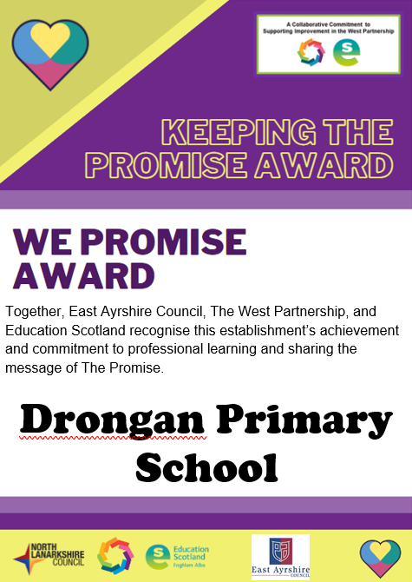  This session staff have engaged with Keeping the Promise training to support care experienced children and young people. All teaching and support staff have successfully completed Level 1 and 2 of the training, providing a shared understanding of the needs, rights, and experiences of care experienced learners. This has strengthened staff awareness of trauma-informed approaches and reinforced the school’s commitment to equity and inclusion. It has deepened staff’s knowledge and enhancing their ability to respond effectively to the individual needs of care experienced pupils. Moving forward, this will support more consistent pastoral care, improve relationships, and increase confidence among staff in delivering targeted support.  As a result of this training, there will be a more compassionate, and responsive school environment. Staff will demonstrate increased sensitivity in their interactions, and there will be a growing emphasis on nurturing approaches, inclusive practice, and improved outcomes for care experienced learners.  The next step is for staff to engage with Level 3, which will focus on evaluating the impact of Keeping the Promise approaches on our young people. This will involve gathering evidence, reflecting on practice, and developing a clear, measurable action plan to demonstrate impact and drive further improvement. Continued progression through this training ensures that the school not only builds staff capacity but also embeds change that meaningfully improves outcomes for care experienced learners.  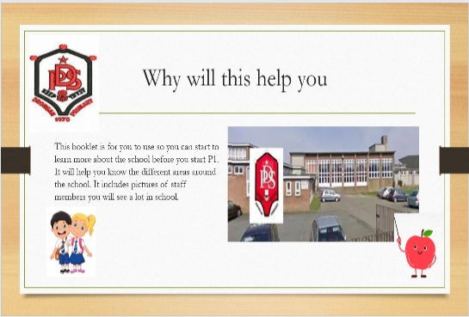  Transition  ECC to School Transition  We have further developed our ECC to Primary 1 transition programme, increasing opportunities for children to familiarise themselves with the school environment. ECC pupils attended weekly visits during the final term, joining Primary 1 classes during soft start sessions. This regular, structured contact allowed children to build positive relationships with key staff, develop confidence within the classroom, and become comfortable with school routines.  In addition, pupils were introduced to their Primary 6 buddies, who provide support in the playground and dining hall. This has strengthened children’s sense of safety and inclusion, ensuring they have a familiar and supportive peer connection from the outset.  Staff collaboration has been a significant strength. Transition meetings between ECC practitioners and Primary 1 teachers ensured a shared understanding of each child’s strengths and next steps for development. Professional dialogue, alongside staff training on ECC learning journals, has supported continuity in learning and teaching approaches, enabling staff to meet children’s needs effectively from the start of the school year.  Parental engagement has also been a central feature of this process. Families were invited to attend a range of transition events, including an Active Schools session, Meet the Staff presentation, and Stay for Lunch experience. These opportunities helped parents feel informed, reassured, and involved in their child’s transition, further supporting children’s emotional wellbeing.  As a result of these approaches, children have entered Primary 1 feeling more confident, secure, and ready to learn. The strong relationships established with staff and peers have enhanced their sense of belonging, creating a positive foundation for engagement and achievement. These improvements demonstrate clear progress towards our priority of ensuring all children feel valued, respected, and supported to achieve their full potential.  https://sway.cloud.microsoft/AcunqnPTOfZBR48X?ref=Link&loc=play  Primary 7 to S1 Transition  During the 2025/26 session, we have continued strengthening our links with our connected secondary school Robert Burns Academy to enhance the transition experience for pupils.  One of our Primary 7 teachers sits on the Transition Working Group which includes representatives from feeder primary schools in the authority and is coordinated by the S1 year head at RBA. Within this meeting discussions take place around ensuring that the transition experience is positive for all pupils. In addition to Enhanced Transition being offered to specific children and Transition days for all pupils, the process is being enriched through additional visits for parents and pupils, visits from guidance staff and former pupils, a STEM session for primary 6 pupils and Guidance staff from RBA attending our Parents’ Evening to be available to answer any questions. In addition, our staff representative has been involved in consultation in relation to the development of a new Transition Policy.  As a result of these close links we are able to share relevant information in relation to wellbeing and learning to ensure our pupils have as smooth a transition as possible to the next stage in their learning journey.  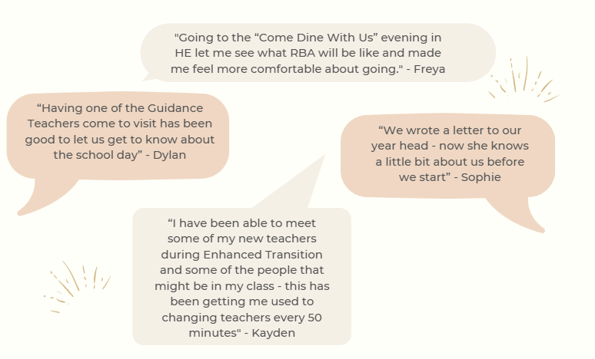  Evidence:  Class transitions  Following our collaborative identification of Transitions as a key improvement priority last session, staff have continued to develop both macro (whole-school) and micro (within-class) transitions to support pupils’ wellbeing, consistency, and readiness to learn.  This session, the work led by the Inclusion Committee has had a positive impact. Their successful campaign to remove the use of the school bell during learning time has contributed to a calmer, more nurturing environment. As a result, children are experiencing reduced anxiety and fewer abrupt interruptions, supporting smoother transitions throughout the school day and promoting a greater sense of respect and wellbeing.  We have also strengthened end-of-session transitions between classes. Pupils have been provided with planned transition visits to their new teacher and classroom during Term 4. These visits have been flexible and responsive, allowing for a bespoke approach tailored to individuals and groups, particularly those requiring additional support. This increased familiarity with new adults, peers, and environments has led to children feeling more confident, secure, and prepared for change. Staff have reported improved engagement during transition activities, with children demonstrating greater readiness to learn and reduced anxieties about moving forward.  Overall, these developments have enhanced continuity, inclusion, and emotional wellbeing, ensuring that transitions are supportive and purposeful. This has had a direct impact on pupils’ ability to settle quickly, engage positively, and sustain progress in their learning.
  Wellbeing Indicator | 2024/25 Rating (out of 5) | 2025/26 Rating (out of 5)
  Achieving | 4.5 | 4.6
  Wellbeing Indicator | June 2026 Rating (out of 5)
  Achieving | 4.3
Next Steps | - ‘We were expecting you!’ training for all staff in school – delivered by Educational Psychologist  - Development of a school ‘Respectful Relationships Policy’  - Pupil wellbeing will continue to be tracked termly through their completion of wellbeing webs – with a focus on the included wellbeing indicator  - Improve collective score for ‘Achieving’ Wellbeing Indicator (P4-7 pupils and ASN identified pupils)  - Consider approaches to share and record achievements.

Improvement Priority  (Expressed as outcomes for learners) | Improvement Priority (Expressed as outcomes for learners)  Rasing attainment for all and achieving equity  - Current P1 writing by 8pp from 73% to 81%  - Current P3 writing by 6pp from 77% to 83%  - Current P3 reading by 6pp from 74% to 80%  - Current P6 writing by 2pp from 71% to 73%  - Current P6 numeracy by 2pp from 77% to 79%  - Percentage of pupils achieving all aspects of literacy will increase by 3pp from 76% to 79% | Education Service Improvement Plan Priority 4: Our Attainment, Destinations and Achievements  We want the very best for all of our young people in East Ayrshire. We aim to ensure that all young people secure a positive destination through excellent achievement and attainment at all levels.
Our Attainment, Destinations and Achievements
Progress and Impact | Overall, we have made good progress towards our improvement priorities, with most targets either met or exceeded.  Progress Against Key Outcomes  P1 Writing  Attainment increased from 73% to 78%, representing a 5-percentage point improvement. This exceeds the target increase of 3pp, showing strong early gains in writing development. While the final target of 81% has not yet been achieved, current progress indicates that learners are on a positive trajectory.  P3 Writing and Reading  - Writing improved from 77% to 82% (+5pp), narrowly missing the 6pp target.  - Reading improved from 74% to 82% (+8pp), exceeding the target by 2pp.  This reflects particularly strong progress in reading, suggesting that targeted literacy strategies are having a significant impact on comprehension and engagement.  P6 Writing and Numeracy  - Writing increased from 71% to 80% (+9pp), significantly exceeding the 2pp target.  - Numeracy improved from 77% to 80% (+3pp), also exceeding the 2pp target.  These outcomes highlight substantial gains at upper stages, suggesting effective teaching approaches, targeted support, and improved learner confidence.  Whole School Literacy  The percentage of pupils achieving all aspects of literacy increased from 76% to 88.7% (+12.7pp). This exceeds the 3pp target by a considerable margin, indicating a whole-school improvement in literacy attainment and consistency across stages.  Summary of Impact  - All targeted areas show improvement, with the majority exceeding expectations.  - Significant gains in P6 and whole-school literacy demonstrate strong impact of targeted interventions and consistent approaches.  - Early level (P1) progress is positive, though continued focus is required to reach the final attainment target.  - Reading improvement at P3 is a key strength, suggesting successful literacy interventions (reading and spelling extra) that could be replicated further.  Conclusion  The school is making very good progress towards achieving equity and raising attainment, with evidence of impactful practice leading to improved outcomes for learners.  Quality Assurance  We have continued with our Quality Assurance calendar and classroom observations. The observation included the various criteria based on the 5 key strategies and pupil focus group questions. The SLT reviewed the main findings from the first round of observations and collated strengths, identified areas to consider and next steps.  Learning Observations – Collated findings / feedback  Overall strengths:  - Clear strengths in identifying and communicating appropriate LI and SC in all classes.  Evidence of co-creating SC together with pupils in most classes.  All teacher and pupils very clear about what the purpose of the learning is and know what is required to be successful.  - There is a good level and variety of class discussion and questioning evident across all stages.  Teachers communicate well with pupils and groups during learning to monitor progress and understanding.  Teachers adapt support provided to pupils throughout most of the time, adapting where necessary.  - Feedback is coming through as being strong. This is evident both in what was observed and in conversation with the pupils. This is encouraging following the focus we had on this. Pupils spoke about how feedback helps them improve.  - Almost all pupils spoke about having opportunities to self and peer assess. There is also some evidence of this in jotters.  - Pupils work and learn independently and are provided with opportunities to take the lead in their learning in almost all lessons observed.  - In almost all classes there was a very good pace of learning, where pupils were engaged in their learning and challenged appropriately. Teachers used various tools including timers, rotations etc to ensure this was the case.  Identified areas to consider:  - Could there be increased opportunities provided to co-create SC? Some pupils stated that they don’t do this a lot and it is usually on the board for them.  Are there more opportunities to include values and wellbeing indicators in SC.  - Could further opportunities be provided for pupils to use higher order thinking skills during class discussions? Some pupils say their work is not challenging enough.  Is there scope to provide more opportunities to utilise all learner response systems (whiteboards)? to ensure all pupils are engaged, while informing teacher knowledge of pupil understanding.  - Continue to explore opportunities for pupils to meaningfully self and peer assess work.  - Continue to incorporate ways for pupils to play a lead role in their learning using a range of skills.  Next steps:  - Feedback will be provided to teaching staff and discussion will take place.  - Opportunities to share good practice around areas consider will be provided.  - Continue to explore CLPL opportunities through Leaders of Learning focus and other sources as well as learning from each other.  - Review our criteria and create a child friendly ‘Excellent Lesson’.  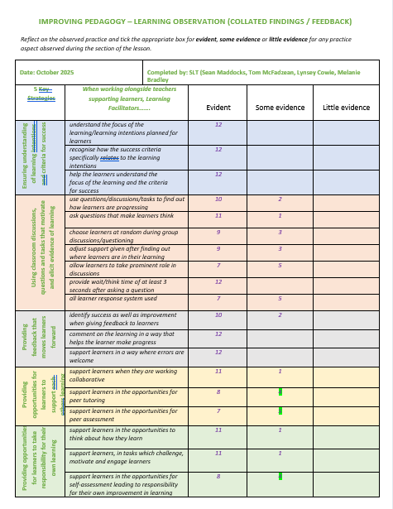  Original criteria and findings from classroom observations.  The Daily Drongan – Excellent Lesson  From the findings of the first round of class observations, we reviewed and updated our criteria as follows.  The development of The Drongan Daily has strengthened our approach to defining and sharing high-quality learning and teaching across Drongan Primary School. By refining the existing Excellent Lesson criteria, we have ensured that expectations are clearer, more relevant, and better aligned with our whole-school priorities. Rebranding this work as The Drongan Daily has helped to create a more engaging and accessible platform for communicating effective practice. It promotes a shared understanding among staff and pupils and celebrates the positive learning experiences taking place across the school. Further enhancements have been made to supporting materials. The updated comment sheet now includes a stronger focus on class ethos and environment, recognising the importance of relationships, culture, and inclusive practice in delivering excellent learning experiences. Additionally, pupil focus group questions have been revised to more closely reflect current whole-school priorities, ensuring that pupil voice is meaningful and directly informs improvement. A key strength of this development has been the collaborative approach. Staff and pupils worked together to co-create a child-friendly poster based on the Excellent Lesson criteria. This process not only supported pupil understanding of what high-quality learning looks like but also empowered them to contribute their ideas and perspectives. As a result, there is increased ownership and consistency across the school.  Revised criteria based on findings from classroom observations.  Child friendly criteria  To review our current practise, all classes were surveyed, using the Pupil Focus Group questions. The results show consistency in some areas, for example 85% of learners agreed, ‘My teacher uses learning intentions that are clear and easily understood. While only 45% of learners agreed that ‘My teacher asks me questions that really make me need to think.’ The responses from this survey have supported the revised criteria.  Overall, this work has had a positive impact on clarity, consistency, and engagement in learning and teaching. When consulting with parents, 98% responded that their child’s needs are being sufficiently supported/challenged at school. Moving forward, continued use of The Drongan Daily will support ongoing reflection, dialogue, and improvement across the school community.  Attendance  This session the overall attendance percentage has dropped slightly by 0.6pp from 94% to 92.4%. The aim at the beginning of the session was to continue to increase attendance, but various factors have affected this. Next session there will be a renewed focus on attendance, where will be following East Ayrshire Council’s guidance and setting a target of 94%.  Although there has been a slight decrease, we have ensured that attendance monitoring processes have been maintained together with targeted supports for pupils who may have barriers that prevent them from attending school. The HWB and Nurture support detailed in improvement priority 3 highlights some of the supports that are available to children who attend Drongan Primary School, and should any child have barriers preventing them from coming to school, we work cooperatively with their family to best identify the most suitable and appropriate supports.  Overall Attainment  The attainment data for 2025-26 reflects positively on the continued effort to provide the best possible opportunities for pupils to achieve their full potential. The attainment data shown below highlights the overall academic achievements of pupils across all stages in Drongan Primary School and the progress that has been made this session.  In reading, writing and numeracy, most children are achieving the national expected levels, with almost all achieving in listening and talking. There has been a significant improvement in writing attainment data this session, as detailed previously in this document. Writing will continue to be a focus for improvement next session.  Attainment Over Time in Literacy and Numeracy (Compared with local and national average)  Once again, Drongan Primary School’s attainment data in Literacy and Numeracy remains strong in the key stages of P1, 4 and 7. There are a few areas where data at these stages is slightly below the projected East Ayrshire averages, but as you can see in the tables above, the data from across all stages is very strong. This positive trend is illustrated in the graphs below for each area of Literacy and Numeracy.  Reading  Writing  Listening and Talking  Numeracy
  Year Group | Session 2024-25 |  | Session 2025-26 |  | Progress to Target
  P1 | Writing |  | Writing |  | Writing
  P1 | 73% |  | (current P1) 78% |  | Increased by 5pp  (target 8pp)
  P3 | Writing | Reading | Writing | Reading | Writing | Reading
  P3 | 77% | 74% | 82% | 82% | 5pp  (target 6pp) | 8pp  (target 6pp)
  P6 | Writing | Numeracy | Writing | Numeracy | Writing | Numeracy
  P6 | 71% | 77% | 80% | 80% | 9pp  (target 2pp) | 3pp  (target 2pp)
  All Year Groups | Literacy |  | Literacy |  | Literacy
  All Year Groups | 76% |  | 88.7% |  | Target exceeded by 10 pp
  READING
   | On Track | Off Track |  |  | On Track | Off Track
  P1 | 23 | 5 |  | P1 | 82.1% | 17.9%
  P2 | 23 | 5 |  | P2 | 82.1% | 17.9%
  P3 | 27 | 6 |  | P3 | 81.8% | 18.2%
  P4 | 29 | 6 |  | P4 | 82.9% | 17.1%
  P5 | 32 | 5 |  | P5 | 86.5% | 13.5%
  P6 | 35 | 6 |  | P6 | 85.4% | 14.6%
  P7 | 33 | 10 |  | P7 | 76.7% | 23.3%
  WRITING
   | On Track | Off Track |  |  | On Track | Off Track
  P1 | 21 | 7 |  | P1 | 75% | 25%
  P2 | 21 | 7 |  | P2 | 75% | 25%
  P3 | 27 | 6 |  | P3 | 81.8% | 18.2%
  P4 | 27 | 8 |  | P4 | 77.1% | 22.9%
  P5 | 31 | 6 |  | P5 | 83.4% | 16.6%
  P6 | 33 | 8 |  | P6 | 80.5% | 19.5%
  P7 | 32 | 11 |  | P7 | 74.4% | 25.6%
  LISTENING & TALKING
   | On Track | Off Track |  |  | On Track | Off Track
  P1 | 25 | 3 |  | P1 | 89.3% | 10.1%
  P2 | 27 | 1 |  | P2 | 96.4% | 3.6%
  P3 | 32 | 1 |  | P3 | 96.9% | 3.1%
  P4 | 34 | 1 |  | P4 | 97.1% | 2.9%
  P5 | 35 | 2 |  | P5 | 94.6% | 5.4%
  P6 | 40 | 1 |  | P6 | 97.6% | 2.4%
  P7 | 42 | 1 |  | P7 | 97.7% | 2.3%
  NUMERACY
   | On Track | Off Track |  |  | On Track | Off Track
  P1 | 24 | 4 |  | P1 | 85.7% | 14.3%
  P2 | 23 | 5 |  | P2 | 82.1% | 17.9%
  P3 | 28 | 5 |  | P3 | 84.8% | 15.2%
  P4 | 28 | 7 |  | P4 | 80% | 20%
  P5 | 32 | 5 |  | P5 | 86.5% | 13.5%
  P6 | 33 | 8 |  | P6 | 80.5% | 19.5%
  P7 | 32 | 11 |  | P7 | 74.4% | 25.6%
Next Steps | - Pilot the Excellent Lesson in the Quality Assurance calendar.  - Participation in Thinking Classroom CLPL sessions with Robert McCallum (QIO).  - Improve the quality of digital technologies and STEM, leading to improved experiences and outcomes for all pupils.  - Drongan Primary School has been invited to participate in the National Writing Programme again next session, this will provide a more consistent approach to teaching writing across all stages  - Staff trained in NIW will lead staff CLPL to ensure consistent approaches across the school, ensuring continued focus on high-quality learning and teaching  - Identified pupils will be supported through boost group support and appropriate interventions  - Continue to closely monitor pupil attendance using the procedures in place, as well as utilising support from EAC Data Analyst

Pupil Equity Fund: Evaluation
Approach/Intervention | Impact  Report on how you have improved outcomes for learners impacted by poverty | What evidence do you have of positive impact?  Outline the data that supports your findings.
Additional staffing to allow for nurture support. | The use of PEF together with additional staffing allocation from the EAC Inclusion Fund has allowed us to provide additional nurture support for identified pupils and groups of children.  Two Principal Teachers and a Classroom Assistant have been utilised to offer support to the identified individuals and groups.  We enhanced the nurture provision through improvements to the physical environment, including the addition of comfortable seating, kitchen equipment, and soft furnishings. This created a calm, welcoming and well-resourced space designed to meet the emotional, social and wellbeing needs of learners impacted by poverty.  The improved nurture environment has contributed to increased engagement, improved emotional regulation and a stronger sense of belonging among targeted pupils. The inclusion of kitchen facilities has also supported the development of life skills, routine, and access to food, helping to reduce poverty-related barriers to learning.  Evidence gathered through attendance data, behaviour tracking, wellbeing assessments and staff observations demonstrates a clear positive impact, including reductions in distressed behaviour, improved attendance, and increased readiness to learn. Pupils report feeling safe, supported and more confident in school. | 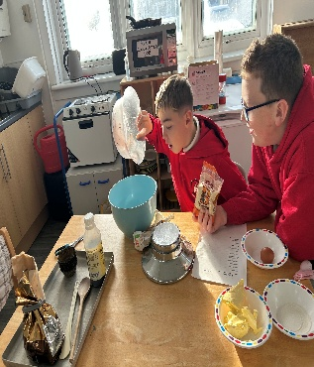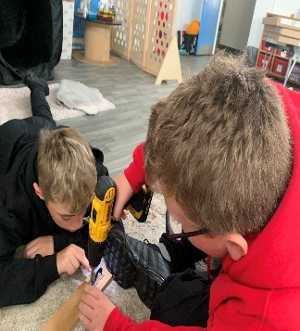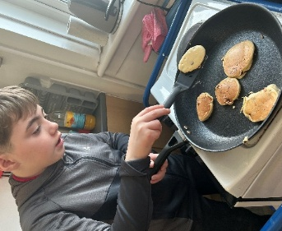
  Wellbeing Indicator | 2024/25 Rating (out of 5) | 2025/26 Rating (out of 5)
  Safe | 4.6 | 4.7
  Healthy | 4.5 | 4.6
  Achieving | 4.5 | 4.5
  Nurtured | 4.6 | 4.6
  Active | 4.7 | 4.7
  Respected | 4.4 | 4.5
  Responsible | 4.6 | 4.6
  Included | 4.6 | 4.6
  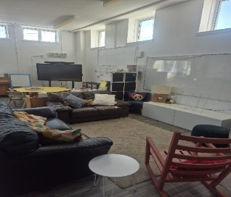 | 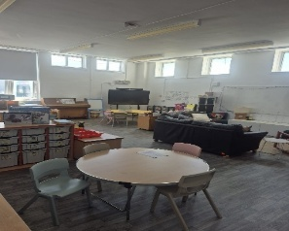
  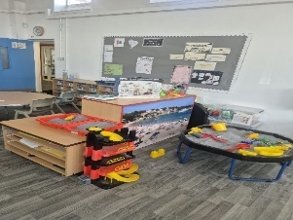 | 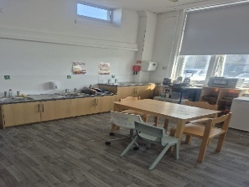
An additional classroom assistant was deployed to support learning across the infant department, with a targeted focus on pupils Primary 2 in response to addition need, large class size, attainment data and SIMD data. This enabled increased support, small group work and early intervention in literacy and numeracy, ensuring that barriers to learning were addressed promptly. | The additional classroom assistant has had a significant and measurable impact on improving outcomes for learner. The intervention has supported equity in attainment, reduced gaps in learning, and contributed to a strong early/first level foundation. | 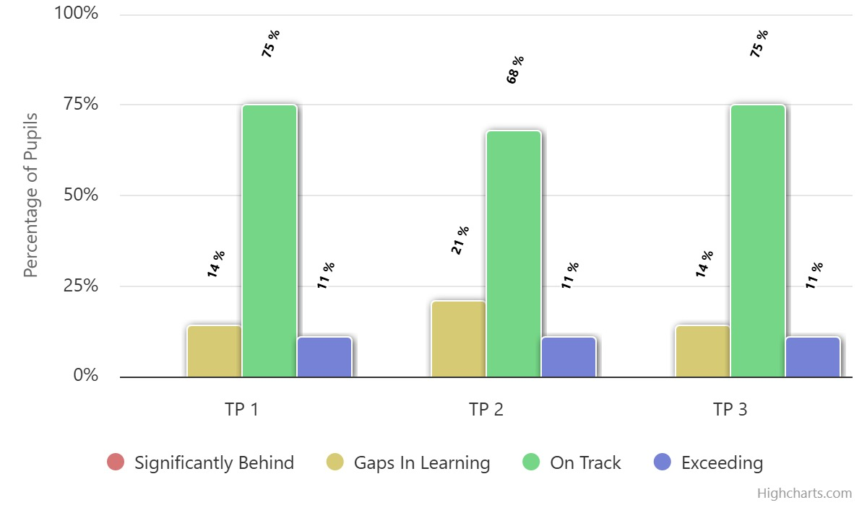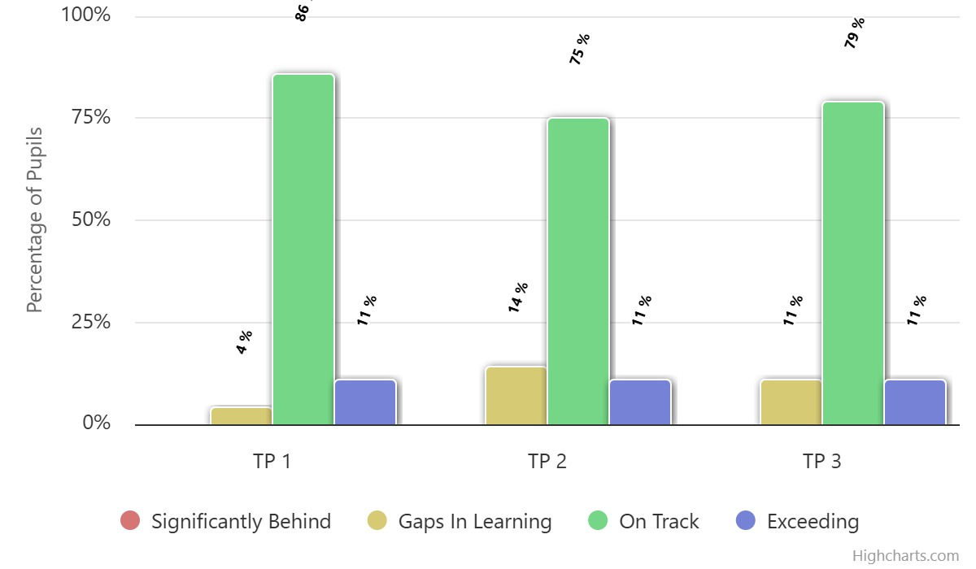
Purchase a range of inclusion and diversity resources, including high-quality texts focused on additional support needs such as dyslexia, autism, ADHD, dyscalculia, and dyspraxia. These resources were used to support whole-school learning during Inclusion Week, alongside targeted classroom activities. A dedicated diversity and inclusion section was also established within the school library to ensure ongoing access for pupils and staff.  Enhance learning and teaching through the purchase of additional high-quality resources across all curricular areas, ensuring equitable access for all learners. These included:  Literacy: Dictionaries and Bug Club reading materials to support reading development and comprehension.  Numeracy: Updated TJ Maths textbooks to provide structured and progressive learning.  IDL: Topic-based books to enrich interdisciplinary learning.  HWB: Inclusion-focused texts to support wellbeing and understanding of diversity.  PE: A wider range of equipment to increase participation and variety in physical activity.  Digital Learning (IT): ClickView subscription and stylus pens to enhance accessibility and engagement through digital platforms  These resources were targeted to remove barriers to participation and learning, particularly for pupils impacted by poverty who may not otherwise have access to such materials. | The targeted use of PEF funding has contributed to improved inclusion, engagement, and equity of experience for learners, particularly those impacted by poverty:  - Pupils demonstrated a greater understanding and awareness of diversity, helping to reduce stigma and promote a more inclusive learning environment  - Increased confidence and participation among learners with additional support needs, supported by representation within learning materials  - Improved peer relationships and respect for differences, contributing to a more positive ethos across the school  - Enhanced engagement in literacy, as pupils were able to access relatable and inclusive texts  The targeted use of PEF funding to enhance curriculum resources has had a positive impact on equity and attainment. By ensuring all learners have access to appropriate, engaging and high-quality materials, the school has:  - Reduced barriers linked to poverty  - Increased engagement and participation  - Improved confidence and independence in learning  - Contributed to measurable improvements in attainment.  We have enhanced the Health and Wellbeing (HWB) curriculum through the purchase of new sports equipment, enabling a significant refresh of the PE programme. This has allowed staff to deliver a broader, more inclusive and engaging range of physical activities, including exposure to contemporary sports such as pickleball. | Pupil voice gathered during and after Inclusion Week indicates that learners can articulate a clearer understanding of different needs and how to support one another  Classroom observations and staff feedback highlight increased participation and engagement, particularly from pupils who previously experienced barriers to inclusion  The creation and ongoing use of the library inclusion section ensures sustained impact, with consistent uptake of resources by both pupils and staff  Links can be made to attainment data showing improved ‘on track’ levels and reduced gaps in learning, particularly in early stages, where inclusive practice supports engagement and progress  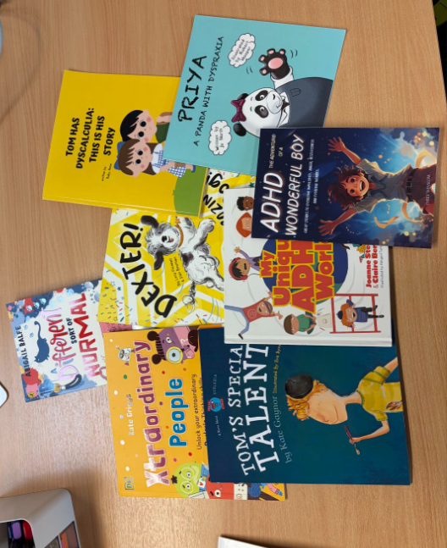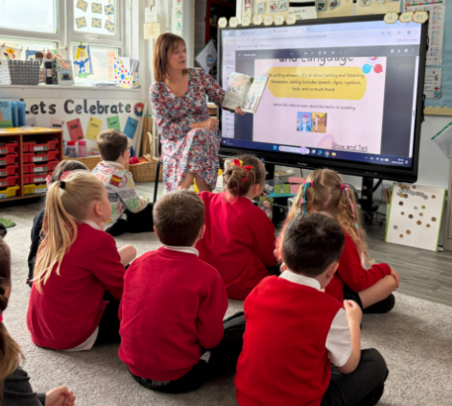  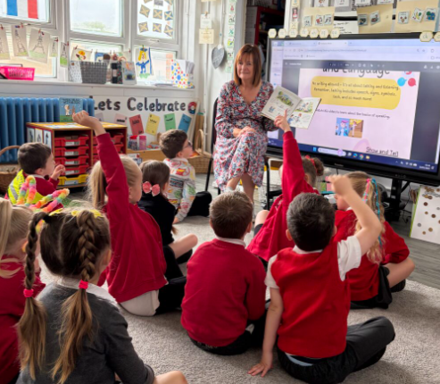  - Pupils demonstrate a greater awareness and understanding of diversity, helping to reduce stigma and promote a more inclusive learning environment  - Increased confidence and participation among learners with additional support needs, supported through inclusive and accessible resources across literacy, HWB and IDL  - Improved peer relationships and respect for differences, contributing to a more positive and inclusive ethos  - Enhanced engagement in literacy, with pupils benefiting from structured programmes such as Bug Club, access to dictionaries, and a wider range of inclusive and topic-based texts  - Pupils show increased engagement and motivation across the curriculum, supported by high-quality, up-to-date resources in numeracy (TJ Maths), IDL and digital learning  - Improved confidence and independence in numeracy, through consistent and progressive teaching approaches  - Greater digital inclusion, with tools such as ClickView and stylus pens enabling learners to access content in a variety of ways suited to their needs  - Increased participation in PE and HWB, supported by a wider range of equipment and more inclusive physical activities, ensuring more pupils can engage successfully  - Reduced barriers to participation for learners who may lack access to resources at home, ensuring equity of experience and opportunity across all curricular areas  - Increased participation and engagement in PE, with a wider range of pupils actively involved and developing physical and teamwork skills  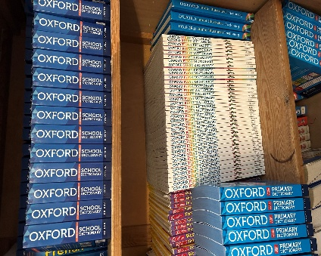  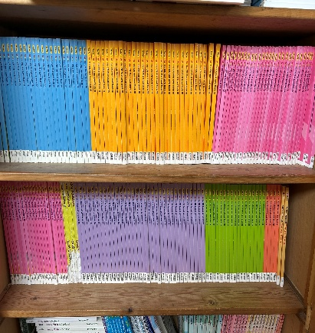  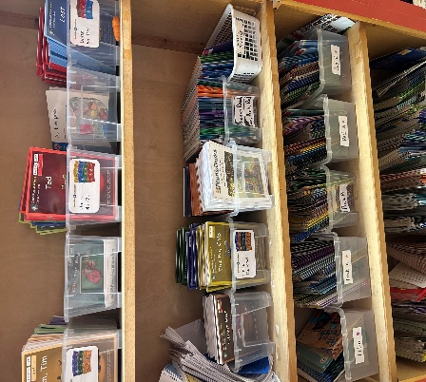  - Improved pupil leadership and responsibility, evidenced through the Sports Committee and better care, organisation and sustainability of equipment.  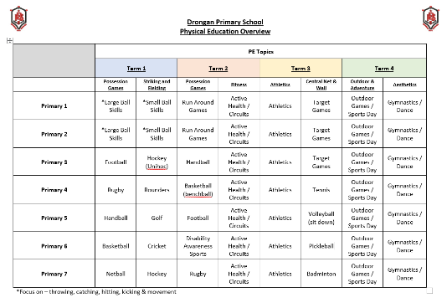  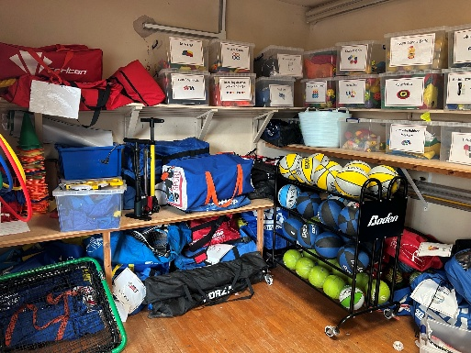

Establishment Self Evaluation: How Good is Our School? 4 Quality Indicators
Quality Indicator 1.3 Leadership of Change | Very Good
Quality Indicator 2.3 Learning, Teaching and Assessment | Very Good
Quality Indicator 3.1 Ensuring Wellbeing, Equality and Inclusion | Very Good
Quality Indicator 3.2 Raising Attainment and Achievement | Very Good

Establishment Capacity for Improvement
Please refer to School Improvement Plan for 2026/27

