
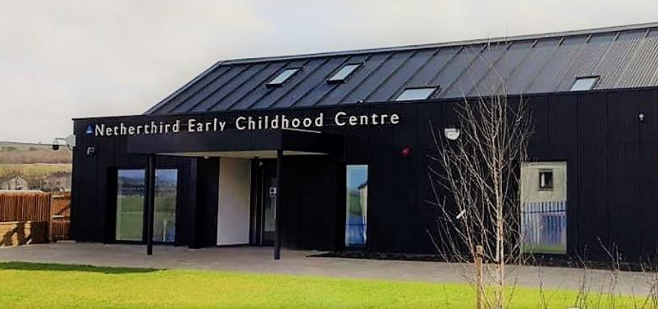
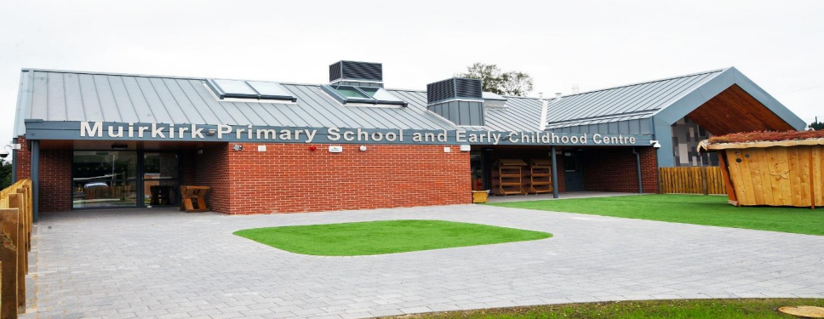



Establishment
Improvement
Plan
2026-27
Establishment: Drongan ECC

East Ayrshire Council
Education and Skills

School Improvement Plan | Drongan ECC
Head Teacher/Head of Centre: | Acting Head Teacher – Tom McFadzean
Date Submitted | Submitted to Chief Education Officer on : 26/06/2026

School / Centre  Vision and Values |   In Drongan Primary School and Early Childhood Centre our vision for all is:  To have a sense of belonging and pride in our local community where everyone is valued and we work together to be the best that we can be.  Within our school, ECC and local community, the shared values that we feel are important to instil in all are:  Teamwork, mutual respect, trust, inclusion, self-belief and resilience (ECC will focus on the values in bold)

Checklist

In line with the Standards in Scotland’s Schools etc. Act 2000 (amended 2016), the following checklist is designed to assist Heads of establishment with whole school/centre improvement planning that fulfils statutory duties in accordance with the Act. This must be completed prior to submission.

SIP Consultation included the following stakeholders: | Complete |  | Content of plan | Complete
Children and Young People | Yes |  | Takes account of strategic priorities outlined in the Education Service Improvement Plan. https://www.east-ayrshire.gov.uk/Resources/PDF/E/Education-Service-Improvement-Plan.pdf | Yes
Parent Council and Forum | Yes |  | HGIOS 4 and EYQF are used as the frameworks to inform the content of SIPs. Where appropriate.  https://education.gov.scot/media/v5sh3dqt/frwk2_hgios4.pdf  https://education.gov.scot/inspection-and-review/inspection-frameworks/quality-improvement-framework-for-the-early-learning-and-childcare-sectors/ | Yes
Teachers, practitioners and ALL school/centre staff | Yes |  | There is clear focus throughout the plan on measures to reduce of inequalities of outcome as a result of socio-economic disadvantage.  PEF: https://www.gov.scot/publications/pupil-equity-funding-national-operational-guidance-2023/documents/  CEF: https://www.gov.scot/publications/care-experienced-children-young-people-fund-operational-guidance-2023-24/documents/  SEF: https://www.gov.scot/publications/strategic-equity-funding-national-operational-guidance-2023/documents/ | Yes
Volunteers/ Community partners | Yes |  | Appropriate cognisance has been made of the links between the plan and the working time agreement for teaching staff. | Yes
Head Teacher / Head of Centre Signature: |  |  | An accessible summary of the SIP is available and contained in this document and will be provided to parents, children and young people. | Yes

Child and parental strategic involvement

For session 2026-27, please describe below how children and young people will be involved in decisions relating to the operation of the school/centre | For session 2026-27, please describe below how parents will be involved in decisions relating to the operation of the school/centre
- Child-lead learning and planning  - Consulting children about ECC values and giving parents/carers a voice on the vision, values and aims.  - Develop the nest provision for a new cohort of children  - Staff being responsive to the children’s interests  - Mascots will be introduced to support the understanding of the values  - Most children will be made aware of their UNCRC rights. | - Parents are invited to induction days before children start and agree settling in procedures for their own child.  - Parent contributions to child’s personal plan and all about me documents  - Parents are involved in setting targets for their child alongside their child’s key worker through the personal plans using the SHANARRI indicators.  - Surveys relating to ECC initiatives  - Parents will have access to their own child’s learning journal daily and will be able to and are encouraged to add to this.  - Further develop our high attendance stay and play sessions.  - Questionnaires and surveys to gather parental views.  - BLOG page on Glow for parents/ learning journals/ECC app where we share lots of the centre’s information.

Community Plan East Ayrshire  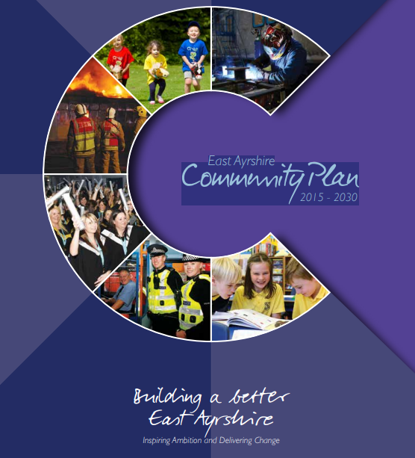  2015 - 2030 | Together, in achieving our Vision, Partners will demonstrate:  Effective leadership  We will provide clear leadership in Community Planning and engage effectively with our employees and communities  Collective ownership  We will take collective ownership for delivering on the Community Plan, the associated Single Outcome Agreement and the Community Plan Delivery Plans, and work hard to improve outcomes for local people and communities  Good governance  We will implement clear operating arrangements to support effective strategic direction, scrutiny and accountability  Democratic accountability  We will measure and report on the impact of our activities to demonstrate how effectively we are improving outcomes for local people and communities, and all partners will be held to account for their contribution.
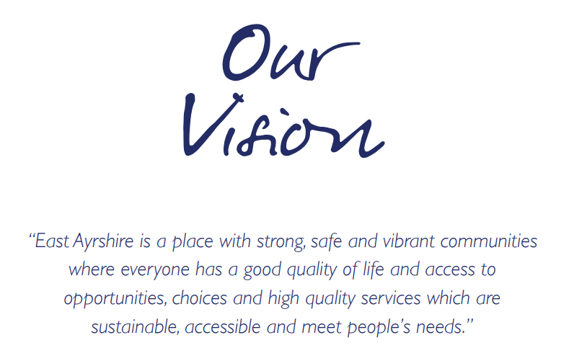  Our Partnership will continue to work to meet the needs of the people who live in our communities. Our guiding principles will be reflected in all that we do and should be evident for all to see. |  | We will:  - Promote lifelong learning.  - Promote equality and tackle inequality;  - Adopt a preventative approach;  - Ensure effective community engagement in the planning and delivery of local services;  - Utilise the strengths and resilience within communities;  - Drive efficiency and performance improvement;

National and Local Priorities
The Scottish Government’s vision for education in Scotland:  - Excellence through raising attainment and improving outcomes  - Achieving equity  Key priorities of the National Improvement Framework:  - Placing the human rights and needs of every child and young person at the centre of education  - Improvement in children and young people’s health and wellbeing  - Closing the attainment gap between the most and least disadvantaged children and young people  - Improvement in skills and sustained, positive  school-leaver destinations for all young people  - Improvement in attainment, particularly in literacy and numeracy | NIF drivers of improvement in the outcomes achieved by children and young people are:  - School and ELC leadership  - Teacher and practitioner professionalism  - Parent/carer involvement and engagement  - Curriculum and assessment  - School and ELC improvement  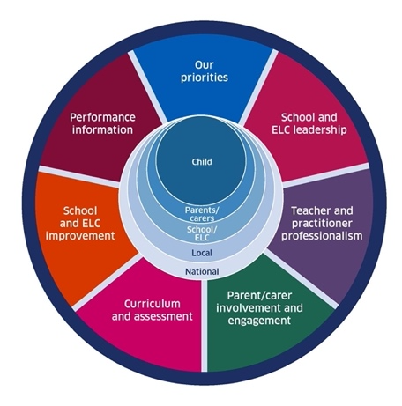  - Performance information | Scottish Attainment Challenge (SAC)  Scottish Attainment Challenge: framework for recovery and accelerating progress  Scottish Attainment Challenge Logic Model – Tackling the Poverty-Related Attainment Gap – Our Theory of Change  SAC organisers:  - Learning and teaching  - Leadership  - Families and communities

East Ayrshire Plans
Key Priorities | Education Service Improvement Plan: | Children’s Services Plan: | Community Learning and Development Plan:
1: Our Leadership | We actively support, promote and enact leadership at all levels. Our young people are supported to be leaders on their learning in our centres, schools and wider life experiences. All staff have ready access to appropriate CLPL and experiences to promote leadership in every classroom and centre. | Priorities for 2023-26:  - Our children and young people feel respected, listened to and influence change  - We are working collaboratively, reducing the impact of social and economic poverty on our children and young people  - Our children and young people feel safe  - Our children and young people have the best start in life  - Our children and young people’s mental health is improving | Outcomes:  - Growth  - Wellbeing  - Fairness  - Sustainability  Action areas  - Youth voice and participation  - Lifelong learning and skills development  - Empowering communities  - Wellbeing and inclusion
2: Teaching and Learning Together | Our young people should experience a teaching, learning and curriculum offer that meets their needs, and those of our local and national context. All staff should be supported to deliver in new and innovative ways by accessing CLPL relevant to their needs and those of our young people.
3: Our Wellbeing and Belonging | We want all of our young people to feel supported by people who know them well, and feel included in all of our schools and centres. Our staff need to be supported in their working with our young people, especially in times of adversity. As a key universal service, it is our vision that all young people attend our establishments on a full-time and regular basis to support them in their development at all stages.
4: Our Attainment, Destinations and Achievements | We want the very best for all of our young people in East Ayrshire. We aim to ensure all young people secure a positive destination through excellent achievement and attainment at all levels.

Our Leadership: Improvement priority: What is going to be the focus of this priority? To work towards gaining our UNCRC Bronze award
Rationale – Within the QIF it is evident that the UNCRC plays a huge part in all the work we do and to ensure children’s rights are being adhered to. We will begin to talk to children about rights and incorporate them into the day and planning.
NIF key drivers: | School & ELC leadership |  |  | School & ELC leadership |  |  |  | Select driver |  |  | Select driver
QIF ELC: | Select QI |  | Select QI |  | Select QI |  |  | Select QI |  | Select QI |  |  | Select QI
ESIP key priorities: | N Teaching & Learning |  |  |  |  |  |  | N Our Wellbeing |  |  | N Our attainment
Outcomes for our learners  By June 2027 we will have gained our UNCRC bronze award |  | Our actions/Approaches/Interventions  Management will apply for registration to work towards the UNCRC Bronze award accreditation  Staff will complete RRSA questionnaire  We will inform parents/carers that the ECC is working towards the RRSA  Staff will become familiar with the UN Convention on the Rights of the Child. We will complete the modules on the e-learning platform. |  |  |  | PEF  N/A | Who  DM  SELCP  All staff |  | Measures  Quality assurance calendar  Parent/carer info and questionnaire  E-learning |  |  | Review/milestones  Term 1  Term 1  Term 1  Term 1
Almost all children will be aware of some of the UNCRC rights and staff will support them to understand. |  | Children will be made aware of the document in a child friendly manner. Pictorial friendly.  Staff will talk to children about their rights through planning and check-ins .  We will incorporate the articles in our daily practice.  Mascots will be developed to support the understanding of the values  Parents will be consulted with regards to the understanding of the UNCRC rights.  Children’s art work will be supported by right articles. |  |  |  | N/A | DM  SELCP  All staff  Parents |  | Daily check-ins  Wellbeing check-ins  Planning and monitoring audit.  Microsoft forms questionnaires  Children’s art work displays |  |  | Termly  Termly/daily  Daily
Teaching and Learning Together: Improvement priority: To ensure that every child achieves the highest possible standards in numeracy.
Rationale – It was evident from data gathered in June 2026 from Learning Journals that 5% of children transitioning to school had achieved less than 80% of the identified numeracy outcomes. Playroom monitoring records also confirmed that numeracy experiences provided were minimal across the ECC in comparison to those planned to develop children’s literacy skills.
NIF key drivers: | Select driver |  |  | Select driver |  |  |  | Select driver |  |  | Select driver
QIF ELC: | Select QI |  | Select QI |  | Select QI |  |  | Select QI |  | Select QI |  |  | Select QI
ESIP key priorities: | N Our Leadership |  |  |  |  |  |  | N Our Wellbeing |  |  | N Our attainment
By June 2027 all children transitioning to school will secure very good progress across the identified numeracy milestones and almost all (41 of 56) children will make good progress in their numeracy development. |  | Our actions/Approaches/Interventions  Staff will agree on 8 numeracy milestones to focus on. These will be selected from the EAC monitoring and tracking tool.  All staff will track children’s numeracy development on an ongoing basis using learning journals. Data on journals will be analysed termly and used to plan targeted intervention for children at risk of not attaining the identified numeracy milestones. |  |  |  | PEF  N/A  N/A | Who  DM  SELCP  DM  SELCP |  | Measures  EAC monitoring and tracking tool.  Staff meeting minutes where they will report of children’s progress.  EAC monitoring and tracking tool  Records of pace and challenge meetings with individual staff |  |  | Review/milestones  Termly  Termly  Termly  Termly  Termly
All children transitioning to mainstream school will be rated amber (all 21) and/or green (15 children) on the eight identified milestones (amber confirms children are making good progress/green confirms the skill has been achieved. |  | The monthly planning system in each zone will include a numeracy focus. Staff will provide ample opportunities to develop their thinking and problem-solving skills. |  |  |  | N/A | SELCP  Numeracy lead |  | Planning records  Numeracy coverage tracker  Planning monitoring  Management observations of experiences, interactions and spaces  The ECERS-E scale audits and reviews. |  |  | Termly  Termly  Termly  Termly  Biannually
All children will make progress across the breadth of the numeracy outcomes (data will be pulled using + function in Nov 26 and May 27). |  | Staff will facilitate a parent/carer workshop to raise awareness of the importance of early numeracy experiences within the home environment.  Staff will plan 3 stay and play sessions over the academic year with a focus on providing fun, stimulating numeracy experiences for children and parents/carers. |  |  |  | N/A  N/A | SELCP  Numeracy lead |  | Parent/carer surveys  Parent/carer contributions to Learning Journals  Children achieved next steps on learning journals. |  |  | Biannually  Biannually  Termly  Termly

Our Wellbeing and Belonging: Improvement priority: To further improve the quality of targeted intervention within the ECC
Rationale – Our recent inspection in February 2026 was highlighted that we were providing high quality learning experiences. Personal Plan audits and Learning Journal evidence showed however, that not all children were achieving their agreed learning and development targets due to attendance.

NIF key drivers: | Select driver |  |  | Select driver |  |  |  | Select driver |  |  | Select driver
QIF ELC: | Select QI |  | Select QI |  | Select QI |  |  | Select QI |  | Select QI |  |  | Select QI
ESIP key priorities: | N Our Leadership |  |  | N Teaching & Learning |  |  |  | N Our attainment
Outcomes for our learners |  | Our actions/Approaches/Interventions |  |  |  | PEF | Who |  | Measures |  |  | Review/milestones
By June 2027 all children (56) will have made progress in their learning. All children will have achieved a minimum of 2-3 next steps each term. Progress over time will be evident for all children when using the + function.  By June 2027 progress will be evident within all My Plans and Teaching Talking assessments. |  | Working groups will be created to include all children and not only those at risk of not attaining. Experiences will be differentiated, ensuring all levels will be appropriate. EAC monitoring and tracking tool will be used to measure progress and data will be used to measure overtime. |  |  |  | N/A | SLT  Staff |  | Learning journal monitoring  Planning monitoring |  |  | Termly
 |  | The ECC will be part of the Chatting Together programme to support the speech, language and communication of children. |  |  |  | N/A | 2 year old staff  SELCP |  | QI data |  |  | Termly
 |  | Teaching talking assessments will be used by staff when concerns are noted with children’s speech and language development. Assessment information will then be used to plan targeted support and share information with necessary agencies. TT assessments will be reviewed to monitor and track progress. |  |  |  | N/A | Staff |  | Teaching Talking assessment |  |  | Termly
By June 2027 a significant increase in child attendance will be having a positive impact on meeting targets. |  | Children’s attendance will be closely monitored and if a child’s attendance begins to decrease SLT will work in partnership with parents/carers or other agencies to try and improve attendance levels. |  |  |  | N/A | Management/ Staff |  | SEEMiS attendance records |  |  | Termly
Our Attainment, Destinations and Achievements: Improvement priority: The ECC was part of the Early Years Quality Improvement project to improve the wellbeing scores of children with ASN. The next steps identified were to continue to develop the learning environment to suit the needs of the learners and to also support the wellbeing of staff.

Rationale - To continue to improve the wellbeing of children and staff through nurturing approaches and develop our nurturing environment

NIF key drivers: | Select driver |  |  | Select driver |  |  |  | Select driver |  |  | Select driver
QIF ELC: | Select QI |  | Select QI |  | Select QI |  |  | Select QI |  | Select QI |  |  | Select QI
ESIP key priorities: | N Our Leadership |  |  | N Teaching & Learning |  |  |  | N Our Wellbeing
Outcomes for our learners  By June 2026, the health and wellbeing of all children will continue to improve by providing a fully inclusive and nurturing environment. Evidence within self-evaluation records will capture the impact of changes/improvements on outcomes for children. For all children and staff to have a wellbeing score of 3.5 or above |  | Our actions/Approaches/Interventions  Staff will foster trusting, loving relationships with children, to help support children feel safe and secure. This will be achieved through a key worker system.  Evidence of positive interactions  All children will be welcomed by their key worker at drop off and collection and this will be done through zones of regulation.  Daily checkins with staff to record their wellbeing |  |  |  | PEF  N/A | Who  Management  Staff  SLT  Staff  Staff |  | Measures  Playroom monitoring  Termly observations  Tracking with staff  Staff checkins |  |  | Review/milestones  Termly  Termly  Termly  Daily  Daily
Children will make progress across the HWB outcomes (data will be pulled using + function in Nov 25 and May 26). |  | Staff will implement effective routines for children.  Visual timetables will be created to map out the pace of the day  Now and next board will be created for children who require additional support.  Staff will provide children with visuals and timers to support transitions. |  |  |  | N/A | Staff  Management |  | Playroom practice observations (spaces, interactions and experiences  Visual board which is interactive for the children  Timers will be available in accessible areas of the playroom. |  |  | Termly  Daily  Daily
Children will confidently separate from their parents/carers almost all of the time. |  | All new children and their parent/carer will have an individual induction with DM/SELCP prior to starting the ECC.  Staff will complete Personal Development Plans to document all health, welfare and safety needs. |  |  |  | N/A | Management  Key workers |  | Induction packs  Termly meet with parents |  |  | Termly  Termly
Develop ‘The Nest’ for an inclusive provision for children with ASN. |  | There will be a change in staff within this area.  Staff member will model best practice prior to maternity leave.  Staff member will be mentored by staff to ensure the provision is effective to the needs of the children. |  |  |  | N/A | Management  Key worker |  | Staff check ins  Planning monitoring |  |  | Monthly

Summary of Improvement Plan directly linking to Education Service Improvement Plan

Our Leadership | Teaching and Learning Together
- Lead staff through our UNCRC RRSA bronze award  - Work alongside the school to support children’s rights  - Empower staff to ensure they are embedding the rights across the ECC. | - Have a robust monitoring system that will clearly show children’s progress.  - Further enhance stay and play sessions and provide information to parents.
Our wellbeing and belonging | Our Attainment, Destinations and Achievements
- Work closely with parents regarding their child’s attendance.  - Continue to foster positive relationships with children and families.  - Ensure staff are checking in with children through zones of regulation. | - Support staff to ensure they are working collaboratively to ensure their own well-being is stable.  - Promote positive relationships with parents/staff and children.  - Continue to extend the provision for our asn children.

