I would like to wish a Happy New Year to all of our parents, carers, children and the Drongan community!

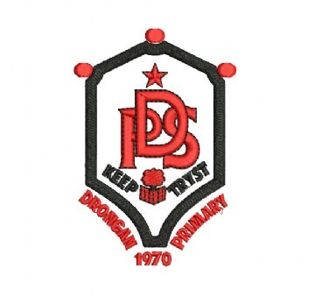

Dear parent / carer,

It has been lovely to welcome the children back to school / nursery this week.

As I have explained in previous communication via the app, we found ourselves in a difficult position due to staffing absences at the beginning of term. We will do everything in our power to ensure consistency and continuity for all classes as we move through this stage of the pandemic. Although we still have absences the overall staffing situation has now stabilised and we hope that this continues to be the case.

Staying with staffing I would like to wish Rhea Ireland (Depute Manager ECC) all the very best for her maternity leave. We wish you and well Rhea, enjoy the time with your family.
I would also like to thank Marilyn Broadfoot for her services to catering at Drongan Primary. Marilyn has decided to leave the catering service but will continue to work with Facilities and Property services in the school.

Primary 1 Enrolment

P1 Registration to attend school, for children whose 5th birthday falls between 1 March 2022 and 28 February 2023 takes place during the week Monday 10 January 2022 until Friday 14 January 2022.

To register please complete the P1 Registration form at http://eastayrshi.re/enrolAtSchool no later than Friday 14 January 2022.

If you are unable to register online then please phone your local school who will assist you to register your child.

To register your child you will require to upload a copy of your child’s birth certificate and two proofs of your residence in the catchment area in the form of a Council Tax Notice or Utility Bill. Should you require a copy of your child’s birth certificate for Registration, this can be obtained at www.certificates.scot

Parents’ Evenings
Please note that following feedback and discussions with staff, we have decided to move Parents’ Evenings forward this session. Parent meetings will now take place on 2nd and 3rd March. This will provide you with an opportunity to discuss your child/children’s progress and any other issues with their class teacher at an earlier stage of the session.
An end of year report will still follow in early June.

Child Protection

Please note that Mr Maddocks HT is the Child Protection Officer for both Drongan Primary School and the Early Childhood Centre. Should you have any concerns about the wellbeing or safety of a child then please contact the school or ECC and ask to speak to Mr Maddocks. In Mr Maddocks absence, Mr McFadzean DHT would be the staff member to speak to.

Parent Council Meeting

The next Parent Council meeting is on Monday 24th January at 7.00pm. All parents and carers of Drongan Primary School pupils are welcome to attend and we really would love to see some new faces at the forthcoming meeting, which will take place virtually.
Please get in touch if you would be interested in supporting the Parent Council and we will pass your details to the relevant person.

Home Lunches

While we encourage our children to stay in school and have a school dinner or packed lunch, we understand that some children prefer to be a home lunch. For health and safety reasons, please send a letter in to school with your child to let us know which days they will be leaving the school at lunchtime. If you are sending a letter with a list of dates, please only do so for the current term.

Children’s Mental Health week

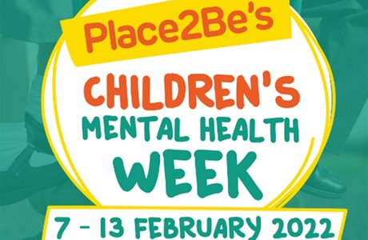

Children’s Mental Health Week runs from 7th-13th February this year. Children will take part in a variety of activities to help raise awareness of mental health. To mark the end of Children’s Mental Health Week, we will be encouraging pupils to take part in a ‘Dress to Express’ day on Thursday 10th February. More information on this will follow soon.

Look out for February’s Right of the Month on our school blog. This will focus on;
Article 2 – No Discrimination Article 13 – Right to share your views and opinions.
If you can, discuss these rights with your children and try some of the activities at home.
The children will also take part in activities linked to the rights in class.

Dogs in the Playground

A reminder that dogs are not permitted in the school grounds, especially during drop off and pick up times.
We would also ask that if you are walking your dog in the surrounding areas, that any dog waste is binned. There have been a couple of unfortunate incidents recently where children have stood on dog waste near the school entrances.

Micro-Tyco

Primary 7 will once again be taking part in the Micro-Tyco enterprise topic this term.

Micro-Tyco is a month-long challenge that enables participants to practice and learn fundamental business principles in a safe, 'micro' environment. Teams from schools, universities or businesses have one month to turn £1 seed capital into as much money as possible. Micro-Tyco unleashes participants' latent talents, fostering essential entrepreneurial thinking, resourcefulness and team work.

More information about the activities will be sent out by P7 shortly, but we once again look forward to the showing their enterprise skills to raise some invaluable funds. As we have done in the last couple of years, funds raised through this topic will be shared between the school fund (to support the P7 summer activities) and a charity.

Scots Verse / Burns Recitation Competition

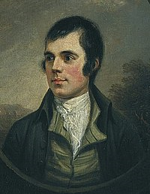

We are looking forward to holding our annual Burns / Scots Verse competition, which will take place at the end of January. Unfortunately for obvious reasons we will not be able to celebrate Burns in the usual way by having all the children in the hall and inviting parents for the final; however, we are keen to hold the competition again after missing it last year.

All classes will be allocated with a poem to focus on. Children are expected to do their best to learn their allocated or chosen poem as homework. Class teachers will also introduce the poems and work together with the children in class to develop their knowledge and confidence. Scots Verse and Burns together with Listening and Talking is part of the curriculum in Literacy and is also an important part of our national and local heritage. As a school we are keen to educate our children about the important heritage and local history with regards to Scots verse and Robert Burns. We fully appreciate that some children are more confident than others when it comes to this sort of thing but encourage all children to do their best.

Three children will be chosen from each class to perform in the final in front of a judging panel where a class winner for every class will be chosen. An overall P1 – 3 winner and P4 – 7 winner will also be announced on the day of the competition.

As discussed, we won’t be able to invite you in to the school to enjoy this with us in the usual way. We will do what we can to film the finalists and post on the blog. The final will take place on Friday 28th January.

National Numeracy Parental Engagement Project

The school is delighted to have been selected to work with the independent charity National Numeracy on an exciting project which encourages children and families to do maths together.
In October, we introduced National Numeracy’s Family Maths scrapbooks and activities. These are weekly activities that help children and families to explore everyday maths at home together. They link the maths that children are learning at school with life outside the classroom.
You don’t need any special knowledge or equipment to work on the activities. Just talking about everyday maths can help develop children’s maths confidence. You might like to take photos, draw pictures, write sums or create diagrams in the scrapbooks – it’s up to you!
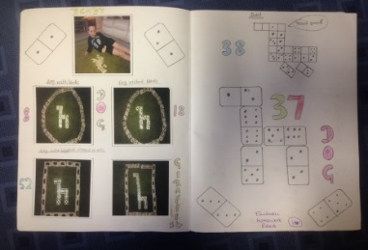
National Numeracy has provided a scrapbook for every child in the school. We encourage all families to support their children’s learning by getting involved with the activities.
However you feel about maths, you can make a big difference to your child’s numeracy learning. In a similar project, 88% of children said they increased their confidence with maths and 86% of parents said they increased their confidence in helping their children with maths.
The children have really enjoyed sharing their scrapbooks with their class and we hope this term, everyone can join in and share their learning.
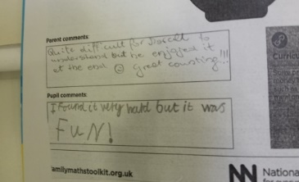
For more information, have a look at what we have done so far, in the Numeracy Blog.

https://sway.office.com/zFOz4U4tHW0fAIiC?ref=Link

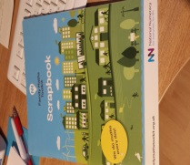

The Scottish Poppy Appeal

Thank you for your support of The Scottish Poppy Appeal. We managed to raise £125.70 for this charity through the sales of poppies back in November.

Children in Need

Our fundraising for Children in Need in November last year was also a success. The pupils enjoyed the ‘Do good, feel good activities that were planned by P7 and coming into school wearing their Pudsey outfits and accessories. They also took part in the Children in Need Ambassador Joe Wicks’ special workout. In total £202.44 was raised for Children in Need. Thanks once again for your support.

P7 Residential

Unfortunately the current guidance prohibits us from booking a residential trip for our P7 pupils again this year. We are hopeful that we will still be able to provide our pupils with some different activities and days out in the summer term, but all of this will be based on guidance from EAC and the Scottish Government.

P7 Hoodies
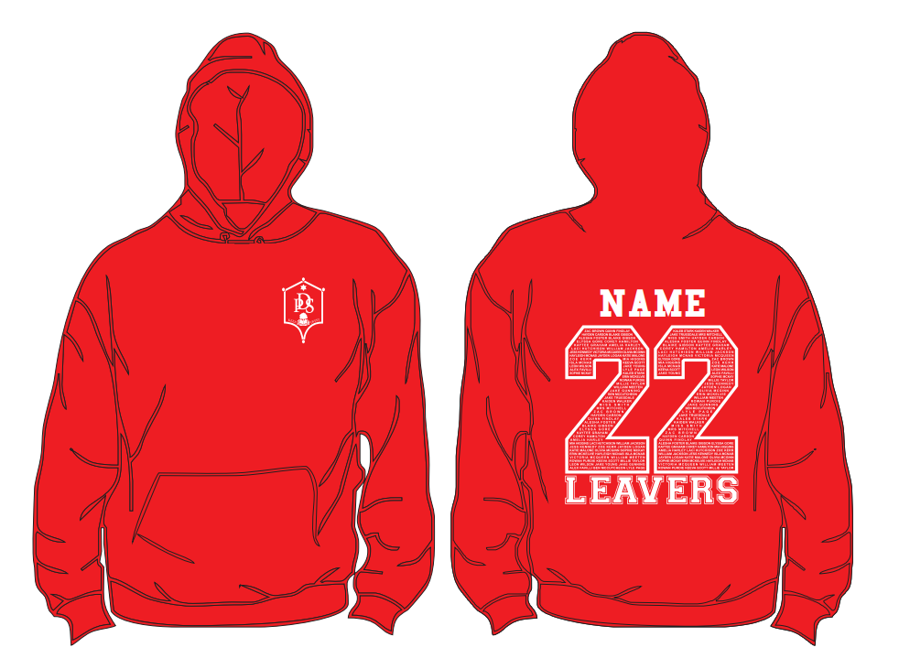

The P7 Hoodies have now been ordered and will hopefully be with us soon.

Reaching Out

The past few years have been challenging for everyone but we are aware that for some members of our community, this has been a particularly difficult and lonely time. Last session, the Pupil Council decided that each class would send personalised letters sharing news, videos, messages and pictures. We hoped this would help everyone in our community feel included and valued.
We had a great response from the community and have therefore decided to continue the project this session.

The Pupil Council have prepared a video to explain more;

https://twitter.com/dronganps/status/1473250545578225666?s=11

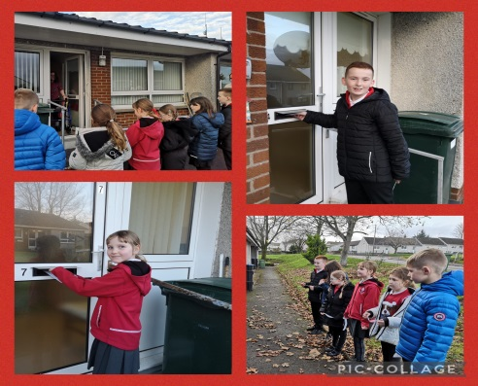

If you can think of anyone – family, friend or neighbour who would benefit from a letter then please complete the form sent home with your child. You can return the form to the school, email Mrs Cowie at lynsey.cowie@eastayrshire.org.uk or contact Mrs Gibson in the school office. We will, once again, include Rowantree Court in the project.

Virtual / Class Assemblies

Another huge well done to our Primary 7s who produced a virtual assembly just before Christmas. The assembly can be found by clicking on the link below.

Drongan News - Christmas Edition 2021 - YouTube

Christmas Song

Well done to the whole school for participating in the recording and filming of our Christmas song. It was good fun and gave us all something to smile about in the run up to Christmas. We even made it on to West FM. Well done everyone, especially our soloists.
You can see the video by clicking the link below.

Christmas Time (May All Your Dreams Come True) - YouTube

Christmas Fundraising

The Christmas Fundraising activities in school were a real hit with the children and wider community. We would like to start by saying a huge thank you to our pupils, parents and wider community for supporting us through buying reindeer food, calendars or raffle tickets; as well as the in school activities that took place for the pupils.
We are looking forward to being able to hold our Christmas Fayre again in the future, but these activities have been invaluable for our school fund, enabling us to buy in new resources and support our children. We are also hoping the money will be able to allow us to subsidise some trips in the future when we can get back to going on educational visits.

The activities raised just over £2200 for the school fund, an incredible amount. Thank you to all of the local businesses for donating prizes for our raffle and to the school community for making donations and supporting us throughout.

Wider Achievements

Wider achievements will continue to be celebrated in classes rather than at assemblies.
Please remember to send trophies, certificates, medals or any other news of your children’s achievement in to school on a Friday morning to be shared with their class. They will also have their photograph taken for our display.

Communication

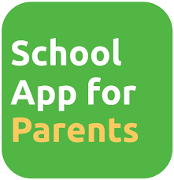

The school app will continue to be our main form of communication with parents and carers. You can also find a lot of information about the school on our Glow Blog / website and we also have a Twitter feed to provide more regular updates as well as celebrating good practice and children’s achievements. If you are on Twitter please follow us @DronganPS. I have also put a link to the Glow Blog, which we have developed over the last couple of years. The blog can also be found by simply searching ‘Drongan Glow Blog’ in Google.

https://blogs.glowscotland.org.uk/ea/dronganpsecc2016/

School & ECC Holidays

The school will close for the February break on Thursday 10th February at 3.00pm and reopen for pupils on Wednesday 16th February.

The school will close for Easter break on Friday 1st April at 2.30pm and re-open to pupils on Tuesday 19th April.

Thank You

Yours sincerely
Mr S Maddocks
Head Teacher
Sean.maddocks@eastayrshire.org.uk

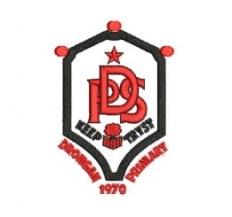

Dates for your diary: January – April

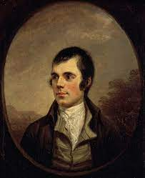
Mon 10th Jan: P1 Enrolment
Mon 24th Jan Parent Council Meeting
Fri 28th Jan: Burns / Scots Verse Competition Final
Fri 28th Jan: Special Scottish Menu:
Haggis, Steak Pie, Mince ‘n’ Tatties, Shortbread

Mon 7th Feb: Children’s Mental Health Week
Tues 8th Feb: Safer Internet Day
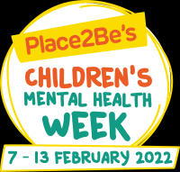
Thurs 10th Feb: Dress to Express Day
Thurs 10th Feb: School Closes
Fri 11th Feb: Holiday
Mon 14th Feb: Holiday
Tue 15th Feb: In-service Day

Wed 2nd March: Parents’ Meetings
Thurs 3rd March: Parents’ Meetings
Thurs 3rd March: World Book Day
Fri 18th March: Comic Relief Day

Fri 1st April: School Closes at 2.30pm
Tues 19th April: School reopens

Drongan Primary School and Early Childhood Centre Vision, Values and Aims

Vision

In Drongan Primary School and Early Childhood Centre our vision for all is:

To have a sense of belonging and pride in our local community where everyone is valued and we work together to be the best that we can be.

Values

Within our school, ECC and local community, the values that we feel are important to instil in all are:

Teamwork

Mutual respect
Trust

Inclusion

Self-belief

Resilience

Aims

In Drongan Primary School and Early Childhood Centre our aim is to develop the four capacities outlined in Curriculum for Excellence in all of our pupils to prepare them for future life.

We will encourage our children to be:

Confident individuals by promoting self-worth, ambition and resilience

Responsible citizens by promoting diversity, communication skills and confidence

Effective contributors by promoting community spirit, enjoyment and participation

Successful learners by promoting skills development, challenge and engagement in learning

