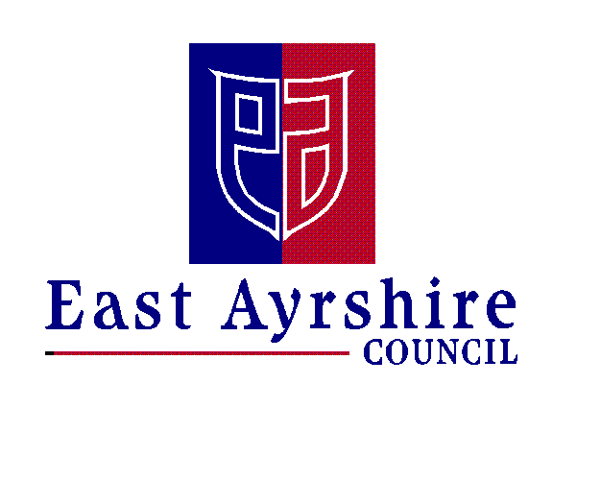Economy and Skills
Depute Chief Executive and Chief Financial Officer
Alexander McPhee ACMA
Drongan Primary School & Early Childhood Centre
Head Teacher: Mr Sean Maddocks
Millmannoch Ave, Drongan, Ayr, KA6 7BY
Tel: (01292) 591291

8th November 2021

INTERGENERATIONAL PROJECT: LOOKING AFTER OUR COMMUNITY

Dear Parent/Carer,

The past few years have been challenging for everyone but we are aware that for some members of our community, this has been a particularly difficult and lonely time. Last session, the Pupil Council discussed this issue and decided that each class would send personalised letters sharing news, videos, messages and pictures. We had a great response from the community and the children were keen to look out for their neighbours.

If you can think of anyone – family, friend or neighbour who would benefit from a letter then please complete the form below. You can return this form to the school, email Mrs Cowie at lynsey.cowie@eastayrshire.org.uk or contact Mrs Gibson in the school office.
We will, once again, include Rowantree Court in the project.

We hope this will make everyone in our community feel included and valued.

Thank you for your help.

Kind regards,

Mrs Cowie and the Pupil Council

----------------------------------------------------------------------------------------------------------------
INTERGENERATIONAL PROJECT

Please complete the table below with the details of your nominated person to receive letter from pupils.

Name:
Address:
Any additional information:
Links to the school/hobbies etc.

Pupils’ name
Class

