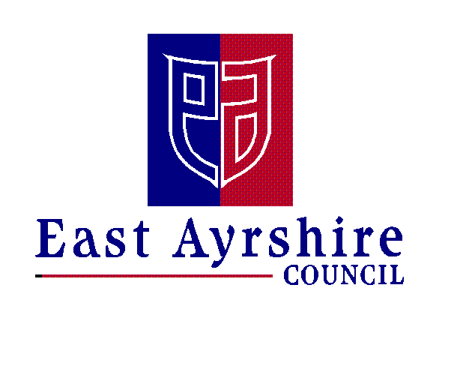Economy and Skills
Depute Chief Executive and Chief Financial Officer
Alexander McPhee ACMA
Drongan Primary School and Early Childhood Centre
Head Teacher: Mr Sean Maddocks
Millmannoch Ave, Drongan, Ayr, KA6 7BY
Tel: (01292) 591291

12th November 2021

CHRISTMAS RAFFLE TICKETS

Dear Parent/Carer

We are now selling tickets for our Christmas raffle. Tickets cost £1 each and we some fantastic prizes, along with 3 adult and 3 child hampers, up for grabs. We will post a list of prizes (we have over 40!) on the app / blog soon, so you can see what you could win.

If you wish to order raffle tickets, please complete the slip below and return it to school with your child before Friday 10th December (payments to be made by this date also). Please note that tickets can be paid for using Parent Pay or in cash. Mrs Tait has set up Parent Pay accounts to allow payments to be made, please indicate on the order slip how you will be paying. Tickets will be issued once payment is made.

The draw for the raffle will be made week beginning 13th December 2021, allowing us time to contact parents to collect prizes.

Next week we will also start selling the ‘Giant Teddy Raffle’ tickets and guesses for ‘Reindeer’s Birthday and the Elf’s Name’. Tickets and guesses are 50p each. Pupils can bring in money for these in school activities. Parent Pay will not be used for these activities in school. We will post a picture of these prizes on the blog next week.

Kind regards

Tom McFadzean
Depute Head Teacher

……………………………………………………………………………………………………………

RAFFLE TICKET ORDERS (can be ordered until Friday 10th December)

I would like to order the following number of raffle tickets for which payment will be made on Parent Pay:

Number of raffle tickets @ £1:00 each: ………………

Amount to be paid on Parent Pay: £………………………….
or
Amount to be paid in cash: £………………………….

Pupil’s name: ............................................................ Class: ....................

Parent’s/Carer’s signature …………………………………………………………………

