Economy and Skills
Depute Chief Executive and Chief Financial Officer
Alexander McPhee ACMA
Drongan Primary School and Early Childhood Centre
Head Teacher: Mr Sean Maddocks
Millmannoch Ave, Drongan, Ayr, KA6 7BY
Tel: (01292) 591291

25th October 2021

DRONGAN PRIMARY CHRISTMAS FUNDRAISING

Dear Parent/Carer

Unfortunately due to the current situation, we are again unable to hold our Christmas Fayre. However, we are planning some fundraising activities to ensure our school community can take part in some nice events on the run up to Christmas. All money raised through our fundraising activities will be added to our school fund to support learning and teaching within the school.

Christmas Raffle
The raffle is always a popular part of our Fayre and because we can do this in a safe way, we have decided to organise a raffle for our school. In preparation, we will be having a Dress Down Day on Friday 29th October (Halloween themed or casual clothes if children want to participate). Children will be asked to bring in a donation for our raffle or hampers, which should help us get our raffle up and running. Please note that any donations made should be new and unopened. A perfect opportunity to donate any unwanted or unopened bottles / gifts / toys / sweets you may have in the house. If you would like to make any additional donations for our raffle, these can be handed in at the school office or sent in with your child. We will be selling tickets for our raffle soon, so please keep an eye out for a letter and message on app about how they can be ordered.

Items you can order – available to order now

Calendars (individual, family or class) - We are once again going to be selling personalised A4 calendars for 2021. You can order a calendar for a cost of £2.50 each. ECC pupils can order an individual calendar or be part of a family calendar if they have siblings in the primary school.

Reindeer Food – If you are looking for something ‘magical’ for Christmas Eve, then our Reindeer Food might be for you. We will be selling these at £1 each and you will see a picture on the order slip.

If you wish to order any of the items listed above, please complete the slips on the reverse of this letter and return them to school with your child before Friday 3rd December. Please note that these items can be paid for using Parent Pay or in cash. Mrs Tait has set up Parent Pay accounts to allow payments to be made, please indicate on the order slip how you will be paying. Orders will be guaranteed once payment is made.

Activities in School – from Monday 15th November

Giant Teddy Raffle – Always a popular activity. Raffle tickets will cost 50p each and the winning entry will win the giant teddy bear!

Guess the Reindeer’s Birthday / Elf’s Name – Pupils will get the chance to take part in our ‘Guess the Reindeer’s Birthday / Elf’s Name’ at a price of 50p, with the winning entry winning a teddy and selection box! Both activities proved very popular last year!

For both of these activities, children will be able to bring cash to school from Monday 15th November if they would like to buy a raffle ticket or have a guess on the other activity. We will not be using parent pay for these in school activities. All money will be quarantined in school before handling.

As well as the fundraising activities mentioned above, we are still going to be having our Christmas lunch, Christmas Jumper Day and class parties. More information about these events will follow.

Kind regards

Tom McFadzean
Depute Head Teacher

CALENDAR ORDERS (can be ordered until Friday 3rd December 2021)

I would like to order the following calendars for which payment will be made on Parent Pay:

Individual Calendar: .......... (amount) @ £2.50 per calendar Name: ..............................

Family Calendar: .......... (amount) @ £2.50 per calendar Family Name: ....................

Class Calendar: .......... (amount) @ £2.50 per calendar Class: ....................

Amount to be set up for payment on Parent Pay: £………………………….
or
Amount to be paid in cash: £………………………….

Pupil’s name: ............................................................ Class: ....................

Parent’s/Carer’s signature …………………………………………………………………

----------------------------------------------------------------------------------------------------------------------------------------------

REINDEER FOOD ORDERS (can be ordered until Friday 3rd December 2021)

I would like to order the following number of bags of reindeer food for which payment will be made on Parent Pay:
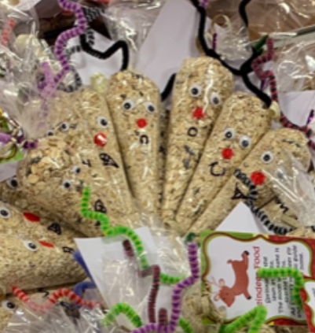
Number of bags of Reindeer Food @ £1:00 each: ………………

Amount to be set up for payment on Parent Pay: £………………………….
or
Amount to be paid in cash: £………………………….

Pupil’s name: ............................................................ Class: ....................

Parent’s/Carer’s signature …………………………………………………………………

