East Ayrshire Support Team
Crosshouse Campus
Playingfield Road
Crosshouse
KA2 0JJ
Tel: 01563 554974
E-mail: catherine.rodger@east-ayrshire.gov.uk

28th October 2021
To the learners of Drongan Primary
We wanted to take this opportunity to thank you for making the Inclusive Practice (DFS) Accreditation Panel so welcome on Wednesday 27th October when we visited Drongan Primary School. We were absolutely delighted to see how embedded the inclusive practice is within your school
The committee were excellent ambassadors for the school and impressed the panel with their knowledge of inclusion including dyslexia, ADHD, dyscalculia, dyspraxia. We observed lots of active learning with learners independently making use of a range of supports e.g. defenders, fidget toys, coloured paper.
It is therefore with great pleasure that we get to officially congratulate you in achieving your Gold Inclusive Practice (DFS) Award. Well done for all your hard work, you should all be very proud of yourselves.
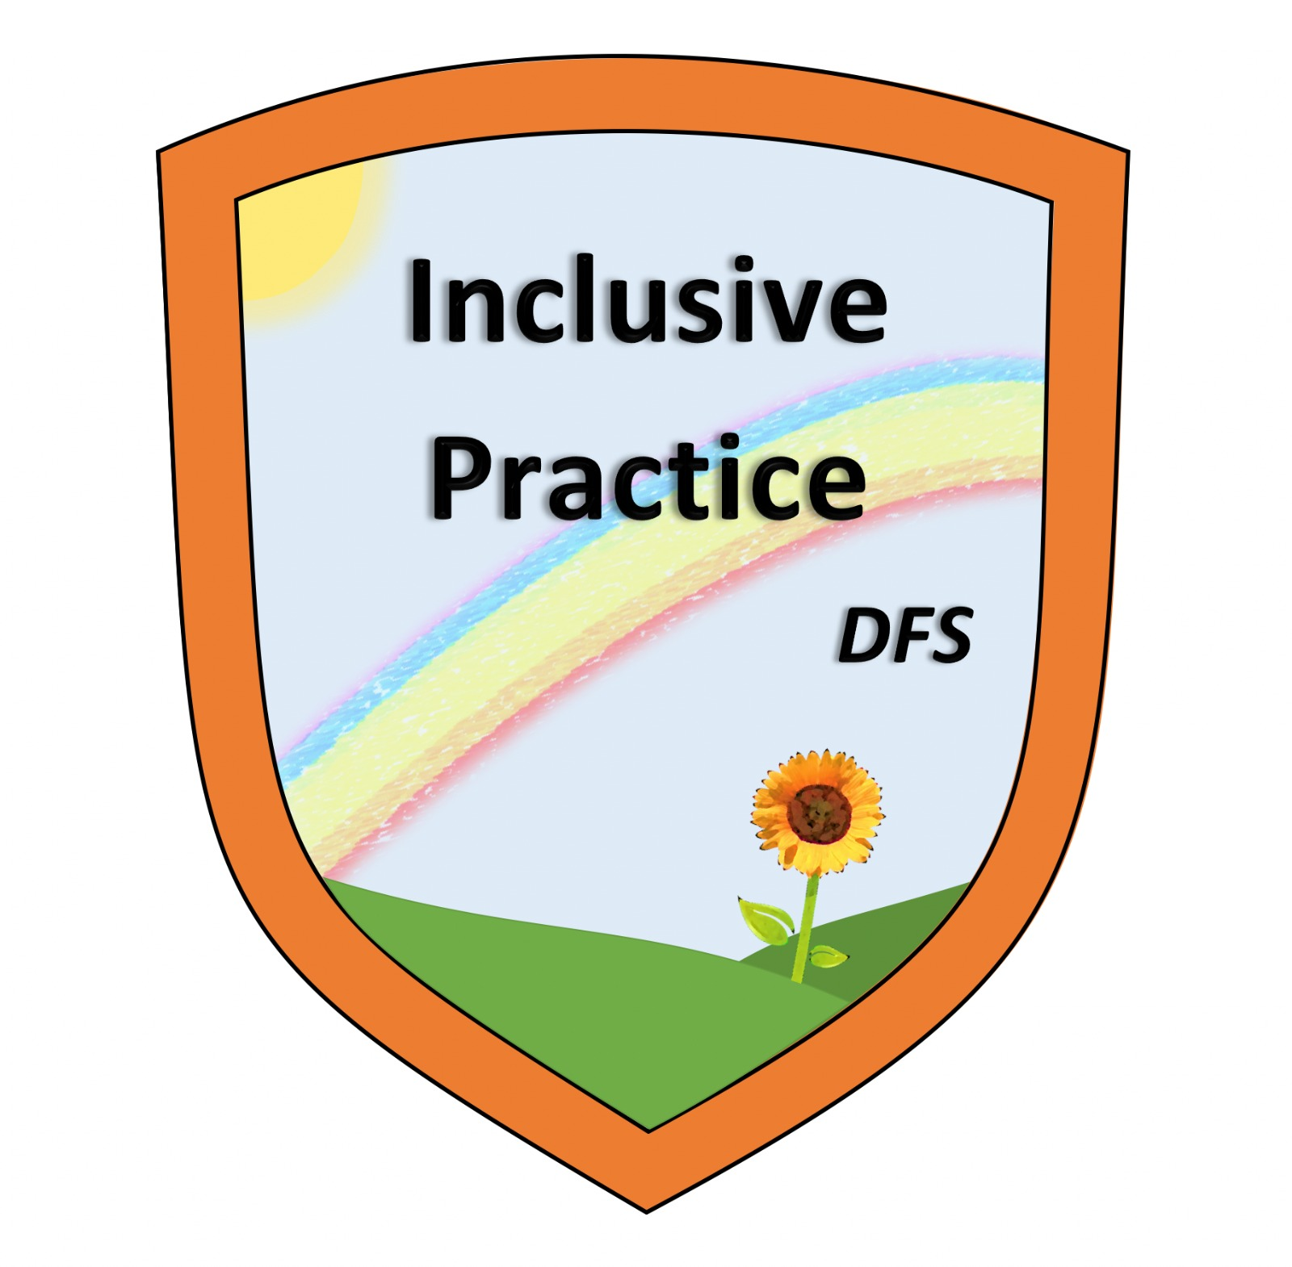
Yours sincerely
The Inclusive Practice (DFS) Accreditation Panel

