Dyslexia
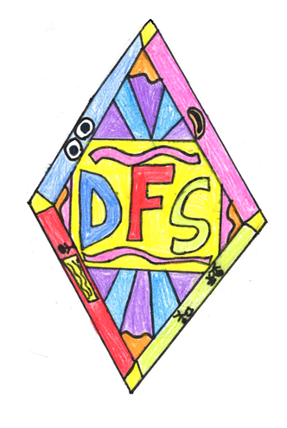

“Being an effective school and becoming dyslexia friendly seem to be two sides of the same coin.”
Neil MacKay, 2001

“The more children are empowered to deal with their dyslexia, the more effectively they will learn…”
Neil MacKay

“The concept of dyslexia represents a continuum of difficulty from very mild, to severe and persistent, and within the continuum there are many patterns of difficulty and learning experiences. All dyslexic pupils are individuals.”
Dyslexia Scotland, 2011

Our Committee
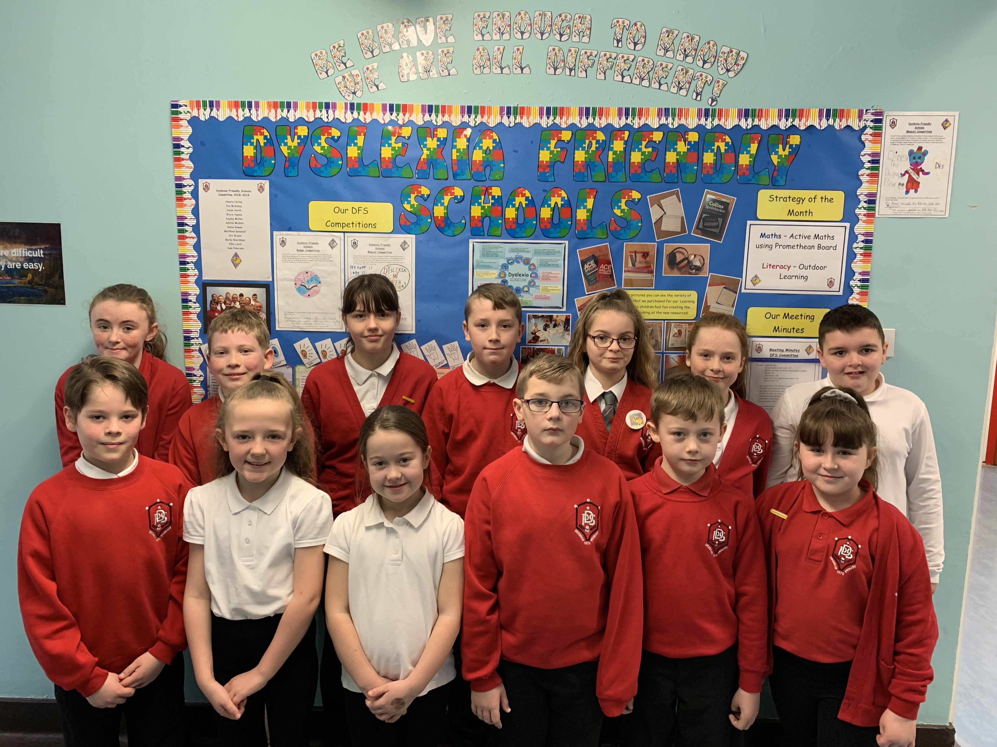

Back Row (from left to right) – Abbie Rowan, Matthew Gemmell, Ellie Laird, Sam Paterson, Alix Brown, Kayley Mullen & Ashton McGinn.
Front Row (from left to right) – Dylan Smith, Eva McKinlay, Amelia Harley, Bryce Agnew, Jake Truesdale & Becky Boardman.

Our Dyslexia Friendly Schools Committee has been working hard on a variety of tasks this year. They have worked alongside Mr McFadzean and Mrs Gilbertson to introduce new initiatives and decide on our next steps.

Parent Open Afternoon
On Wednesday 6th March, we welcomed our parents into the school to visit their children in their learning environments. The feedback has been very positive and we know the children enjoyed sharing their DFS learning experiences with you. Here are some comments from parents:

“I enjoyed seeing the various activities and different ways of learning.”

“I enjoyed seeing how much she has learned in such a short time.”

“It was lovely to see my child in her classroom and seeing the work she does daily.”

DFS Week
Our Dyslexia Friendly Schools Week ran from Monday 4th March to Friday 8th March. There was a range of activities for the children explore, which enhanced their understanding of dyslexia and increased their knowledge of different learning styles. The DFS Committee led an assembly, which was aimed at explaining how our minds can play tricks on us. On ‘No Pens Wednesday’ the children experienced a range of learning activities that didn’t involve using a pen or pencil. The children were given the chance to research famous people who have dyslexia and appreciate that with a lot of hard work; you can overcome difficulties and find success. We also celebrated World Book Day, which you will read about below.

Competition Winners
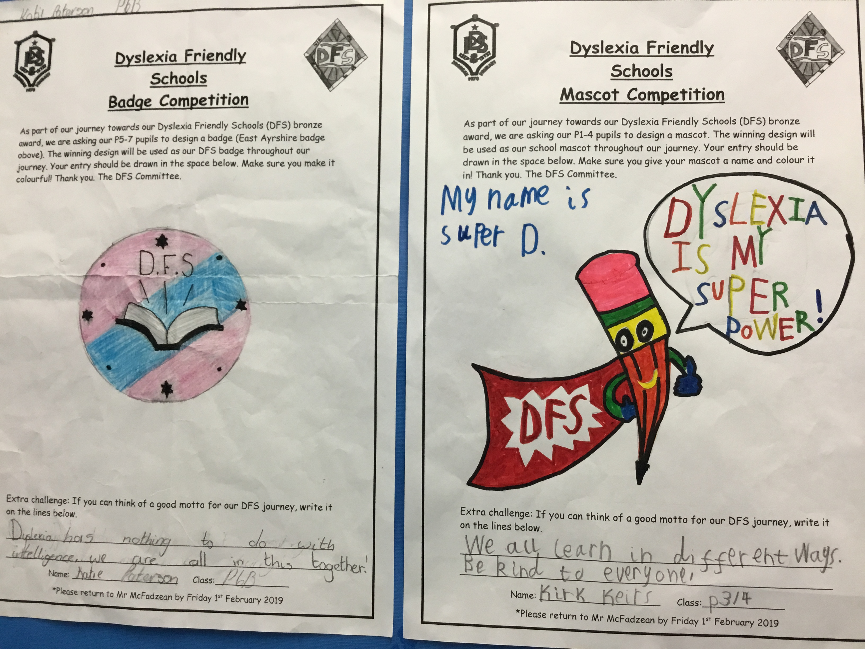
As a committee we decided that we needed a school mascot, badge and motto for our DFS journey. We introduced the mascot competition for P1-4 and the badge competition for P5-7. Alongside these competitions, we gave everyone the chance to come up with a motto for our school. We worked as a committee to vote on the winning designs. Kirk Keirs (P3/4) designed the winning mascot, Katie Paterson (P6b) designed our new DFS badge and Kaytee Graham (P4) came up with the motto:
“Be brave enough to know we are all different.”
This motto encapsulates the message we are trying to get across with our DFS work: we are unique and all have talents and strengths that should be nurtured and celebrated.
Bronze Accreditation
As part of our DFS journey, we will submit the evidence of our progress to EAST, who will assess us on the work we have done to embed DFS practice at Drongan Primary School. Our evidence will be submitted at the end of March and Mr McFadzean will go along and present our work in April, after which we will find out if we have been successful.

Strategy of the Month
Multi-sensory learning is a big part of our DFS Journey. It goes hand-in-hand with active learning and we spent DFS Week getting the chance to explore some different multi-sensory activities. These activities are also known as out ‘DFS Strategies’. Each month we will be having a Strategy of the Month for literacy and numeracy. Last month our numeracy focus was ‘Active Learning’, which focussed on using the Promethean board to explore maths in an interactive way. Our literacy strategy was ‘Outdoor Learning’. We know our pupils enjoyed taking their learning outside of the classroom.

Our ‘Learning Boxes’
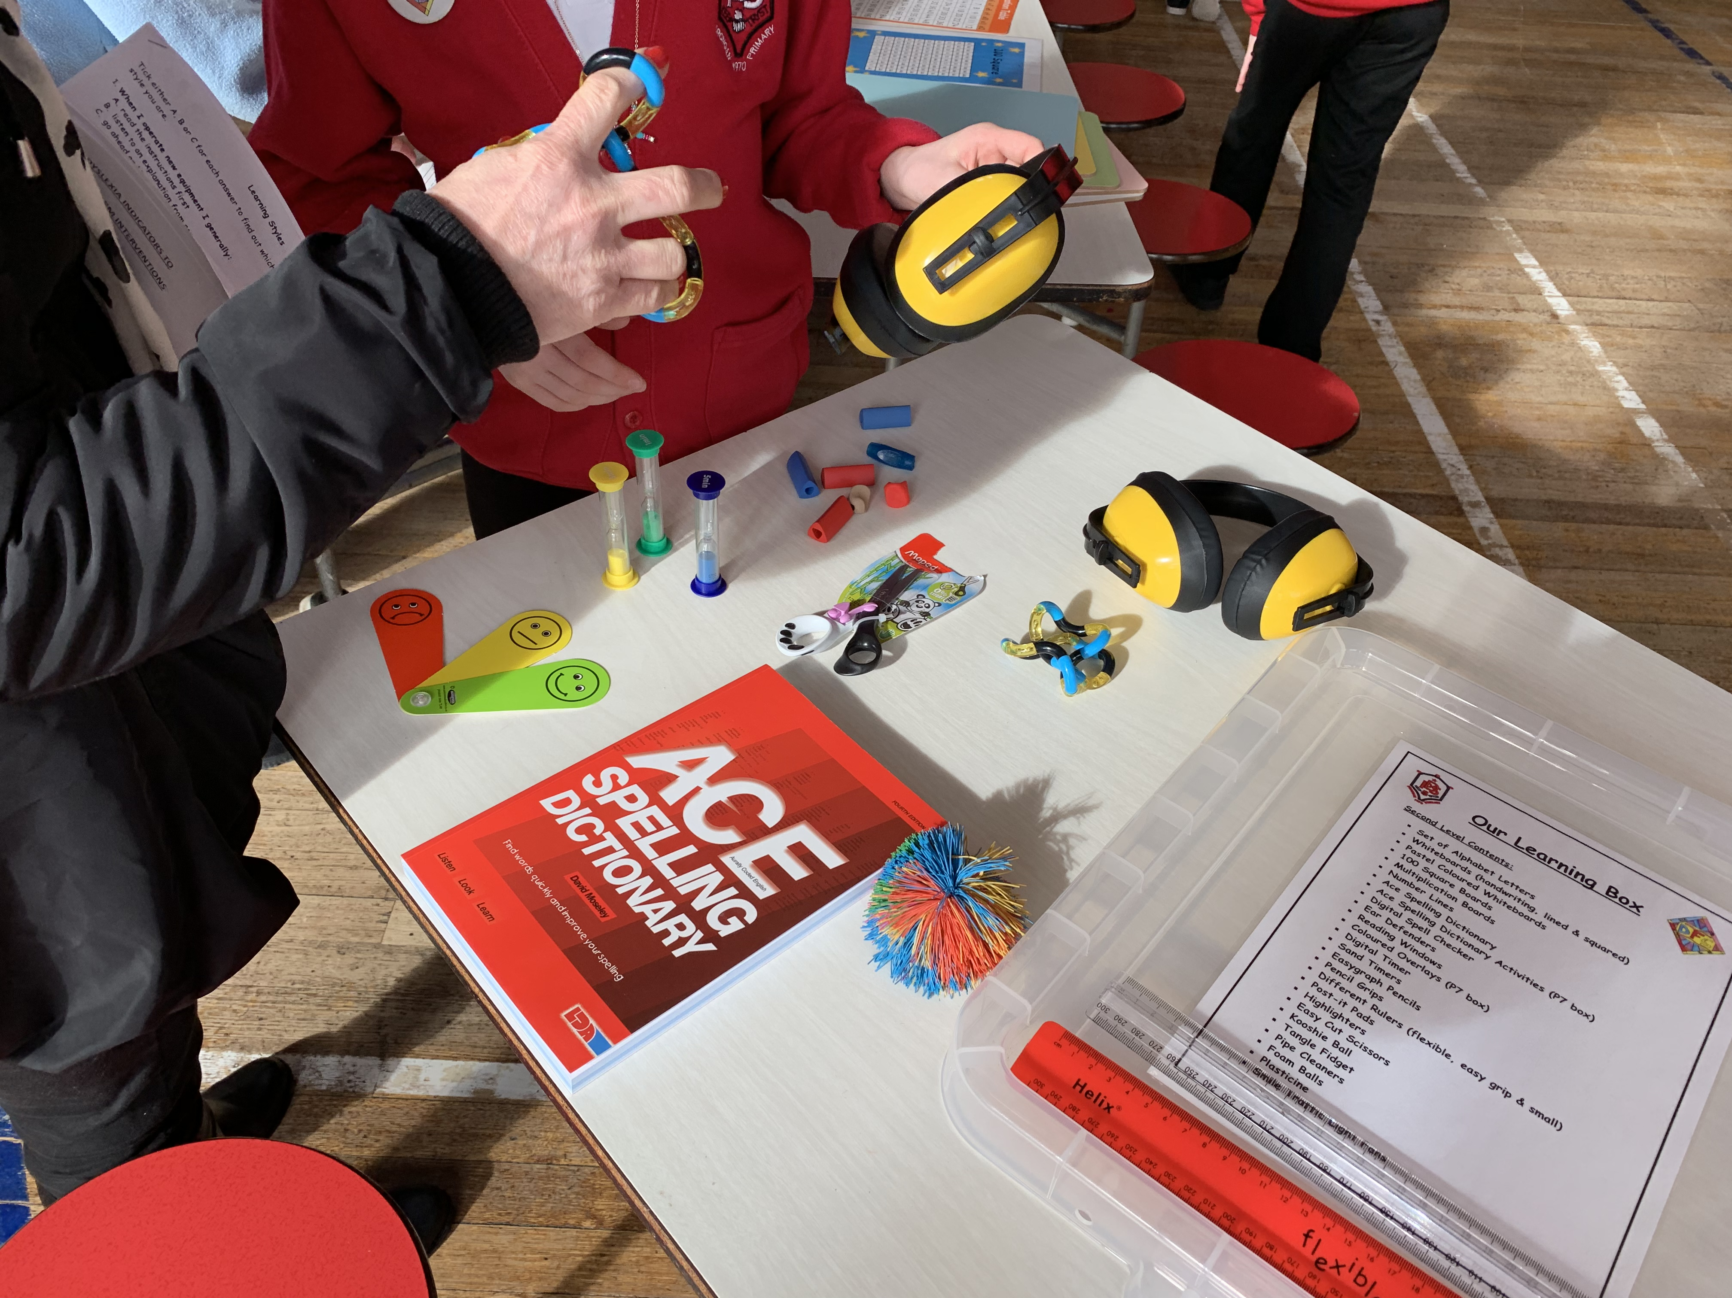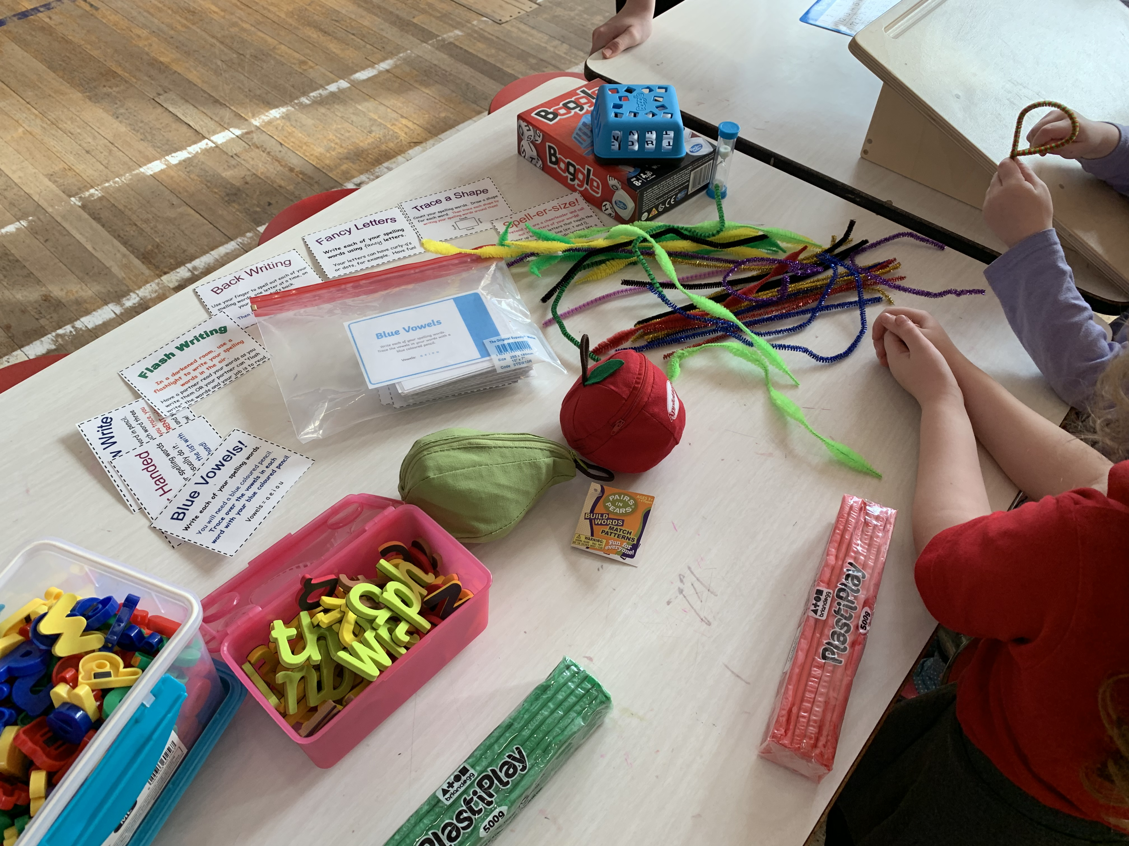
One of the bigger tasks that the committee have undertaken is the creation of our class ‘Learning Boxes’. The boxes provide the children with a range of resources to enhance their learning experiences. The children spoke to their peers and were able to identify some resources that would be helpful to enhance learning. After looking at examples from other schools too, the committee used a catalogue to source resources, create the boxes and then deliver them to classes with an explanation. Some of the resources we bought were ear defenders, coloured overlays, active literacy resources, timers, spellcheckers fidgets and a range of stationery.

Learning Styles
One of the activities during our DFS Week allowed us to find out our preferred learning style. We completed a questionnaire and discovered if we were a visual, auditory or kinaesthetic learner. Our teachers also completed a questionnaire and during our Parent Workshop we also gave the parents a chance to find theirs out too!

World Book Day
We were lucky that World Book Day fell on the Thursday of our DFS Week. This allowed our children to have a literacy focus that day and explore even more of our DFS Strategies. The theme of ‘Share a Story’ was explored in all classrooms and the children enjoyed dressing up as their favourite book character and sharing their favourite story with their peers. Our P6 and P7 pupils also worked with our infant pupils to do some shared reading activities.

Thank you for taking the time to read our first ever DFS newsletter. We hope you have enjoyed looking at some of our pictures too!
Mr McFadzean & The DFS Committee

Parent Workshop
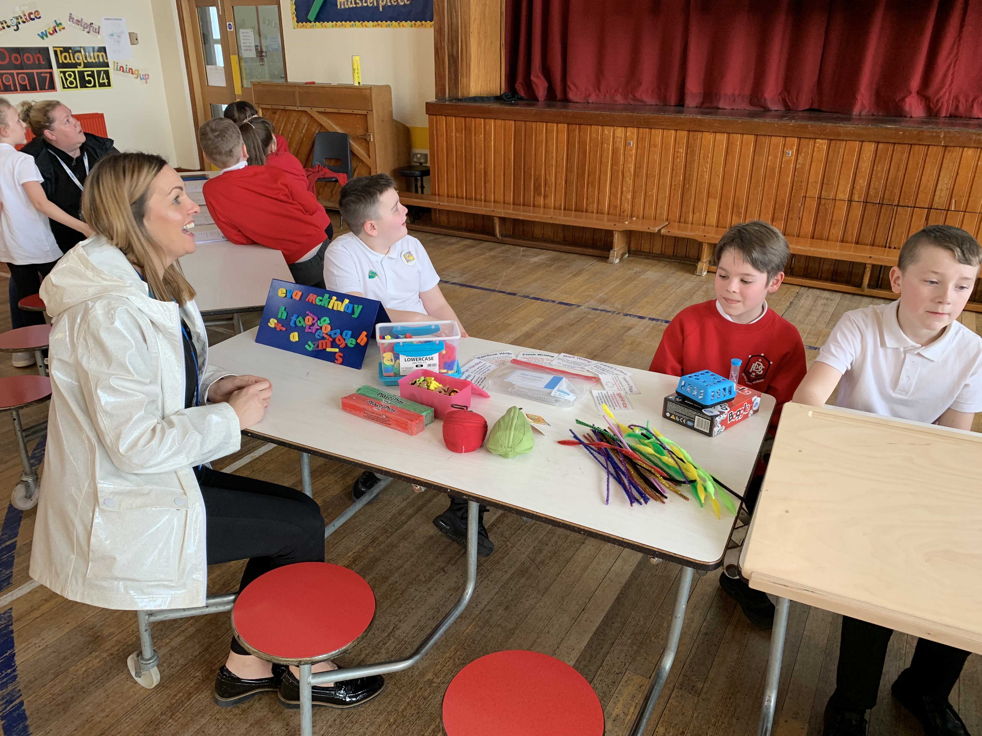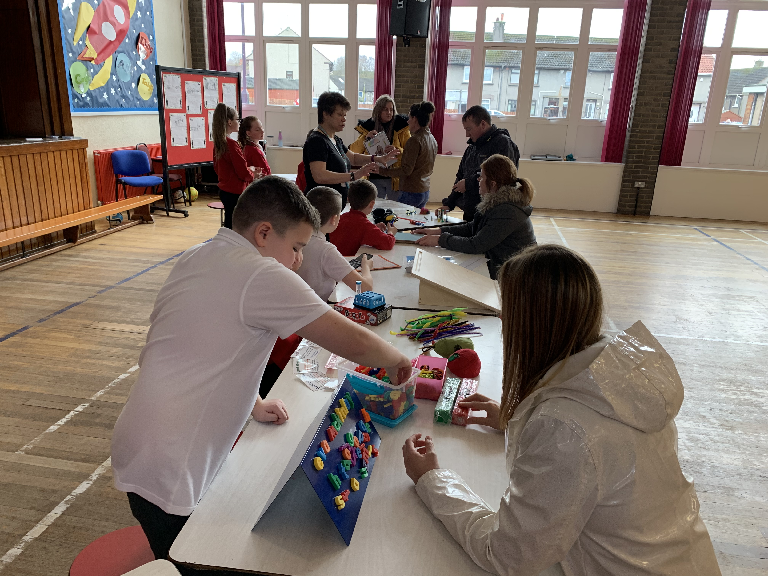

During our Open Afternoon, our DFS Committee held a workshop in the main hall with Mr McFadzean and Mrs Gilbertson. They enjoyed getting the chance to share our new resources, let parents find out their leaning style and hand out leaflets with DFS information. Here is what the committee had to say about the workshop:

“I enjoyed discussing DFS with the parents and showing them what resources we use in class.” Abbie

“It was good getting the chance to show the parents our resources from the Learning Boxes.” Kayley

“I got the chance to talk to my mum about the things the DFS Committee do.” Eva

“My mum liked getting the chance to see the overlays that I am using to help me with my learning in class.” Bryce



