



## Drongan Primary School

## A guide to access digital communication & homework.

|  |
| --- |
| **Digital** **Communication & Homework** **January 2021**  This guide has been created to help direct you to the different digital platforms; where to find them and what they are used for.  Primary 1 and 2 will join with their peers virtually in a meeting via the platform, ‘V-Scene’. Your class teacher will provide information in their weekly overview about when and how the meetings will take place.  Children in Primary 3-7 will be able to access weekly overviews and activities on Teams. Overviews for all stages will also be shared on the school blog and on the school app. Sharing this information on 3 different platforms allow us to support as many children and families as possible.  We will continue to use ‘Maths Factor’, a recent addition to ‘Bug Club’ to support numeracy. Your child’s class may also be using new aspects of the Bug Club programme, ‘ActiveLearn’ as we trial a few new programmes. Your child may also be using a reading programme, ‘Giglets’. This will help children develop reading comprehension skills through exciting and interactive questions and activities.  We hope we can work together to resolve any digital issues and passwords. We understand that access to digital technologies can be limited and variable therefore we have created learning packs that many of you have collected from the school already.  This guide is designed to help make sense of digital communication; where to look and how to access. |

# **The School App**

# What information will I find on the app?

All general and whole school communication will be posted on the school app. This may include holidays, school lunch menus, and updates directly from East Ayrshire.

# How do I access the school app?

You can download the School app to your phone by holding your camera over the QR code or following the link below.

|  |  |
| --- | --- |
| SCHOOL APP – Google Play Store    [[https://play.google.com/store/apps/ details?id=com.appscentral.psa&hl=en_US](https://play.google.com/store/apps/details?id=com.appscentral.psa&hl=en_US)S](https://play.google.com/store/apps/details?id=com.appscentral.psa&hl=en_US) | SCHOOL APP – App Store    <https://apps.apple.com/gb/app/school-app-for-parents/id1309721219> |

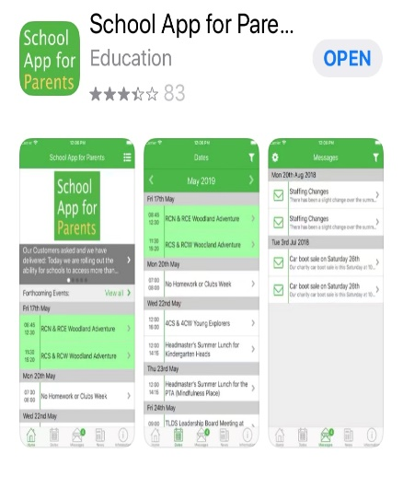

# **The School Blog**

# What information will I find on the school blog?

The school blog is a bit like a website for the school. Anyone can access this therefore no confidential information will be shared on the blog. You will find general and whole-school updates as well as access to each class blog. Photographs of children, children’s work, learning links and important communication from the class teacher may be communicated in the class blog. **Weekly learning plans** will be shared onto the class blog. If you have a computer, then you can download the weekly plan to your desktop. This may be useful if you have files or links attached to your homework. You do not need a password to access the blog, therefore this is a quick way to access your child’s weekly learning plan. You will find this by selecting your child’s class and following the tabs for learning plans.

# How do I access the blog?

|  |
| --- |
| Drongan Primary School and ECC Blog    <https://blogs.glowscotland.org.uk/>  ea/dronganpsecc2016/ |

Scan the QR code, click the link below or type into your internet web browser; ‘Drongan Primary Blog’.

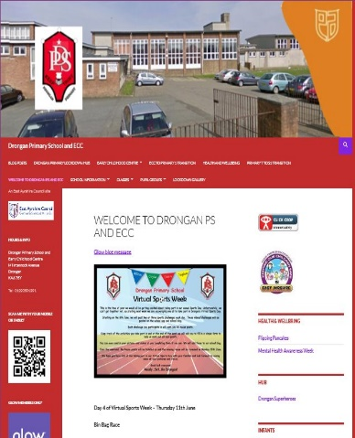



# Image result for vscene app**3. P1-2: V Scene**

# What information will I find in V Scene?

Primary 1 and 2 children will join with their peers virtually in a meeting via the platform, ‘V-Scene’. Your class teacher will provide information in their weekly overview about when and how the meetings will take place. You do not need your own V Scene login to join a meeting, the login option on the website is purely for licence holders/admin.  We will not ask you for anything other than the details below and your name to access a meeting.  If accessing via a device or laptop they should have their camera and microphone enabled.

To access V Scene, send your email address to your child’s class teacher. The teacher will then add this email address to the class contact list ensuring you are invited to all meetings, and sent the relevant information (including access codes for meetings). If you have not yet passed on your email address, please send to the relevant person below.

P1a: Mrs Brady –  [jacqueline.brady@eastayrshire.org.uk](mailto:jacqueline.brady@eastayrshire.org.uk)

P1B: Mrs Glasgow –  [lorna.glasgow@eastayrshire.org.uk](mailto:lorna.glasgow@eastayrshire.org.uk)

P2A: Miss Hogarth –  [megan.hogarth@eastayrshire.org.uk](mailto:megan.hogarth@eastayrshire.org.uk)

P2B: Miss Adams –  [rachael.adams@eastayrshire.org.uk](mailto:rachael.adams@eastayrshire.org.uk)

# Using your phone or tablet

* You can join via a phone/tablet by downloading the V Scene App from the App/Play Store.
* Allow the app to access your camera and microphone (you will have full control to switch this off/on when in the app)
* To access the meeting room please type the unique V Scene room number E.g. **1472647**into the App, then your child's name (as you want it to appear in the meeting) and the pin code E.g. **1902**
* You should now be in the meeting room with your class!

# Using a tablet

# V Scene is compatible with Google Chrome, Mozilla Firefox and Microsoft Edge. It does not work with Internet Explorer.

* Click on the link provided by the class teacher to access the meeting via a laptop/computer.
* Please type in your child's name.
* Enter the pin number also provided by the class teacher E.g. **1902.**
* You may need to permit V Scene to have access to your microphone or camera.

Finally, If for some reason you are forced out of the virtual meeting room, please try to log on again using the same login details.

Our friends at Willowbank Primary have made this very helpful V Scene video. Please watch prior to our meeting:

<https://www.youtube.com/watch?v=Kbr2ATZOVeo>





# See the source image**P3-7: Microsoft Teams**

# What information will I find in Microsoft Teams?

Each class/stage in P3-7 has its own Team. This is personal to the class/stage and only members (the pupils and teachers) can access. The team provides a safe platform for children to chat and support each other in learning activities. The teacher will upload any work and links to any activities. While the children are learning remotely, the teachers will be available within school hours to answer questions and support your children if they are unsure about what to do. Your child will have the opportunity to interact with their class and teacher within live meetings. These are accessed directly on the class teams page at the time stated on the weekly overview. To ensure children are making progress and to provide supportive feedback, we would like the children to submit certain aspects of their learning each week. Your child’s teacher will provide further details about this in the Weekly Overview.

# How do I access Teams?

Teams works best when you download as an app to your phone or onto your computer desktop. The username for Teams is your Glow email address. This is your child’s GLOW username (e.g., gw13johnsmith) with “@glow.sch.uk” added. You can also access Teams through your Glow account. If you download the phone app, you can have more than one account added without signing out. This is useful if you have more than one child accessing Microsoft Teams. **You are unable to access Teams via GLOW on an apple device therefore desktop app is required.**

|  |  |  |
| --- | --- | --- |
| TEAMS DESKTOP APP    <https://teams.microsoft.com/downloads> | TEAMS APP – Google Play store    [https://*play.google.com*/*store*/*apps*/details?id=com.microsoft.*teams*](https://play.google.com/store/apps/details?id=com.microsoft.teams) | TEAMS APP – App Store    [https://*apps*.*app*le.com/us/*app*/microsoft-*teams*/id1113153706](https://apps.apple.com/us/app/microsoft-teams/id1113153706) |

# **Glow**

# What information will I find on Glow?

Glow is the Scottish Schools National Internet, managed by Education Scotland. This digital environment can support learning across the whole curriculum. Your child can access Teams from their GLOW Launchpad. This is where your child will access email (outlook) providing a direct link between home and school. For more details about Glow please access GLOW Connect: [www.glowconnect.org.uk](http://www.glowconnect.org.uk). This website will give you further detail about using GLOW and how to keep safe online.

# How do I access Glow?

To access Glow, follow the link below. You will be prompted to type in your Glow username and password.

|  |
| --- |
| GLOW LOG IN PAGE    https://sts.platform.rmunify.com /Account/SignIn/glow |

**Thank you for reading!**

We understand how overwhelming digital learning can be and hope you find this information useful and informative. If you have any problems accessing digital communication or resources: Contact Mr McFadzean, D.H.T

([eatom.mcfadzean@glow.sch.uk](mailto:eatom.mcfadzean@glow.sch.uk)).

We are so proud of our pupils. Many of them are engaging positively with what the class teachers are sharing. Keep up the good work!

We look forward to seeing you all soon,

Mrs Cowie

Principal Teacher

Drongan Primary School