Drongan Primary School Inclusion Week 2021 Homework Challenge P4-7
This week we are going to be focussing on inclusion. We will learn about our own learning styles, and about some different additional support needs. We will also celebrate our strengths, and focus on being kind to others.
Your homework challenge is to create something of your choice (it could be a poster, an information leaflet, a rap, a song, or a roleplay) to show one thing that you have learned about this week. You may choose to focus on a specific additional support need, or maybe you will focus on the larger theme of inclusion.
Your creation is due back in class on Friday 8th October when you will be given an opportunity to show off what you have made.
Posters and information leaflets will be displayed throughout the school.
Good luck!
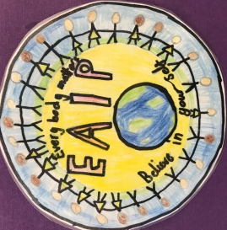
The DFS Inclusion Committee

