Drongan Primary School Inclusion Week 2021 Homework Challenge P1-3
This week we are going to be focussing on inclusion. We will learn about our own learning styles, and about some different additional support needs. We will also celebrate our strengths, and focus on being kind to others.
Your homework challenge is to complete an act of kindness at home every day this week! You could help someone out, you could draw someone a nice picture, you could give someone at home a hug, you could share… The list is endless!
At the beginning of every day, check in with your classmates and teacher to tell them about the act of kindness you did the day before.
Good luck!
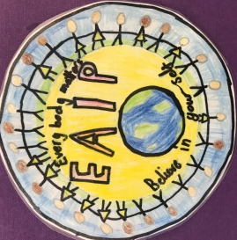
The DFS Inclusion Committee

