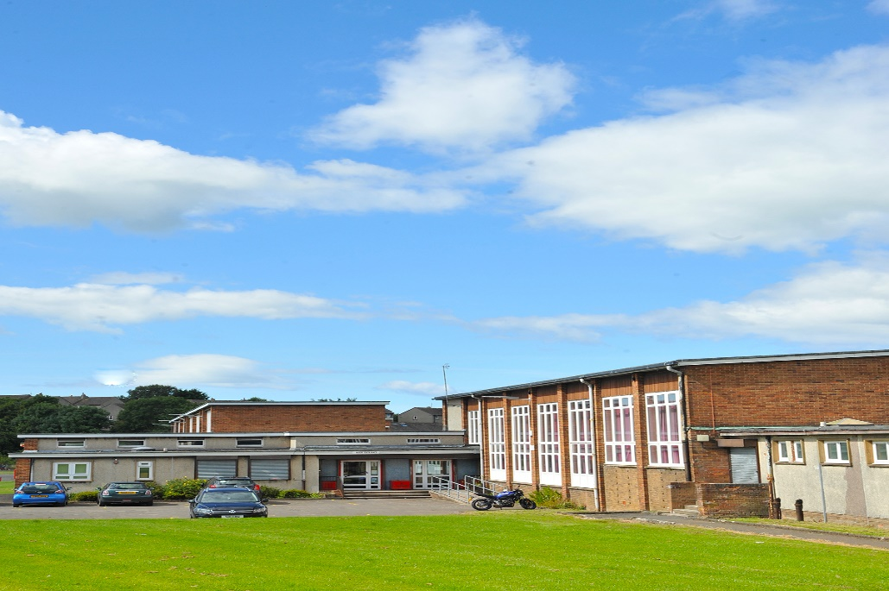

Drongan Primary and Early Childhood Centre
Millmannoch Avenye,
DRONGAN
KA6 8BY

Telephone No: | 01292 591291
Email: | Sean.maddocks@eastayrshire.org.uk
School Blog: | https://blogs.glowscotland.org.uk/ea/dronganpsecc2016/
Twitter: | @DronganPS
School App: | Available on appropriate mobile devices  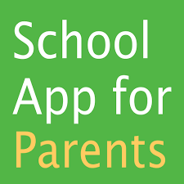
Denominational Status (if any): | Non-Denominational
School Roll: | Primary School: 273  ECC (2 - 5 year olds): 74
Further Information: | www.east-ayrshire.gov.uk/schoolhandbooks
WELCOME TO DRONGAN PRIMARY SCHOOL
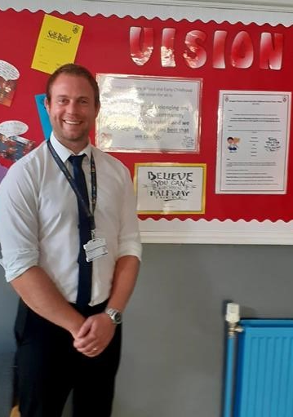
Dear Parents/Carers,

On behalf of all of the staff at Drongan Primary School and Early Childhood Centre, welcome to our handbook. This document is compiled to give you basic information about the school and what we aim to offer your child. We hope you find the information contained in this handbook helpful; however, if there is anything that you are unsure of please contact us.
We have an open door policy in Drongan Primary School and Early Childhood Centre where parents are welcome and we make every effort to meet and work with parents regarding any concerns they may have. There may be occasions when a member of the management team will not be able to meet with you immediately; however, we will always get back to you to discuss any issues you may have regarding your child’s education or wellbeing.
We hope that you find our handbook informative and helpful and that it gives you some insight into what life is like at Drongan Primary School and ECC.
Yours sincerely

Sean Maddocks
Head Teacher
SECTION 1
Our aim is to develop the four capacities outlined in Curriculum for Excellence in all of our pupils to prepare them for future life, learning and work. This is delivered by providing a stimulating environment where there is a nurturing culture where all children’s achievements are recognised. We encourage our children to be confident individuals, responsible citizens, effective contributors and successful learners. We work together to instil our shared values of teamwork, mutual respect, trust, inclusion, self-belief and resilience. These shared values have been agreed by all stakeholders of our local community when we recently reviewed our vision, values and aims.
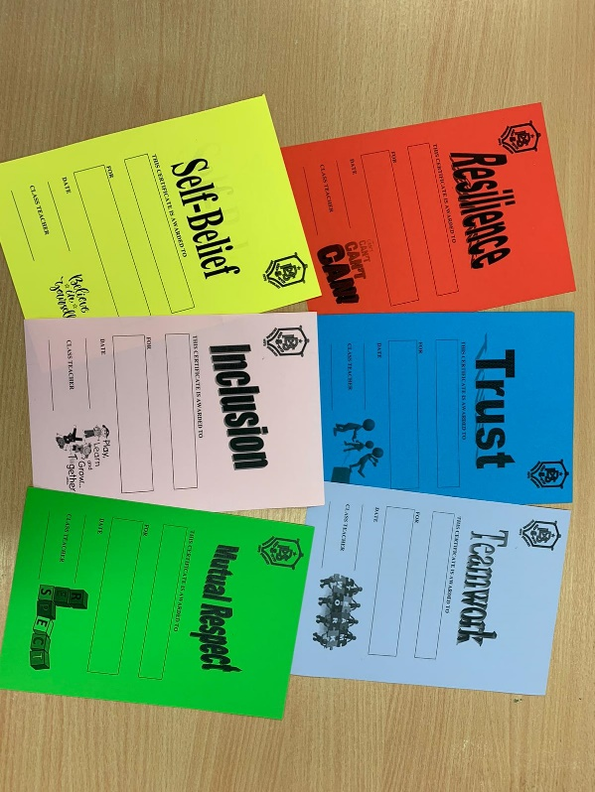
In line with The Scottish Government’s vision, we encourage excellence and equity in Drongan Primary School and ECC, where children are provided with the best possible opportunities to achieve their full potential and to be the best that they can be. We encourage children to have a sense of belonging and pride in their local community, which we see as an extension of the educational establishment. We are proud of the links that we have to our local and wider community ensuring that our school and ECC plays its part in the life of our village. In Drongan Primary School and ECC we regularly seek opportunities to provide children with real life experiences linked to the world of work.
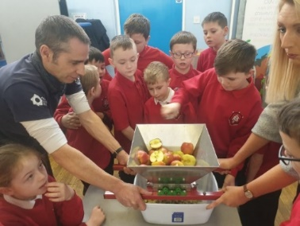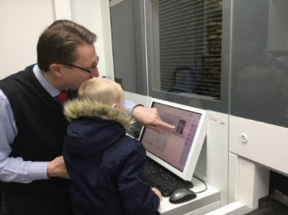
We work in partnership with parents/carers and partners to encourage high standards of behaviour and attitude to learning where we encourage our children to reflect on their actions and make the appropriate choices.
Parents are the most important people in a child’s life and have the biggest influence on the children that we work with. We see it as our duty to provide you with the opportunity to be involved in your child’s education as much as possible. We look to develop positive relationships with our parents and carers, built on mutual trust and respect, where we work together to support your child. We are proud of the relationships that we have developed with parents and will continue to build on the good work that has been done within Drongan Primary School and Early Childhood Centre. When parents play an active role in their child’s education, children are more likely to achieve their potential while behaving in a positive way. All parents are welcome in our establishment and if there is ever an issue we are keen to work together to resolve it.
Class assemblies, open afternoons, parent workshops, focus groups, parent council meetings, prize giving, services, parent helpers, homework, questionnaires and stay and play days are just some of the examples of the opportunities that we provide to encourage our parents to engage with their children’s learning. We hope to see you at these events throughout the session and look forward to welcoming you in to the school and ECC. If you would like to be added to our database of parent helpers please contact the school.
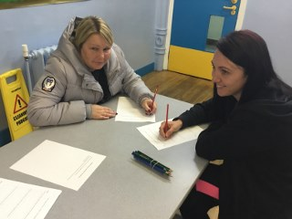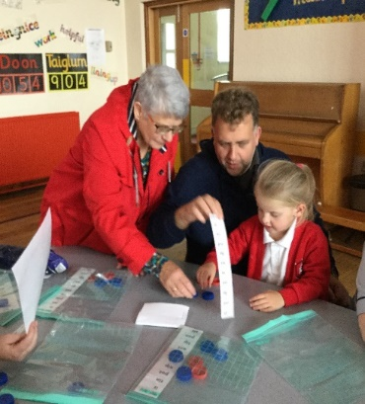
We aim to communicate effectively with parents and carers to keep you as informed as possible about your child’s education and the life of the school and ECC. We have a number of ways of achieving this:
- Termly newsletter
- The Primary School and ECC App
- Twitter @DronganPS
- Glow blog - https://blogs.glowscotland.org.uk/ea/dronganpsecc2016/
- Microsoft Teams groups
- Termly curriculum overviews
- Parents’ evenings
- Reporting to parents
- Parent workshops
- Open afternoons
- Team Around the Child meetings where appropriate

Drongan Primary School and Early Childhood Centre Vision, Values and Aims
(Agreed in session 2018-19 and reviewed in May 2021)
Vision
In Drongan Primary School and Early Childhood Centre our vision for all is:
To have a sense of belonging and pride in our local community where everyone is valued and we work together to be the best that we can be.

Values
Within our school, ECC and local community, the values that we feel are important to instil in all are:
Teamwork
Mutual respect
Trust
Inclusion
Self-belief
Resilience

Aims
In Drongan Primary School and Early Childhood Centre our aim is to develop the four capacities outlined in Curriculum for Excellence in all of our pupils to prepare them for future life.
We will encourage our children to be:

Confident individuals by promoting self-worth, ambition and resilience
Responsible citizens by promoting diversity, communication skills and confidence
Effective contributors by promoting community spirit, enjoyment and participation
Successful learners by promoting skills development, challenge and engagement in learning
SECTION 2
Transitions
We have recently developed our programmes for children making transitions between pre-school to Primary 1 and Primary 7 – secondary education. A range of activities, workshops and events take place throughout the year to ensure that children have as smooth a transition at key points in their education. Some of these activities will involve parents, where you will be welcome to join your children. You will be notified of important dates, including registration and transition programme events via our normal means of communication.
Please click on the link below to see some examples of our early years transition programme in action:
https://blogs.glowscotland.org.uk/ea/dronganecc/transition/
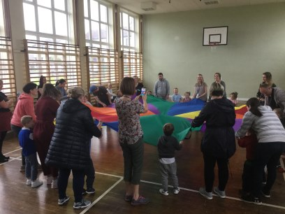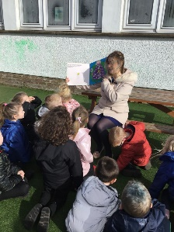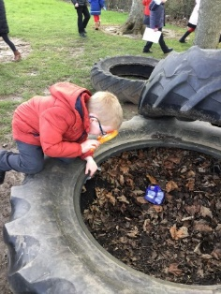
The contact details of the associated primary or secondary and onwards
- Drongan Early Childhood Centre – 01292 591521
- Robert Burns Academy – 01290 427280

Support for children and young people and parents/carers
Head Teacher – Sean Maddocks
Depute Head Teacher – Tom McFadzean
Principal Teachers – Melanie Bradley and Lynsey Cowie
Depute Heads of Centre – Rhea Ireland and Avril Holmes
Contacts for parents where a concern requires to be raised:
Telephone: 01292 591291
Email: sean.maddocks@eastayrshire.org.uk or tom.mcfadzean@eastayrshire.org.uk

Additional Support for Learning
Occasionally, a child may face difficulties preventing them from effective learning. We identify them as having additional support needs, which may be short term, or for their whole school journey. Children and young people who have been identified as having additional support needs will be supported through an Action Plan (AP), Individual Learning Plan (ILP) or in some cases a Coordinated Support Plan (CSP).
You and your child will be fully involved in developing these plans at all stages.

Our Early Childhood Centres have a variety of procedures to assist in the early identification of children with additional support needs and planning will take place at the earliest possible stage.

SECTION 3
The School/Centre Day and Year
School
9.00am school opens
10.30 – 10.45 break
12.30 – 1.15 lunch
3.00pm school closes

ECC
The ECC is moving to deliver 1140 hour provision in August 2021. There are a variety of models that children and families can utilise to make up their allocation of 1140 hours per year. The ECC would be happy to provide further information on this and details can also be found on the Scottish Government’s website.
https://www.gov.scot/policies/early-education-and-care/

The School/Centre Holidays and In-Service Days
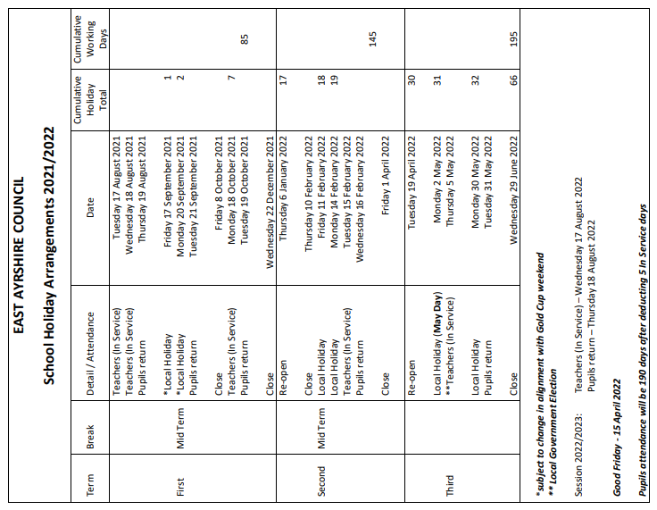

Attendance and Timekeeping
We appreciate that there will be occasions when children are either late to school or absent. We encourage good time keeping and high attendance in order to ensure that children have access to the best opportunities possible and that they do not feel excluded in any way. I am confident that you will work with us to encourage the important life skill of punctuality.
Please inform the school in the morning if your child is going to be absent by phoning 01292 591291. There is a messaging service should a member of clerical not be able to answer the phone. Please leave name of child and reason for absence.
We monitor attendance regularly in line with East Ayrshire Council’s policy. We would ask that all contact details are up to date and that the school / ECC are informed when any changes are made.

Behaviour and Anti-Bullying
Every child and young person in East Ayrshire should grow up free from bullying behaviour.

Please refer to our Respect for All Anti-Bullying policy for more detailed information with regards to behaviour and anti-bullying.

Across all sectors, those working with children and young people in East Ayrshire are already aiming to fulfil the Scottish Government and local government commitment to ensuring children and young people become confident individuals and responsible citizens. It is our aspiration that all those who play a role in the lives of children and young people are enabled to prevent and respond effectively to incidents of bullying behaviour. Getting it right for every child (GIRFEC) in East Ayrshire ensures that the child and their family are at the centre of policy and practice and that the views of the child, young person and their parents/carers are sought, listened to and taken into account when decisions are being made.

In Drongan PS and ECC we view Respectful Relationships as being an essential component of the social integration framework. Respectful Relationships are also vital to aid the development of all pupils, within a positive ethos, so that they can take their place in society as responsible citizens.
Factors which contribute in supporting this aim are: a positive whole school ethos where all stakeholders are involved, a culture of promoting positive behaviour and appropriate choices for all and ensuring that incidences of bullying are addressed in an effective and consistent manner.
The following are discussed within our policy, where we have taken into consideration cultural diversity and equality. Our main guide is East Ayrshire Council’s Respect for All Anti-Bullying policy and East Ayrshire Council’s Equality and Diversity policy.
Children come to school and ECC from a variety of backgrounds, and this variety is taken into consideration when dealing with the individual needs of pupils. It is important that the school and ECC develop mutual respect and children are encouraged, with support, to make appropriate choices and are fully consulted on consequences for the actions they take. This is to prepare them to become Responsible Citizens and Effective Contributors in their local community and the wider world.
This begins in our ECC and children gain in confidence as they progress through the primary school.
We all have an important role to play in maintaining overall discipline within the school.

Bullying
Bullying is both behaviour and impact; the impact is on a person’s capacity to feel in
control of themselves. This is what we term as their sense of ‘agency’. Bullying takes
place in the context of relationships; it is behaviour that can make people feel hurt,
threatened, frightened and left out. This behaviour happens face to face and online.
Respect for All Guidance, Scottish Government.

Bullying can take different forms. All of them are wrong. Bullying is not acceptable in any form. Someone who is being bullied will feel unable to stop it happening. It can be carried out by a group or one person.
Bullying can take several forms, and although no list can clearly be definitive it can include:
- Emotional
- Mental - when pressure to conform is applied
- Material – when possessions are stolen, damaged or hidden or extortion takes place
- Social – when not being spoken to or left out of activities
- Physical – pushing kicking, hitting, punching or any use of violence, aggression without or without the intention of causing hurt
- Verbal – name calling, sarcasm, teasing, spreading rumours and personal comments
- Cyber – all areas of the internet, such as email and internet chat, social networking misuse, mobile threats and text messages
- Prejudice based – focusing negatively on the identity of the victim, based on their race, ethnicity, colour, sexual orientations, religion or belief, gender or other distinguishing features.

It should be emphasised that there is a difference between one-off incidents amongst peers in the classroom/playground and the systematic and ongoing targeting of a particular pupil or group.
Children accused of bullying may need support as much as those being bullied. Within our Respectful Relationships Policy, Drongan PS and ECC highlight that we always take incidents of bullying seriously and will endeavour to investigate fully, supporting all children involved, consulting parents/carers and implementing appropriate strategies for support.
Dress Code
We are very proud of the fact that all of our children wear school uniform. We want all children to feel that they are part of Drongan Primary School and ECC and uniform is a big part of identifying with an educational establishment.
Our uniform consists of:
Black or grey skirt or trousers
White or red polo shirt
Red jumper or cardigan
White shirt or blouse
Tie
Blazer

Security and Visitors
The safety of the children is of paramount importance and for that reason it is essential that we know who is in the building at any point of the day. Therefore all visitors, including parents, are asked to use only the main entrance to the school to enter the building.
All visitors and trades-people are asked to sign the register at the front of the school and to sign out as they leave.
If you are collecting a child early it is vital that you inform a member of staff when doing so.
Please press the buzzer at the front entrance and one of our clerical staff will ensure that you are attended to. If you would like to speak to a teacher please either phone or visit the school and arrangements can be made.

Homework and Study
Children will be given a variety of homework tasks each week focusing mainly on literacy and numeracy. We use Bug Club, which is an on line reading scheme; however, Primary 1 children will take their reading books home. Children will have login details to access Bug Club to complete homework tasks set by teachers. Active Literacy spelling words will be given each week and children are encouraged to complete homework tasks set and learn words for their spelling test. Children will also receive a maths task or activity to complete. Teachers may issue homework tasks for other areas of the curriculum.
We have worked together as a staff team to develop a more consistent approach to homework and have also consulted with parents when doing so.
With the recently developed class Microsoft Teams we will be using this as the main means of communication in relation to homework. All classes now have their own blog within the Drongan Glow blog and we look forward to developing this further to utilise the resource on a more regular basis. Teachers will all upload a weekly overview to their class blog where parents and children can access their homework tasks.
The link below will take you to the Homework section of our blog where further information is available regarding digital learning.
https://blogs.glowscotland.org.uk/ea/dronganpsecc2016/homework/

In our ECC there are often home-link challenged and activities, which encourage parents to work together with their child to complete.

School Canteen Facilities, including use of Parentpay
We encourage all children to have a school dinner. Our catering staff work hard to ensure that the food that is provided is of a very high standard. They work in partnership with the school to welcome parents in to the establishment for parent / child lunches. Lunchtime is a time when children have an opportunity to develop their social skills and enjoy eating together with their peers. There is a wide range of food for the children to choose from and enjoy, made from excellent ingredients with no processed food.
The school menu, which operates on a three week rota is available on the school app and also at the following link:
https://www.east-ayrshire.gov.uk/EducationAndLearning/Schools-Catering/SchoolLunchMenus.aspx
Primary 1 – 3 will come along to the dinner hall straight away at lunch time. School dinners and packed lunches are allowed to sit together. Packed lunches in P4 – 7 will be put in black boxes, which will be brought along to the dinner hall by the janitor before lunchtime. The dinner hall is always supervised.

Complaints Handling
If you have any concerns at all regarding your child’s education or experience in the school or ECC please visit or phone the school immediately and ask to speak to a member of the management team. We will always make time for you and work together with you and your child to resolve the issue or concern. We are committed to ensuring that your child is happy in school or ECC and care about making their educational experience a positive one.

Emergency Procedures / Medical matters
In the event of an emergency we will contact you as soon as possible. We use the Primary School App, group texts, twitter and East Ayrshire council work closely with Westsound Radio and West FM to inform of any emergencies.
If your child is feeling unwell or has an injury, they will be attended to by one of our first aid trained members of staff. You will be contacted if your child needs to be collected. There may be times when your child has been injured when we contact you to inform you; however, they may not require to go home. We always endeavour to keep you as informed as possible of any injuries or medical issues that arise during the day.
If your child requires any medication through the day, you must complete an administration of medication form at the office and the medication should be brought in to school by an adult.
Please always ensure that your contact details are up to date to enable us to contact you.

Parent Council details
All parents are welcome to attend Parent Council meetings and support the great work that they do for the school. Information about the dates and times of the meetings can be found on termly newsletters and the school app.

SECTION 4
The Curriculum
We are continuously evaluating and developing our curriculum to ensure that the experiences are relevant, where there is breadth, depth, challenge and enjoyment, progression, personalisation and choice and coherence. Following a detailed consultation process our Curriculum Rationale was created in session 2019-20. This takes account of the local context of the school and local community, our vision, values and aims and also national guidance. Our Curriculum Rationale is a key driver in informing curriculum development and can be found on our Glow page.
https://blogs.glowscotland.org.uk/ea/dronganpsecc2016/school-information/important-documents/
All stakeholders are included and involved in curriculum development to ensure that there is a collaborative approach to achieve improvements.
We have developed backdrop plans, which detail the content of what will be taught in various stages and areas of the curriculum. Teachers ensure that short and long term planning is effective in order to deliver the broad general education through stimulating learning experiences.
In Drongan Primary School and Early Childhood Centre we provide a broad range of learning experiences where children can develop their personal skills that will equip them well for later life. Literacy, Numeracy and Health and Wellbeing are the three main areas where we develop these skills, ensuring that children are literate, numerate and have the resilience to be able to cope with the challenges that they may face. These skills are essential if young people are to gain access to learning, to succeed in life and to pursue a healthy and active lifestyle.
We provide a range of opportunities throughout the school session for children to develop their skills in all areas of the curriculum, where teachers use progression pathways to ensure that there is appropriate support and challenge for all children. There are also opportunities through various clubs and activities, events, pupil committees, citizenship assemblies, pupil focus groups, leadership roles and after school clubs where children can develop their personal skills.
You can find information about Curriculum for Excellence by clicking on the following link:
https://education.gov.scot/education-scotland/scottish-education-system/policy-for-scottish-education/policy-drivers/cfe-building-from-the-statement-appendix-incl-btc1-5/what-is-curriculum-for-excellence
Assessment is an integral part of learning and teaching and in Drongan Primary School we have developed an assessment framework. Teachers continuously monitor children’s progress and use assessment to identify their strengths and areas for development. Although a lot of assessment is carried out on a day-to-day basis, periodic summative assessment is also required to build a holistic picture of how children are progressing. We use a range of assessments in order to ensure that children are being supported and challenged appropriately and that we are meeting their needs effectively. In the ECC most assessments will be carried out through observations and activities with the children.

Curriculum for Excellence recognises 8 key areas of the curriculum within the Primary School. These include:
- English Language/ Modern Languages
- Mathematics
- Health & Wellbeing
- Social Studies
- Sciences
- Technologies
- Religious and Moral Education
- Expressive Arts

Children are consulted regularly about their learning. Teachers use a wide range of teaching strategies to provide challenge and enjoyment, where children are often involved in leading learning. We have worked to ensure that there is a more consistent approach to target setting, where teachers work together with children to set realistic and meaningful targets. Children are involved in setting success criteria at the beginning of lessons and are encouraged to reflect on their own learning.
Through our Thrilling Thursday assemblies, pupil committees and pupil focus groups, children are involved in important developments of the curriculum and take ownership of these. Parents are also involved in change processes within the school. This is achieved through regular questionnaires and surveys as well as parent workshops. As parents, you will be consulted about our improvement priorities and will have an opportunity to feedback about what we do well and what we could do better.

SECTION 5
Achievement and Improvement
Drongan Primary School and Early Childhood Centre is at the heart of village life and works together with the local and wider community. Our shared vision, values and aims continue to be promoted across the establishment and throughout the local community. We are proud of how we have worked together as a school community to improve the experiences of our young people. This was recognised in Education Scotland’s follow up inspection visit in September 2019 where they recognised that ‘staff and partners speak positively about a changing culture with people feeling more involved in the life of the school’. They also highlighted that ‘the head teacher and staff are making good progress in addressing a number of the issues identified as points for action in the initial inspection’.
Throughout the session we have increased opportunities for parents to be involved in the life of the school and engage with their child’s education. Open afternoons, class assemblies, parent workshops, school fundraisers, Christmas activities and Come Dine with Me are just some of the activities that have helped us improve our partnership with parents.
We have also established sustainable links with businesses and organisations from the local and wider community. This has helped to provide children with more meaningful learning experiences linked to the world of work. Visits out with school and visitors to school have included:
- Author
- Farmer
- Minister
- Dean Park Ranger
- Fire Brigade
- Doctor
- SSPCA
- Royal Highland Educational Trust
- Dentist
- Police
- Science Centre
- Micro-Tyco
- Dumfries House
- Pharmacy
Throughout the session children from Drongan Primary School are represented in the local community through attending Community Association meetings, choir performances, community litter picks and several school events where the community are invited in to the school.
In Drongan Primary School and ECC we provide children with several opportunities to achieve and to celebrate their successes. This can include both achievements reached in school and wider achievements gained out of school. We also work with other organisations to provide children with wider opportunities to gain personal achievements.
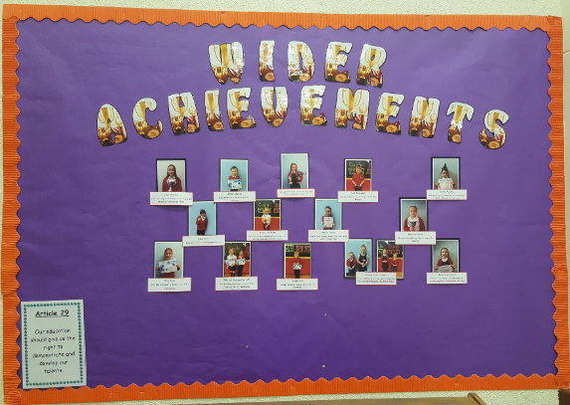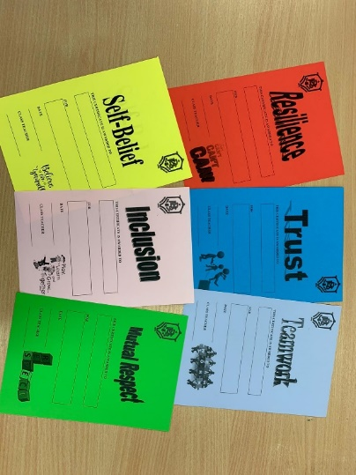

Drongan Primary School and ECC are proud of the successes and achievements that we have had this session despite the being restricted by the pandemic. More than ever the strength in community in Drongan was evident and the positive relationships across the school / ECC community shone through. We have continued on our improvement journey as we strive for excellence and we are proud of the way that all stakeholders have worked to support the learners. The parent and pupil surveys reflected extremely positively.

All of our committee groups have supported the positive change and improvement that has taken place within the school. Our DFS – Inclusive Practice Committee are excited about the prospect of a visit early in the new session to confirm our Gold accreditation. Our Rights Respecting Schools Committee continue to work towards Silver accreditation and hope to achieve this early next session. Unfortunately due to the restrictions we haven’t been able to attend Community Association meetings this session.

Our Primary 4 children have successfully completed their Heritage Detective Awards through learning all about their local community.
Our Primary 6 children have also worked hard to achieve their John Muir award.

Further information on the establishment’s performance at local and national level can be obtained via Parentzone:
https://public.tableau.com/profile/sg.eas.learninganalysis#!/vizhome/SchoolInformationDashboard-Primary/Introduction
Our improvement priorities for session 2020-21 are as follows:

- Learning and Teaching: Further embedding Active Literacy Programme, Lynda Keith Numeracy and Number Talks. Learning and Teaching Policy to be created.
- Health and Wellbeing: Monitor the wellbeing of our children and evaluating the impact of intervention implemented. Continue on our Dyslexia Friendly Schools and Rights Respecting Schools journeys.
- Curriculum: Develop identified areas of the curriculum. Continue to establish and build on existing links with local and wider community to provide real-life learning experiences linked to the world of work.
- Leadership at all levels: Working parties and pupil committees created and developed in line with School Improvement Plan priorities.

SECTION 6
Assessment
Teachers use a range of assessments to monitor children’s progress. We use summative and formative assessment to help inform more accurate teacher judgements relating to children’s achievements. Children also participate in Scottish, National Standardised Assessments in P1, 4 and 7. We use East Ayrshire’s assessment toolkit in literacy and numeracy to support our assessments in p4 and 7 as well as newly developed reading assessments and writing criteria. In Drongan primary School we have recently developed our framework for assessment, which outlines the expectations of when specific assessments should be carried out throughout the session.

In our ECC, a range of assessments are used to monitor the progress of our children.
Written reports are issued to parents annually. We arrange formal parents meeting in October and May when parents can meet with their child’s teacher to discuss their child`s progress. We also share the learning through Twitter, our school apps, open afternoons and class assemblies. Where required, additional meetings are arranged to keep parents informed and involved in the progress of the children.

Further information
I hope the content of this handbook has been helpful and informative. If you require any further information please either visit the school or contact us on 01292 591291.

