**[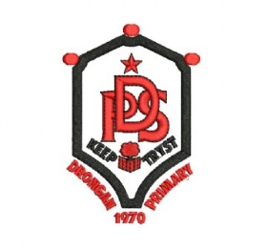](https://www.schooltrendsonline.com/uniform/DronganPrimarySchoolKA67BY)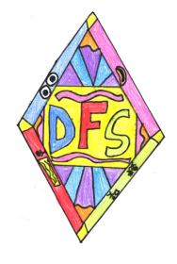East Ayrshire**

**Inclusive Practice (DFS)**

**Logo Competition**

*“East Ayrshire’s Dyslexia Friendly School Accreditation Pathway has been rebranded as “East Ayrshire’s Inclusive Practice (DFS) Accreditation Pathway”. To support this rebranding we are looking to schools to help us create a brand new logo to reflect the new name and the broader theme of inclusion met through dyslexia friendly and inclusive practices.”*

Drongan PS are encouraging our children to submit a new design for this Logo competition using the space below. We will choose 3 entries from this competition to represent the school, but will also choose our own winner to become our new **DFS Inclusive Practice** logo for our gold accreditation journey and beyond. East Ayrshire’s old logo can be seen above. **Entries MUST be submitted by Thursday 10th December at the latest**. Thank you. The DFS Inclusion Committee.