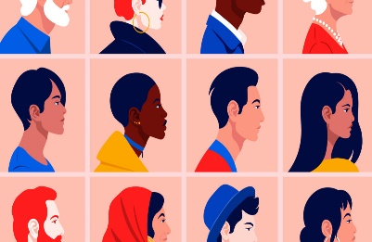
Home Links
Right of the Month
Article 2
All children have rights, no matter who they are, where they live, what their parents do, what language they speak, what their religion is, whether they are boy or girl, whether they have a disability, whether they are rich or poor.
No child should be treated unfairly!
To help learn more about this right, you and your child could:
- Watch these videos. They explain what discrimination means. https://youtu.be/6uXgJA-VfjI (P1-3)
https://youtu.be/hGECP1eGe1M (P4-7)
- Think of somewhere they know well. It might be a library, a park or a swimming pool. Does it welcome everyone? Can all children take part equally? What could make the place better for everyone?
- Listen to ‘The Flamingo Who Didn’t Want To Be Pink’ and discuss. A short video of the story can be found here - https://youtu.be/cKkfOUiu2NA (P1-3)
- Think about people in history who have campaigned about unfair discrimination – Martin Luther King Jnr, Dame Tanni Grey Thompson, Malala Yousufzai. Find out more about what they campaigned for.

