Home Links
This is Drongan Primary’s ‘Right of the Month’ for November.
Please have a look at the article below and if you have some time with your child, learn more about this right together.

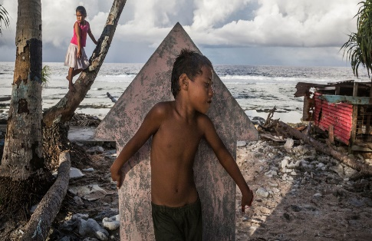
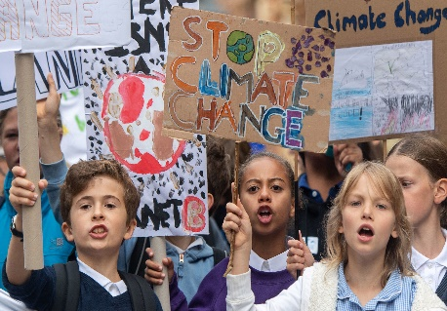
Right of the Month November

Article 24
I have the right to the best health care possible, safe water to drink, nutritious food and a clean and safe environment.

Article 13
I have the right to find out things and share what I think with others

To help learn more about these rights, you and your child could:
- Discuss the importance of having safe water to drink, nutritious food and a clean and safe environment to live.
- Talk about children in less developed countries (Malawi, Gongo, Burundi) and how these rights might not be available. (video below)
- Talk about Climate Change how this could affect a child’s right (across the world) to have clean water, nutritious food and a clean and safe environment.
*Useful websites for videos and activities related to these rights
https://www.nationalgeographic.com/family/activities-teach-kids-climate-change/
https://climatekids.nasa.gov/menu/make/
The Third World - Education Video

