

Diacritical Marking

On day six of the ten day programme, the children are introduced to diacritical marking. Diacritical marking involves investigating words – recognising and identifying which phonemes are contained within each word. Children are involved in listening carefully, enunciating the words accurately and using the diacritical marking code to identify individual sounds and blends.

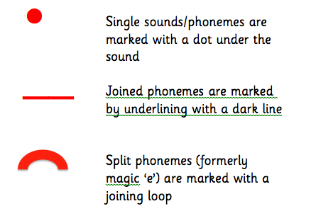

Assessment

Children are no longer assessed purely on the basis of a single word spelling test. Teachers can make judgements about a child’s ability to spell words by placing them in a context e.g. a dictated sentence/paragraph.

Weeks Three

The ‘Thinking Strategies Approach’ is used to teach spelling and this will involve children in using the common word unit or in making their own personal spelling word banks.

Introduction

The aim of this leaflet is to provide you with information about how your child is taught phonics and spelling at school and to give you information to allow you to support your child at home.

In Class

Spelling and Phonics are taught together at this stage. The children are taught in a block of four weeks, with two weeks being focussed on teaching phonemes and their representations, one week on strategy spelling and one week on spelling rules.

The children will continue to use the structure of SAY, MAKE/BREAK, BLEND, READ and WRITE, with which they have become familiar during stages 1-3. They will also continue to work with a partner and reciprocally teach.

In the first two weeks of the programme, the focus is on teaching the different representations of a phoneme sound. For example the sound ‘ee’ can be made by ee, e, ea, ie, e-e. The children follow a ten day programme which involves, independent and partner tasks, to consolidate their phonological awareness.

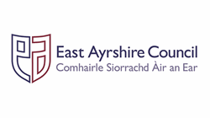





Spelling Strategies (Week Three)

The strategies the children are taught are:

* Using Phoneme Knowledge (sounding out)
* Syllabification – breaking words down into syllables. The children can clap out words to identify syllables e.g. go-ing/An-drew
* Word Shape – Look at letter shape, size, ascending and descending letters.
* Tricky Letters – Looking at the position of tricky letters as an aid to spelling.
* Compound Words – Breaking the compound word into simple words e.g. into makes in and to.
* Mnemonic – using an aide memoire e.g. because – Big Elephants Can Add Up Sums Easily
* Using Analogy – If you know how to spell one word you can spell similar words e.g. if you can spell hill, you can spell mill, will, fill etc.

Week Four

This will involve the children in learning and using a spelling rule which involve them in selecting and revisiting all of the problem solving phonics into spelling and thinking strategies they have used over the month.

At Home

You can help your child to identify words, which contain the different representations of the phoneme. You could ask them to diacritically mark words containing the phoneme representations. You could dictate sentences or paragraphs containing the phoneme representations.

When your child comes home with a list of common words, you could discuss with them what strategy they would use to help them remember to spell each word.

Active Literacy

A Guide for Parents

Stage 4-5

Phonics and Spelling