Comprehension Strategies

The stage four and five programme also highlights the importance of developing children’s higher order thinking and critical literacy skills. These skills are developed through the teaching of the six comprehension strategies:

* Prior Knowledge
* Metalinguistics (Tricky Words)
* Visualisation
* Inference
* Main Idea
* Summarisation

During fluency the children will continue to refer to and use the Word Attack Strategies when they come across unfamiliar words.

Word Attack Strategies

* Look at the first letter
* Sound out the first few letters
* Break the word into syllables
* Look at the last letters
* Read the sentence again
* Look at the picture
* Look at the shape of the word

Introduction

The aim of this leaflet is to provide you with information about how your child is taught reading and writing at school and to allow you to support your child at home with this.

Principles of the Programme

The programme adopts an integrated approach and therefore has a direct link to the spelling and phonics programme. Children are taught to apply their knowledge of spelling and phonics within the context of reading and writing.

In Class

Children are explicitly taught through a four day reading programme, that comprises of:

1 Fluency

2 Comprehension

3 Writing linked to reading/novel

4 Talking and Listening linked to reading/novel

The programme adopts a multisensory, problem solving approach which is well structured and interactive.

The reading books selected have been identified as quality texts providing opportunities for reflection and discussion, rather than being from a traditional reading scheme. In this way children are exposed to a wider variety of authors, styles and contexts.

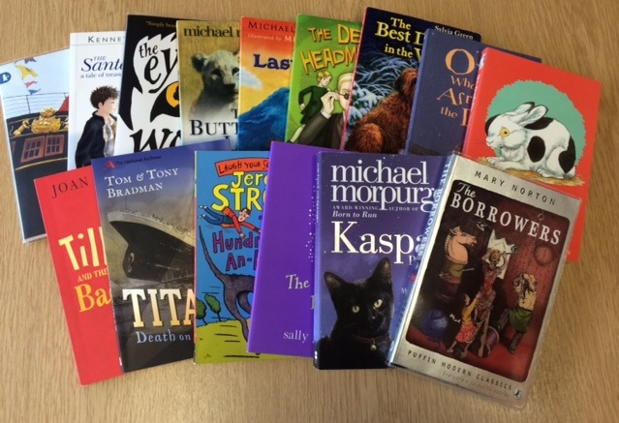

Active Literacy

A Guide for Parents

Stage 4-7

Reading

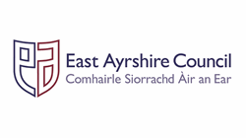



Writing and Talking Linked to Reading

The four day programme stresses the need for children to be talking and writing about the quality text they have read in order to improve their ability to identify and comprehend the main messages within the text.

At Home

You should encourage your child to read at home and for sustained periods of time, ensuring they are covering the chapter(s), which have been identified that week in school. You could assist them if they are unsure about the pronunciation or meaning of a word, by encouraging them to make use of the Word Attack Strategies. You could ask them about what happens in the chapters they have read to check their understanding. Having texts at home or through visiting the library can support your child in their development of reading and writing.