Home Learning Grids- Second Level (P6 & P7)
Suggested ‘Learning at Home’ Activities 20/21 for Those Self-isolating

The following activities are suggested learning at home activities. They are to provide some depth and consolidation of learning while your child is not at school. Please adapt and adjust according to your individual child. There is a 2-week grid with activity ideas for home learning and a list of online resources and websites for literacy, numeracy and other curricular areas. At the bottom of this document is a grid of spelling activities that children could complete with the phonemes they have been learning in class and reading activities they could complete using a book of their choice or Bug Club book.

For the home learning 2-week grid: choose 1 literacy and 1 numeracy task and either 1 expressive arts/STEM challenge OR 1 from the separate P.E. challenge grid. If you choose an expressive arts/STEM challenge on day 1, you could choose a P.E. challenge on day 2 or vice versa. If you are looking for additional things to keep you busy- attempt the challenges added to several tasks and see the list of additional websites below.

All children can login to Glow to get free access to Microsoft Word, PowerPoint, Excel etc. Funded by the Scottish Government and managed by Education Scotland, Glow provides a safe, online environment for educators, learners and parents/carers to communicate and collaborate using services such as Glow Blogs, Microsoft Office 365 and the Glow RM Unify Launch Pad.

Class teachers will also upload weekly homework on their Teams page which children can access from home using their Glow login. Class teachers will also be uploading reading and numeracy activities to your child’s Bug Club and Giglets accounts.

Week 1
Literacy | Numeracy | Expressive Arts/STEM
Design a Starbucks Smoothie-  Starbucks want you to design a new smoothie for their Autumn/Winter collection. Write the recipe-  - List the ingredients  - Method- how do you  make it?  - Draw a picture of what it  Will look like. | Topmarks Bingo Game-  Choose a times table you find tricky. Play Topmarks Bingo- Multiplication & Division for 20 minutes or until you feel more confident with the answers. Could you challenge a family member to play with you?  https://www.topmarks.co.uk/  *Challenge- choose another multiplication game to play.* | Mindfulness Hands Art-  Draw around your hands and decorate inside of the hand to show your emotions.  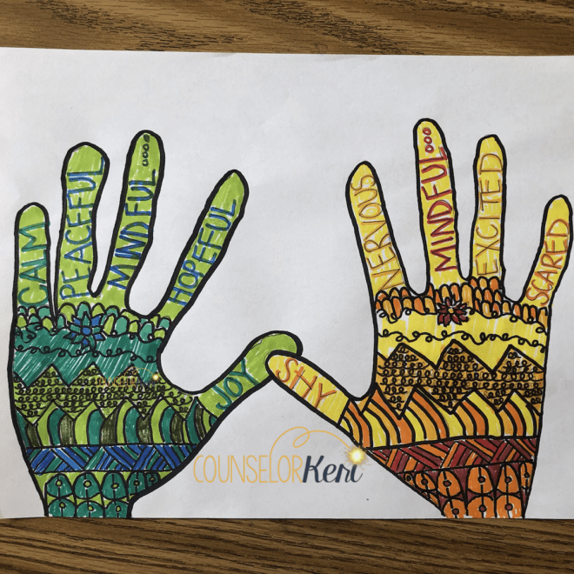
Farm to Plate-  Complete the Bitesize topic: Farm to Plate.  https://www.bbc.co.uk/bitesize/topics/ zfmpb9q/articles/z4tbn9q  *Challenge- figure out the food miles and journey for the food in your fridge. | Sumdog-  Spend 45 minutes on Sumdog- if your teacher has set your class a challenge, complete this first. If not, choose your own games!  https://pages.sumdog.com/ | Pizza Toast-
Question Master  Create six questions about the book you are currently reading (either personal or class novel). Try to ask ‘Why’ questions. If you were a teacher, what questions would you ask your pupils? Could you ask inferential questions? | 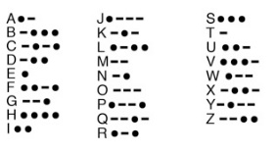  Morse Code Challenge- Write a secret message for a family member using the Morse Code. Ask them to decode it. *Challenge- use a torch or whistle to  send your message- video it if you like!*  https://sites.google.com/site/shorthillsed tech/morse-code-for-kids (Find out more!) | Spaghetti Bridge STEM-
Literacy | Numeracy | Expressive Arts/STEM
Isolation Interview-  Interview someone you know- they could live with you or you could phone them. Questions could include:  - What have you had to change about your life in the last few months?  - Do you have any new hobbies?  - What do you miss most?  - Have you learned any important life lessons?  Take notes on their answers.  *Challenge- think of your own additional questions to ask.* | Transum Problem Solving-  - Complete the ‘Starter of the Day’  https://www.transum.org/Software/SW/ Starter_of_the_day/  - Complete ‘Flash Tables’ game  https://www.transum.org/Software/SW/Flash_Tables/  - Complete the ‘Scatter Graph’ game  https://www.transum.org/Maths/Activity/ Scatter_Graphs/Cartoon.asp  *Challenge: choose 1 more game to complete!* | Word Art  Go to https://wordart.com/ and create a word art picture filled with compliments for someone that means a lot to you.  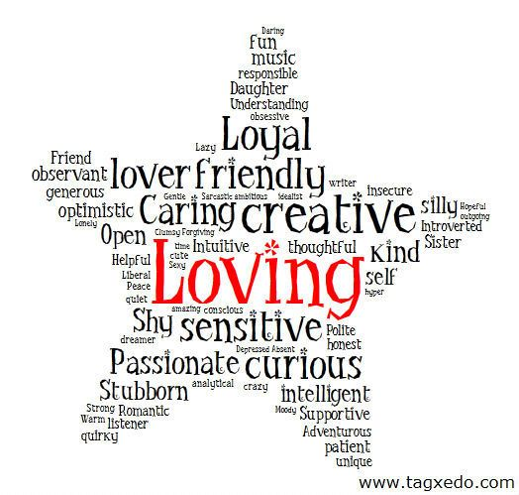
Job Application Task-  What is your dream job? Write a CV.  Tell us why this is your dream  job, why you should get it,  list your skills and qualities  and why you are suitable for  this job.  You can find examples of CVs  Online to help. | Maths Challenge Card-  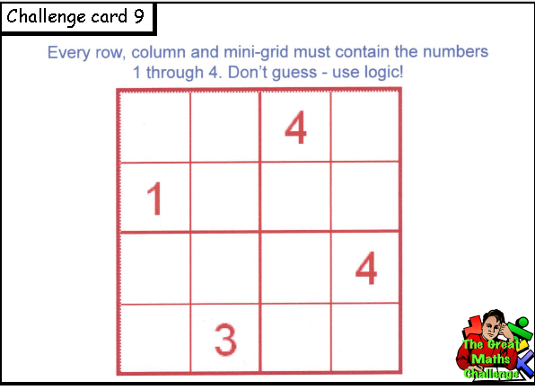 | Photography Challenge-
*Remember to complete a minimum of 30 minutes per day Accelerated Reading. If you don’t have any books at home, try reading magazines, cookbooks, comics or online books. Oxford Owls have a library of free books: https://www.oxfordowl.co.uk/
For additional activities:
All children have a log in for Sumdog & Education City, sites which develops mental maths and problem solving skills: https://pages.sumdog.com/ https://www.educationcity.com/ (ask your child’s teacher if they don’t know their log in)
Oxford Owls have a library of free books: https://www.oxfordowl.co.uk/
Free audiobooks for children: https://www.storynory.com/
Lots of free maths games: https://www.topmarks.co.uk/
Daily lessons in literacy, numeracy and health and wellbeing: https://www.bbc.co.uk/bitesize
Learn, create and play through exploring Scotland’s history and heritage: https://www.historicenvironment.scot/learn/
STEM (Science, Technology, Engineering & Maths) with Mr N: https://www.youtube.com/channel/UCxziq4omrQP-EKSLilOIPhw
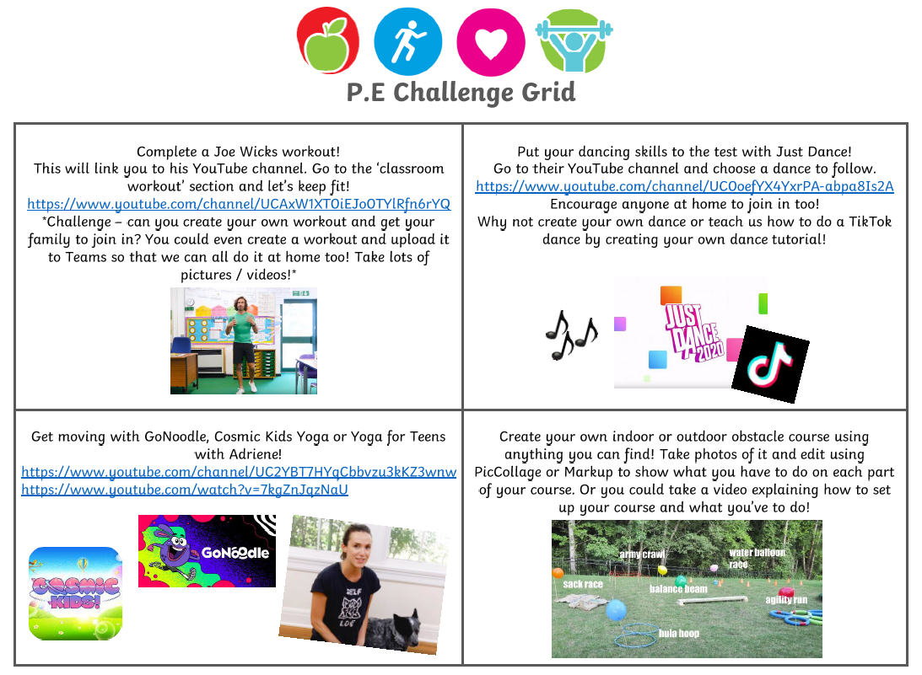

Week 2
Literacy | Numeracy | Expressive Arts
My Wellbeing Journal-  Write a short diary entry each day about how you are feeling, what ideas you have to keep busy each day, any challenges you have had and how you have overcome them. | Education City-  Spend 45 minutes on Education City- if your teacher has set your class a challenge on My City, complete this first. If not, choose your own games!  https://educationcity.com/ | Kitchen Roll Art-  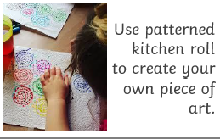
Research Project-  Choose a city you would love to visit. Create a fact sheet (handwritten or typed on Word or a short Powerpoint)  - What is the currency?  - What are the main attractions/landmarks?  - What is the weather like? | Transum Problem Solving-  - Complete the ‘Starter of the Day’  https://www.transum.org/Software/SW/ Starter_of_the_day/  - Complete ‘Flash Tables’ game  https://www.transum.org/Software/SW/Flash_Tables/  - Complete the ‘Prison Cell Problem’ game  https://www.transum.org/software/SW/ prison/prison.asp  *Challenge: choose 1 more game to complete!* | Blanket Fort-  Design and create your own blanket fort. Take a picture and share it on Seesaw.  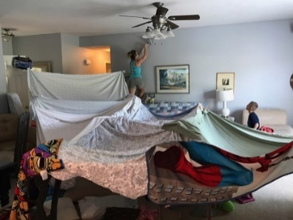
Poetry Task-  Listen to a poem on:  https://childrens.poetryarchive.org/  Three Sharings:  - What did you like/dislike about the poem?  - Any connections you can make to your own life?  - Puzzles- anything that confused you?  *Challenge- record yourself reciting the poem.* | Topmarks-  Play Hit the Button Division Facts (divide by 7, 8, 9 & 10) for 45 minutes:  https://www.topmarks.co.uk/maths-games/hit-the-button  *Challenge- try divide by 11 and 12.* | Cereal Box STEM Challenge-
Literacy | Numeracy | Expressive Arts/STEM
Newspaper Challenge-  Using a newspaper, magazine or a book find words that you don’t know the meaning to. Write them down and use a dictionary (online dictionary is fine) to find a definition for them. | Maths Challenge Cards-  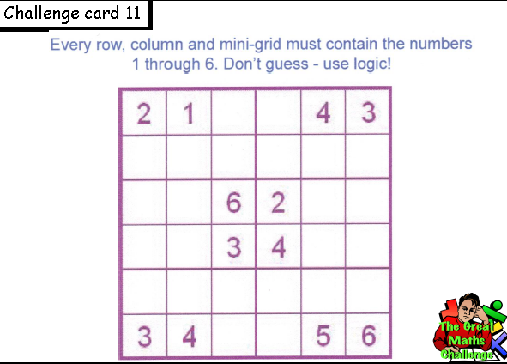 | Origami Activity-  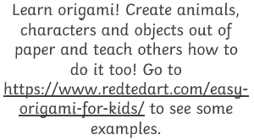
ABC Order-  Write the words you used in your newspaper challenge out in alphabetical order. Then write them in reverse alphabetical order.  Word Search-  Create your own word searches using your words. Or use this link to get your computer to do it for you.  http://puzzlemaker.discoveryeducation.com/ | Nrich Maths- National Flag Game-  Choose one of the national flags from the Olympic games that are displayed and answer the questions on a piece of paper.  https://nrich.maths.org/7749  *Challenge- choose another flag from the list that you think will be trickier than the first one and complete.* | Coding Challenge-  Go to https://code.org/learn and choose a coding activity to complete. My personal favourite is the Minecraft Hour of Need one.  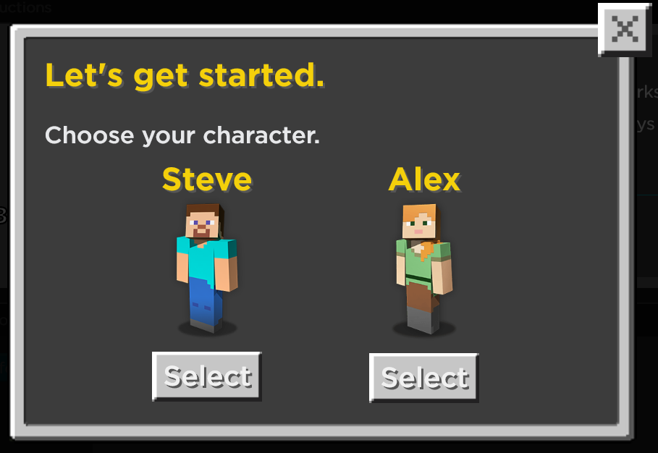
*Remember to complete a minimum of 30 minutes per day Accelerated Reading. If you don’t have any books at home, try reading magazines, cookbooks, comics or online books. Oxford Owls have a library of free books: https://www.oxfordowl.co.uk/

