Home Learning Grids- First Level (P1 & P2)
Suggested ‘Learning at Home’ Activities 20/21 for Those Self-isolating

The following activities are suggested learning at home activities. They are to provide some depth and consolidation of learning while your child is not at school. Please adapt and adjust according to your individual child. There is a 2-week grid with activity ideas for home learning and a list of online resources and websites for literacy, numeracy and other curricular areas. At the bottom of this document is a grid of spelling activities that children could complete with the phonemes they have been learning in class and reading activities they could complete using a book of their choice or Bug Club book.

For the home learning 2-week grid: choose 1 literacy and 1 numeracy task and either 1 expressive arts/STEM challenge OR 1 from the separate P.E. challenge grid. If you choose an expressive arts/STEM challenge on day 1, you could choose a P.E. challenge on day 2 or vice versa. If you are looking for additional things to keep you busy- attempt the challenges added to several tasks and see the list of additional websites below.

All children can login to Glow to get free access to Microsoft Word, PowerPoint, Excel etc. Funded by the Scottish Government and managed by Education Scotland, Glow provides a safe, online environment for educators, learners and parents/carers to communicate and collaborate using services such as Glow Blogs, Microsoft Office 365 and the Glow RM Unify Launch Pad.

Class teachers will also upload weekly homework on their Teams page which children can access from home using their Glow login. Class teachers will also be uploading reading and numeracy activities to your child’s Bug Club and Giglets accounts.

Week 1
Literacy | Numeracy | Expressive Arts/STEM
Phonics- Learn to Read- Rhyming Words-  Watch the Alphablocks video and encourage your child to say out loud the letters/words they recognise. https://www.youtube.com/watch?v=Os9P7wsDZa0  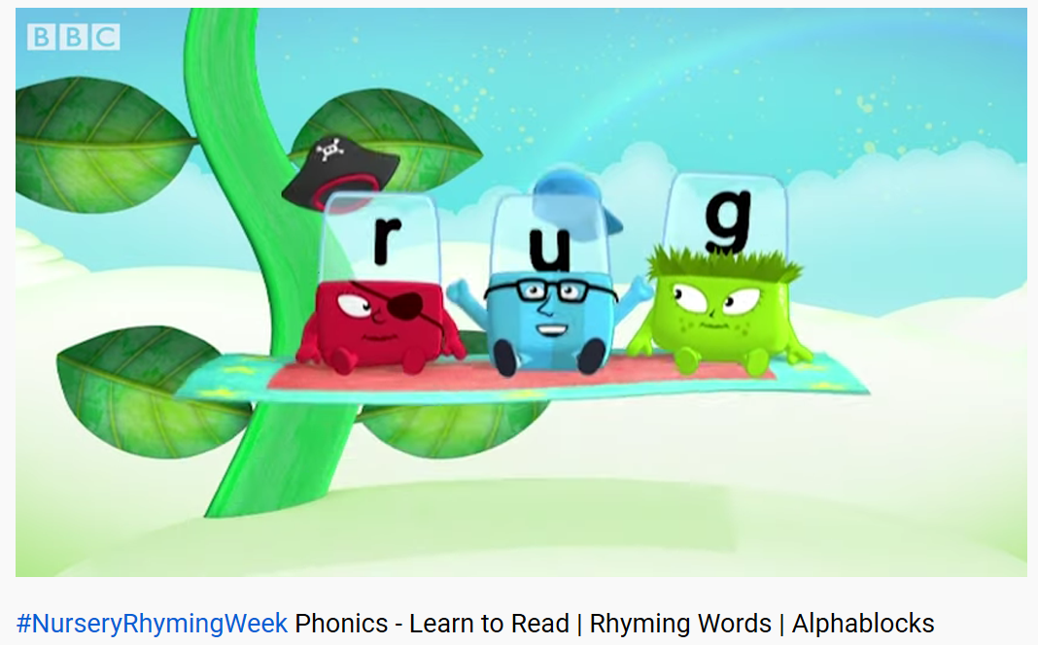 | Topmarks Number Bonds Game-  Play Topmarks Number Bonds Up to 10 games for 20 minutes or until you feel more confident with the answers. If you find this easy, move on to Number Bonds up to 20 games.  https://www.topmarks.co.uk/maths-games/hit-the-button  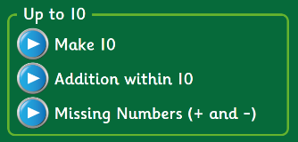  *Challenge- try playing Number Bonds Up to 100 games.* | My Favourite Things-  Draw a picture of your favourite things about school.  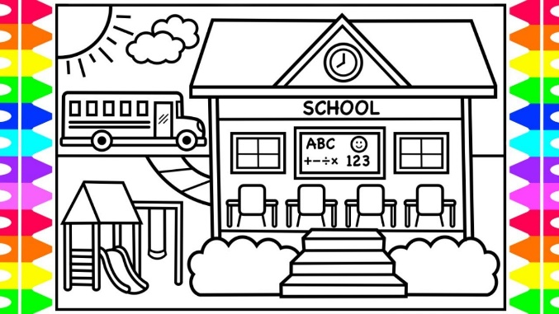
Story Book Challenge- Read a short story or ask an adult to read one to you.  - Choose 1 character. Would you like him/her to be your friend? Why?  - What was your favourite part of the story? Explain.  - Anything you didn’t like? Why?  *Challenge- video yourself answering one or all the above questions. | Sorting Objects-  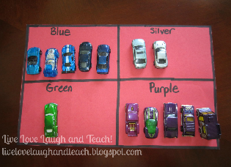  Find some objects from around your house or from the garden and sort them into different groups. How many ways can you sort them? E.g. toy cars - sort them by size, colour or make.  Take a photo and send it to us! | Arty Food Task-  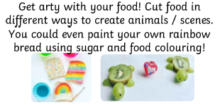  Ask a parent to help you with this task.
Literacy | Numeracy | Expressive Arts/STEM
Colour by Christina Rossetti-  There are 3 videos to watch:  - Listen to the story  - Read key words from the story  - Share enjoyment of the story  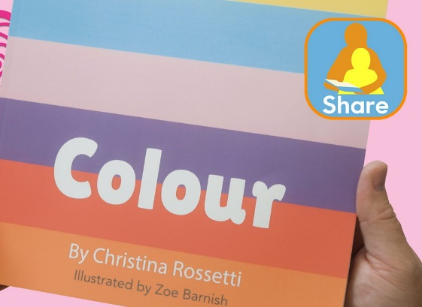  https://www.bbc.co.uk/bitesize/topics/zvyc7nb/articles/zjyfnrd | The Spider’s Web-  Write number’s 1-20 randomly on a page and circle each number. Start at 1 and join in order up to 20. If you find this easy, try numbers 1-50 and if you really want to challenge yourself, 1-100!  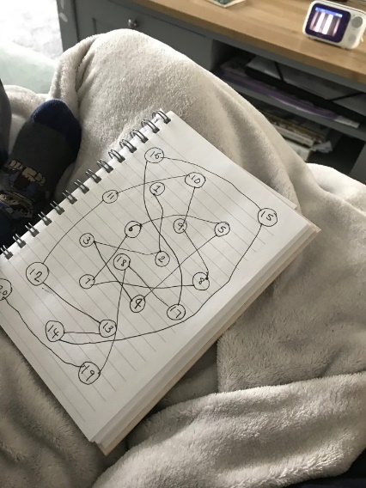 | Salt Dough-  Make the salt dough recipe below. You could:  - Make prints with leaves, stones, etc.  - Print with toys, e.g. Lego, dinosaurs  - make your name  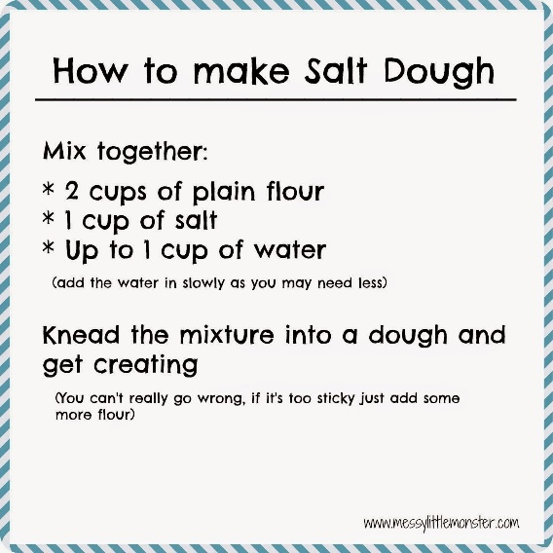
Spelling Activity-  Choose 5 words from your reading book that you think are ‘Wow Words’.  - Air write your words in the air  - Cut out letters from a magazine and stick to make the words  - Rainbow write your words  - Draw a picture to match each word  *Challenge- write a sentence for each word (or say the sentence and ask an adult to write it for you). | Topmarks Helicopter Rescue Game-  Play Find a Number and Count On & Back 1-10 &1-20. If you find this easy, play 1-30.  https://www.topmarks.co.uk/learning-to-count/helicopter-rescue  *Challenge- try 1-50 and 1-100!* | Shape Art  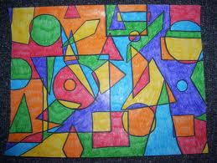  Try and find as many different shaped items around the house. Draw round them on a piece of paper and colour to create your own ‘shape art’.
Literacy | Numeracy | Expressive Arts/STEM
Fine Motor Skills-  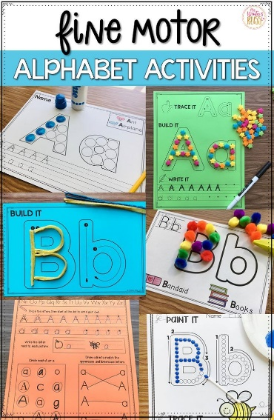  Practise making patterns, letters and numbers in sand, rice, shaving foam or with buttons and playdough. Anything you have in the house! | Shop Imaginary Play Activity-  Find 5 toys, write 5 amounts on post its or pieces of paper, e.g. 5p, 8p, etc. ‘Play shops’- use a calculator as a till register and loose change. Children can be the customer or the shop worker and they need to find the right amount to pay for the items or work out change.  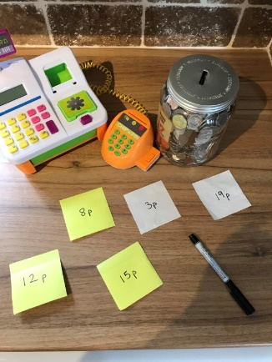  *Challenge- try larger amounts and buy more than 1 item. | Freezing Liquids Activity-  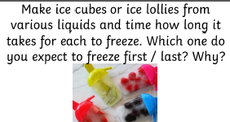
For additional activities:
All children have a log in for Sumdog & Education City, sites which develops mental maths and problem solving skills: https://pages.sumdog.com/ https://www.educationcity.com/ (ask your child’s teacher if they don’t know their log in)
Oxford Owls have a library of free books: https://www.oxfordowl.co.uk/
Free audiobooks for children: https://www.storynory.com/
Lots of free maths games: https://www.topmarks.co.uk/
Daily lessons in literacy, numeracy and health and wellbeing: https://www.bbc.co.uk/bitesize
Learn, create and play through exploring Scotland’s history and heritage: https://www.historicenvironment.scot/learn/
STEM (Science, Technology, Engineering & Maths) with Mr N: https://www.youtube.com/channel/UCxziq4omrQP-EKSLilOIPhw
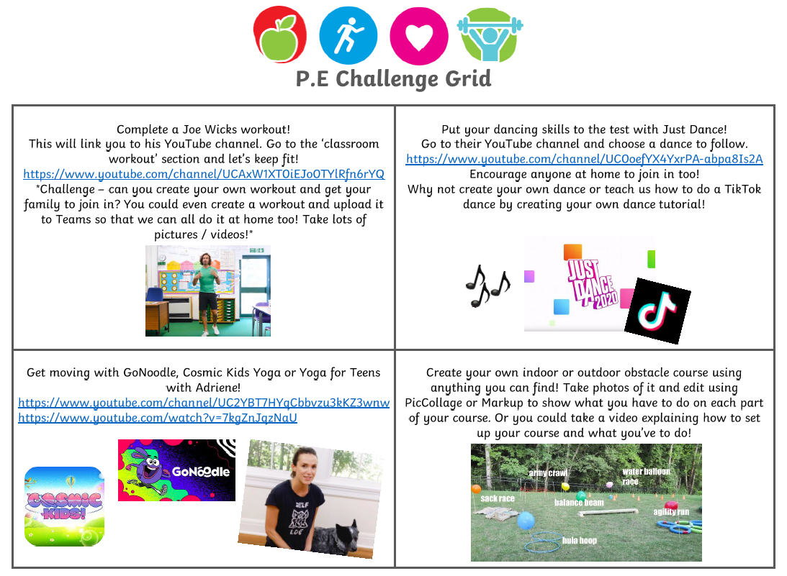
Week 2
Literacy | Numeracy | Expressive Arts
Aliens Love Underpants-  There are 3 videos to watch:  - Listen to the story  - Read key words from the story  - Share enjoyment of the story  https://www.bbc.co.uk/bitesize/topics/ zvyc7nb/articles/zmgbvk7 | Tick Tock-  How many times can you do these things in just one minute? (use a phone timer)  - bounce a ball  - hop of one foot  - run around your garden  - write your name  - do star jumps  Write your scores down and try to beat them! | Kitchen Roll Art-  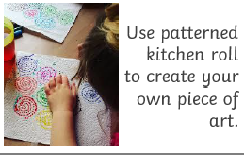
Research Project: Favourite Animal-  Choose an animal that you love and want to find out more about.  - What does this animal look like?  - What do they eat?  - Where do they live?  - Can you find out fun facts about this animal? (Youtube videos are great for this!) | Numberjacks-  Learn to count with Numberjacks:  https://www.youtube.com/watch?v=4aC6D4VcmaA  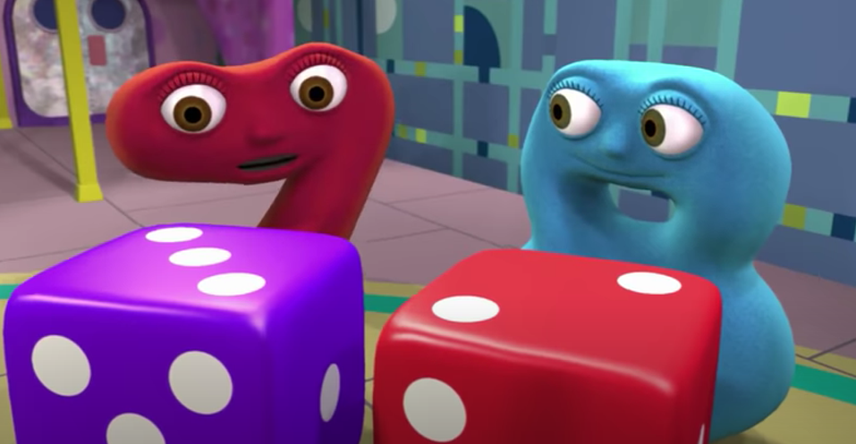  *Challenge- write down the numbers that you spot in the Numberjacks clip. At the end, count the number you’ve written down the most. | Blanket Fort-  Design and create your own blanket fort. Take a picture and share it on Seesaw.  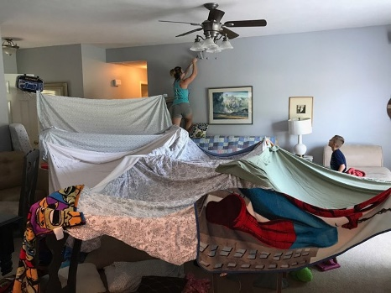
Literacy | Numeracy | Expressive Arts/STEM
Safety in School Poster-  Design a poster that we can use at school to show children how to stay safe:  - Wash your hands  - Sneeze into elbows  What other things do we need to remember? | Topmarks Coconut Odd or Even Game  Play the odd or even games 1-20. If you find this easy, try 1-50.  https://www.topmarks.co.uk/learning-to-count/coconut-odd-or-even  *Challenge- try up to 100 games! | Build Your Own Castle Features-  Build your own arch, battlements, drawbridge or portcullis at home! Use what you have- Lego and blocks, pillows and blankets, or cereal boxes and yoghurt pots. See link below for ideas:  https://www.historicenvironment.scot/media/ 6466/build-your-own-castle-features.pdf  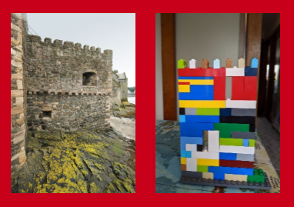
Spelling Activity-  Choose 5 words from your reading book that you think are ‘Wow Words’.  - Air write your words in the air  - Draw a picture and hide your words inside  - Write your words on someone in your house’s back and ask them to guess what the word is  - Write the words in all small letters then all capital letters  *Challenge- write a sentence for each word (or say the sentence and ask an adult to write it for you). | Four Pin Bowling  Which pins must be knocked down to score exactly 5?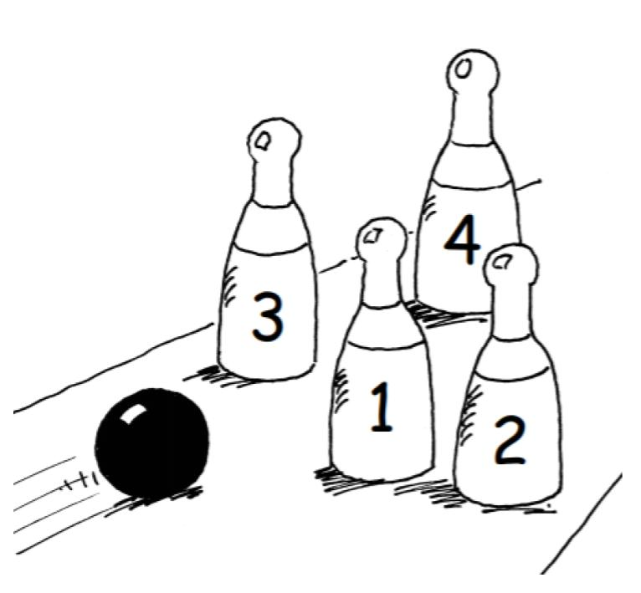  Find 2 different ways:  - to score 5  - to score 6  - to score 7 (Write down your sums and answers.) | Treasure Hunt-  Create a treasure hunt for someone to complete with clues that will lead them round the house/garden to a final destination.  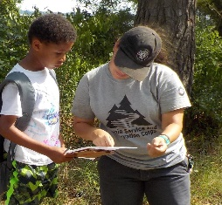
Literacy | Numeracy | Expressive Arts/STEM
Lego Characters Story Writing-  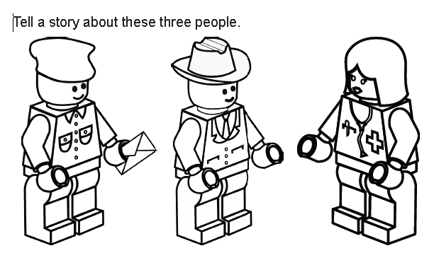  Either tell the story out loud to an adult, film yourself telling the story or write the story down.  - What are the characters names?  - What jobs do you think they do?  - What are they talking about?  - What happens next? | Snowflakes Activity-  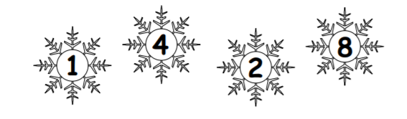  - Pick a pair of numbers and add them together, write all the numbers and answers.  - Keep doing it, how many different ways can you find?  - Now take the numbers away from each other, how many different answers can you get?  *Challenge- choose 4 of your own bigger numbers and repeat the steps above.* | Battery Scavenger Hunt-  Do batteries really power the world? Find as many things around your house as you can that are powered with batteries.  - Take pictures or draw the items you find.  - Sort your toys into categories: ‘battery powered’ and ‘don’t need batteries’  - How do batteries work? Can you find out?  *Remember batteries are not toys and should be left to an adult to handle.*
For additional activities:
All children have a log in for Sumdog & Education City, sites which develops mental maths and problem solving skills: https://pages.sumdog.com/ https://www.educationcity.com/ (ask your child’s teacher if they don’t know their log in)
Oxford Owls have a library of free books: https://www.oxfordowl.co.uk/
Free audiobooks for children: https://www.storynory.com/
Lots of free maths games: https://www.topmarks.co.uk/
Daily lessons in literacy, numeracy and health and wellbeing: https://www.bbc.co.uk/bitesize
Learn, create and play through exploring Scotland’s history and heritage: https://www.historicenvironment.scot/learn/
STEM (Science, Technology, Engineering & Maths) with Mr N: https://www.youtube.com/channel/UCxziq4omrQP-EKSLilOIPhw

