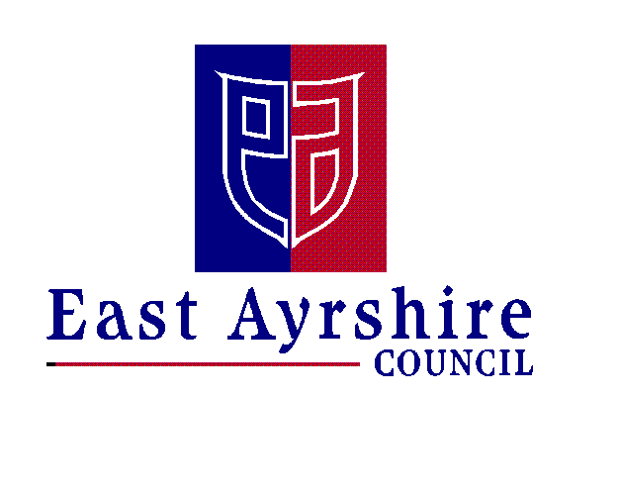Economy and Skills
Depute Chief Executive and Chief Financial Officer
Alexander McPhee ACMA
Drongan Primary School & Early Childhood Centre
Head Teacher: Mr Sean Maddocks
Millmannoch Ave, Drongan, Ayr, KA6 7BY
Tel: (01292) 591291

20th October 2020

HALLOWEEN THEMED LUNCH – FRIDAY 30th OCTOBER 2020

Dear Parent/Carer,

On Friday 30th October Mrs Shields and her catering team will be putting on another themed lunch for our pupils. Please note the options below will replace the menu for this date.

The menu for Friday will be as follows:

Main Course options:

Chicken Burger or
Macaroni Cheese or
Pizza
*all served with potato wedges

Dessert:

Halloween Treat Bag (sweet treats)

Please fill in the slip below and return it to school as soon as possible (by Tues 27th October) if your child would like to take part in the themed lunch next Friday. Please use ParentPay if you are required to pay for school meals. A reminder that all children in P1-3 are entitled to a free school meal.

Kind regards,

Tom McFadzean
Depute Head Teacher

----------------------------------------------------------------------------------------------------------------HALLOWEEN THEMED LUNCH – FRIDAY 30th OCTOBER 2020
My child _________________________ in Primary _________ would like to have a themed lunch.

They will have (please tick):

Main Couse: Chicken Burger
(select one)
Macaroni Cheese

Pizza

Signed: ________________________________ Date: __________________

