[](https://www.schooltrends.co.uk/uniform/DronganPrimarySchoolKA67BY)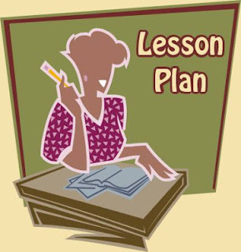

*‘We know we have learned something*

*if we can teach it to others’*

**The Excellent Lesson**

**As agreed by teachers, pupils and parents**

**Active Learning**

* Pupils learn by carrying out a variety of activities
* Pupils think creatively, investigate and solve problems
* Pupils have choices
* Pupils work on their own, in pairs and in groups
* Pupils engaged in ‘Think, Pair, Share’ activities
* Pupils use different resources including ICT
* Teachers don’t rely on textbooks or worksheets
* Pupils often learn outdoors
* Activities relate to real life
* Lesson has links with other subjects
* Lesson links with local businesses and community

**Skills Development**

* Skills for Life
* Skills for Learning
* Skills for Work
* Leadership Skills
* Higher order thinking skills
* In-depth study skills

**Meeting Pupils’ Needs**

* Everyone has high expectations
* Every pupil is learning
* Teachers teach in a variety of ways to accommodate different learning styles
* Teachers challenge and support all pupils
* Pupils all work at an appropriate pace
* Pupils can explain to others what they have learned in different ways to ‘Make Thinking Visible’
* Pupils evaluate their learning experiences
* Pupils evaluate the lesson
* Pupils feel:
* Safe
* Healthy
* Achieving
* Nurtured
* Active
* Respected
* Responsible
* Included

**Assessment is for Learning**

* Teachers discuss previous learning with pupils
* Pupils understand learning intentions
* Teachers and pupils agree success criteria
* Pupils know the level they are working towards
* Pupils reflect on learning and set targets through the use of E-portfolios, blogs, target jotters and displays
* Teachers and pupils use a variety of questioning styles to provide challenge
* Pupils and teachers are aware that mistakes are acceptable and can be learned from
* Teachers give pupils constructive and positive feedback to help them improve
* Pupils assess and learn from each other
* Pupils gain success within their learning intention(s) by the end of lesson(s)