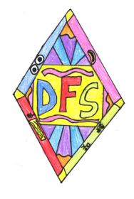[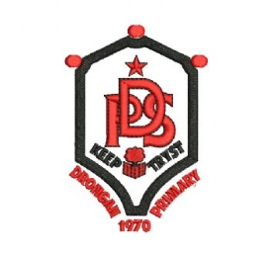](https://www.schooltrendsonline.com/uniform/DronganPrimarySchoolKA67BY)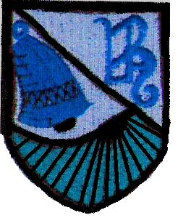**Drongan Primary School & Early Childhood Centre**

**Dyslexia Friendly Schools Policy**

At Drongan Primary School & ECC, being a Dyslexia friendly school not only helps us to meet the needs of dyslexic pupils, but also the needs of pupils who have delayed Literacy skills. Drongan Primary School & ECC endeavours to ensure the identification, assessment and intervention for pupils with Dyslexia takes a high priority. Our aim is to provide children with the skills to cope with/overcome their difficulties/challenges throughout their lives.

We also recognise that a child’s self-esteem and confidence goes hand in hand with successful learning. Therefore, our children are made aware of what dyslexia is and positive role models are discussed and displayed around school to raise awareness among pupils and staff.

**Aims**

At Drongan Primary School & ECC we are committed to:

* Whole school awareness of what dyslexia is and how we can support children with dyslexia
* Whole school responsibility for supporting children / young people with literacy difficulties including dyslexic difficulties
* Empowerment of teachers to meet the needs of all their pupils
* Dyslexia friendly learning environments
* Early identification of children / young people at risk of developing literacy difficulties and appropriate intervention strategies suited to meet individual’s needs
* Confidence and consistency in using the Staged Intervention Model embedded within East Ayrshire’s Dyslexia Guidelines
* Effective monitoring and tracking systems to record pupil’s literacy development
* Effective networking for sharing and celebrating good practice
* CPD opportunities for staff
* Resilience in pupils
* Development of children / young people’s empathy and awareness towards dyslexia
* Positive and effective Parent / Carer partnership

**What is Dyslexia?**

The word ‘dyslexia’ has a Greek origin

* + ‘Dys’ means ‘difficulty’
  + ‘Lexia’ comes from the root ‘lexis’ which means ‘words or language’

At its simplest dyslexia means ‘difficulty with words or language’

Worldwide there is no one single, commonly accepted definition of Dyslexia. This is Dyslexia Scotland’s definition and the one we refer to:

*“'Dyslexia can be described as a continuum of difficulties in learning to read, write and/or spell, which persist despite the provision of appropriate learning opportunities. These difficulties often do not reflect an individual's cognitive abilities and may not be typical of performance in other areas.”*

[www.dyslexiascotland.org.uk](http://www.dyslexiascotland.org.uk)

It is important to note that dyslexia exists in all cultures and across the range of abilities. It is a hereditary, life-long, neuro-developmental condition. As such, we cannot cure dyslexia but we can help pupils to develop strategies that can help them overcome many of the difficulties and barriers to learning they encounter as a result of their dyslexic difficulties.

In Drongan Primary School & ECC we view dyslexia as being:

* A learning difference
* A pattern of weaknesses and strengths
* A processing difference

**Early Identification of Dyslexia and Intervention**

The procedures that the school follow when identifying a child with dyslexia are outlined in East Ayrshire’s Standard Circular 102. The diagram below illustrates the steps that should be followed:

1. **Concerns raised**

**2. Decide appropriate assessments**

**3. Assess**

**4. Analyse assessments**

**5. Devise intervention plan based on assessment**

**6. Share targets with child**

**7. Adapt curriculum, environment and/or staff practice**

**8. Assess ongoing progress to targets**

**9. Review**

**THE EAST AYRSHIRE DYSLEXIA AND LITERACY ASSESSMENT PROCESS**

The initial concern may be raised by the parent / carer or the class teacher. After it has been agreed that there is a need for assessment and consent has been given the ASN Coordinator within the school will complete the Assessment Request Form. A variety of appropriate assessment materials will then be gathered by the class teacher with support of the ASN Coordinator and EAST Teacher. An Assessment Team Meeting will then take place where professionals will analyse the assessment information that has been gathered and a decision will be made. An appropriate intervention plan should then be devised which targets the young person’s specific needs. This plan should be shared with the young person and their parents / carers. The class teacher will make any recommended adaptations to the learning environment that is likely to be helpful to the child. Assessment should then be continuous and the impact of the interventions should be reviewed.