HWB Weekly Overview - Week Beginning: 08/03/21
Here are some suggested activities for HWB this week. This term our focus will be Food and Health.
If you can, try to complete some of these activities as part of your home learning for HWB.

This week the activities all link to the Respected wellbeing indicator.
Primary 4 | L.I – To know and respect that different countries and cultures have different food choices. HWB 1-29a | 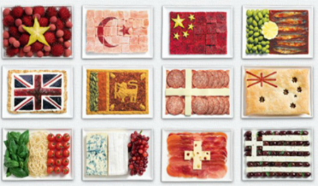  Activities –It is important that we respect different countries/cultures and their food choices.  Research a country (internet, books etc) from the list below. Find out about the foods traditionally associated with that country.  Create a poster on word or on paper to share what you have learned about the foods eaten in your chosen county. Include pictures of the food and try and give a little information about each food.  China, Mexico, Turkey, France, India, Spain, Italy  The example below can be edited and used to complete this activity.
Primary 5 | L.I - To know and respect that different countries and cultures have different food choices. HWB 2-29a | Activities – Chinese New Year was on the 12th February but Chinese food is popular all year round in our country.  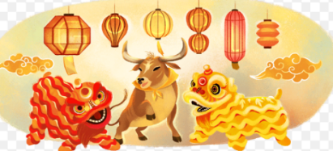  Traditional Chinese food is very different to the traditional foods we eat in Scotland.  Research some traditional Chinese foods. Can you create a menu (use the template below) of some dishes that a family might eat together to celebrate Chinese New Year?
Primary 6 | L.I- To know and respect that there are different factors that influence people’s food choices. HWB 2-09a | 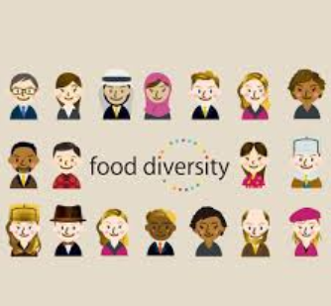  Activities – There are many reasons why people choose to eat or avoid certain foods.  One of those reasons is to obey their culture’s food laws for religious reasons.  You should already know of a few culture’s  Food laws through work in RME.  Watch this short video that explains some religious food laws from around the world - Religious and Cultural Food Laws  Pick a religion/culture and research their food laws. What are people allowed/not allowed to eat and why?  Create a poster on word or paper showing what you know about another culture’s food laws.
Primary 7 | L.I- To know and respect that there are different factors that influence people’s food choices. HWB 2-09a | 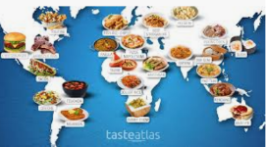  Activities – We must respect that other cultures and countries have their own reasons for eating certain foods. This might be because of religious food laws, history and tradition or due to the countries climate and what can be grown there.  Have a look at this website and look at some traditional recipes from countries around the world.  http://www.foodbycountry.com/  Can you pick a simple dish and try to make it with someone at home? Use your senses to explore the different textures, smells and taste of the ingredients compared to what you are used to eating.  It could be as easy as a French baguette!  Expand your taste buds! You never know…it might be your new favourite!

