HWB Weekly Overview - Week Beginning: 22/02/21
Here are some suggested activities for HWB this week. This term our focus will be Food and Health.
If you can, try to complete some of these activities as part of your home learning for HWB.

This week the activities all link to the Nurtured wellbeing indicator.
Primary 4 | L.I – To recognise that people have different nutritional needs/experiences of food throughout their lives. HWB 1-32a  I can use a Venn diagram to organise data. MNU 1-20b | Activities –Talk to an adult at home about the different foods you ate as a baby/toddler and think about the foods you eat now.  Our taste buds grow and change as we grow. Use the Venn diagram in the activity sheet to discuss and record the food you once ate to the foods you eat now. There might be some foods you still enjoy.  
Primary 5 | L.I- To understand that some people may eat or avoid certain foods HWB 2-32a | 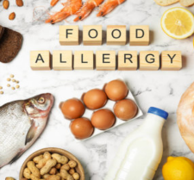  Activities – Many people can’t eat or even handle certain foods due to food allergies. Watch the series of allergy videos on the link below.  What is a Food Allergy?  *Research a common food allergy from the list below;  Milk Wheat (Gluten) Peanut Eggs Shellfish  *After researching one of these allergies, create/design an information poster that provides information about this allergy.  - Think about the foods that should be avoided.  - Think about the dangers/symptoms experienced by eating foods containing these allergens.  - Think about any medication that might have to be taken as a result of this allergy.
Primary 6 | L.I- To understand that some people may eat or avoid certain foods HWB 2-32a | Activities – People may have to eat or avoid certain foods for lots of different reasons. Research some of the reasons why.    *Complete the mindmap (using the template) to brainstorm the reasons why people may avoid certain foods. I have added an example to get you started.
Primary 7 | L.I- To understand that some people may eat or avoid certain foods HWB 2-32a | Activities – For various reasons people make the decisions to avoid certain foods. Vegans choose only to eat certain foods.  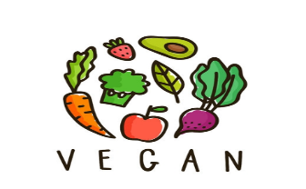  *Research what it means to be Vegan. Have a look at the PowerPoint (on Teams).  *Use your knowledge of Veganism to sort the food cards into Vegan and Non Vegan foods  Lots of people each year take part in Veganuary during the month of January. Could you go Vegan for a period of time?  *Complete the activity sheet (on Teams). What would be the advantages/disadvantages of a Vegan diet?  -Think about your health, the environment, effect on the economy/businesses and livelihood.  -Try to provide as much detail as possible.

