HWB Weekly Overview - Week Beginning: 11/01/21
Here are some suggested activities for HWB this week. This term our focus will be Food and Health.
If you can, try to complete some of these activities as part of your home learning for HWB.

This week the activities all link to the Safe wellbeing indicator.

Primary 1 | L.I -To begin to recognise the importance of cleanliness, hygiene and safety within everyday routines. HWB 0-33a | Activities - Sorting and matching activity – can you place real or pretend foods and drinks from your house in the correct storage places eg, cupboard/fridge etc.  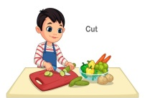  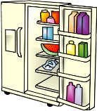  Can you practice cutting soft fruit and vegetables with the help of an adult?  Think about your snacks or helping with dinner.
Primary 2 | L.I - To understand the effects of good hygiene and safety on health and wellbeing. HWB 1-33a | Activities – Watch the hygiene PowerPoint below (Double click picture)  Can you create a safety and hygiene poster to help others when preparing food eg. put on apron, tie long hair back, wash hands etc.
Primary 3 | L.I - To understand the effects of good hygiene and safety on health and wellbeing. HWB 1-33a | 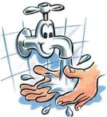  Activities – Can you create a set of safety rules to promote personal hygiene in general eg. do not cough or sneeze over food, wash hands after using the toilet.
Primary 4 | L.I - To understand the effects of good hygiene and safety on health and wellbeing. HWB 1-33a | Activities – Watch carefully and ask how your mum/dad demonstrates safe and hygienic practice when preparing dinner. What are they doing that shows good food hygiene?  Can you Illustrate/Explain what might happen if you don’t prepare food safely e.g feel unwell, stomach pains, feel sick, diarrhoea.
Primary 5 | L.I- To understand the importance of cleanliness, hygiene and safety when preparing and storing food. HWB 2-33a | Activities - Illustrate an ‘ideal kitchen’ environment, annotating good hygiene and safety eg, safe storage of utensils, hand-washing facilities; clean and clear surfaces. Watch this PowerPoint to help (Double click on picture)
Primary 6 | L.I- To understand the importance of cleanliness, hygiene and safety when preparing and storing food. HWB 2-33a | Activities - Investigate factors that can increase the risk of food poisoning eg cross-contamination, poor hygiene, unsafe storage, expiry dates being ignored etc. Illustrate the effects of food poisoning.
Primary 7 | L.I- To understand the importance of cleanliness, hygiene and safety when preparing and storing food. HWB 2-33a | Activities – Do a little research on safe food storage. Can you make a sorting/matching game for younger pupils to teach them about safe food storage.

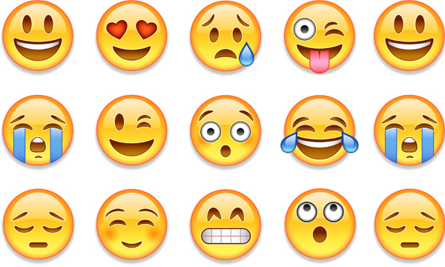
Wellbeing Focus – Design a new emoji. Draw a big circle and then decide what your emoji will represent. Have fun with your creations!

