HWB Weekly Overview - Week Beginning: 1/02/21
Here are some suggested activities for HWB this week. This term our focus will be Food and Health.
If you can, try to complete some of these activities as part of your home learning for HWB.

Again, the activities all link to the Healthy wellbeing indicator.
Primary 1 | L.I - To begin to understand that we need to eat different foods to stay healthy.  HWB 0-32a | Activities – Have a listen to this song Food Groups are Rocking Tonight. Enjoy singing along.  Also have a look at the Eatwell Plate which shows the types of food we should be eating more and less of. Talk about these with an adult.  *If you can, plan a visit to the supermarket and buy healthy snacks for a Teddy Bear’s Picnic. Can you include some snacks from the different food groups? Send in pictures of you and your teddies.  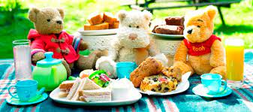
Primary 2 | L.I – To recognise that we need to eat a wide variety of food to keep our bodies healthy. HWB 1-30a | 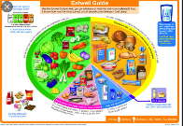  Activities – Think about all the different kinds of fruit and vegetables you get. Have a look at the Eatwell Plate again to remind you.  *Look at the different colours of fruit and veg and create a fruit and veg rainbow. You can make your own or use the sheet below.
Primary 3 | L.I – Select and prepare foods for a healthy, balanced meal/snack, with some support. HWB 1-30a | Activities – Remind yourself of the different foods you should be eating at each meal - Eatwell Plate.  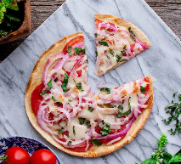  *With an adults help, try to plan a healthy meal using some or all food groups. Click on the link below for some recipe ideas.  Healthy Recipes for Children
Primary 4 | L.I – Select and prepare foods for a healthy, balanced meal/snack, with some support. HWB 1-30a | Activities – Remind yourself of the different foods you should be eating at each meal - Eatwell Plate.  *Try to plan a healthy meal using some or all food groups. Click on the link for some recipe ideas. Healthy Recipes for Children  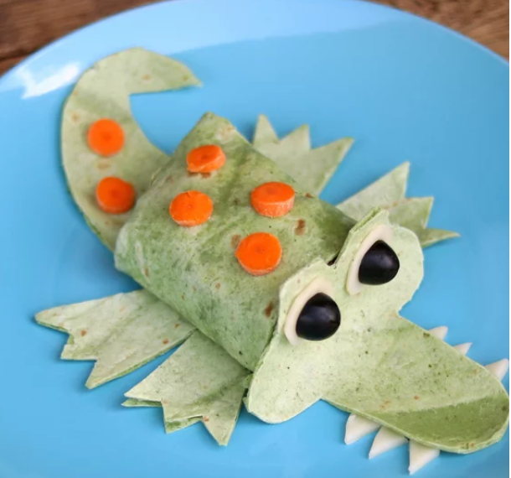
Primary 5 | L.I- Examine the main nutritional information that is displayed on food labels and use this to make healthy food choices.  HWB 2-36a | Activities – Have a look at the range of food packaging in your house and investigate the nutritional information on each. Make comparisons between different foods.  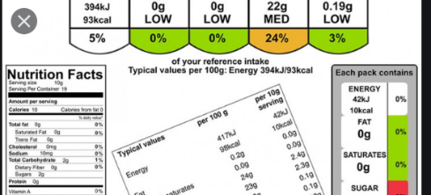  *Perhaps compare two  different types of cereal or white and brown bread.
Primary 6 | L.I- Examine the main nutritional information that is displayed on food labels and use this to make healthy food choices.  HWB 2-36a | Activities – Watch the PowerPoint that tells you all about the importance of food labelling. (Double click on Picture)  *Go on a scavenger hunt around your house. Find food items in your house and look at the food labels. Fill in as many as you can.
Primary 7 | L.I- Examine the main nutritional information that is displayed on food labels and use this to make healthy food choices.  HWB 2-36a | Activities – Watch the PowerPoint that tells you all about the importance of food labelling. (Double click on Picture)  *Using food packaging in your house, complete the food labelling hunt activity sheet below.

Click on the link below to watch a video of Mrs Bradley making Ninja stress balls.
Homemade Ninja Stress Balls

